Introduction
Biodiversity Response Planning (BRP) is a long-term area-based planning approach to biodiversity conservation in Victoria. It is designed to strengthen alignment, engagement and participation between government, Traditional Owners, non-government agencies and the community.
DELWP Regional staff have been working with stakeholders on actions to conserve biodiversity in specific landscapes, informed by the best available science and local knowledge.
These Fact Sheets capture a point in time, reflecting data and knowledge available in 2020. They provide information for many (but not all) landscapes across Victoria, containing general information on the key values and threats in each area, as well as the priority cost-effective actions that provide the best protection of biodiversity. Fact Sheets are intended to provide useful biodiversity information for the community, non-government and government organisations during project planning and development.
Further information and the full list of Fact Sheets is available on the Department’s Environment website.

Landscape description
Gariwerd focus landscape is 86,767ha in size with 23% native vegetation cover remaining. Public land makes up 3% of the area.
Current ecological modelling shows the Gariwerd focus landscape occurs within the Dundas Tablelands Bioregion with small areas occurring in the Greater Grampians Bioregion; the eastern face of the landscape is also bounded by the Victorian Volcanic Plain. The landscape has over 17,200ha of threatened Ecological Vegetation Classes (EVC). Within the southern extent, fragmented areas of endangered Plains Grassland, Plains Grassy Woodland, Plains Grassy Wetland and Plains Sedgy Wetland EVC occur. The Victorian Biodiversity Atlas has records of 11 federally protected species, 31 state protected species and 65 rare or threatened species on the Victorian Advisory List occurring within the landscape.
The Eastern Maar Aboriginal Corporation are Traditional Custodians of this focus landscape with current stakeholders including Ararat Rural City Council, Birdlife Australia, Beyond Bolac Catchment Action Group, Glenelg Hopkins Catchment Management Authority, Grampians Wimmera Mallee Water, Greening Australia, Nature Glenelg Trust, Parks Victoria, Regional Roads Victoria, Trust for Nature and Wannon Water.

Cultural importance
In Meerreengeeye Ngakeepoorryeeyt¹, the Gariwerd focus landscape is bounded by Gariwerd Country (the Grampians) to the north-west, which is significant in the Eastern Maar creation story. It was a refuge for Eastern Maar ancestors and provides an abundance of resources, some of which can still be found today¹. The majority of the Gariwerd focus landscape though can be found in Hill Country. Meerreengeeye Ngakeepoorryeeyt acknowledges the Country’s historic importance for trade routes and seasonal food¹.

Stakeholder interest
There are numerous valuable ecological assets present in this focus landscape, including those identified by Traditional Owners, partners and community.

0BEcological Values identified by Traditional Owners, partners and community within this focus landscape
Nationally Important Wetlands including Lake Muirhead, Mt William Swamp, Woorndoo-Hopkins Wetlands, Picnic Lakes, and Lake Tim Dunn | Grasslands of the Victorian Volcanic Plain including high conservation roadsides
Brady Swamp Wildlife Reserve | Green Swamp Wildlife Reserve
Walker Swamp | Wickliffe Streamside Reserve
Willaura Streamside Reserve | Hopkins River
Cockajemmy Lakes

Habitat Distribution Models identify 19 species with more than 5% of their modelled Victorian range in this focus landscape | Threatened terrestrial species within this focus landscape requiring specific actions other than those identified in Strategic Management Prospects (SMP)
19 plants, notably:  - Clumping Golden Moths (Endangered)  - Wind-blown Tussock-grass (Endangered)  - White Sunray (Endangered) | None identified

Strategic Management Prospects
Strategic Management Prospects (SMP) models biodiversity values such as species habitat distribution, landscape-scale threats and highlights the most cost-effectiveness action for specific locations. For a further in depth look into SMP for this landscape please refer to NatureKit.

Which landscape-scale actions are most cost-effective in this landscape?
The coloured areas in the map below indicate where the identified landscape-scale actions are most cost-effective and will maximise biodiversity benefit across Victoria for multiple species.
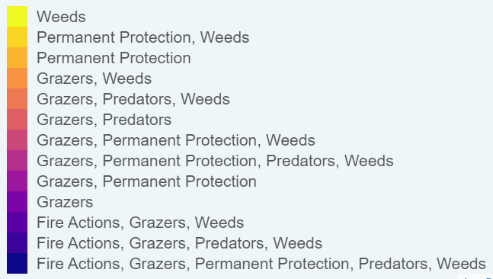
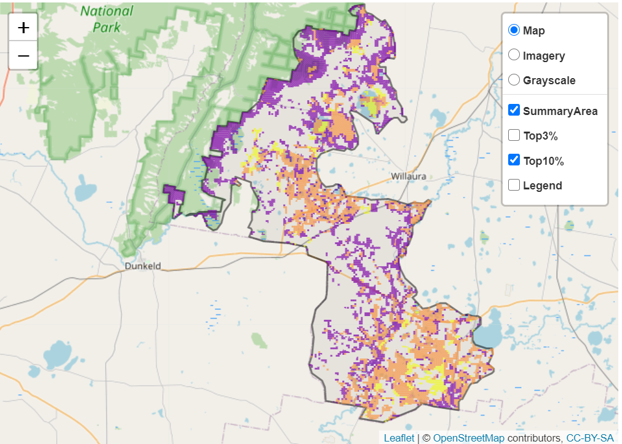
The main SMP priority actions within this focus landscape which rank among the top 10% for cost-effectiveness are listed on the right:
Control Rabbits 33,031ha
Control Weeds 18,155ha
Control Goats 6,514ha
Control Pigs 2,553ha
Control Overabundant Kangaroos 1,757ha
Control Foxes 697ha

Within this landscape, goat control, rabbit control, weed control and permanent protection (10ha) were also identified among the top 3% for cost-effectiveness.

Additional threats and considerations
Threats and considerations (in addition to those modelled in SMP) identified by Traditional Owners, partners and community groups during the BRP process for this focus landscape were:
Threats | Ecological processes and values requiring further considerations
Climate change | Appropriate burning regimes
Stock access to riparian and wetland areas | Wetland hydrology
Altered hydrology | Ground water dependent ecosystems
 | Aquatic/riparian species and catchment influences
 | Indicator species and ecosystem engineers

References
1. Eastern Maar Aboriginal Corporation, 2015. Meerreengeeye Ngakeepoorryeeyt, Eastern Maar Country Plan

