Goulburn Broken Catchment Management Authority (GBCMA) partnered with the Landcare group in the Strathbogie Ranges to deliver the Wetlands Tender in 2010-2011, a project which credits its success largely to a long term investment in relationship building by experts from the local Landcare group and the EcoTender process developed by the ecoMarkets team at the Department of Sustainability and Environment (DSE).

The Wetlands Tender provided $227,000 to 16 landholders, resulting in conservation and management of 77 hectares of wetlands in the Strathbogie Ranges, near Ruffy, Caveat and Terrip in north-east Victoria.

Landcare Coordinator Janet Hagen said it was great to be spreading the word about the program and building an interest in conservation of wetlands among locals.

“This kind of work benefits from years of relationship building. You can’t just do it straight away. This area is home to a lot of traditional farmers, historically there hasn’t been a great emphasis on the environment,” she said.

“The tender process involves landholders nominating a price for undertaking conservation and management work on their properties, according to five year management agreements with DSE. Plans generally include work such as fencing, managing weeds and planting native trees.
Janet said, “For some landholders it was a pretty bold move and they thought pretty hard about their bids. A lot of people had never applied for any kind of funding before; it’s an older farming community. Probably because they know me and they might be more sceptical of someone from ‘government’ or a catchment management authority, they were more likely to get on board. I did stick my neck out a bit, so was glad when it was successful,” Janet said.

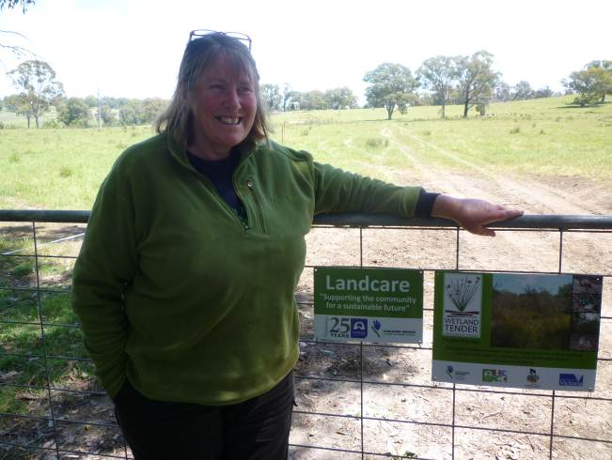

Landcare Coordinator, Janet Hagen

“I was trained in EnSym – an environmental modelling program – then used EnSym when doing the site assessments for participating landholders. I also did training in using the Index of Wetland Condition which is part of the site assessments too.

“I worked on gathering all of the data, doing the assessments, then all of the bids go to the bid assessment team. They use the scores
generated by EnSym to rank bids according to which offer the best environmental value, and then contracts are offered to those which ranked highest.

“In the end nearly everyone was successful and Landcare could do other work with some landholders, so no-one had a bad experience.

“Following on from the Wetlands Tender, we set up a conservation management network, partly to keep up the momentum, to keep people thinking about conservation and connectivity across the landscape.

“Traditionally, farmers had mainly dug out their wetlands or built a dam. Now protecting wetlands and bogs is becoming normal.

“Some earlier research had found that simply fencing off bogs and keeping stock out wasn’t enough to get better biodiversity – you still have to keep the biomass down somehow. So we continue to learn about the best ways to do things.

“Next we’re planning to partner with GBCMA on a rocky outcrop conservation project, working with landholders in the same area to conserve the rocky outcrops which are such an important feature of this area,” she said.

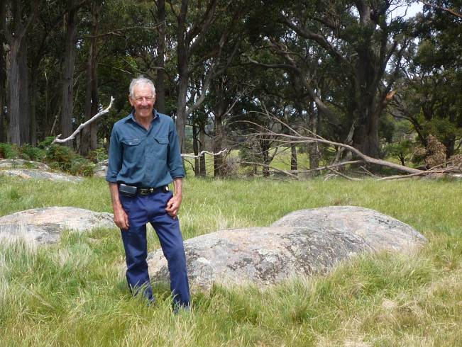

Successful landholder in the Wetlands Tender, Billy Eddy, on his property near Ruffy

