VBA - Generate Species Checklist
  - How to generate a list of species in the
  - Victorian Biodiversity Atlas

Tips
Make sure that you have allowed pop-ups from your browser (you will need to allow these from the VBA site)
- Visit VBA (https://vba.dse.vic.gov.au/vba/) and enter as a guest or via your Login Name & Password
- Navigate to the Search section in the top left of the Welcome page and then select Download Species Checklist.
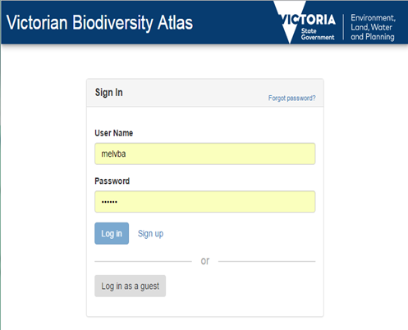

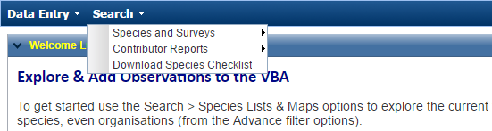

k
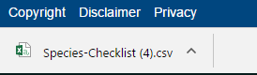
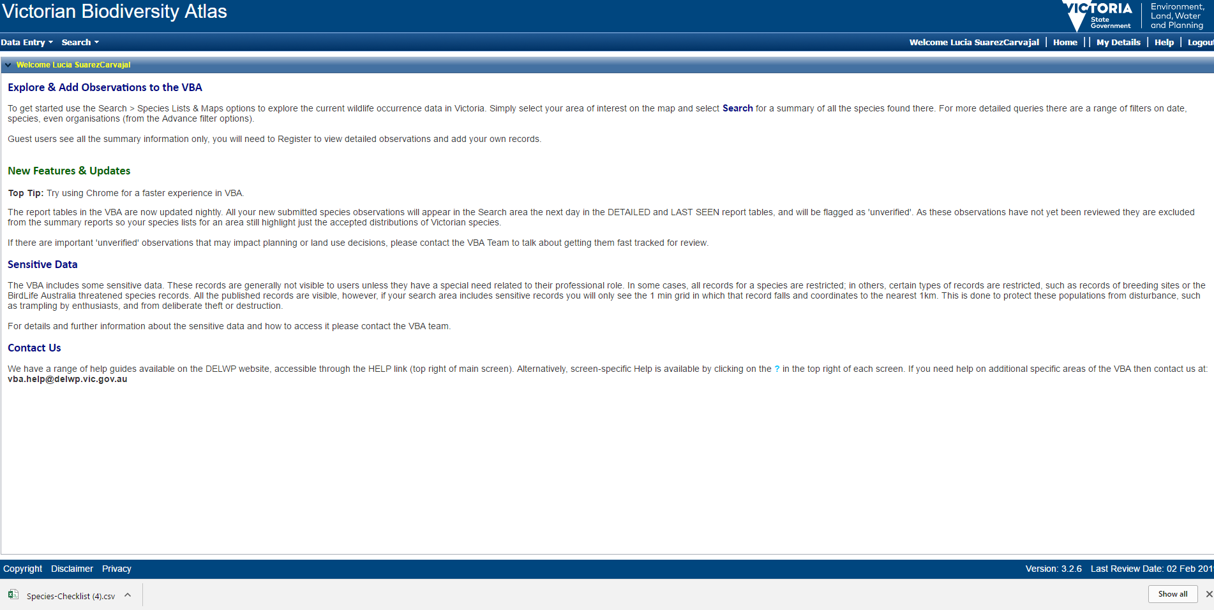
Click on “Species-Checklist.csv” file downloaded and open the VBA species list to identify the species taxon ID.

