|  |
| --- |
| NaturePrint |
| Strategic Biodiversity Values |

Evidence-based decision making is critical to improving outcomes for biodiversity. The Strategic Biodiversity Values map combines information on biodiversity values with vegetation type and condition to show the relative value of landscapes in Victoria. This can help to identify priority areas for protection.

# Strategic Biodiversity Values

Strategic Biodiversity Values (SBV) is one of NaturePrint’s decision-support products. It combines information on areas important for threatened flora and fauna, and vegetation types and condition to provide a view of relative biodiversity importance of all parts of the Victorian landscape. This integrated information is important because decision-makers need access to an objective, comprehensive and spatially explicit view of the rank of biodiversity assets to enable comparison of locations across Victoria.

The information provided by SBV is potentially useful for a wide range of decision makers and natural resource managers. Information about the relative value of biodiversity assets can help inform conservation decision-making processes, such as:

* native vegetation permitted clearing and offsetting
* prioritising areas for protection
* raising awareness of the spread of biodiversity values across Victoria.

|  |
| --- |
| NaturePrint  NaturePrint is a suite of decision-support products and tools designed to help us make choices about what actions to take, and in which places, to protect Victoria’s environment and plan for the future. The tools currently include:   * Habitat Distribution and Importance Models * Threat and Benefit of Action Models* * Strategic Biodiversity Values * Strategic Management Prospects*   *currently focused on terrestrial environment  Further information about NaturePrint, including information sheets, is available at [https://www.environment.vic.gov.au/‌biodiversity/natureprint](https://www.environment.vic.gov.au/biodiversity/natureprint).  NaturePrint products can be viewed using NatureKit – the department's online biodiversity mapping and reporting tool: <https://naturekit.biodiversity.vic.gov.au>. |

## Constructing the SBV v4 map

The SBV v4 map (Figure 1) was created by combining and analysing biodiversity information across Victoria using Zonation conservation planning software. The objective of this analysis was to rank all locations across Victoria for their ability to represent threatened (VROT) vertebrate fauna, vascular flora, and the full range of Victoria’s native vegetation. It is based on efficient and effective spatial coverage of these biodiversity values.

Another way of thinking about it is to imagine designing Victoria’s conservation reserve system from scratch. What would be the best arrangement of reserves to capture the greatest amount of Victoria’s remaining biodiversity values if the reserve system was 5%, 10% or 15% of Victoria?

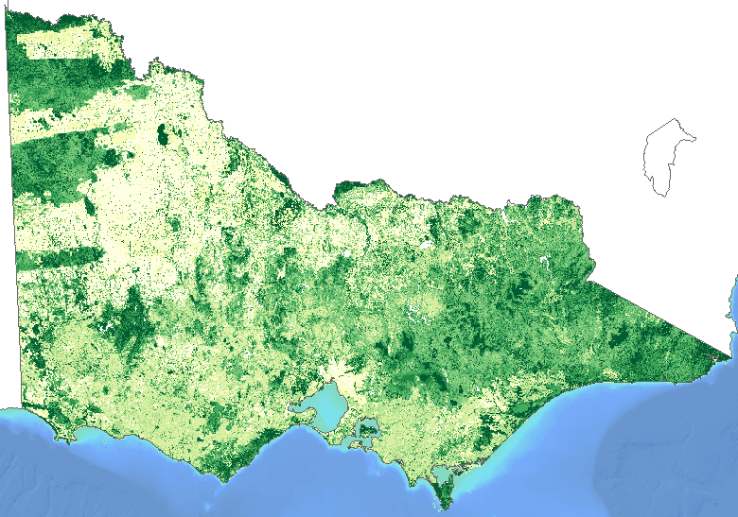

Figure 1: Strategic Biodiversity Values v4 map, showing areas of biodiversity value ranked from highest (dark green) to lowest (light green).

The biodiversity information used in the SBV v4 analysis included:

* species habitat distribution models
* models of uncertainty of the likelihood of modelled habitat (and, for fauna, habitat importance models) for Victoria’s rare or threatened species (VROT)
* models of vegetation types in Victoria
* a model of native vegetation condition.

The analysis first looked for locations with the least biodiversity value and then identified the location with the next lowest level of biodiversity value. This process continued until there was a complete ranking of locations across the state. The biodiversity value that informed the ranking was based on the modelled range and likelihood of species habitat or vegetation type in a location, compared to pre-settlement levels.

This iterative, bottom-up approach is used so that the analysis considers the connectedness and aggregation of habitat at the same time as the representation of values.

This analysis results in the areas with little biodiversity value ranked lower, the most degraded and poorly located examples of the most common habitat or vegetation in the middle of the ranking, and the best and most well-connected examples of VROT species’ habitats across the state ranked higher. This means that some locations with low condition vegetation can be more highly ranked because they provide links for habitats, or are the only remaining habitat for certain species.

For some species, significant areas of likely habitat may not be occupied, either due to insufficient recovery time since a disturbance event or due to catastrophic historic impact that is beyond normal recovery capability. These factors are not yet included in Habitat Importance Models nor in the current SBV map.

## **Input datasets**

### Species’ habitat models

Individual field observations of species are a critical source of information, however extrapolation by modelling species’ habitat distribution is essential to put these observations in context. The *Habitat Distribution Models and Habitat Importance Models* information sheet describes the development of species’ habitat distribution models.

This includes the current potential distribution of likely habitat for all of Victoria’s vertebrate fauna and rare or threatened invertebrates with sufficient available data, as well as their pre-1750 distribution. Habitat distribution models have also been created showing the pre-1750 distribution of Victoria’s rare or threatened flora species (where sufficient data was available). The models supplied to the Strategic Biodiversity Values analysis were continuous and were used at 225 metre resolution to make computation tractable.

The level of uncertainty in the species’ habitat models was considered in the analysis. Where all other inputs to any pixel ranking decision are equal, pixels with lower variance will be preferred to pixels with higher variance.

### Vegetation types

Vegetation types provide an additional perspective on how biodiversity is distributed across the landscape. The department uses Ecological Vegetation Classes (EVCs) for this purpose, however they are mapped with discrete boundaries rather than the continuous gradients that are required for the SBV analysis. Vegetation types similar to EVCs were generated specifically for this analysis based on attributes describing the structure, function, and floristic composition and spatially modelled using a combination of field observations of the vegetation, with remote sensing and other mapped data. Three different but nested levels of this classification were used in the SBV analysis.

### Condition

The flora condition data is based on the pre-1750 habitat distribution models for each species, multiplied by a model of site condition (in which native vegetation condition scores vary across private land, but are universally high across public land).

For the majority of fauna species, a Habitat Importance Model (HIM) was produced which scored the habitat of the species based on the home range size, dispersal abilities and area required for a viable population for each species relative to its extant habitat model. This importance model was used as a view of habitat condition for fauna. For taxa where no habitat importance model was available (e.g. fish), the condition was scored uniformly high. By multiplying the habitat distribution models by a condition layer, a view is created of how the relative level of disturbance affects the overall biodiversity value of a specific location.

## Continuous improvement

We are committed to a continuous improvement approach, which enables the NaturePrint products and tools to be updated and refined as further data, computational power, research and modelling methods become available. NaturePrint products have a version number to help identify the currency of each product.

Everyone can contribute to the improvement of the NaturePrint tools. For example, by submitting species records to the Victorian Biodiversity Atlas which is a key source of information for NaturePrint. Visit the [Victorian Biodiversity Atlas](https://www.environment.vic.gov.au/biodiversity/victorian-biodiversity-atlas) web page for more information.

Opportunities for feedback on other data layers will be developed.

|  |  |
| --- | --- |
| © The State of Victoria Department of Environment, Land, Water and Planning 2018  LogoThis work is licensed under a Creative Commons Attribution 4.0 International licence. You are free to re-use the work under that licence, on the condition that you credit the State of Victoria as author. The licence does not apply to any images, photographs or branding, including the Victorian Coat of Arms, the Victorian Government logo and the Department of Environment, Land, Water and Planning (DELWP) logo. To view a copy of this licence, visit http://creativecommons.org/licenses/by/4.0/  ISBN 978-1-76047-670-0 (pdf/online)  Disclaimer  This publication may be of assistance to you but the State of Victoria and its employees do not guarantee that the publication is without flaw of any kind or is wholly appropriate for your particular purposes and therefore disclaims all liability for any error, loss or other consequence which may arise from you relying on any information in this publication. | Accessibility  If you would like to receive this publication in an alternative format, please telephone the DELWP Customer Service Centre on 136186, email [customer.service@delwp.vic.gov.au](mailto:customer.service@delwp.vic.gov.au), or via the National Relay Service on 133 677 [www.relayservice.com.au](http://www.relayservice.com.au). This document is also available on the internet at [www.delwp.vic.gov.au](http://www.delwp.vic.gov.au). |