|  |
| --- |
| VBA - Generate Summary Species Lists |
| How to generate a summary species report in the Victorian Biodiversity Atlas |

## A Summary species list report will generate a summarised list of the taxa recorded in your chosen area and can be created by any user of the VBA. Follow these steps to generate your own report.

## *Tips*

*Throughout the VBA each window has a* ***?*** *in the top right hand corner – this is window-specific help that will provide further details about how to complete the fields.*

*Make sure that you have allowed pop-ups from your browser (you will need to allow these from the VBA site)*

1. Visit VBA (https://vba.dse.vic.gov.au/vba/) and enter as a guest or via your Login Name & Password
2. Navigate to the Search section in the top left of the Welcome page and then select Species and Surveys > Species Lists & Maps

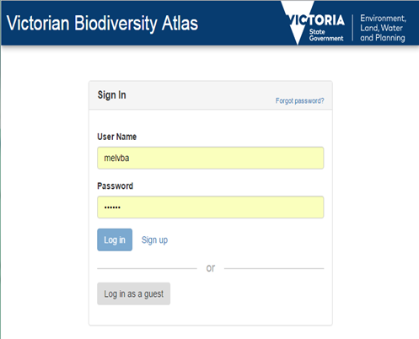

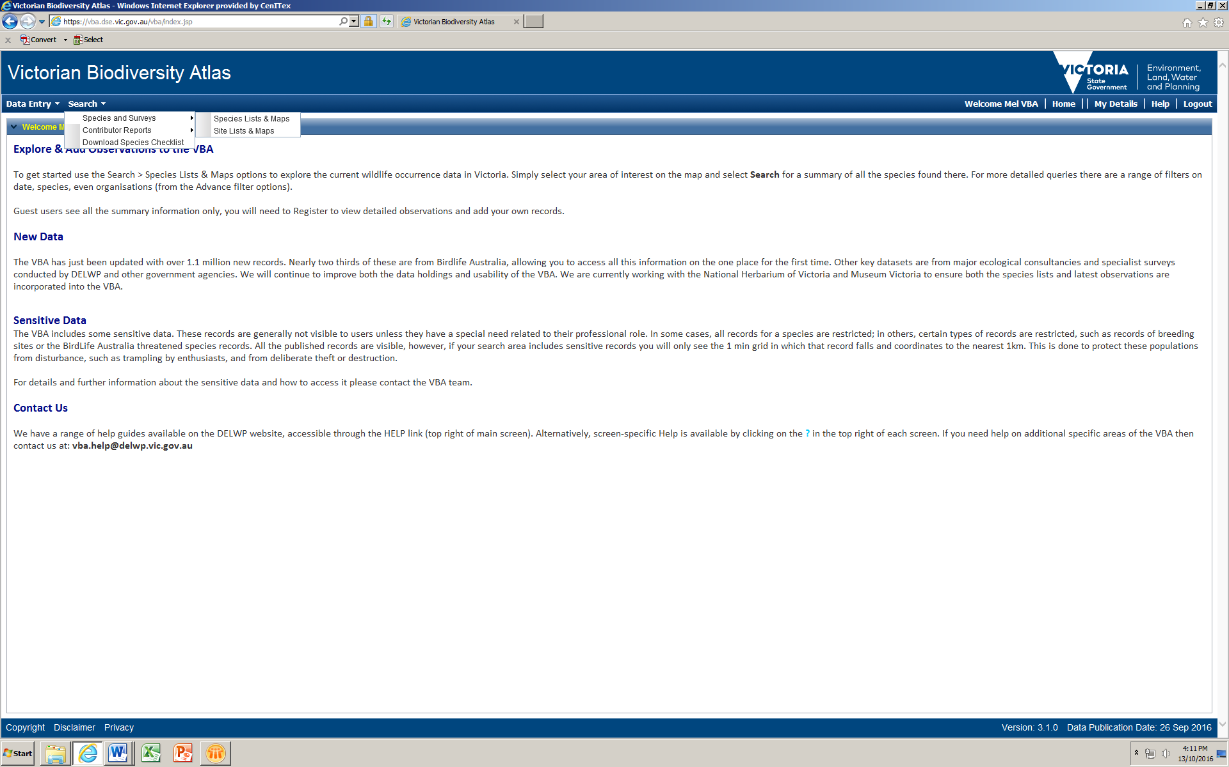

From here you have access to the spatial and non-spatial search elements to query the VBA database.

There are multiple ways you can select your search area. You have the option to:

* manually draw your search area (Type = User Polygon; Click then Draw) – after drawing your search area, follow steps 5-7 below
* 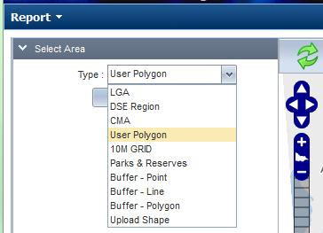select from a pre-defined polygon (Type = LGA, DSE Region, CMA, 10 minute Grid, or Parks & Reserves) – refer to steps 3-7 below
* upload your own shapefile, then follow steps 5-7 below
* create a point, line or polygon and buffer it (Type = Buffer – Point, Buffer – Line or Buffer – Polygon; Click then Draw, type in required buffer, Apply Buffer), follow steps 5-7 below

The following steps show you how to use an existing polygon for your search:

1. To select from one of pre-defined polygons, choose the relevant option from the drop-down list – eg Parks & Reserves. Once you select one of these options, you can then select the specific polygon you need – eg Ada Tall Trees Reserve
2. Next click Zoom To and your map will zoom to that polygon.
3. Select Summary and click Search.
4. The list of species for that area will appear at the bottom of your screen.
5. You can now either Print or Export this list.

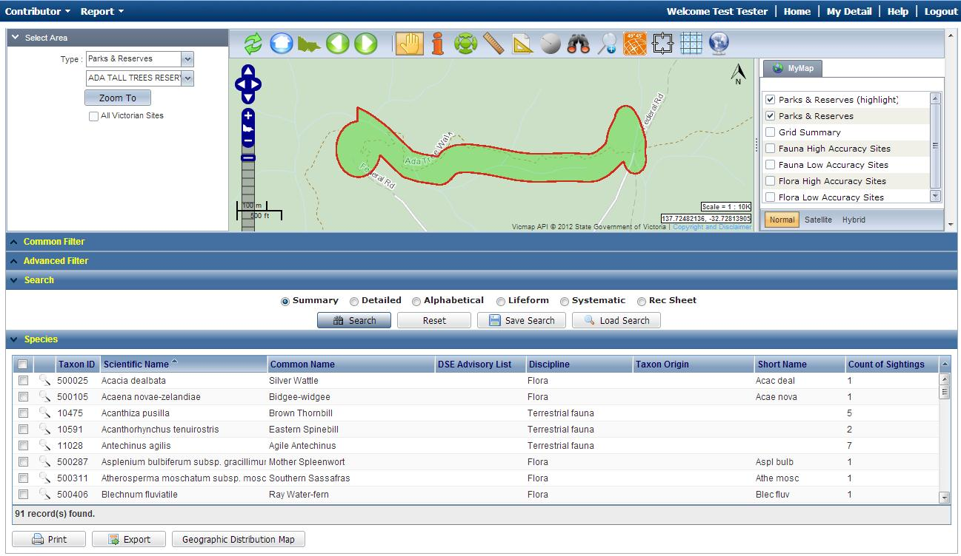

|  |
| --- |
| **Related Quick Help Guides:**   * Search - Detailed Species List for an Area * Search - Species Distribution Map * Search – Detailed Statewide Records for a Single Species |

|  |  |
| --- | --- |
| © The State of Victoria Department of Environment, Land, Water and Planning 2017  LogoThis work is licensed under a Creative Commons Attribution 4.0 International licence. You are free to re-use the work under that licence, on the condition that you credit the State of Victoria as author. The licence does not apply to any images, photographs or branding, including the Victorian Coat of Arms, the Victorian Government logo and the Department of Environment, Land, Water and Planning (DELWP) logo. To view a copy of this licence, visit http://creativecommons.org/licenses/by/4.0/  Disclaimer  This publication may be of assistance to you but the State of Victoria and its employees do not guarantee that the publication is without flaw of any kind or is wholly appropriate for your particular purposes and therefore disclaims all liability for any error, loss or other consequence which may arise from you relying on any information in this publication. | Accessibility  If you would like to receive this publication in an alternative format, please telephone the DELWP Customer Service Centre on 136186, email [customer.service@delwp.vic.gov.au](mailto:customer.service@delwp.vic.gov.au) or via the National Relay Service on 133 677 [www.relayservice.com.au](http://www.relayservice.com.au). This document is also available on the internet at [www.delwp.vic.gov.au](http://www.delwp.vic.gov.au). |