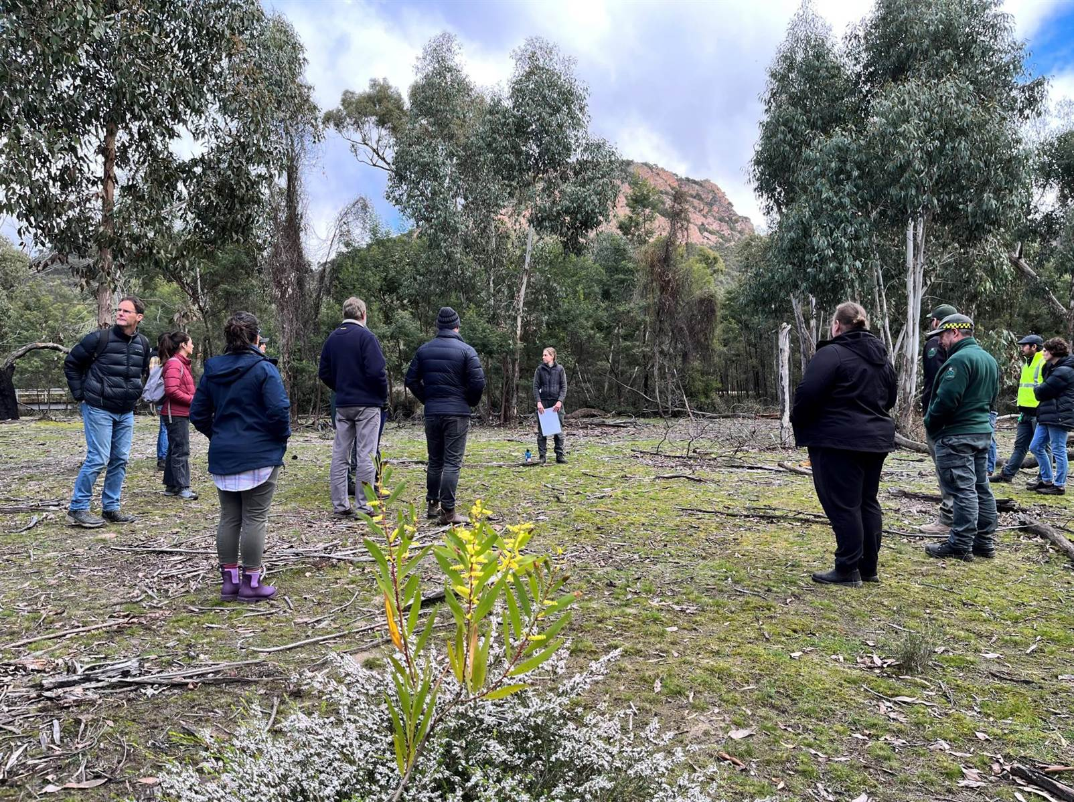

Weeds and Pests on
Public Land
Program Report
2022-2023

WPPL field trip to the Grampians National Park 2023 – Bianca Gold.
OFFICIAL

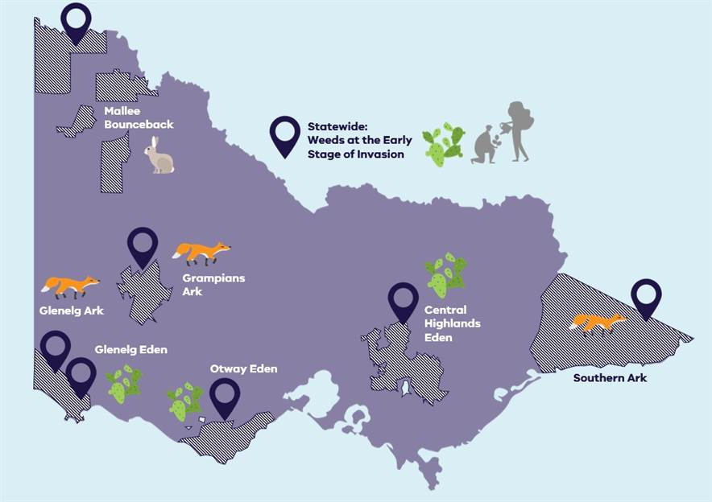
Weeds and Pests on Public Land 2022-2023
2

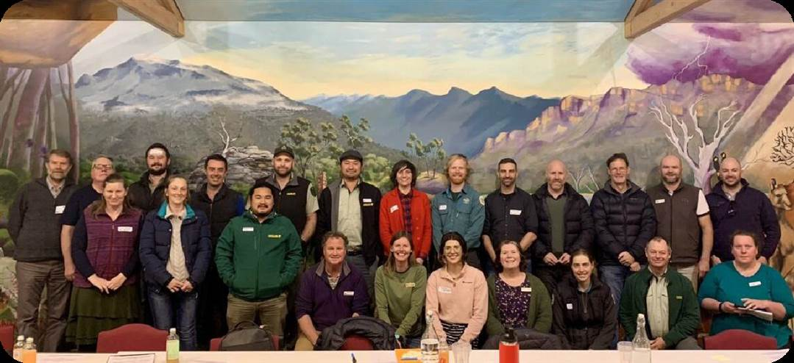
WPPL Collaboration Event in the Grampians in 2023 – Ally Hughes.

The Weeds and Pests on Public Land (WPPL) Program funds landscape-scale weed and pest projects, focusing on protecting Victoria’s biodiversity. The program began in 2005 and is delivered by DEECA and Parks Victoria along with now 42 partners and key stakeholders across Victoria. In 2022-2023, the WPPL Program continued to fund eight flagship projects across Victoria including:
- Glenelg Ark, Grampians Ark, and Southern Ark projects targeting foxes to protect and benefit a wide range of native mammals, birds, and reptiles.
- Central Highlands Eden, Glenelg Eden, and Otway Eden projects controlling high risk weed species that threaten native plants and animals.
- The Mallee Bounceback project which aims to control rabbits to restore semi-arid woodlands.
- The Weeds at the Early Stage of Invasion (WESI) project which builds the capability of land managers to respond to early invader weeds.

3
WPPL Program Achievements in 2022-2023

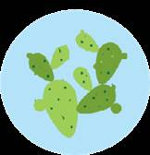

10
Traditional Owner groups engaged or involved

18
Staff directly employed

21
Community engagement events delivered by projects

2,254
Volunteer hours

42
Delivery partners and key stakeholders

721,111
Total hectares of predator control
457,698 Ha in priority
locations

50,239
Total hectares of herbivore control
49,084 Ha in priority
locations

9,407
Total hectares of weed control
4,888 Ha in priority locations
$

$1.91 mill
of co-investment provided by project partners

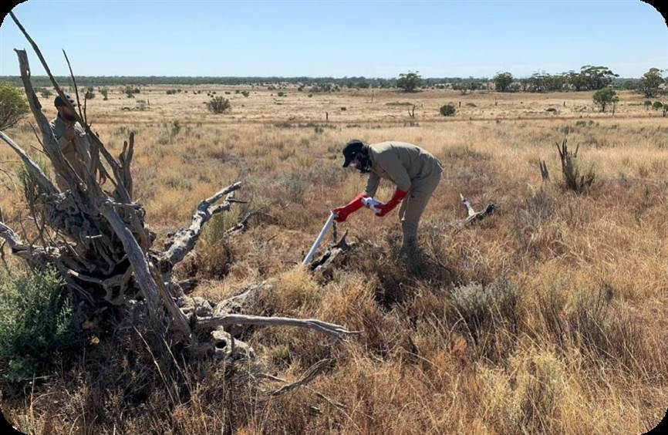
4 Partnering and engaging with Traditional Owners
OFFICIAL
Mallee Bounceback
First People of the Millewa Mallee Aboriginal Corporation Cultural Rangers undertook rabbit control in Taparoo Murray Sunset National Park allowing them to build skills and knowledge regarding rabbit control

Weeds at the Early Stage of Invasion (WESI)
WESI ran a Swifts Creek, Gippsland, weed identification training event that was attended by 8 First Nations people, including participants from Moogji Aboriginal Council East Gippsland and Bidwell First Nations Clans Aboriginal Corporation
Southern Ark
Partnered with Moogji Aboriginal Council East Gippsland to deliver the fox baiting program across the Murrungowar area

Rabbit fumigation being undertaken by a Cultural Ranger at Taparoo - Rhett Cameron.

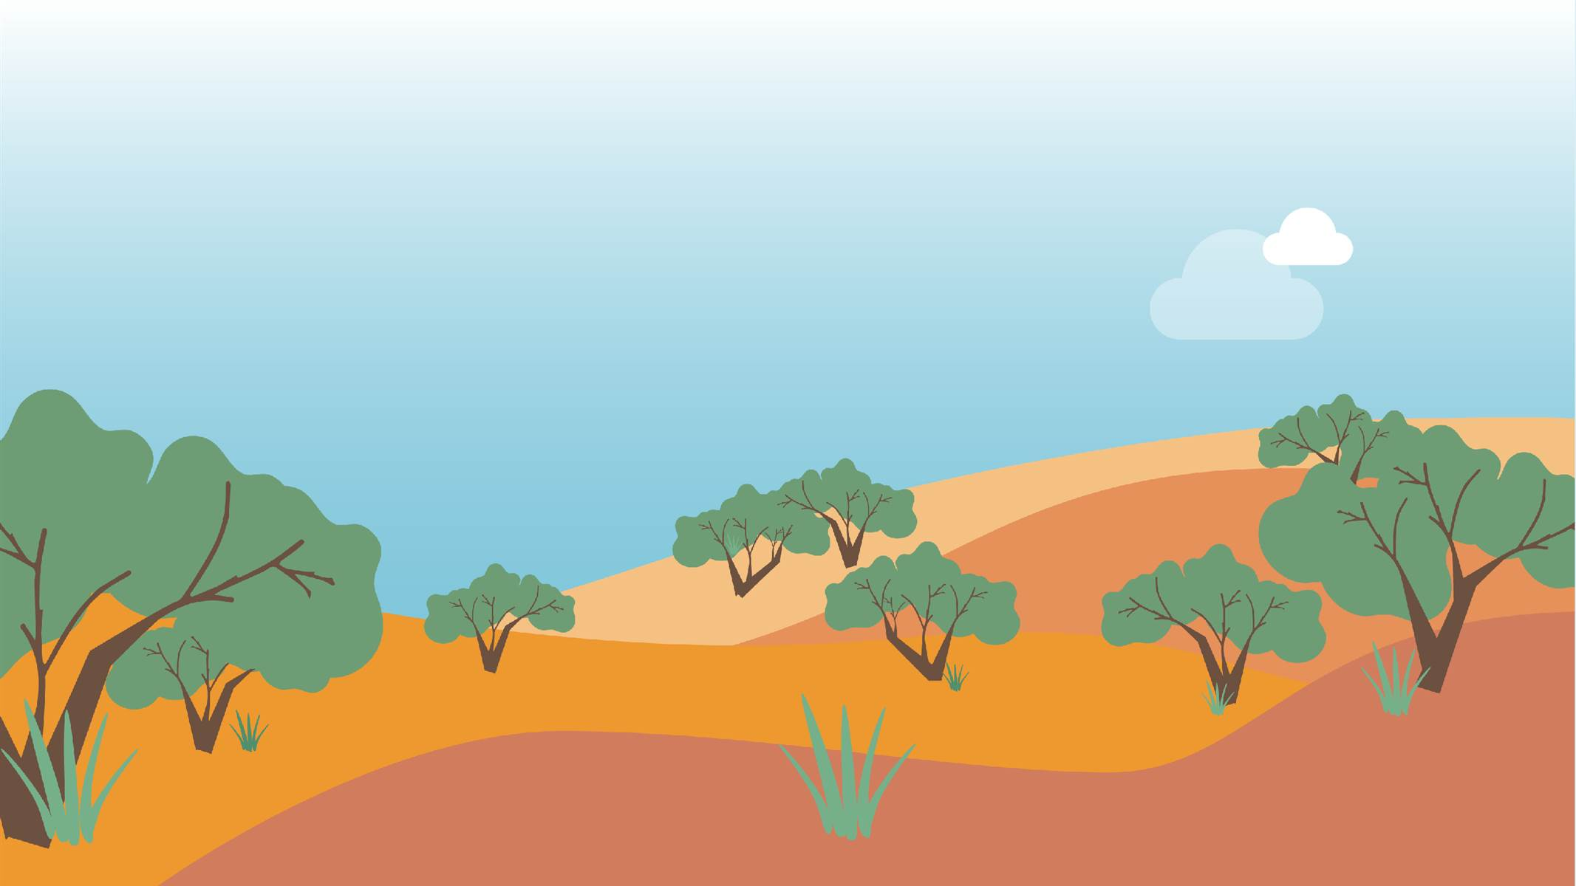
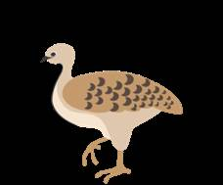
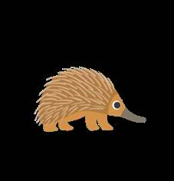
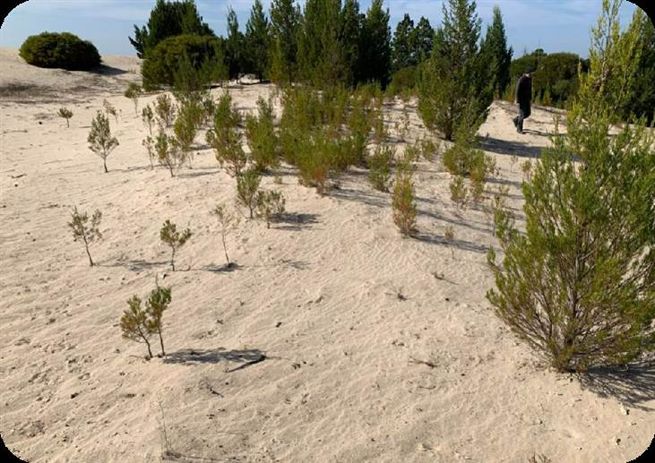
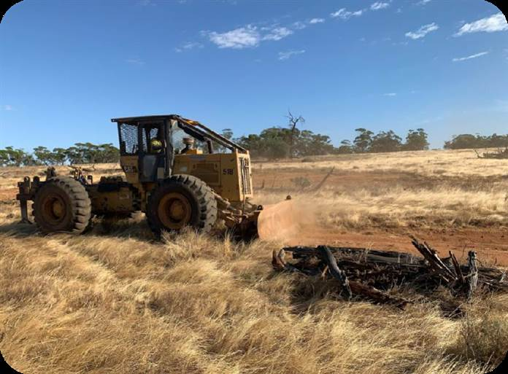
5 Mallee Bounceback

Protecting and restoring the biodiversity of semi-arid woodlands in north-western Victoria

50,239 Ha of rabbit control
3,124 rabbit warrens fumigated
2,334 rabbit warrens ripped
96% of transects with an average of 1 or
fewer rabbits per spotlight kilometre
- No evidence of rabbit browsing pressure at most sites
- Increase in juvenile canopy trees
- Semi-arid woodlands still in decline and need additional intervention such as revegetation
2 engagement events
- Neds Corner Safe Haven Workshop
  - Parks Victoria field visit to Pippins
Management block and Murray
Sunset National Park

Ripping rabbit burrows at Taparoo – Rhett Cameron. Pine regeneration at Wyperfeld National Park – Rhett Cameron.
OFFICIAL

6 Weeds at the Early Stage of Invasion

Supporting Victorian land managers to manage environmental weeds threatening our native biodiversity

3 newsletters published
3 school visits
2 training events delivered with 51 people attending
Social media engagement
5 social media accounts
2,963 followers across all social media platforms (Facebook, Instagram & X/Twitter) 34,988 Tweet (X) impressions
WESI has shared its resources with over 68 stakeholders via its newsletters, social media engagement, and training events

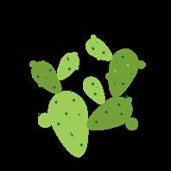
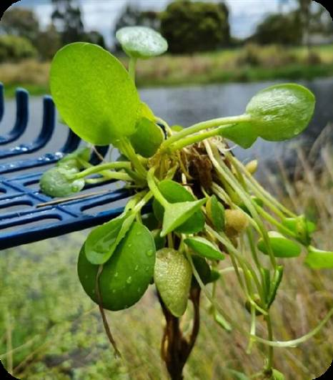
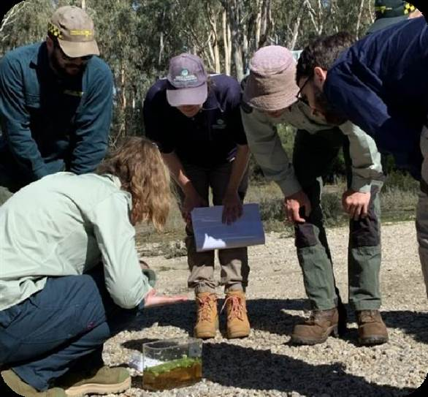
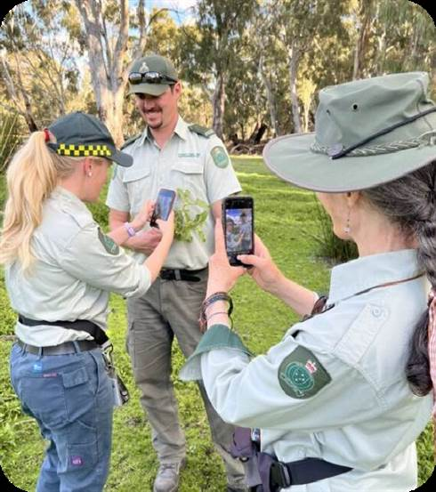
OFFICIAL

From left-right: the weed, Amazon Frogbit, found in Bairnsdale – Bianca Gold; informal weed training in Gunbower – Kate Blood; weed ID in action with the help of apps and good quality photos – Bianca Gold.

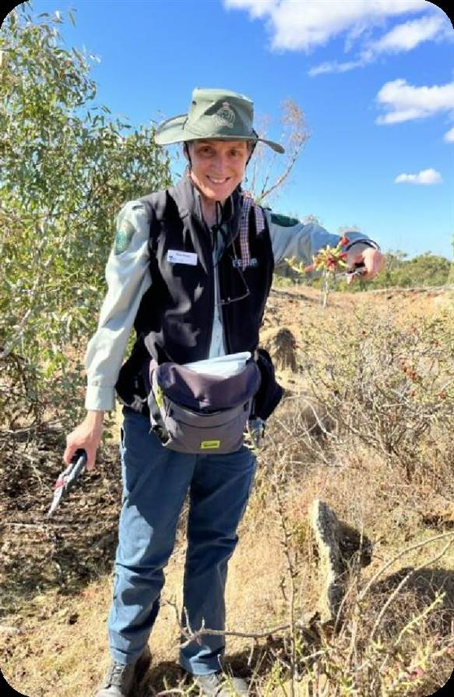
7

Weeds at the Early Stage of Invasion

Case Study: First record of the weed, Pencil Cactus,
found in Victoria
Pencil Cactus (Cylindropuntia leptocaulis) is listed as a Weed of National Significance in Australia. It has been introduced from Southwest USA and northern Mexico. Until April 2023, this weed species had not been recorded in Victoria.

The WESI Team, in collaboration with DEECA's Loddon Mallee Region, undertook a field survey and found 35 plants over an area of approximately 400-700m2. The site of this new invasive cactus is on public land in north central Victoria, about 70km north of Bendigo. All plants have been mapped and will be entered into the Victorian Biodiversity Atlas.

To raise awareness about the new cactus, WESI did a radio interview with the ABC. Information about the new weed was successfully shared on social media, in the WESI newsletter, and in subsequent weed ID training.

The WESI Team is supporting local land managers with its eradication.
OFFICIAL
Pencil Cactus discovery with Kate Blood pictured – Bianca Gold.

8 Central Highlands Eden

Reducing the impact of high threat weeds to protect native biodiversity of Victoria’s Central Highlands

4,476 Ha of weed control
10 partners involved
WeedStop training occurred for the first time
since 2019, with 34 participants completing

On-ground works in 20 (of 24) biodiversity asset areas
the accredited course in November 2022

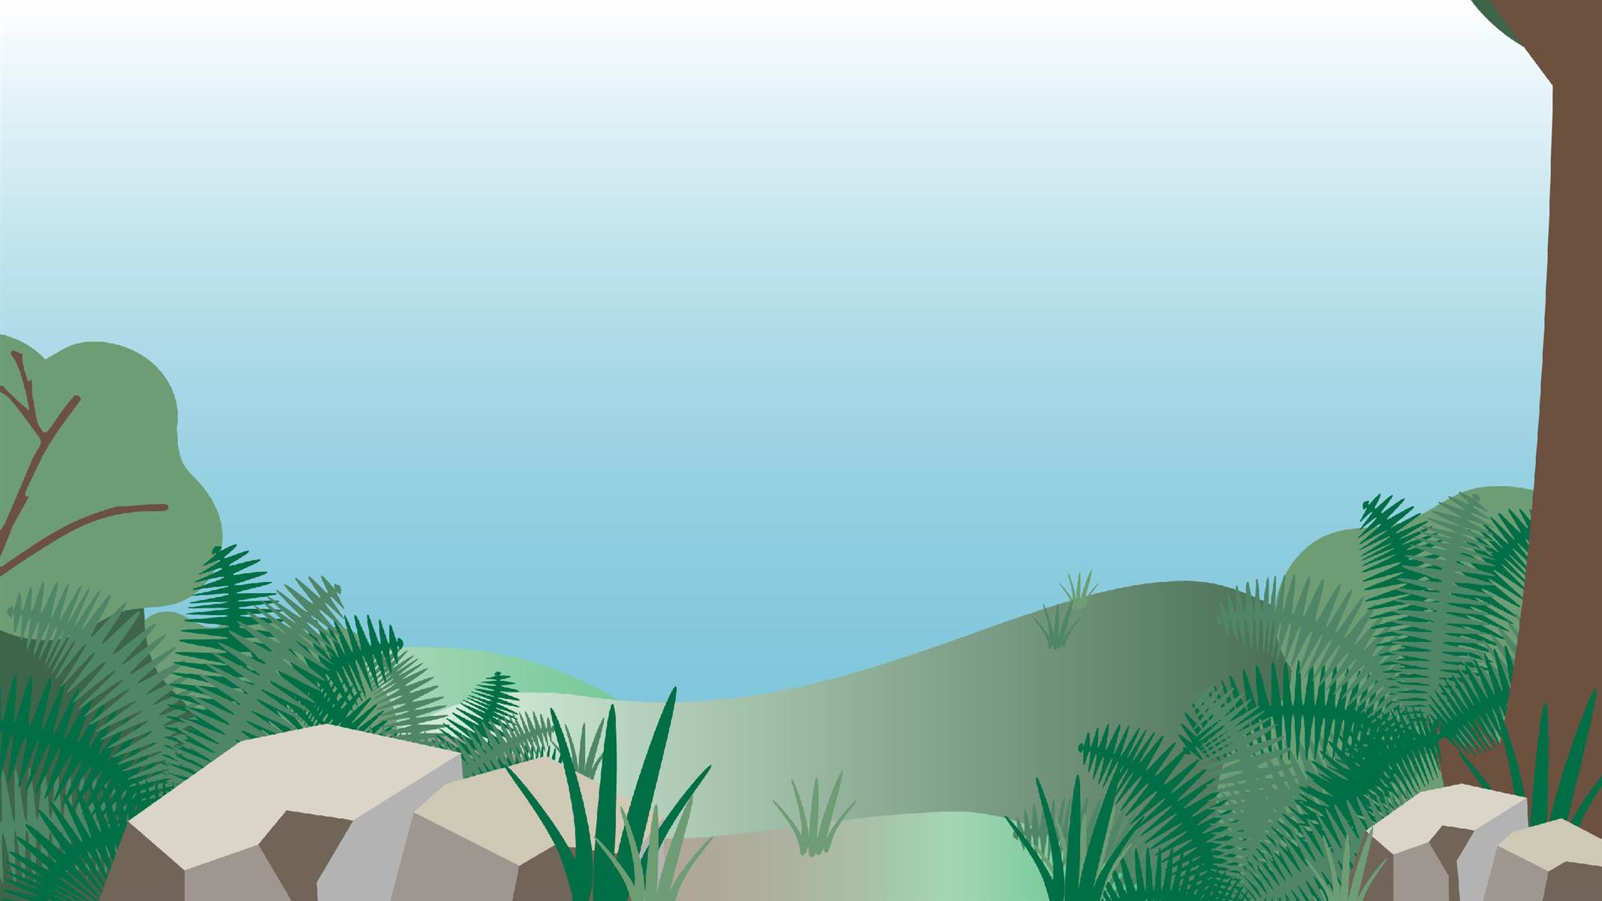
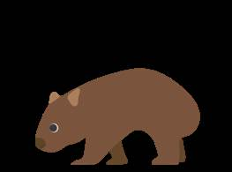
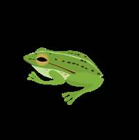
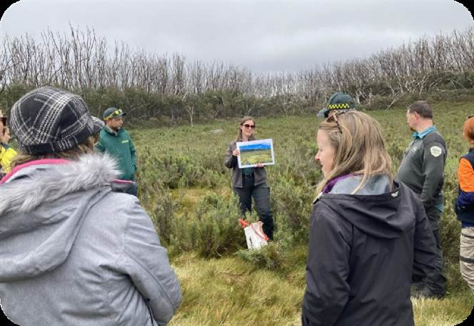
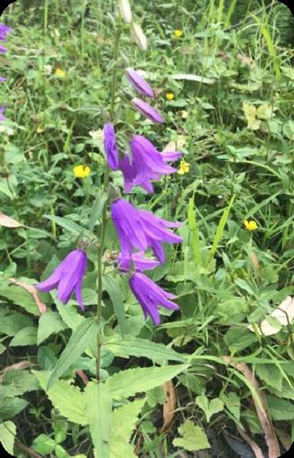
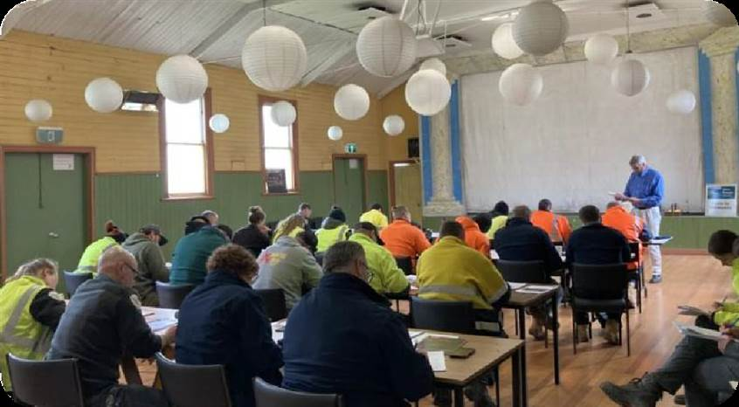
OFFICIAL

20 eradication target species
18 containment target species

From left-right: Field trip to Lake Mountain to talk about Central Highlands Eden weed control – Sally Lambourne; the weed, Creeping Bellflower (Campanula rapunculoides), in the project area – Bradley Matthews; WeedStop training class – Sally Lambourne.

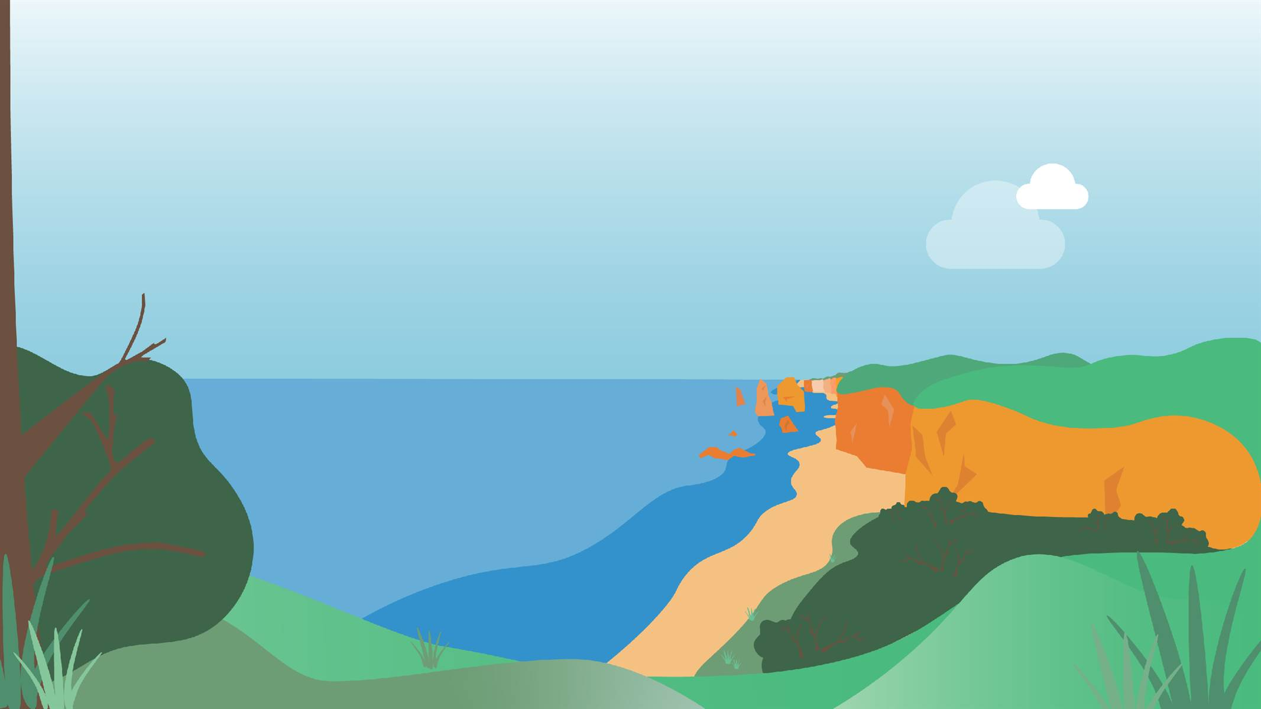
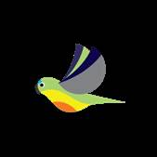
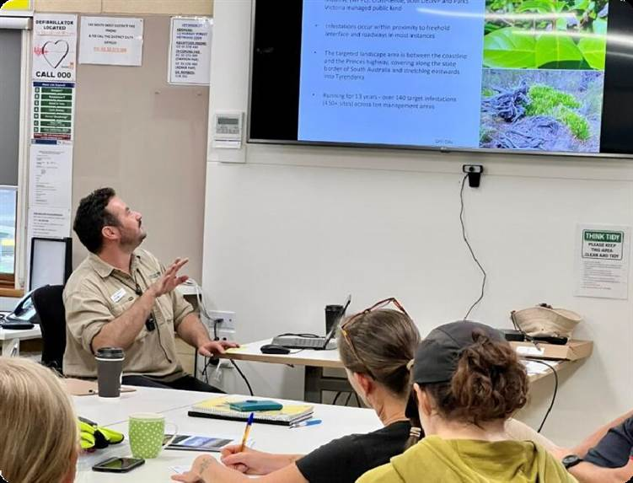
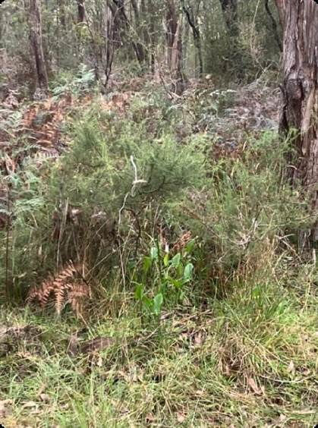
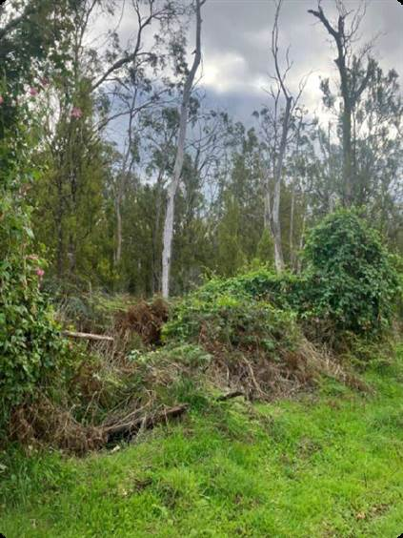
9 Glenelg Eden

Reducing the impact of high threat weeds to protect the native biodiversity of Victoria’s far south-west

4,246 Ha of weed control

2 training events delivered
Building capability of Gunditj Mirring Traditional
Owners to respond to high threat weeds
Workshop with South West TAFE students
The team treated weeds at 250 sites across the landscape this season:

76% of all eradication targets treated
17 species of priority weeds for containment infestations
3 species of priority weeds for asset protection infestations

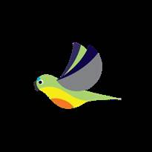
From left-right: Arum Lily (Zantedeschia aethiopica), one of the eradication target species; Banana passionfruit (Passiflora tarminiana) weed found in the project area; South West TAFE training workshop – Mitch Williams all photos.
OFFICIAL

10 Otway Eden

Reducing the impact of environmental weeds to restore the biodiversity of the Otway Ranges National Park

686 Ha of weed control

13 delivery partners

371 volunteer hours
15 species of weeds were targeted for eradication
25 species of priority weeds for
containment infestations
45 species of priority weeds for asset protection infestations

Control areas were extended to cover new infestations of South African Weed Orchid in Metallic Sun Orchid population sites in the Port Campbell Area

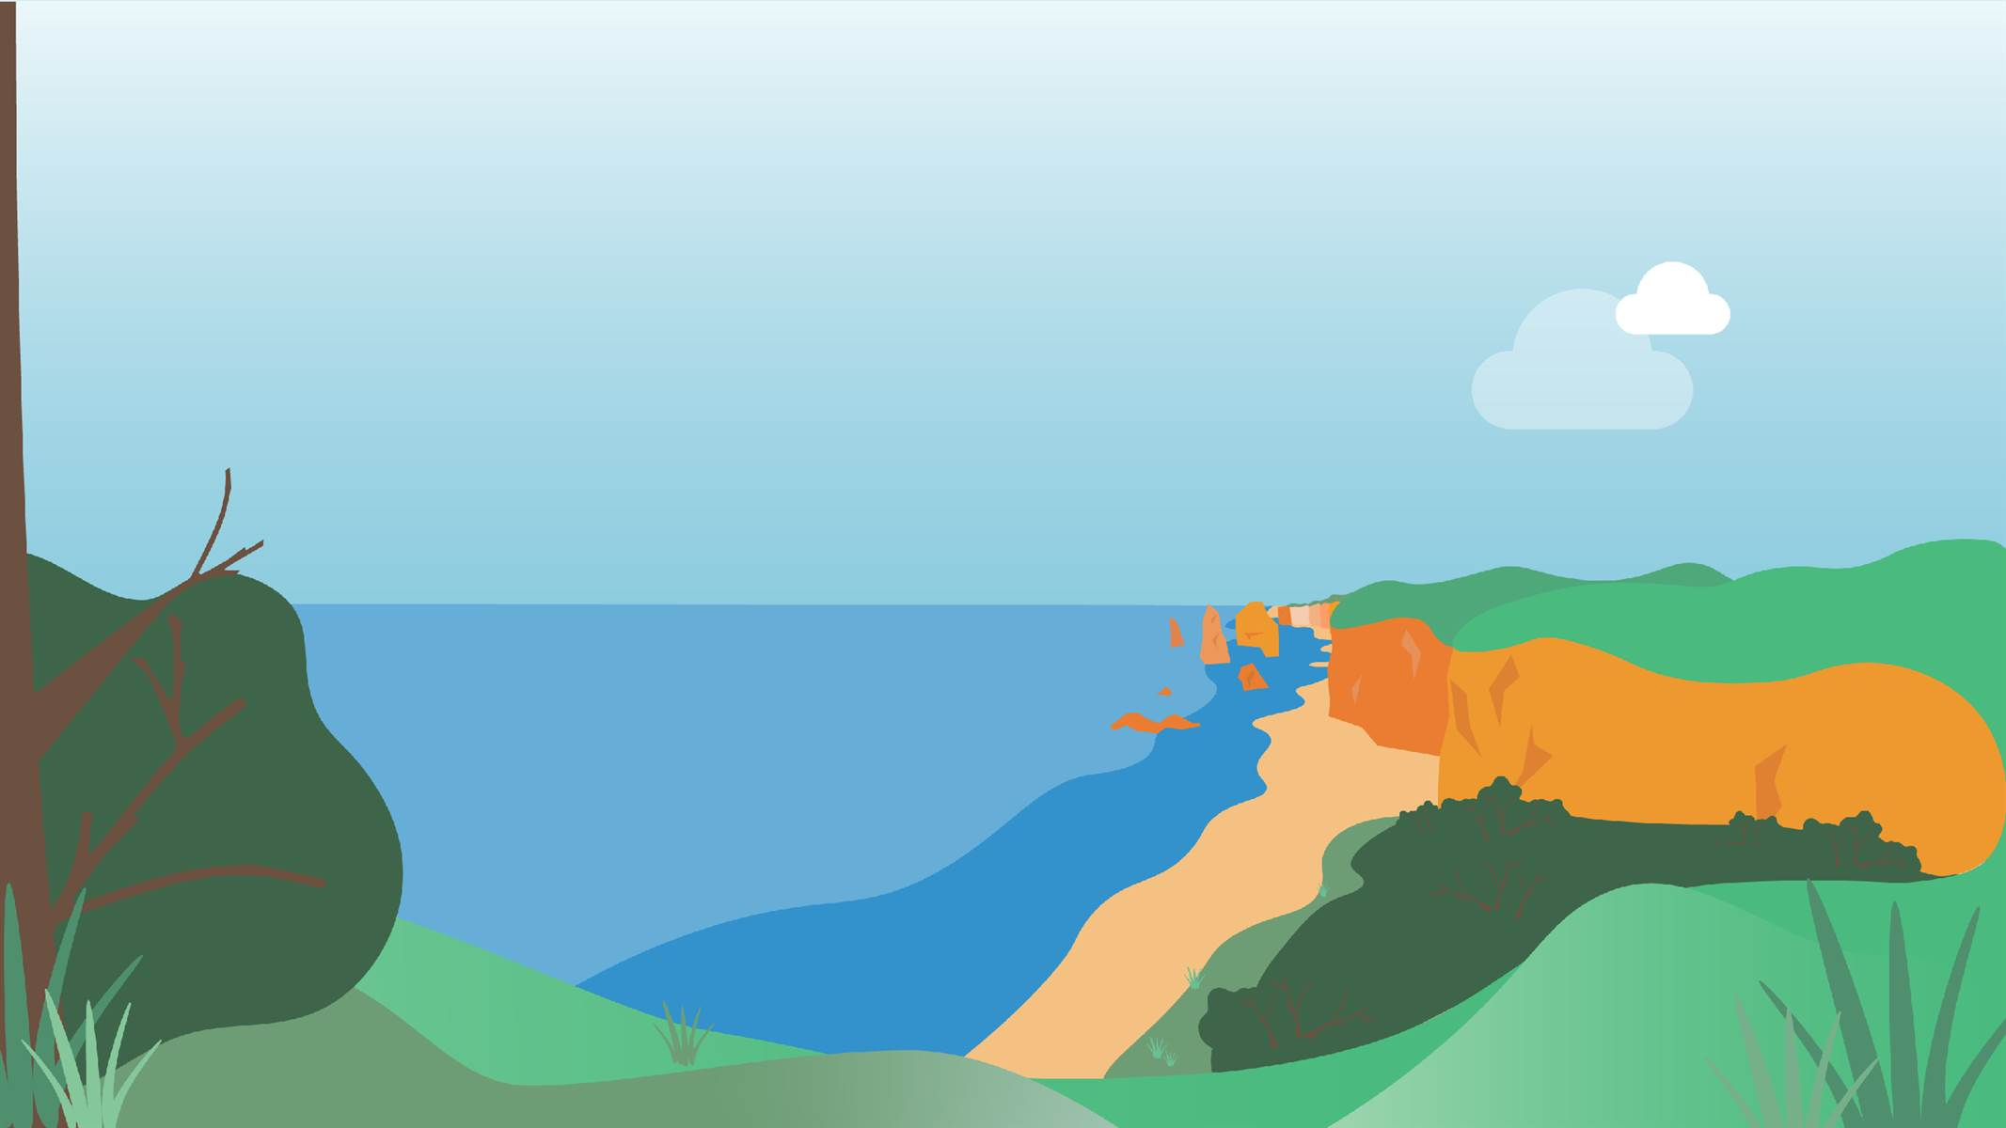
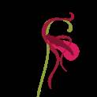
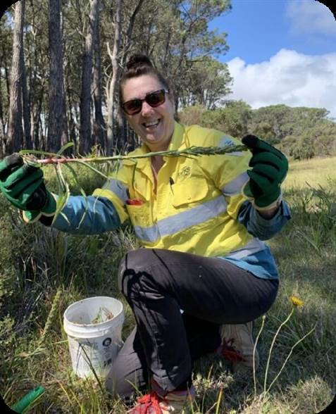
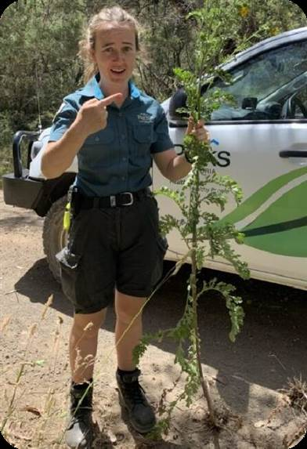
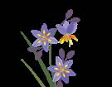
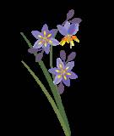
OFFICIAL

From left-right: A field employee finds and removes a South African Weed Orchid (Disa bracteata); Large Ragwort (Senecio jacobaea) found at Port Campbell National Park – Sarah Matthews all photos.

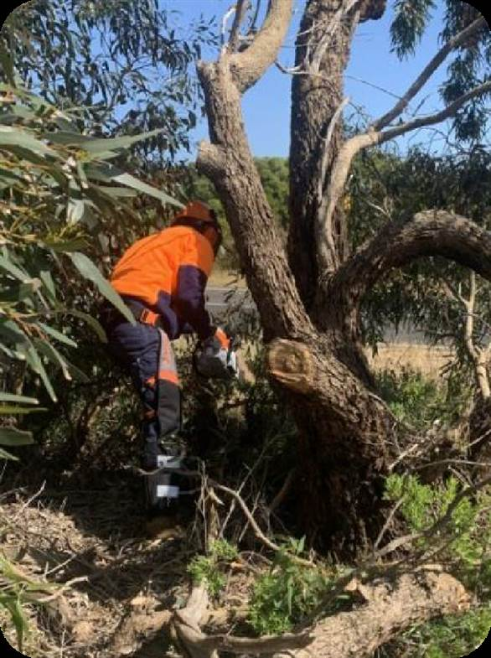
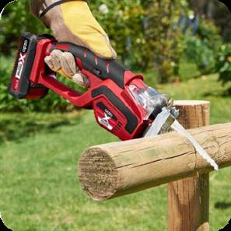
11 Otway Eden
OFFICIAL

Key learning:
Pruning saws for woody weed removal
The Otway Eden team have found the purchase of a relatively inexpensive item – a small battery-powered pruning saw – has made woody weed control much more efficient.

Traditional chainsaws are heavier and therefore harder on the operator, and comparatively less safe. These small saws are ideal for cutting woody weeds with a diameter less than 15cm.

As they don’t use petrol they are also more environmentally friendly, don’t expose the user to fumes, and help to reduce the carbon
emissions associated with weed control.

Weed removal in the Great Otway National Park –
Matthew Russell.

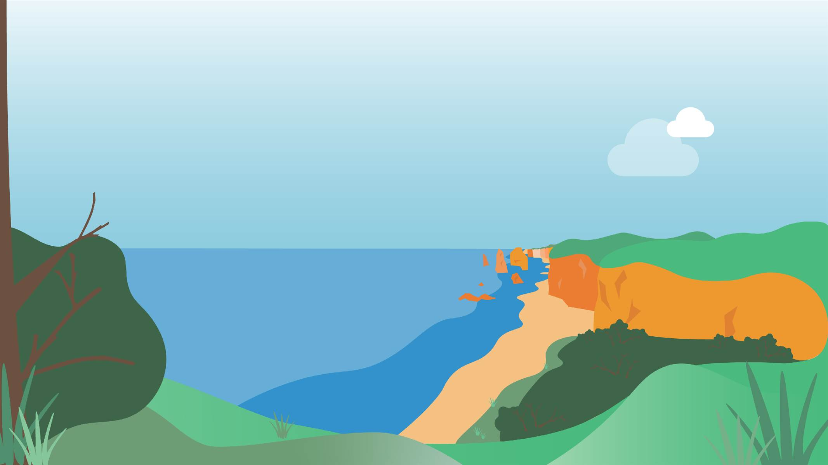
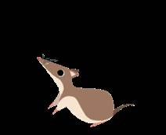
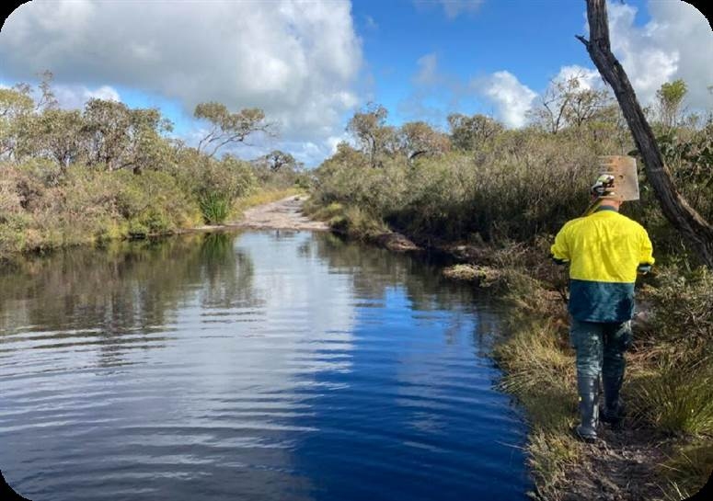
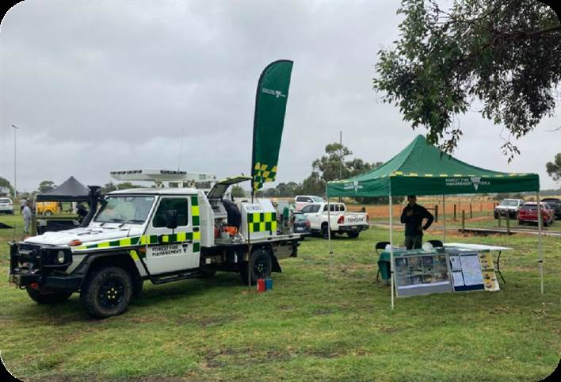
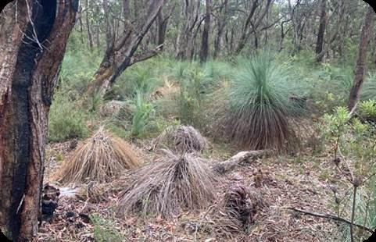
12 Glenelg Ark

Landscape-scale fox control to protect the native biodiversity of Victoria’s far south-west

73,630 Ha of fox control

13,000 baits deployed for fox control through 26 treatment rounds
The annual monitoring program was delivered in October 2022

Over 100,000 images from camera traps were collected and processed
3+ engagement presentations
to South West TAFE students, Country Fire Authority members, & field staff about the risks of Phytophthora

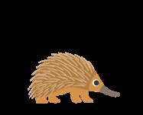
From left-right: wet conditions in the Glenelg Ark project area in 2022-2023; Community engagement in action; Phytophthora dieback observed in Grass-trees in the project area – Glenelg Ark team all photos.
OFFICIAL

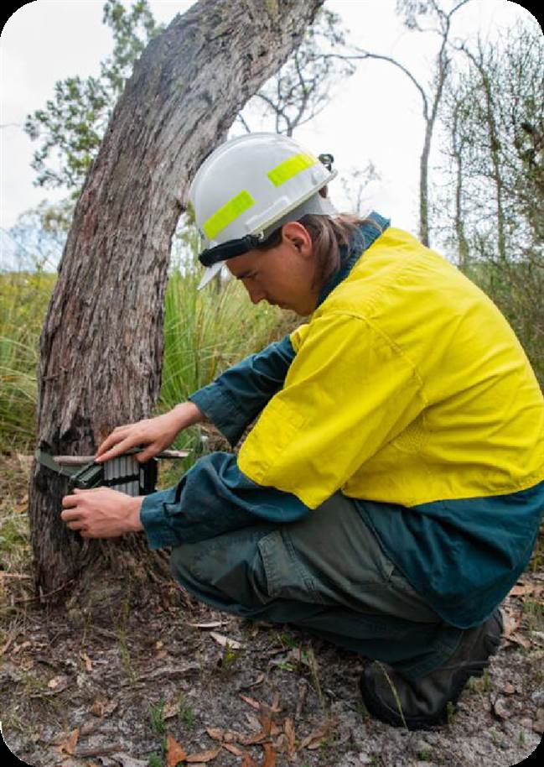
13 Glenelg Ark

Case Study: Ecological monitoring in the Glenelg Ark project

In June 2023, Alan Robley and Paul Moloney from the Arthur Rylah
Institute (ARI) produced the 2022 monitoring and evaluation update for the
Glenelg Ark project with assistance from Glenelg Ark lead Ethan Le Duc.

This was the 13th report produced on the project and touches on the progress made in achieving biodiversity benefits by reducing levels of fox predation. Three native species are the focus of this monitoring: Common Brushtail Possum (Trichosurus vulpecula), Long-nosed Potoroo (Potorous tridactylus) and Southern Brown Bandicoot (Isoodon obesulus).

The report found that colonisation and/or survival rates for Long-nosed Potoroo and Southern Brown Bandicoot were higher at locations with fox control than at locations without fox control. Common Brushtail Possums were less influenced by fox control, although at areas with fox control their rates were higher.

There was also some evidence that the Short-beaked Echidna (Tachyglossus aculeatus) may also have benefited from this ongoing fox control, and this needs further investigation.

Text taken from the report:
Robley, A., Moloney, P.D. and Le Duc, E. (2023). Glenelg Ark—2022 monitoring and
evaluation update. ARI Technical Report Series No. 358. DEECA, Heidelberg, Victoria.
Setting up a camera for monitoring native and invasive species within the Glenelg Ark footprint – Glenelg Ark team.
OFFICIAL

14 Grampians Ark

Landscape-scale fox control to protect native mammals in the Grampians National Park

162,779 Ha of fox control

11,150 baits deployed

1,854 volunteer hours

7 delivery partners
3,000+ camera nights and 8,784 trap nights (Elliott & Cage traps) monitoring small mammal populations
2 Long-nosed Potoroo’s were fitted with GPS trackers, the first capture in the Gariwerd landscape in almost 20 years
Increased capture of Southern Brown
Bandicoot’s at long-term monitoring sites
The Grampians Ark team hosted 3 work experience students and ran 3 training events

The autumn Great Gariwerd Bird Survey recorded 1,796 individual birds across 60 species

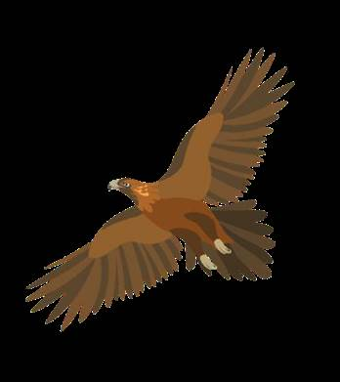
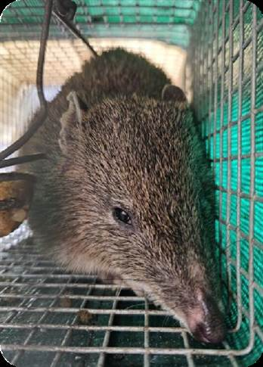
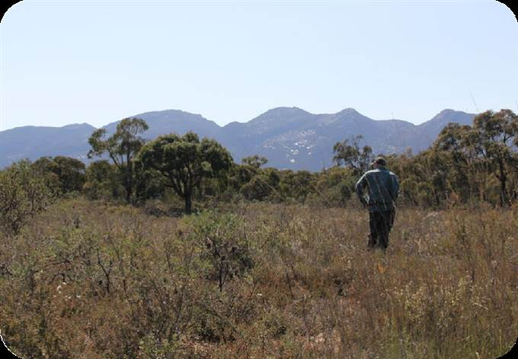
OFFICIAL

From left-right: bird watching and identification in the Great Gariwerd Bird Survey – Kailee Savoia; Southern Brown Bandicoot (Isoodon obesulus) found in project mammal monitoring – Deakin University.

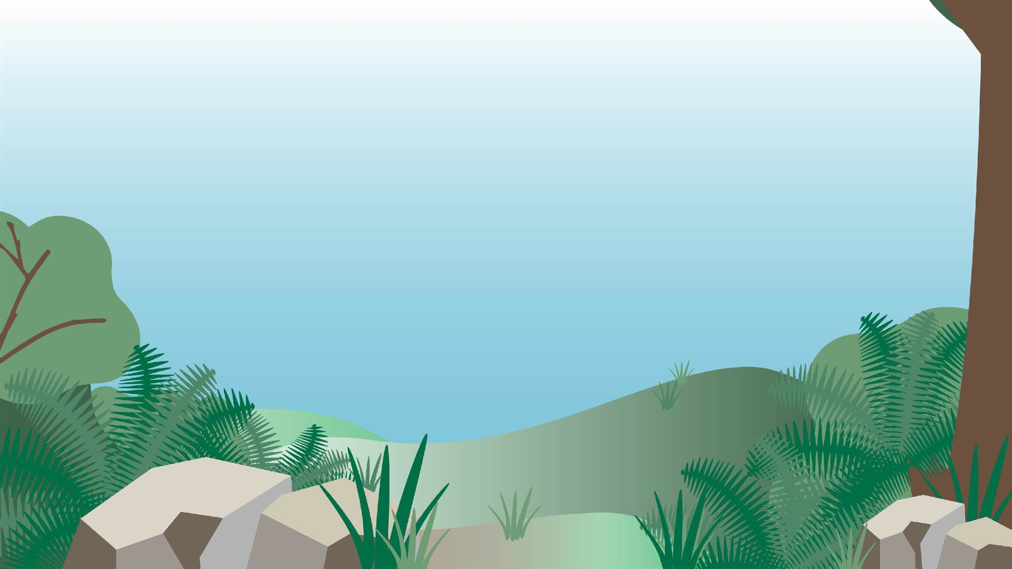
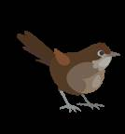
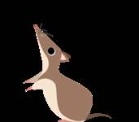
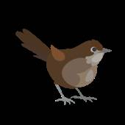
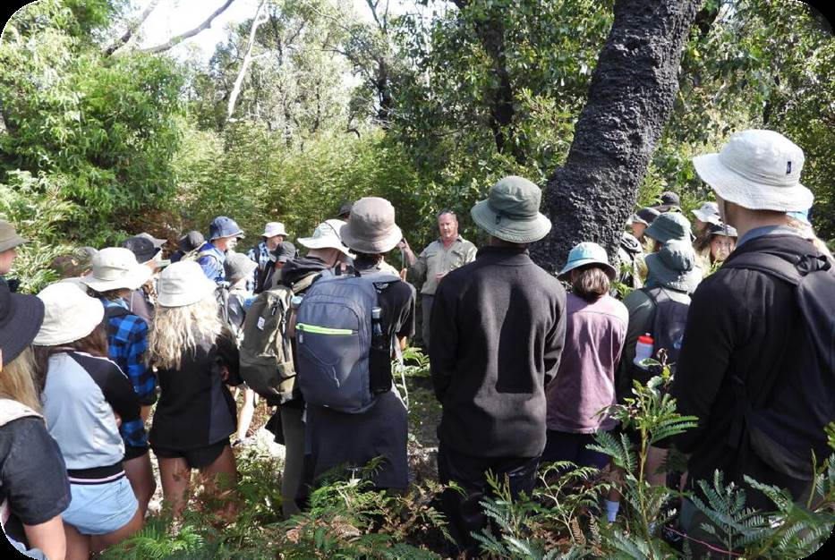
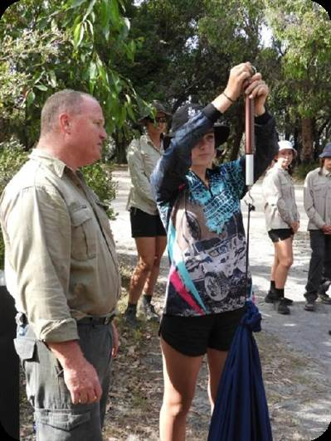
15 Southern Ark

Landscape-scale fox control to protect the native biodiversity across eastern Victoria

484,702 Ha of fox control

16,340 fox baits deployed
with 26% bait take
- community events & presentations
1 radio interview

1 DEECA Yammer posts
5 DEECA Gippsland Facebook posts
Camera-trap monitoring of 679 sites undertaken in 2022
Sites were surveyed for 35 nights, equating to 23,765 camera-trap nights
Over 2.6 million images are currently being analysed in 2023-2024

OFFICIAL

Marty Healey from the Southern Ark team teaching Gippsland Grammar students about camera trapping – Andy Murray.

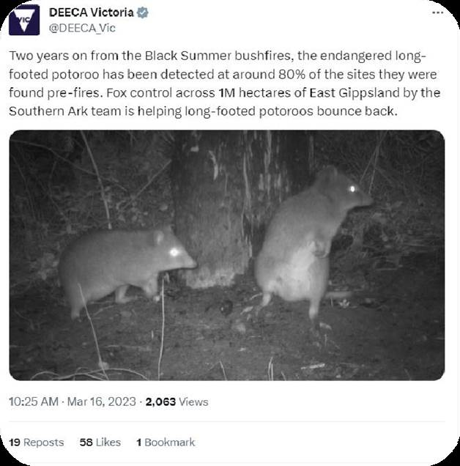
Southern Ark
16

Case Study: Community engagement by Southern Ark
The Southern Ark team led the charge in 2022-2023 with excellent community engagement. See below for a snapshot into the events they presented at or hosted to promote their work and to share their project’s learnings:

- Provided Gippsland TAFE students with an overview of the Southern Ark
project.
- Provided members of the Bidwell Nation an overview of the project.
- Engaged over 100 Year 9-10 students from Gippsland Grammar, giving them an overview of the Southern Ark project and having them carry out cage and camera-trapping activities.
- ABC Gippsland radio interview on Long-nosed Bandicoots.
- Provided a project update to community in Mallacoota, Goongerah Hall, Wairewa Hall, and Tubbut Community Hall.
- Presented at “The Nature of the Bluff” (covering Red Bluff, part of
Lakes Entrance-Lake Tyers Coastal Reserve, baited by
A DEECA Twitter/X post on the Southern Ark
project – @DEECA_Vic.
Southern Ark)
- Southern Ark overview at DEECA conference “Gipps-yarn”.
OFFICIAL

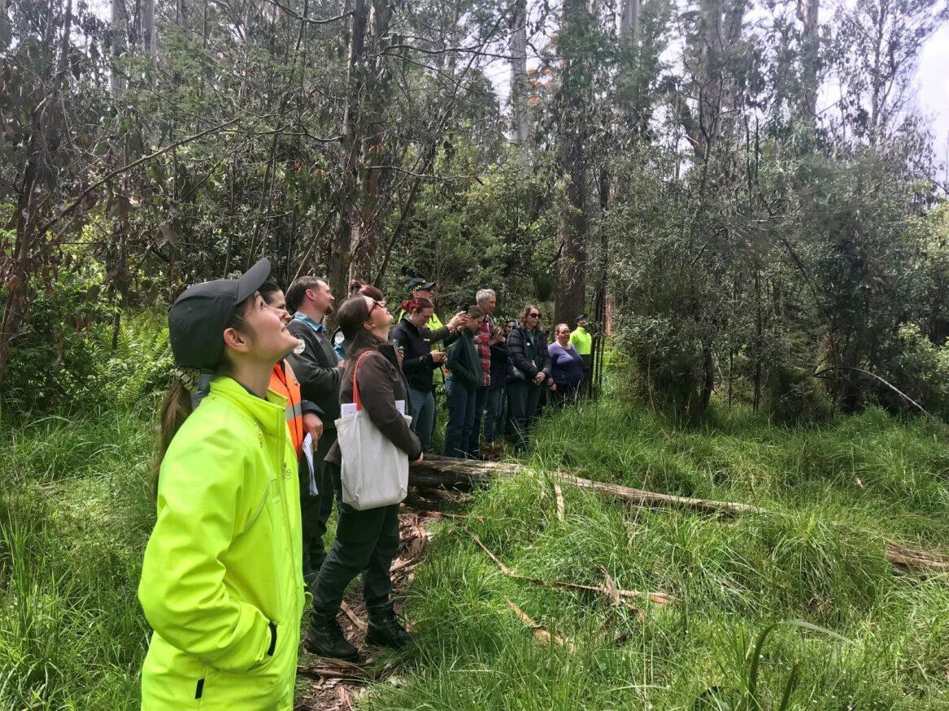

Weeds and Pests on
Public Land
Program Report
2022-2023

Central Highlands Eden Field Trip to Cambarville – Bradley Matthews.
OFFICIAL

