Suburban parks are important to all of us. They are where families create memories, connect with nature and each other. Suburban parks provide habitat for our native plants and animals, support healthy rivers and creeks, and help us tackle climate change.
The Victorian Government is investing $315 million in the Suburban Parks Program. It will create more than 6,500 hectares of new and upgraded parks and trails across Melbourne’s growing suburbs. The Department of Environment, Land, Water and Planning leads this program.
Why create new parks?
- to improve health and wellbeing
- to protect nature
- to strengthen cultural heritage
- to address climate change
- to attract jobs, investment, skilled people and visitors to Melbourne’s growing outer suburbs.

What is Cardinia Creek Regional Parklands project?
In 2018, the government committed to establishing Cardinia Creek South Parklands, a 508-hectare parkland near Officer.

This collaborative project will refresh the Cardinia Creek Regional Parklands Future Directions Plan.
It will also link existing open space reserves including:
- Cardinia Creek Parklands
- Beaconsfield Flora and Fauna Reserve
- Akoonah Park
- Beaconsfield Recreation Reserve
- Bob Burgess Reserve
- Manna Gum Park
- Cardinia Creek retarding basin.
The parklands will include new areas of creekside parklands south of Princes Freeway.
A Draft Future Directions Plan was released in May 2022 and feedback will be incorporated into the final parklands plan due to be released in late 2022.
Cardinia Creek Cultural Values Mapping has been completed by the Bunurong Land Council Aboriginal Corporation to guide parkland planning and protect cultural values.
A walking and cycling path will be constructed to increase access to underused areas of existing parklands and a new boardwalk bridge, seating, tables and information kiosk will be completed by mid-2023.
A feasibility study for release in late 2022 will look at designs for a footbridge across the creek south of Inglis Road.

Location
The expanded parklands are on Bunurong Country and will stretch from Beaconsfield to Clyde in Melbourne’s south-east.

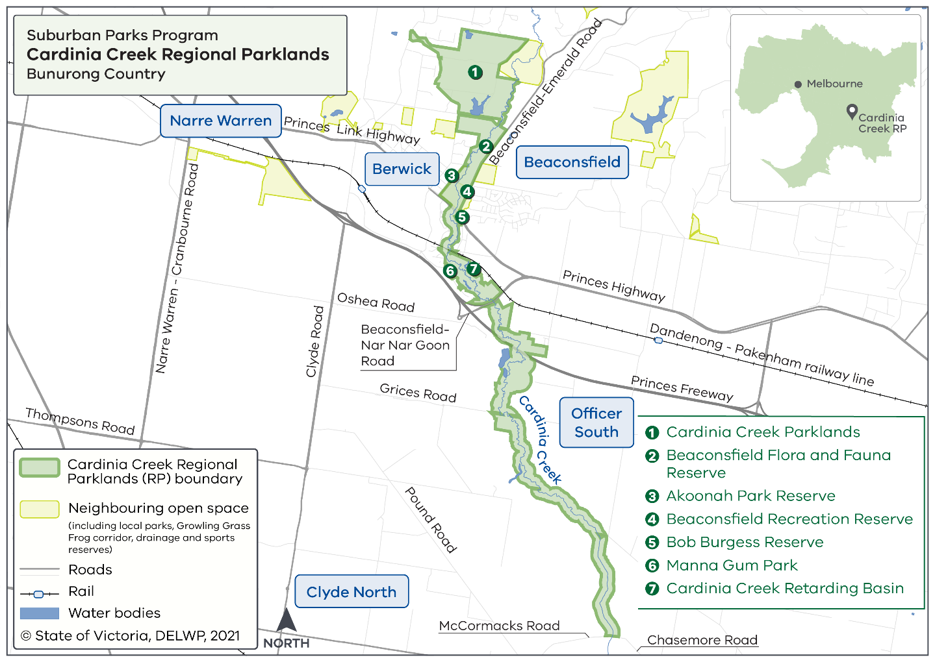

When will the park open?
You can visit some areas of the parklands now. New sections will open in stages from 2023. Visitors will be able to enjoy walking and cycling trails through this beautiful natural environment.

Project partners and stakeholders.
The project is led by a Parkland Partnership Group including:

- Bunurong Land Council Aboriginal Corporation
- City of Casey
- Cardinia Shire Council
- Melbourne Water
- Parks Victoria
- DELWP.

Community consultation took place in November 2021 and May - June
2022. Check Engage Victoria for updates.

More information
Updates on the Suburban Parks Program are available online. Or you can email the Cardinia Creek Regional Parklands project team.

