Introduction
Biodiversity Response Planning (BRP) is a long-term area-based planning approach to biodiversity conservation in Victoria. It is designed to strengthen alignment, engagement and participation between government, Traditional Owners, non-government agencies and the community.
DELWP Regional staff have been working with stakeholders on actions to conserve biodiversity in specific landscapes, informed by the best available science and local knowledge.
These Fact Sheets capture a point in time, reflecting data and knowledge available in 2020. They provide information for many (but not all) landscapes across Victoria, containing general information on the key values and threats in each area, as well as the priority cost-effective actions that provide the best protection of biodiversity. Fact Sheets are intended to provide useful biodiversity information for the community, non-government and government organisations during project planning and development.
Further information and the full list of Fact Sheets is available on the Department’s Environment website.

Landscape description
This 45,221ha area is a mix of cleared and vegetated land (42% native vegetation cover) and is mostly private land (78%). The landscape is bordered by Glenelg River in the south and Edenhope in the north.

Habitat Distribution Models identify 5 species with more than 5% of their Victorian range in this landscape
4 Plants
- Heathy Guinea-flower (10% Victorian range in landscape, vulnerable)
- Pink Gum (7% Victorian range in landscape, vulnerable)
- Prickly Raspwort (7% Victorian range in landscape, vulnerable)
- Elegant Spider-orchid (5% Victorian range in landscape, vulnerable)

1 Bird
- Red-tailed Black-Cockatoo (6% Victorian range in landscape, endangered)

Strategic Management Prospects
Strategic Management Prospects (SMP) models biodiversity values such as species habitat distribution, landscape-scale threats and highlights the most cost-effective actions for specific locations. More information about SMP is available in NatureKit.

Which landscape-scale actions are most cost-effective in this landscape?
Some areas of this focus landscape (coloured areas on the map) have highly cost-effective actions which provide significant benefit for biodiversity conservation.
The SMP priority actions which rank among the top 10% for cost-effectiveness of that action across the state are in order:
 | Control overabundant kangaroos 7,214ha
 | Control rabbits 5,370ha
 | Control deer 1,973ha
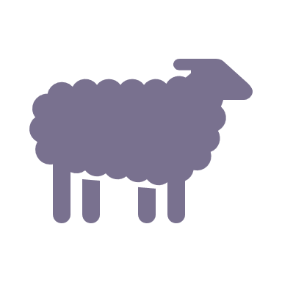 | Control domestic grazing 1,429ha
 | Permanent protection 814ha
 | Control foxes 751ha
 | Control cats 746ha
 | Revegetation 622ha
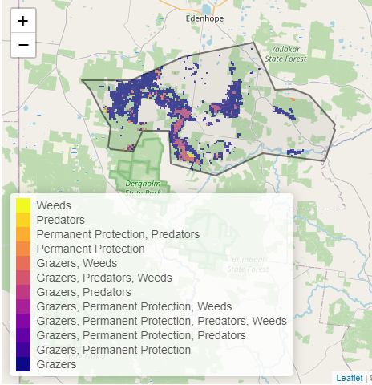

The most cost-effective actions for flora & fauna
Plants - Control kangaroos, control rabbits, control deer
Birds - Control kangaroos, control rabbits, control deer, combined fox and cat control
Mammals, Reptiles - Control kangaroos, control rabbits, combined fox and cat control
Amphibians - Control kangaroos, control rabbits, control deer

For a further in depth look into SMP for this landscape please refer to NatureKit.

