“We acknowledge the Wadawurrung people of the Kulin Nation as the Original Custodians of the lands which represents the following information. We pay respects to Elders past, present and emerging leaders that continue their obligations to care for Country. We care for Country, Culture and Wadawurrung people”.

Range - Central

Introduction
Biodiversity Response Planning (BRP) is a long-term area-based planning approach to biodiversity conservation in Victoria. It is designed to strengthen alignment, engagement and participation between government, the Original Custodians, non-government agencies and the community.
DELWP Regional staff with Wadawurrung Traditional Owners Aboriginal Corporation have been working with stakeholders on actions to conserve biodiversity in specific landscapes, informed by the best available science and local knowledge.
These Fact Sheets capture a point in time, reflecting data and knowledge available in 2020. They provide information for many (but not all) landscapes across Victoria, containing general information on the key values and threats in each area, as well as the priority cost-effective actions that provide the best protection of biodiversity. Fact Sheets are intended to provide useful biodiversity information for the community, non-government and government organisations during project planning and development.
Further information and the full list of Fact Sheets is available on the Department’s Environment website.
This Fact Sheet includes the information from the Strategic Management Prospects (SMP) Output Summary for the Bay zone and the feedback from our stakeholders.

Landscape description
The Central Range area is 118,703ha. The native vegetation cover is 48% and public land cover is 31%.
It is one of three undulating ranges that branch off from the Great Dividing Range in Wadawurrung Country. The predominant bioregion that covers these three ranges is the Central Victorian Uplands. The base of the range is surrounded by the Victorian Volcanic Plains bioregion.
Significant waterways in this zone are the Werribee River, Moorabool River West Branch, Yarrowee River, Kuruc A Ruc Creek, Mount Misery Creek, Woady Yaloak River and Hoyles Creek. These waterways also have many tributaries. There are no significant wetlands, and three reservoirs: Moorabool, White Swan, and Bostock.
The public land in the north and south of this zone contain the highest biodiversity values. A linkage is formed by the eastern side of the regional town, Ballarat, and the waterways which link up the small interspersed public land blocks.
This landscape has a partial overlap with both the Daylesford - Wombat and Creswick landscapes. For more information please refer to both the Daylesford - Wombat and the Creswick Fact Sheets in the full list of Fact Sheets.

Cultural importance
Wadawurrung Country holds many values culturally and ecologically throughout the diverse landscape. Mountain country, grassland country, sea and coastal country provides for many flora and fauna species to inhabit the landscapes. Resources were aplenty and managed sustainably by the Wadawurrung. Due to previous land activities such as mining, land fragmentation and the introduction of pest species, the landscapes require good partnerships between Wadawurrung Original Custodians and land managers to reinvigorate Country. Wadawurrung land management practices will be supported and guided by the aspirations of the Wadawurrung Healthy Country Plan.

Landscapes of interest added through feedback process
Trust for Nature – Victorian Midlands: Barkstead, Korweinguboora, Spargo Creek, Bolwarrah, Gordon, Enfield, Dereel, Berringa, Staffordshire Reef, Ross Creek, Smythesdale, Scarsdale, Linton, Snake Valley, Hillcrest and Smythes Creek.
Moorabool Shire Council – High value reserves: Spargo Creek Mineral Springs and Paddock Creek. High value roadside reserves: Portland Flat Rd, Ballan-Egerton Rd, Vinecombes Lane, Yankee Flat Rd, Atchison Rd.
Ballarat Environmental Network – Moloney Lane Recreation Reserve, Skirkas Rd (Buninyong), Shirkas Rd Recreation Reserve, Gravel Reserve (Buninyong), O’Loughlin Rd Recreation Reserve, Brennans Road Recreation Reserve, Pioneer Lane Pub Recreation Reserve, Peers Lane Conservation Reserve, Hardies Hill Water Reserve – Enfield, Battery Rd Bushland Reserve-Dereel, Warrambine Recreation Reserve, Corindhap Gravel Reserve, Corindhap Old Reserve, Plantation Reserve - Dereel, Illabarook Recreation Reserve, Berringa Soil Depot, Three Wells – Berringa, Berringa Reservoir, Moonlight Reservoir, Staffordshire Shire Reef Conservation Reserve, Staffordshire Shire Reef Recreation Reserve, Scarsdale Public Recreation Reserve, Newtown Recreation Reserve, Grams Rd Public Purpose Reserve, Woady Yalloak Recreation Reserve, Hillcrest Water Supply Reserve, Mooney’s Dam Reserve, Chepstowe Recreation Reserve and Flagstaff Hill – Argyle.
Central Highlands Water – Lal Lal North, East, South and West, Lal Lal Diamond, Moorabool Reserve, Devils Creel Junction Block and Kennedys Block, Mollongghip, Donovans Creek Spring, Musk Creek Spring, Devils Creek Spring, Wilsons Reserve, Badgers Hill (Pollards Cnr), Burkes Rd Block, Upper Frawleys Creek, Camerons, Beales Reservoir, Bully Park, Geddes Plantation, Triggs Spring, Gong Gong North and South, White Swan (Scholes), Tree Bush (Pootilla) and White Swan.
Pyrenees Shire – Snake Valley Habitat Linkage and Environmental Focal Landscape.

Ecological Vegetation Classes (primary EVCs)
Endangered: Grassy Woodland, Plains Grassy Woodland, Swampy Riparian Woodland, Creekline Grassy Woodland, Plains Grassy Wetland, Riparian Woodland, Aquatic Herbland/Plains Sedgy Wetland Mosaic.

Ecological Vegetation Classes (secondary EVCs)
Environment Protection and Biodiversity Conservation Act: Natural Temperate Grasslands of the Victorian Volcanic Plains, Grassy Eucalypt Woodland of Victorian Volcanic Plains, Seasonal Herbaceous Wetlands (Freshwater) of the Temperate Lowland Plains ecological community.
Flora and Fauna Guarantee Act: Western Plains Grasslands Community.

Habitat Distribution Models identify 6 species with more than 5% of their Victorian range in this landscape area (updated 26/07/2020) | The following have been identified as focal species by the Original Custodians and stakeholders
6 plants with more than 5% of Victorian range in area  - Enfield Grevillea (vulnerable, 82%), Wombat Bush-pea (rare, 12%), Golden Bush-pea (8%), Yarra Gum (rare, 7%), Australian Sheep’s Burr (6%), Bicolour Everlasting (6%) | 38 plants: Snow Gums, Sharp Club-sedge, Thread Rush, Large Kangaroo Apple, Sea Rush, Kangaroo Grass, Hedge Wattle, Sheep’s Burr, Black Wattle, Swamp Gum, Running Postman, Common Tussock-grass, Golden Wattle, Drooping Sheoak, Pink Bindweed, Common Spike-sedge, Pale Rush, Small Loosestrife, Narrow-leaf Cumbungi, Light Wood, Cranberry Heath, Silver Banksia, River Bottlebrush, Water Ribbons, Kidney-weed, Weeping Grass, Common Reed, Blackwood, River Red-gum, Prickly Tea-tree, Slender Dock, Silver Wattle, Coarse Dodder-laurel, Cherry Ballart, Austral Crane’s-bill, Tall Bluebell, Small-leaf Bramble, Wallaby Grass.

Strategic Management Prospects
Strategic Management Prospects (SMP) models biodiversity values such as species habitat distribution, landscape-scale threats and highlights the most cost-effective actions for specific locations. More information about SMP is available in NatureKit.

Additional threats
Threats identified (in addition to those modelled in SMP) through the consultation process were illegal tracks from driving off-road, littering, barriers to on-ground management, inappropriate land use, water quality and quantity, native vegetation removal, urban encroachment, wildfire, and Phytophthora cinnamomi.

Which landscape-scale actions are most cost-effective in this landscape?
The map shows where the most cost-effective threat control actions in this landscape are. Actions in these areas will maximise biodiversity benefit across Victoria for multiple species.
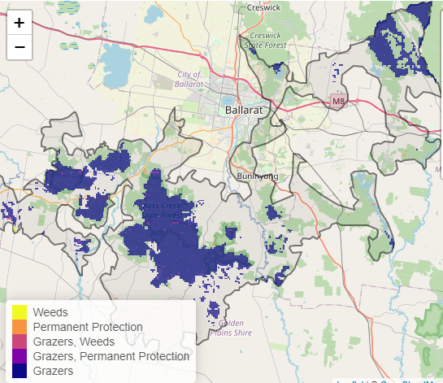

The very best threat control actions to do in the Top 3% of cost-effective areas are: goats, pigs and permanent protection.
When we bring in the Top 10%, we also add the activities: grazing pressure (all grazers), deer, rabbit, permanent protection, weeds and overabundant kangaroos.

Area available for highly cost-effective revegetation
5ha

For a further in depth look into SMP for this landscape please refer to NatureKit.

Priority Areas Map – Range - Central
Base layers: This data is from SMP and represents the best areas to carry out the most cost-effective actions for specific threats (also referred to as the Top 10% of Mean Cost-effectiveness (MCE) actions), and the Top 20% locations (these locations have been given names and are referred to as descriptors)
Priority Areas: Wadawurrung Priority Areas, stakeholder’s Landscapes of Interest (LoI), endangered Ecological Vegetation Classes (EVCs), National Parks & Reserves
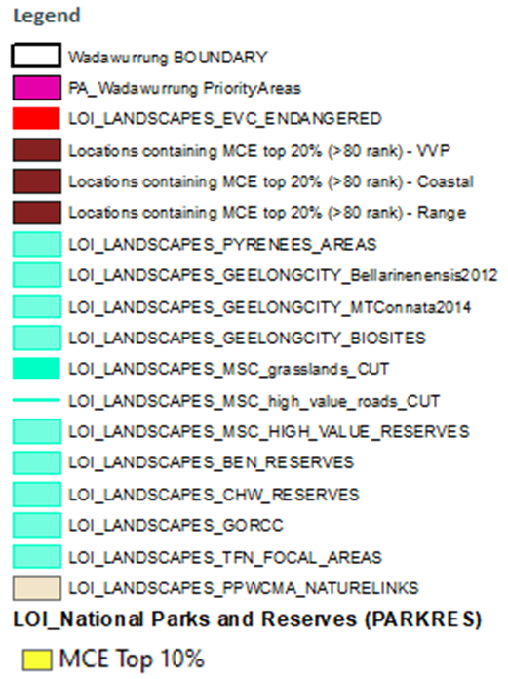
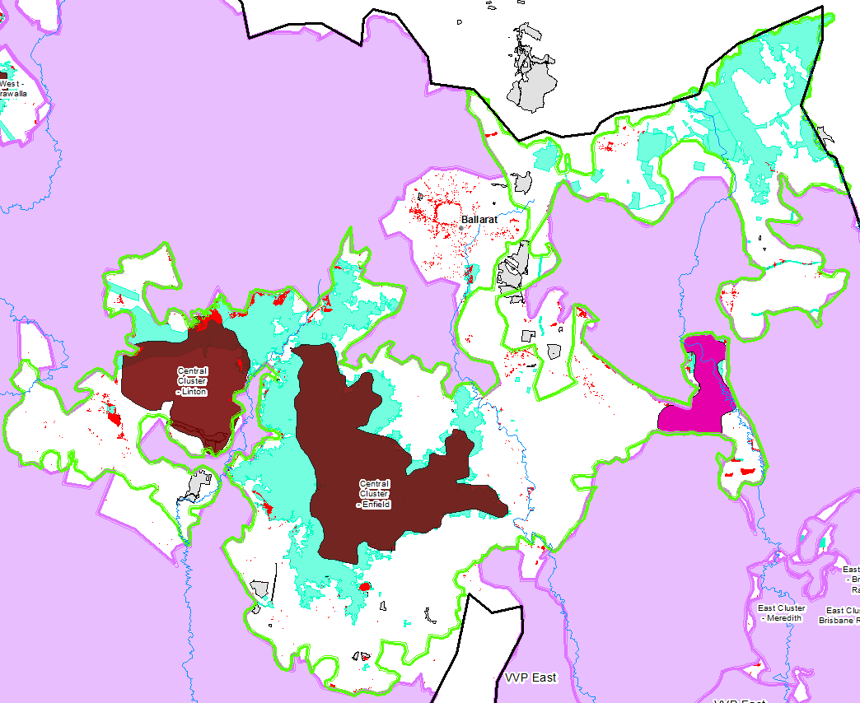
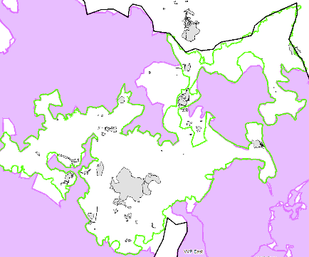
National Parks and Reserves (grey)

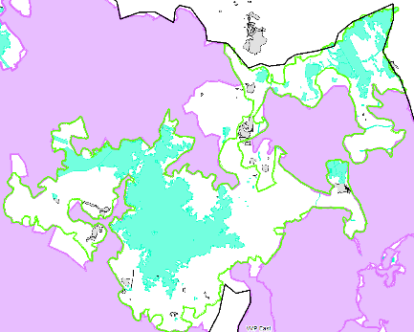
Stakeholder’s LoI (aqua)

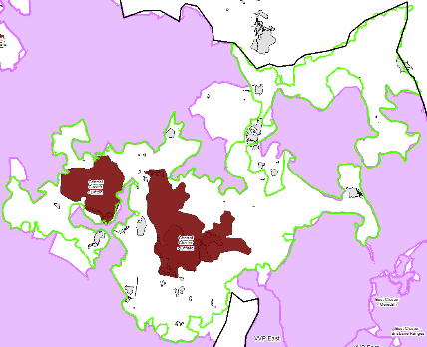
Descriptors (brown)

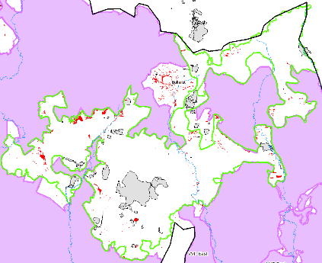
Endangered EVCs (red)

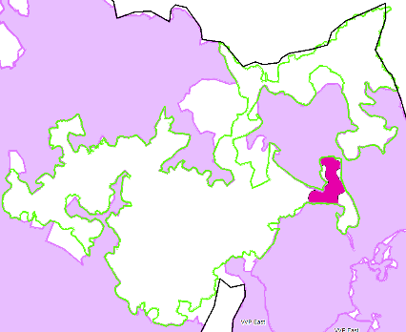
Wadawurrung initial Priority Areas (pink)

