Introduction
Biodiversity Response Planning (BRP) is a long-term area-based planning approach to biodiversity conservation in Victoria. It is designed to strengthen alignment, engagement and participation between government, Traditional Owners, non-government agencies and the community.
DELWP Regional staff have been working with stakeholders on actions to conserve biodiversity in specific landscapes, informed by the best available science and local knowledge.
These Fact Sheets capture a point in time, reflecting data and knowledge available in 2020. They provide information for many (but not all) landscapes across Victoria, containing general information on the key values and threats in each area, as well as the priority cost-effective actions that provide the best protection of biodiversity. Fact Sheets are intended to provide useful biodiversity information for the community, non-government and government organisations during project planning and development.
Further information and the full list of Fact Sheets is available on the Department’s Environment website.

Landscape description
The Lower Avoca Plains landscape covers 29,139ha, with 38% of the area covered in native vegetation. Public land makes up 15% of the area which includes Bael Bael Nature Conservation Reserve (NCR), Yassom Swamp NCR and Korrak Korrak NCR. Refer to the map at the end of this Fact Sheet.

Cultural importance
We recognise that the entire landscape has high cultural value for Traditional Owners. Landscapes identified as having “notable” cultural importance is based on the density of recorded cultural heritage sites and knowledge shared by Traditional Owners. We also recognise that there are locations important to Traditional Owners not within these landscapes.

Stakeholder interest
As part of the BRP process, in October 2020 stakeholders were asked to nominate focus landscapes and actions of interest. Northern Plains Conservation Management Network, Barapa Country Aboriginal Corporation, Trust for Nature, and Parks Victoria all nominated the Lower Avoca Plains.
Possible future investment/project development in this landscape will be available to any interested stakeholders in addition to those who nominated this landscape.

0BEcological values identified by Traditional Owners, partners and community within this landscape
The Northern Plains are part of the ‘Natural Grasslands of the Murray Valley Plain’ ecological community, which is listed as critically endangered under the Environment Protection and Biodiversity Conservation Act 1999 (EPBC)
On Victoria’s Northern Plains, approximately 95% of native grasslands have been lost, making Bael Bael NCR and surrounding Trust for Nature private properties extremely significant
Cultural fire on Country – Korrak Korrak – Barapa Land and Water (BLW) Korrak Korrak NCR
Bael Bael NCR is largest contiguous protected area of native grassland in Victoria at 2884ha
Unique largely intact mosaic of floodplain associated grassland and grassy woodland communities, significant flora and fauna values

 | Habitat Distribution Models identify 2 species with more than 5% of their Victorian range in this landscape area | Traditional Owners, stakeholders and community groups identified the following species of interest within this landscape
 | 1 Plant, notably:  - Grassland Bindweed (Convolvulus graminetinus), endangered with 11% of its Victorian range in area | - Chariot Wheels  - Australian Boxthorn  - Swainsona spp.
 | Mammals | - Fat-tailed Dunnart  - Population of Red Kangaroo – outside distribution range
 | 1 Reptile:  - Hooded Scaly-foot, critically endangered with 6% of its Victorian range in area | - Samphire Skink  - Hooded Scaly-foot
 | Birds | - Plains-wanderer

Traditional Owners, stakeholders and community groups identified the following threats within this landscape
Cultivation of remnant grasslands
Lack of biomass management – undergrazing
Weed invasion, includes African Boxthorn and Bathurst Burr
Lack of awareness on the value and importance of grasslands
Lack of compliance of non-permitted clearing of grasslands
Overgrazing (lack of biomass present)
Inappropriate fire regime
Habitat destruction and fragmentation

Strategic Management Prospects
Strategic Management Prospects (SMP) models biodiversity values such as species habitat distribution, landscape-scale threats and highlights the most cost-effective actions for specific locations. More information about SMP is available in NatureKit.

Additional threats
Threats identified (in addition to those modelled in SMP) through the consultation process were:
- alterations to hydrology
- land salinisation
- soil erosion
- habitat degradation due to extremes of climate and weather
- lack of regeneration in some vegetation classes
- recreational activities causing fragmentation
- loss of vegetation, and erosion
- legacy use of public land
- private land use impacting biodiversity
- inappropriate land use planning
- inappropriate fire regimes (planned burning and bushfires)

Some individual threatened species may also require targeted intervention, beyond actions to manage landscape-scale threats, to improve their future prospects.

Which landscape-scale actions are most cost-effective in this landscape?
The coloured areas indicate where the identified landscape-scale actions and locations are most cost-effective and will maximise biodiversity benefit across Victoria for multiple species.
Control weeds 5,994ha
Control rabbits 2,177ha
Control grazing 1,195ha
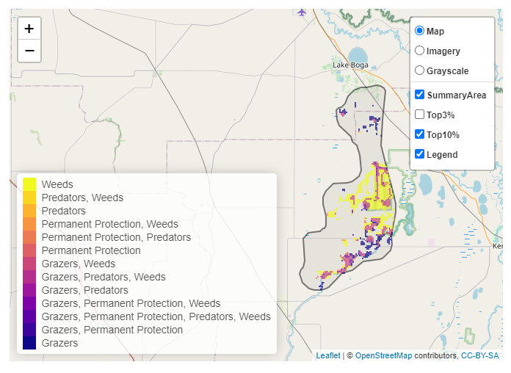
The SMP priority actions which rank among the top 10% for cost-effectiveness of that action across Victoria for much of the landscape are in order of the top 3 actions, see map and list below:

Of the top 10% of cost-effective actions, controlling weeds provides the most cost-effective biodiversity benefits when considering all flora and fauna.
From the nomination process, the following additional actions were also suggested for this landscape:
- revegetation
- permanent protection
- cultural fire
- biomass management
- maintaining optimal grassland habitat

The most cost-effective action for flora and fauna
Plants, mammals, reptiles, birds - Control weeds
Amphibians - Control grazing

For a further in depth look into SMP for this landscape please refer to NatureKit.

