Introduction
Biodiversity Response Planning (BRP) is a long-term area-based planning approach to biodiversity conservation in Victoria. It is designed to strengthen alignment, engagement and participation between government, Traditional Owners, non-government agencies and the community.
DELWP Regional staff have been working with stakeholders on actions to conserve biodiversity in specific landscapes, informed by the best available science and local knowledge.
These Fact Sheets capture a point in time, reflecting data and knowledge available in 2020. They provide information for many (but not all) landscapes across Victoria, containing general information on the key values and threats in each area, as well as the priority cost-effective actions that provide the best protection of biodiversity. Fact Sheets are intended to provide useful biodiversity information for the community, non-government and government organisations during project planning and development.
Further information and the full list of Fact Sheets is available on the Department’s Environment website.

Landscape description
This 1,222ha area is situated on the Mornington Peninsula, between Mount Martha and Hastings. The landscape of interest encompasses the Devilbend Natural Features Reserve, which includes both Devilbend and Bittern Reservoirs. The area is recognised as an ‘Important Bird Area’ by BirdLife Australia as being globally important for the conservation of bird populations. The reserve is an important remnant of native vegetation, with much of the surrounding land cleared for orchards and grazing. The landscape has 40% native vegetation, and 84% public land.

Cultural importance
We recognise that the entire landscape has high cultural value for the Bunurong People of the Kulin Nation. Over the years, Devils Bend Reservoir has recorded over 20 cultural sites from artefact discovery to hearths discovery – information shared by Bunurong Land Council.
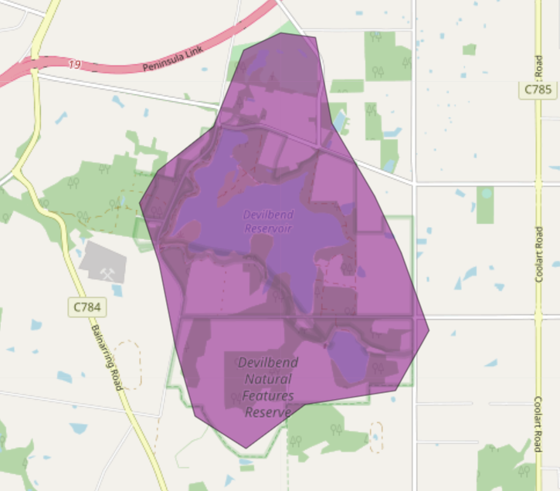
Figure 1: Map showing location of Devilbend Reservoir landscape (purple).

Habitat Distribution Models identify 0 species with more than 5% of their Victorian range in this landscape
- 0 Plant species with more than 5% of their Victorian range in this landscape area
- Notable species: Frankston Spider-orchid (endangered, 1.9% statewide range in area), Mount Martha Bundy (endangered, 1.9% statewide range in area)
- 0 Mammal species with more than 5% of their Victorian range in this landscape area
- Notable species: Southern Brown Bandicoot (near threatened, 0.03% statewide range in area)
- 0 Reptile species with more than 5% of their Victorian range in this landscape area
- Notable species: Swamp Skink (vunerable, 0.05% statewide range in area), Glossy Grass Skink (vulnerable, 0.04% statewide range in area)
- 0 Bird species with more than 5% of their Victorian range in this landscape area
- 0 species of amphibians with more than 5% of their Victorian range in this landscape area
- Notable species: Southern Toadlet (vulnerable, 0.04% statewide range in area)

Strategic Management Prospects
Strategic Management Prospects (SMP) models biodiversity values such as species habitat distribution, landscape-scale threats and highlights the most cost-effective actions for specific locations. More information about SMP is available in NatureKit.
Areas of Devilbend Reservoir shown in Figure 2 have highly cost-effective actions (within the top 10% of cost-effectiveness for that action across the state) that provide significant benefit for biodiversity conservation.
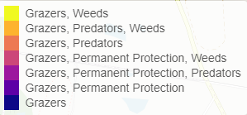
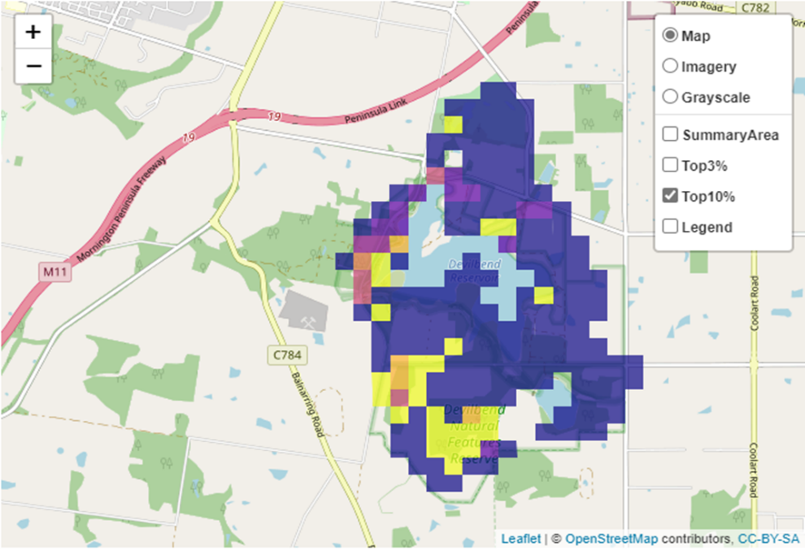
Figure 2: The SMP priority actions which rank among the top 10% for cost-effectiveness of that action across the state. “Grazers” includes deer, domestic grazing, goats, horses, over-abundant kangaroos, pigs, rabbits and total grazing pressure

Actions with area in the top 3% and top 10%
Specific Action | Area in top 3% (ha) | Area in top 10% (ha)
Control Rabbits | 0 | 1,095
Total Grazing Pressure | 511 | 910
Control Overabundant Kangaroos | 0 | 366
Control Domestic Grazing | 0 | 309
Permanent Protection | 0 | 116
Control Weeds | 5 | 96
Revegetation | 0 | 77
Control Foxes | 0 | 5
Control Cats | 0 | 5

The most cost-effective action for flora & fauna
Plants, Birds, Mammals, Amphibians and Reptiles - Control total grazing pressure

For a further in depth look into SMP for this landscape, please refer to NatureKit.

Current actions in Devilbend Reservoir
Specific Actions | Current actions – top 10% (ha) | Current actions – outside top 10% (ha)
Weed Control | 14 | 60

Current actions – top 10% = The area (ha) of the specific action currently occurring in locations identified by SMP as being in the top 10% for cost-effectiveness for that action across the state
Current actions – outside top 10% = The area (ha) of the specific action currently occurring in locations within this landscape that are not identified by SMP as being in the top 10% for cost-effectiveness for that action across the state

What you told us
SMP is just one tool to use in the process of understanding biodiversity values. Feedback from our stakeholders is also vitally important and forms the basis of our understanding of knowledge gaps.

Devilbend Reservoir was identified by stakeholders as a focus landscape in the ‘small’ category in Port Phillip region.

Stakeholder interest

Important landscapes
- Devilbend Natural Features Reserve
- Central ridge land core of the Mornington Peninsula

Current activities/programs/partnerships
- Port Phillip and Westernport CMA Regional Catchment Strategy – Naturelinks – Mornington Peninsula (concept phase)

Additional threats
Threats identified through the consultation process (in addition to those modelled in SMP):
- Fragmentation of remnant patches

