Introduction
Biodiversity Response Planning (BRP) is a long-term area-based planning approach to biodiversity conservation in Victoria. It is designed to strengthen alignment, engagement and participation between government, Traditional Owners, non-government agencies and the community.
DELWP Regional staff have been working with stakeholders on actions to conserve biodiversity in specific landscapes, informed by the best available science and local knowledge.
These Fact Sheets capture a point in time, reflecting data and knowledge available in 2020. They provide information for many (but not all) landscapes across Victoria, containing general information on the key values and threats in each area, as well as the priority cost-effective actions that provide the best protection of biodiversity. Fact Sheets are intended to provide useful biodiversity information for the community, non-government and government organisations during project planning and development.
Further information and the full list of Fact Sheets is available on the Department’s Environment website.

Landscape description
This 17,590ha area covers French Island. The island’s isolation has contributed to its rich and diverse flora and fauna. The landscape has 65% native vegetation, and 60% public land.

Cultural importance
We recognise that the entire landscape has high cultural value for Traditional Owners. Some landscapes have notable cultural importance based on knowledge shared by Traditional Owners.
French Island has significance to the Bunurong people. French Island was used as a hunting ground for the Bunurong people who would travel there on rafts from the mainland. There are many important sites of the shell middens and stone scatters.

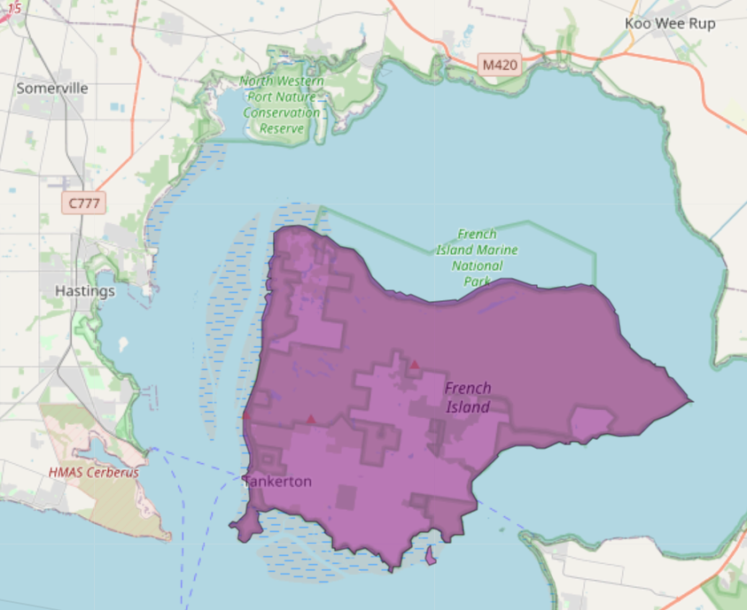
Figure 1: Map showing location of French Island (purple).

Habitat Distribution Models identify 6 species with more than 5% of their Victorian range in this landscape | Traditional Owners, stakeholders and community groups identified the following species of interest
- 5 Plant species  - 2 species with more than 10% of statewide range in this landscape  - Notable species: French Island Spider-orchid (vulnerable, 100% statewide range in area), Swamp Pelican-orchid (rare, 22% statewide range in area), Slender Leek-orchid (vulnerable, 9.6% statewide range in area) | - French Island Spider-orchid
- 0 Mammal species with more than 5% of their Victorian range in this landscape  - Notable species: Long-nosed Potoroo (near threatened, 0.4% statewide range in area) | - Introduced population of Eastern Barred Bandicoots  - Long-nosed Potoroos  - Koalas
- 0 Reptile species with more than 5% of their Victorian range in this landscape  - Notable species: Four-toed Skink (near threatened, 2.6% statewide range in area) | - Swamp Skink
- 1 Bird species  - 0 species with more than 10% of statewide range in this landscape  - Notable species: Many Victorian Rare or Threatened species, including King Quail (endangered, 6.8% statewide range in area), Grey-tailed Tattler (critically endangered, 3.4% statewide range in area) | - King Quail  - Orange-bellied Parrot  - White-bellied Sea-Eagle

Strategic Management Prospects
Strategic Management Prospects (SMP) models biodiversity values such as species habitat distribution, landscape-scale threats and highlights the most cost-effective actions for specific locations. More information about SMP is available in NatureKit.
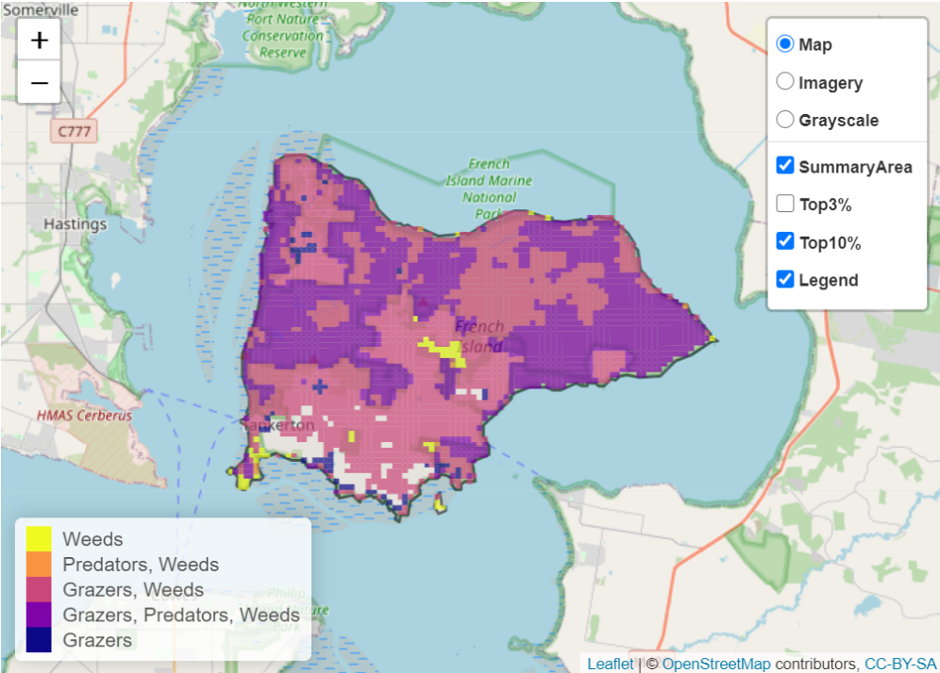
Areas of French Island shown in Figure 2 have highly cost-effective actions (within the top 10% of cost-effectiveness for that action across the state) that provide significant benefit for biodiversity conservation.
Figure 2: The SMP priority actions which rank among the top 10% for cost-effectiveness of that action across the state. “Grazers” includes deer, domestic grazing, goats, horses, over-abundant kangaroos, pigs, rabbits and total grazing pressure

Actions with area in the top 3% and top 10%
Specific Action | Area in top 3% (ha) | Area in top 10% (ha)
Control weeds | 7,482 | 16,465
Control Goats | 6,589 | 12,387
Control Rabbits | 3,632 | 9,931
Total Grazing Pressure | 4,603 | 8,995
Control Cats | 0 | 7,827
Domestic Grazing Control | 182 | 3,783
Control Deer | 0 | 3,107
Control Foxes | 0 | 466

The most cost-effective action for flora & fauna
Plants – Control weeds
Mammals, Reptiles – Control cats

Birds, Amphibians – Control total grazing pressure

For a further in depth look into SMP for this landscape, please refer to NatureKit.

Current actions on French Island
Specific Actions | Current actions – top 10% (ha) | Current actions – outside top 10%) (ha)
Weed Control | 165 | 0
Domestic Grazing Control | 125 | 40
Rabbit Control | 110 | 55
Fox Control | 0 | 165

Current actions – top 10% = The area (ha) of the specific action currently occurring in locations identified by SMP as being in the top 10% for cost-effectiveness for that action across the state
Current actions – outside top 10% = The area (ha) of the specific action currently occurring in locations within this landscape that are not identified by SMP as being in the top 10% for cost-effectiveness for that action across the state

What you told us
SMP is just one tool to use in the process of understanding biodiversity values. Feedback from our stakeholders is also vitally important and forms the basis of our understanding of knowledge gaps.

Stakeholder interest

Important landscapes
- The island as a whole – its 580 indigenous plant species, wetlands, seagrass beds, mangroves and mud flats
- French Island’s National and Marine Park status
- Westernport coastal wetlands – two Ramsar wetlands

Current activities/programs/partnerships
- Melbourne Water’s Healthy Waterways Strategy – Western Port Coastal Wetlands
- The Westernport Ramsar Wetlands (Port Phillip and Westernport CMA)
- Establishment of Eastern Barred Bandicoot population (Zoos Victoria)
- Friends of French Island/Parks Victoria
- French Island Feral cat eradication program
- Goat eradication program
- Bushfire Relief and Recovery Program - Safe Havens
- French Island Koala Management Plan (Parks Victoria and DELWP)
- Trust for Nature land covenanting program

Additional threats
Threats identified through the consultation process (in addition to those modelled in SMP):
- Cinnamon fungus
- Feral cats
- Environmental weeds
- Sea level rise/climate change
- Overabundant koalas

