Introduction
Biodiversity Response Planning (BRP) is a long-term area-based planning approach to biodiversity conservation in Victoria. It is designed to strengthen alignment, engagement and participation between government, Traditional Owners, non-government agencies and the community.
DELWP Regional staff have been working with stakeholders on actions to conserve biodiversity in specific landscapes, informed by the best available science and local knowledge.
These Fact Sheets capture a point in time, reflecting data and knowledge available in 2020. They provide information for many (but not all) landscapes across Victoria, containing general information on the key values and threats in each area, as well as the priority cost-effective actions that provide the best protection of biodiversity. Fact Sheets are intended to provide useful biodiversity information for the community, non-government and government organisations during project planning and development.
Further information and the full list of Fact Sheets is available on the Department’s Environment website.

Landscape description
The Otway Ranges Bioregion area is 137,286ha in size with 70% native vegetation cover remaining. Public land makes up 71% of the area.
Current ecological modelling shows the Otway Ranges Bioregion focus landscape largely occurs within the Otway Ranges Bioregion with the exclusion of a very small section at the eastern-most extent occurring in the Otway Plain Bioregion. The landscape has over 9,600ha of threatened Ecological Vegetation Classes (EVC) with Wet Forest bounded by areas of Shrubby Wet Forest and Shrubby Foothill Forest EVCs being the most dominate vegetation types. Cool Temperate Rainforest occurs largely within the gullies, while Wet Sands Thicket and Riparian Forest are also found along with small patches of Wet Heathland. Along the coast, Damp Sands Herb-rich Woodland and Coastal Headland Scrub EVCs can be found along with small sections of Sand Heathland at the eastern extent of the landscape. The Victorian Biodiversity Atlas has records of 37 federally protected species, 69 state protected species and 173 rare or threatened species on the Victorian Advisory List occurring within the landscape.
The Eastern Maar Aboriginal Corporation are Traditional Custodians of this focus landscape, with current stakeholders including Barwon Water, Birdlife Australia, Central Otway Landcare Network, Colac Otway Shire Council, Conservation Ecology Centre, Corangamite Catchment Management Authority, Great Ocean Road Coast and Parks Authority, Greening Australia, Parks Victoria, Regional Roads Victoria, Southern Otway Landcare Network, Trust for Nature and Upper Barwon Landcare Network.

Cultural importance
In Meerreengeeye Ngakeepoorryeeyt¹, the Otway Ranges Bioregion focus landscape is captured in Wet Forest Country and is bounded by Sea Country. There are over 100 archaeological sites registered on the Victorian Aboriginal Heritage Register within the landscape⁴. Shell middens are prevalent along the coast with numerous other cultural sites located near rivers and streams. These systems are an important part of Country and traditional practices such as eeling continue today².

Stakeholder interest
There are numerous valuable ecological assets present in this focus landscape, including those identified by Traditional Owners, partners and community.

0BEcological Values identified by Traditional Owners, partners and community within this focus landscape
Great Otway National Park | Otway Forest Park
Nationally Important Wetland – Aire River wetlands and estuary | Cumberland River
Aire River | Great Ocean Walk
Great Ocean Road

Habitat Distribution Models identify 80 species with more than 5% of their modelled Victorian range in this focus landscape | Threatened terrestrial species within this focus landscape requiring specific actions other than those identified in Strategic Management Prospects (SMP)
76 plants, notably:  - Wrinkled Buttons (Vulnerable)  - Snow-berry (Endangered)  - Satinwood (Rare) | Ground Spleenwort  Satinwood  Snow-berry  Wrinkled Buttons  Tasman Fan-fern  Bristly Shield-fern  Hairy Shepherd's Purse  Pale Groundsel  Otway Black Snail
1 mammal
- Long-nosed Potoroo (Near threatened)
3 birds, notably:
- Rufous Bristlebird (Near threatened)

Strategic Management Prospects
Strategic Management Prospects (SMP) models biodiversity values such as species habitat distribution, landscape-scale threats and highlights the most cost-effectiveness action for specific locations. For a further in depth look into SMP for this landscape please refer to NatureKit.

Which landscape-scale actions are most cost-effective in this landscape?
The coloured areas in the map below indicate where the identified landscape-scale actions are most cost-effective and will maximise biodiversity benefit across Victoria for multiple species.

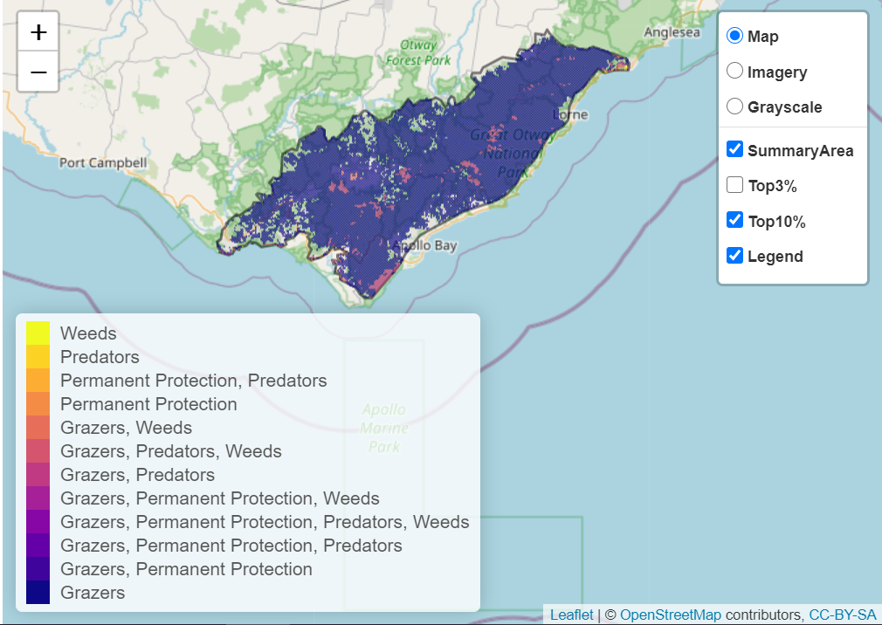

The main SMP priority actions within this focus landscape which rank among the top 10% for cost-effectiveness are listed below:
 | Control Pigs 118,121ha |  | Control Total Grazing Pressure 4,128ha
 | Control Deer 70,791ha |  | Permanent Protection 2,455ha
 | Control Rabbits 5,351ha |  | Control Cats 1,900ha
 | Control Overabundant Kangaroos 4,174ha |  | Control Foxes 1,871ha

Within this landscape, pig control, permanent protection, deer control, control total grazing pressure, rabbit control, fox control and cat control were also identified among the top 3% for cost-effectiveness.

Additional threats and considerations
Threats and considerations (in addition to those modelled in SMP) identified by Traditional Owners, partners and community groups during the BRP process for this focus landscape were:
Threats | Ecological processes and values requiring further considerations
Climate change | Appropriate burning regimes
Stock access to riparian and wetland areas | Aquatic/riparian species and catchment influences
Koala over-browsing | Indicator species and ecosystem engineers
Erosion and landslide
People (visitor management)

References
- Eastern Maar Aboriginal Corporation, 2015. Meerreengeeye Ngakeepoorryeeyt, Eastern Maar Country Plan
- Hale, J. and Butcher, R., 2011. Ecological Character Description for the Western District Lakes Ramsar site. Report to the Department of Sustainability, Environment, Water, Population and Communities, Canberra.
- Department of Environment, Land Water and Planning, 2020. NatureKit 2.0: https://maps2.biodiversity.vic.gov.au/Html5viewer/index.html?viewer=NatureKit
- Park Victoria, 2009 (amended 2019). Caring for Country — The Otways and You. Great Otway National Park and Otway Forest Park Management Plan.

