www.delwp.vic.gov.au

Applications close midday 27 November 2020

Biodiversity On-ground Action Tranche 2

Icon Species 2021 Guidelines

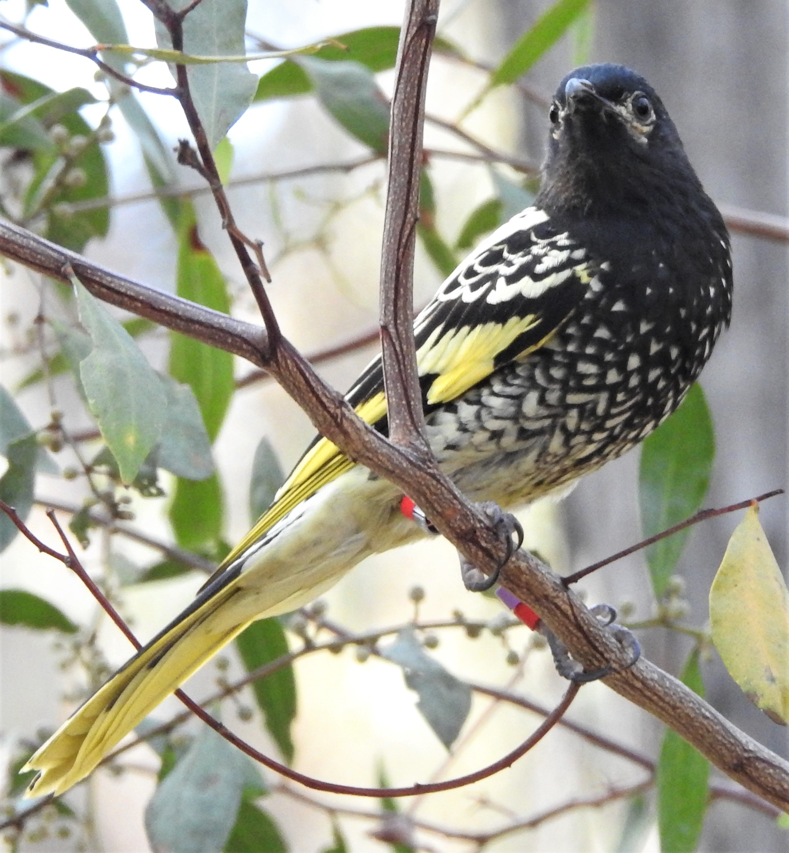
Photo credit: Regent Honeyeater – Glen Johnson, DELWP (project BOA2017Icon008)
 | 

1. Background

1.1 Icon Species sub-program
The Biodiversity On-ground Action initiative is funded by the Victorian Government’s Sustainability Fund and delivered by the Department of Environment, Land, Water and Planning (DELWP). Icon Species were one of several sub-programs under the Biodiversity On-ground Action Tranche 1 (BOA T1) program.
Icon species are those faunal species with a high community profile and are near to or are at immediate risk of rapid decline or extinction (including localised extinction).
Ten Icon Species projects were funded through BOA T1 and ended in June 2020. Feedback from the projects indicates that the funding model was flexible and the length (4 years) was a major benefit.

The ten species previously funded are:

Baw Baw Frog

Brush-tailed Rock Wallaby

Eastern Barred Bandicoot (mainland subspecies)

Helmeted Honeyeater

Leadbeater’s Possum (lowland population)

Mountain Pygmy Possum

Orange-bellied Parrot

Hooded Plover

Regent Honeyeater

Plains-wanderer
Information on these projects is available at https://www.environment.vic.gov.au/biodiversity/biodiversity-on-ground-action/icon-species.
One year of funding for an extension of the Icon Species sub-program is part of the Biodiversity On-ground Action Tranche 2 (BOA T2) program. The 2021 round is based on the original BOA T1 program objectives.

1.2 Objective
To provide financial support, policy guidance, sound governance and explicit decision support tools to support recovery programs to explore opportunities to improve the outlook of a number of species in the wild.

2. Context

2.1 Rationale
A shift in the balance of investment in biodiversity conservation is required from intensive management of critically endangered species towards investment in threat mitigation measures at an appropriate scale that is more likely to improve the likelihood of persistence of a broader range of native species in the face of climate change.
However, Biodiversity 2037 recognises that under the game-changing influence of climate change, new types of intervention and projects that maintain a single species focus will still be needed, in combination with broadscale threat management, particularly for threatened species.
For identified species, there are some unique biodiversity management situations, in which species or locations won’t benefit enough from the landscape-scale actions currently in Strategic Management Prospects (SMP) and need further consideration. For example, we still need to make decisions about the conservation of critically endangered species for which species-specific actions are required to ensure persistence. This also includes projects that employ novel or unique conservation actions.
Specific Needs Assessment (SNA) is a structured decision support process to help determine the relative cost-effectiveness of a range of potential direct interventions for species persistence. The method also enables cost-effectiveness to be assessed in a means which is comparable to SMP results for landscape-scale and more typical interventions, using Change in Suitable Habitat as a measure. SNA is a flexible tool which uses expert elicitation to determine a species or population probable response to various management scenarios. The method enables factors like climate change to also be readily incorporated and enables experts to indicate the level of uncertainty for estimates. This method can be applied at a range of scales and for a range of management scenarios.
The SNA process follows the same method used to collect expert judgements for the landscape-scale actions in SMP but focuses on more direct (including potentially novel and bespoke) actions. This process identifies the most cost-effective actions for unique biodiversity management situations. As it uses the same method and quantifies benefit in the same manner as SMP, the Specific Needs estimates can also be used to compare those actions against the cost-efficiency of all SMP actions to identify where conservation investment should go more generally. This process also incorporates uncertainty in the same way as SMP and therefore can also provide the inputs for uncertainty analysis.

2.2 Intensive management activities
The types of intensive management envisaged include, but are not limited to; collection from the wild, captive breeding, reintroduction, translocation, supplementary feeding, genetic reinforcement, guarding of colonies and specific engineering measures to protect habitat and/or provide for safe movement of animals during key life stages.

2.3 Key stakeholders
Threatened Species recovery teams, Zoos Victoria, Birdlife Australia, conservation agencies from other jurisdictions, private facilities such as Mt Rothwell Sanctuary, research institutions, Traditional Owners and community groups supporting recovery efforts. Projects should demonstrate engagement of all relevant stakeholders including traditional owner groups to reflect the rights and interests of Traditional Owners in the management of biodiversity resources, and be consistent with the following policies and guidelines:
- Pupangarli Marnmarnepu ‘Owning Our Future’ - Self-Determination Reform Strategy 2020.
- Agreements with Traditional Owners
- Aboriginal Participation Guidelines for Victorian CMAs
- Joint management between Traditional Owners and Parks Victoria.

2.4 Requirements of Icon Species 2021 projects
Recipient projects will be required to adopt best practice guidelines for the operation of recovery teams, preparation of and adherence to the relevant recovery plan/action statement and participation in the development of a Specific Needs Assessment (SNA) to help identify the relative cost-effectiveness of potential management options. The SNA will be supported by DELWP.
The funds are subject to standard DELWP contract and acquittal procedures and will require regular reporting of progress. Recovery program projects should also ensure that duty of care requirements are met, including that:
- prior to commencement of on-ground activities for the Project, the written consent of the property owner/s or property manager/s (private, public or Traditional Owner) of the nominated site/s to implement proposed Project activities is obtained.
- advice and permissions where required, are sought from Aboriginal Victoria and local Traditional Owner groups, regarding cultural heritage where proposed activities may affect Indigenous sites or places of value.
- the proposed Project complies with all requirements set out in any applicable State, Commonwealth, territory and local government laws, and declare that all necessary planning, approvals and/or permits will be in place prior to the commencement of on- ground activities in the Project.
- all relevant Departmental policies and procedures are complied with, including OHS and safety of staff, contractors, volunteers, children and others involved in the project.
And where the lead organisation is not a government agency or authority, that Personal Accident and Public Liability insurance cover is obtained and maintained for the life of the project.
Project applications for the Icon Species 2021 round, will also need to describe how organisations are planning for the long-term persistence of the species through alternative funding support and models.

3. Application process

3.1 Application process
Where Victorian recovery teams are already operating, DELWP will approach the team to discuss the opportunity for funding support over 2021. In the absence of a Victorian recovery team, DELWP will liaise with the organisation leading the recovery efforts to develop a project proposal in line with best practice guidelines for the operation of recovery teams.
As part of the application, proponents will need to prepare a project plan outlining the key activities and expenditure for the grant. The funds will be subject to standard DELWP contract and acquittal procedures. Project plan proposals stating how the funds will be used will require submission through the GEMS Grants Management System (a link will be provided to lead organisations).
Proponents will also be required to submit a spatial file (template to be provided by DELWP) outlining proposed project area and activities.

3.2 How much funding is available?
Limited funding is available for a 12-month period for projects over the 2021 calendar year. Existing icon species projects can apply for funding up to $40,000 (ex GST) and new projects can apply for up to $50,000 (ex GST).
A larger funding allocation (up to $100,000) may be considered where projects can justify short-term critical actions over the next 12 months that are needed to prevent the rapid decline and potential extinction of species populations under immediate threat. Additional funding would only be granted after consideration and assessment of all funding proposals and demonstration of capacity to deliver within the 12-month timeframe.

3.3 Who can apply?
To be eligible, applicant organisations must either be a;
- local, state government agency or statutory authority (eg. DELWP, Parks Victoria, Catchment Management Authorities); or
- Not for Profit and/or non-government organisation, such as a conservation organisation
Applicants must also meet the following eligibility criteria:
- have at least one of the following:
- have an ABN, and be registered with the Australian Charities and Not-for-profit Commission; or
- be a state or local government entity
- have at least $10 million Public Liability Insurance, with enough construction allowance to cover the project Applicants who don’t meet the eligibility criteria can partner with another organisation who does meet the criteria, known as an auspice.
Projects by state government entities must not cover regulatory or mandatory actions or responsibilities.

3.4 Who is ineligible to apply?
The following applicants are ineligible to apply for this funding;
- commercial organisations or bodies established for profit-making purposes;
- sole traders and other individuals (for profit); or
- community groups such as Landcare, schools, Friends of groups, etc.
Individuals and community groups with an interest in Icon Species are encouraged to contact the lead organisation to discuss how they can participate in on-ground activities and engagement opportunities.

3.5 What are the conditions of funding?
Successful applicant organisations are required to;
- ensure relevant Traditional Owner organisations have been consulted with on the planned project
- hold insurance sufficient to safeguard volunteers and participants involved in funded activities, including public liability insurance of at least $20 million, personal accident insurance and professional indemnity cover
- have an Australian Business Number (ABN)
- enter into a funding agreement with the Biodiversity Division of DELWP. This may be a Common Funding Agreement, Memorandum of Understanding (MoU) or Statement of Expectations (SoE)
- be responsible for meeting contractual obligations to deliver the project and report on its success by the due date
- have appropriate land manager approval and relevant permits, including planning and cultural heritage
- adhere to all relevant legislation including Occupational Health and Safety requirements and Child Safe Standards
- acknowledge the Victorian Government funding in publications and promotions
- undertake at least two communication activities, targeting the general community, and including at least five photos with permission to reproduce. This may include Project data and results updates on-line, social or print media, community seminars and telecommunications events (e.g. SWIFFT teleconferences, webinars)
- you may also have specific conditions applied to your project, which you will also need to adhere to. If this happens, we will discuss the specific requirements with you

3.6 What will be funded?
The Icon Species 2021 funding will primarily support on-ground and specific needs works. Costs associated with the protection and management of the species will be considered, including the following categories of expenditure;
- engaging and partnering with the Traditional Owners and Registered Aboriginal Parties of the project area
- materials (e.g. exclusion fencing) and site preparation (e.g. equipment hire, security fencing)
- contractors (e.g. presenters, surveyors, installers, weed controllers for particularly difficult weeds or sites)
- training that supports the project’s activities (e.g. learning a new approach, how to use equipment, First Aid)
- project management and coordination (e.g. staff time to manage the budget, coordinate volunteers, and secure approvals). It is recommended that project management costs do not exceed 10% of your budget total. If you apply for greater than 10%, then additional justification will be required.
- other types of expenditure may be considered during assessment of your project if well justified and deemed suitable. You will need to demonstrate that all activities and budget items are essential to the success of the project and that the amounts requested are reasonable.
- salaries where additional resources are employed for the purpose of delivering the project.
There are no caps or limits for eligible items. Value for money will be considered as part of the assessment process.

3.7 What won’t be funded?
The following will not be funded as part of this program.
- costs and activities that are already funded through another organisation, program or fund source. projects can build on the success of past or existing projects but must essentially be new work.
- the grant must fund additional activities that wouldn’t occur without this funding. for example, this funding is not to avoid cost shifting.
- activities that were intended to be your in-kind contribution to another funded project
- actions or costs associated with native vegetation offset sites or activities. for example, meeting a condition of a permit, contract or investment program.
- any activity involving clearing of native vegetation, unless it is a declared environmental weed in your area. in this instance, a permit for removal of vegetation may still be required.
- any activity involving the use of fire-arms, tranquilisers, or explosives.
- any illegal activity.
- purchase of goods for competitions, prizes, giveaways, vouchers or alcohol (e.g. plastic educational/promotional items, pens, sample packs, keep cups, stickers, bags).
- barbed wire fencing.
- computers, laptops, tablets and smartphones.
- insurance.
- any other action or activity determined by the panel through the assessment process to be an inappropriate or unsuitable use of the funds.
- any action that are part of a land manager’s legal duty of care.

3.7 How do I apply?
Applications must be submitted online using the DELWP Grants Online portal. To apply, go to https://www.environment.vic.gov.au/biodiversity/biodiversity-on-ground-action/icon-species/biodiversity-on-ground-action-tranche-2-icon-species-2021-round and click on the ‘Apply now’ button. To return to a saved draft application, click on the ‘Resume application’ button. You can save your application and work on it until you are ready to submit it. We recommend that you start your application as early as possible. Your online application can only be accessed by one set of login details.
Supporting documents must be in an acceptable file type, such as Word, Excel, PDF, or JPEG. The maximum file size for each file is 5MB.
You must upload the budget details template to your application. The template is available to download in the application form in Grants Online.
You will receive an application number when you submit an application online. Please quote this number in all communications with the department relating to your application. Only one file can be uploaded for each upload type in the application form. If you have more than one file to upload, zip these into a file and then upload the file. All supporting material must be received by the application deadline.
Make sure your application is submitted by midday on Friday 27 November 2020.

4. Assessment

4.1 Assessment criteria
Eligible project applications will be assessed by panel members with technical expertise in threatened species and grant administration. Once approved, recovery teams will be notified.
Assessment criteria will include, but not necessarily limited to;
- link to recovery team or similar, and/or recovery plan or action statement
- demonstrated need and community benefit
- special consideration will be given for urgent actions around threatened species
- whether a specific needs assessment has been completed/preparedness of proponent to undertake as part of the proposed project
- actions will benefit a diversity of species across the program
- group capacity, technical feasibility and timing
- stakeholder engagement and capacity building
- value for money including amount of in-kind contribution
- communication plan to describe how project outputs will be communicated
The panel may also take into consideration other funding available to support the species as well as the mix of species to be funded under this program.
We are looking for projects that;
- clearly and logically explain what outcomes (i.e. changes) the project will deliver, and how the proposed activities are the best means to achieve this
- outline a strong plan for how the project will be delivered, including how key partners, contractors, and interest groups are involved in the project
- demonstrate the use of best practice for the project’s delivery
- involve key project partners including community and Traditional Owner organisations
- consider the specific risks to the successful delivery of the project, and describe how you intend to manage and/or mitigate these
- can be scaled up to a 2-4 year project should additional funding become available
- build on what you (and other groups) have learnt and done in previous projects
- outline a plan for long-term funding and support for recovery plan
- have secured in-principle support from the land manager (if working on a site)

4.2 When will we hear if we are successful?
You will be advised of the outcome of your application in writing after the assessment and the approval process is completed, which will likely be in December 2020.
Unsuccessful applicants will be given a general indication of why their application did not received funding. All decisions, including conditional offers of funding, are final and are not subject to further review. You are welcome to ask for feedback on your application.

4.3 Funding Conditions
Successful applicants will receive payments once a funding agreement has been signed and all paperwork has been submitted to and accepted by DELWP.
All successful applicants will need to complete a final report, which will be due 4 weeks after the project is scheduled to finish. This will be outlined in the Funding Agreement, MoU or SoE.
Reporting will be completed online using the links provided and submit through the DELWP Grants Online Portal. The reporting template will be made available just before it is due. The report will need to include;
- how you spent the grant
- what you achieved with the project
- data that you collected during the project (if any). Data may be made publicly available.
- what you learnt from the project

5. Additional information

5.1 Key dates
Task | Date
Applicant briefing (FAQ session) | 11 November 2020
Round opens for project proposals | 13 November 2020
Round closes | 27 November 2020
Assessment period | early - mid December 2020
Recommended projects approved | late December 2020
Contracting and payment | January 2021
Project commencement | January 2021
Projects complete activities | 31 December 2021
Completion reports submitted | 31 January 2022
Please note that these dates are indicative only.

5.2 Further information
If you have any queries regarding the round, please contact Sheri Burmeister or the grant administration team at enviro.grants@delwp.vic.gov.au.

