|  |
| --- |
| Mapping activity output data  using a geodatabase or shapefiles |
| **Accurate representation of projects and activities** |

When mapping activity output data it is important to map what is being delivered accurately and consistently.

**Adding spatial activity data to the biodiversity outputs geodatabase (gdb)**

In ArcMap create a connection to the folder that contains the ‘Biodiversity outputs geodatabase template’ from the Catalog window. The geodatabase is an ESRI geodatabase then you will need ArcMap to connect to the geodatabase.

The ‘biodiversity outputs template.gdb’ contains the four classes of activity outputs as in the “DELWP Output Data Standards”: Environmental Works; Management Services; Planning & Regulation; and Structural Works. It also contains the ‘Project’ shapefile template to map a project area and add your project information.

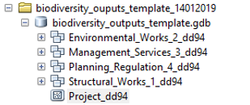

Each output layer in the geodatabase contains drop-down menus to select valid attributes. The drop-down

menus will display after mapping a feature (polygon/line/point) for any activity output. Fields in the attribute

table are either auto-populated, selected from the drop-down menus or need to be populated manually.

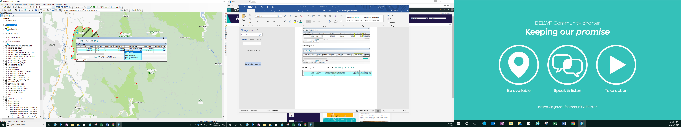

**Adding spatial activity data to the biodiversity outputs using shapefiles template**

Another option is to add spatial data using the activity output shapefiles templates. **The shapefiles do not contain the drop-down menus for selecting valid attributes and do not have fields that are auto-populated; you will need to type every valid value as instructed in the ‘**DELWP Output Data Standards**’**. Shapefiles can be imported in any GIS systems. The shapefiles for each activity output are classified in the four classes: Environmental Works; Management Services; Planning&Regulation; and Structural Works. Choose the activity ouput shapefiles templates that are relevant to your project and import them in your GIS system to map your activity data.

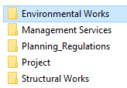

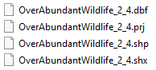

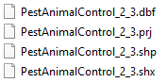

**Mapping your activity data**

To map your activity data, connect to the ‘biodiversity outputs template.gdb’ in ArcMap or import relevant activity output shapefiles templates in your GIS system. Your activities will be bounded by a project area. Map your project area and complete the project information. Map activities features (polygon/line/point) and complete the attributes for these features. When mapping your project area(s), you may have one of the following scenarios:

1. A project delivered in one location with one or many activities delivered under it
2. A project delivered in more than one location with one or many activities delivered under it

## Scenario 1: A project may be delivered at one location and may have one or many activities delivered under it. Your project area should be mapped to include those areas where activities are being or will be carried out. The activity areas should accurately reflect where the activities are delivered. The picture below illustrates three outputs resulting from activities delivered bounded by a project area.

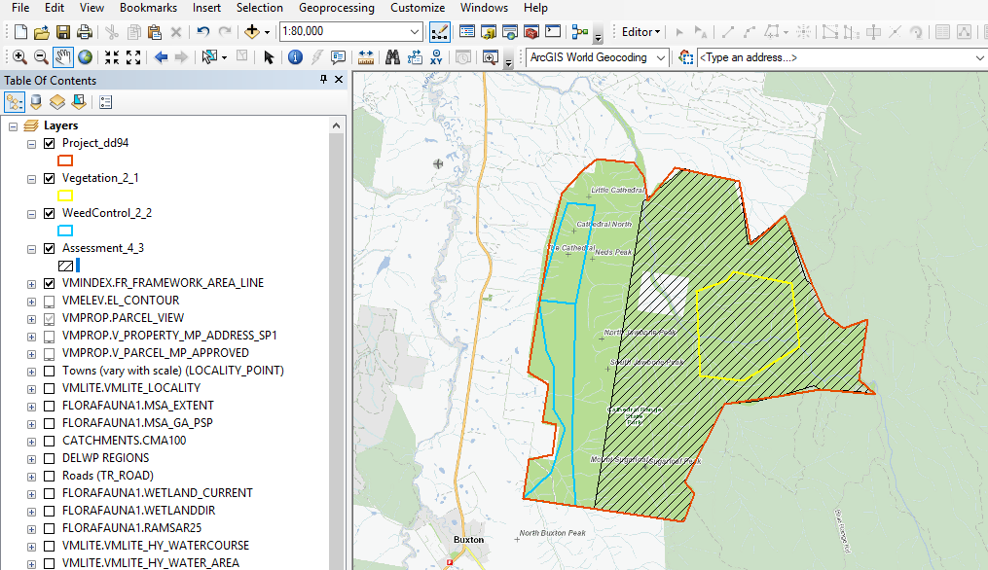

## Scenario 2. A project may be delivered at more than one location and may have one or many activities delivered under it. Multiple project areas should be mapped separately if the activities delivered are located some distance apart. The picture below illustrates a project being delivered in four different locations and five types of activities delivered. Note that you can combine in one polygon project locations that are close and maintain project locations that are far apart as separated polygons.

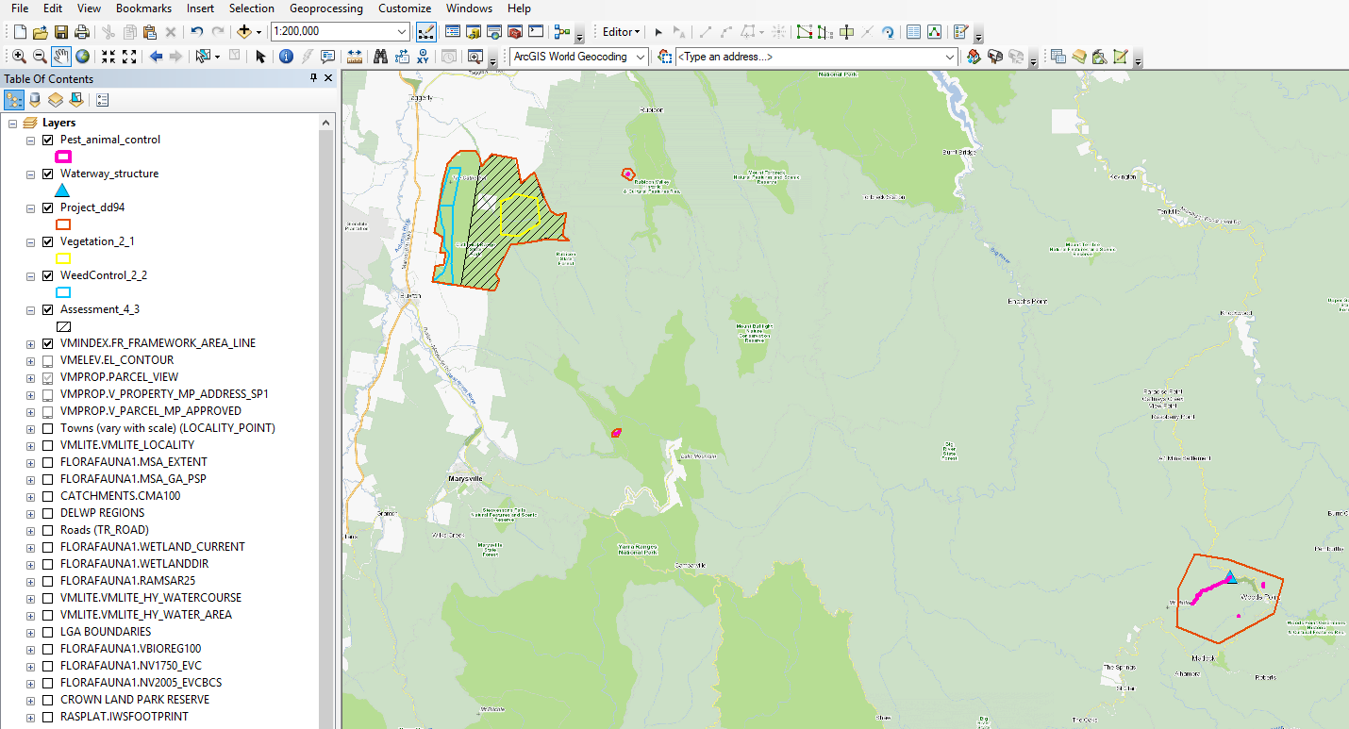



Avoid bounding in one large project area activities delivered in many locations that are a large distance apart.

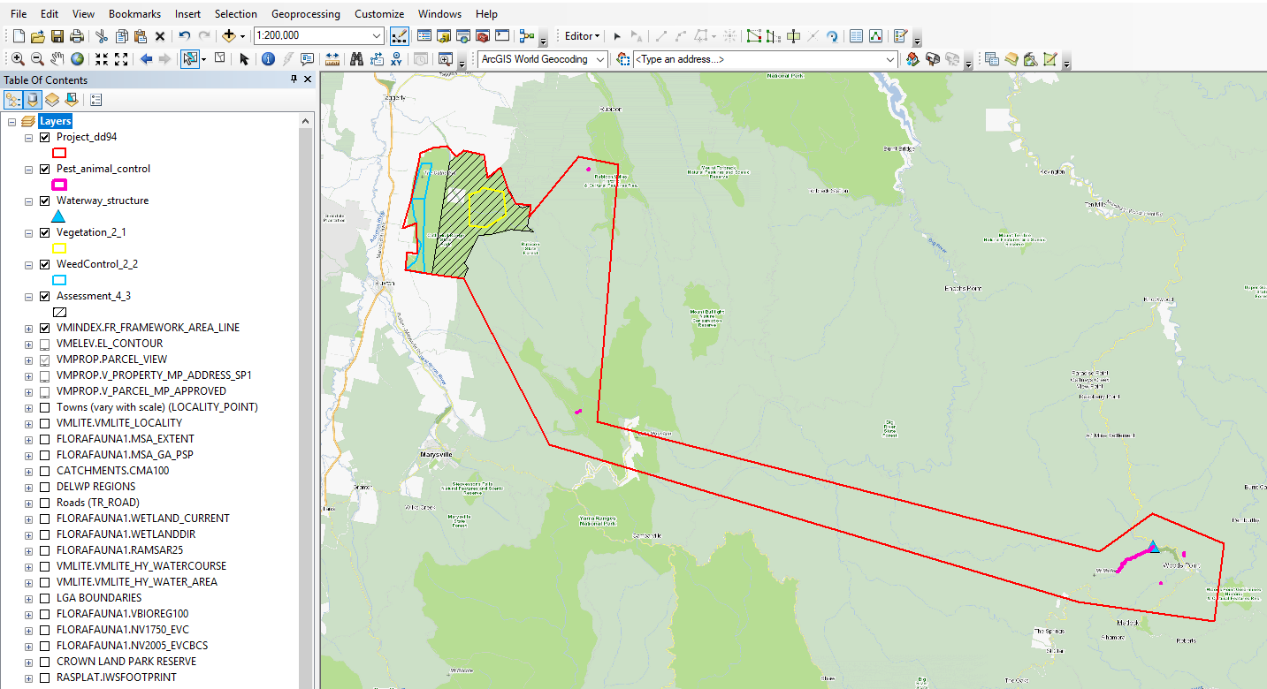



**Representing spatial activity data over a period of time**

Projects and activities delivered over multiple years will be mapped for each year that they are delivered. The ‘Year Completed’ is the financial year in which the activity was delivered. For example, weed control delivered in July 2018 will have ‘Year Completed’ as 2019, just as weed control delivered in June 2019 will also have ‘Year Completed’ 2019.

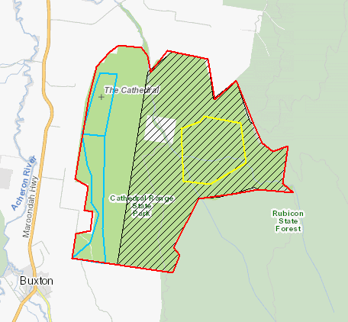

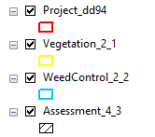



The attributes for each output must be representatives of ‘DELWP output data standards’: Over time the mapped features together with the correct attributes give a picture of activities at a place over time.

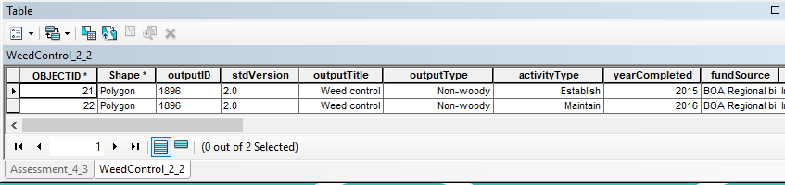

|  |  |
| --- | --- |
| © The State of Victoria Department of Environment, Land, Water and Planning 2019  LogoThis work is licensed under a Creative Commons Attribution 4.0 International licence. You are free to re-use the work under that licence, on the condition that you credit the State of Victoria as author. The licence does not apply to any images, photographs or branding, including the Victorian Coat of Arms, the Victorian Government logo and the Department of Environment, Land, Water and Planning (DELWP) logo. To view a copy of this licence, visit http://creativecommons.org/licenses/by/4.0/  Disclaimer  This publication may be of assistance to you, but the State of Victoria and its employees do not guarantee that the publication is without flaw of any kind or is wholly appropriate for your particular purposes and therefore disclaims all liability for any error, loss or other consequence which may arise from you relying on any information in this publication. | Accessibility  If you would like to receive this publication in an alternative format, please telephone the DELWP Customer Service Centre on 136186, email [customer.service@delwp.vic.gov.au](mailto:customer.service@delwp.vic.gov.au) or via the National Relay Service on 133 677 [www.relayservice.com.au](http://www.relayservice.com.au). This document is also available on the internet at [www.delwp.vic.gov.au](http://www.delwp.vic.gov.au). |