|  |
| --- |
| Understanding Strategic Management Prospects (SMP) – Bar Plots |

Strategic Management Prospects (SMP) bar plots show the relative contribution that different actions make to the prospects for species and taxon groups. Two of the bar plots demonstrate benefit (the potential total benefit for each action and also the potential benefit available for the cost-effective actions). The third bar plot shows the benefit:cost ratio of each action.

Some management actions are not included in the SMP analysis because at this stage they are difficult to cost and/or have legal or social ramifications that are beyond the scope of SMP. Only the actions that are costed in the SMP analysis appear in the cost-effective action bar plots and benefit-cost bar plots.

Benefit Bar Plots

The x-axis shows each of the modelled management actions, and the y-axis shows the benefit, measured as hectares of Change in Suitable Habitat (CSH), available for each of the actions (in the polygon used). The y-axis shows both the total benefit to all species, and how much each action benefits each taxonomic group.

The **Total Benefit Bar Plot** shows how much potential benefit could be gained (for all species in the polygon) if all actions were undertaken. The CSH shown in this bar plot assumes that each action is undertaken everywhere the corresponding threat is present within the polygon. To see how much benefit could be gained by individual species, look at the SMP Total Benefits Table (refer to *Understanding SMP Total Benefits Tables* for more information - available at <https://www.environment.vic.gov.au/biodiversity/natureprint>).

The **Benefits of** **Cost-effective Actions Bar Plot** shows the potential CSH from the cost-effective actions that collectively benefit as many species as possible. The cost-effective actions bar plots summarise the SMP Cost-effective Actions Maps and the CSH shown assumes that the actions are undertaken in the locations specified.

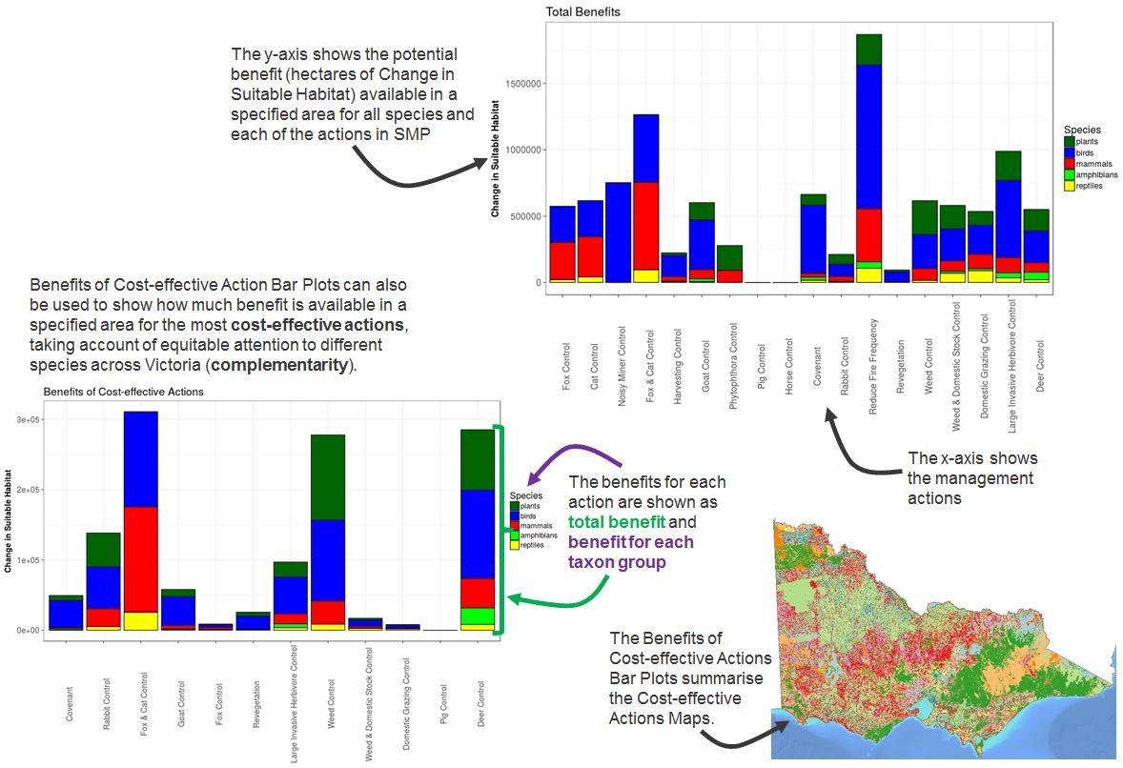

Benefit-cost Bar Plot

The **Benefit-cost Bar Plot** demonstrates how cost influences the cost-effective actions for a defined area (polygon). The x-axis of the benefit-cost bar plot shows the costed actions in the SMP analysis, and the y-axis shows the benefit:cost ratio, enabling comparison of the relative cost-efficiency of each costed action in the polygon. The benefit-cost bar plot identifies the actions most likely to provide greater benefit per dollar spent for all species (and each taxon group) in the polygon. The relative cost-efficiency (or benefit-cost) is calculated for each action as a ratio of a species’ probability of persistence per unit cost, so the y-axis of the benefit-cost bar plot does not relate to the potential geographic area that an action will be undertaken in.

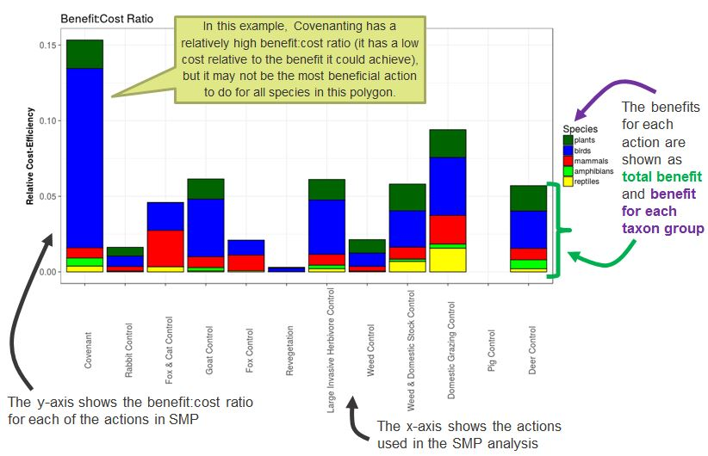

For more information about Strategic Management Prospects visit <https://www.environment.vic.gov.au/biodiversity/natureprint>.

|  |  |
| --- | --- |
| © The State of Victoria Department of Environment, Land, Water and Planning 2018  LogoThis work is licensed under a Creative Commons Attribution 4.0 International licence. You are free to re-use the work under that licence, on the condition that you credit the State of Victoria as author. The licence does not apply to any images, photographs or branding, including the Victorian Coat of Arms, the Victorian Government logo and the Department of Environment, Land, Water and Planning (DELWP) logo. To view a copy of this licence, visit http://creativecommons.org/licenses/by/4.0/  Disclaimer  This publication may be of assistance to you but the State of Victoria and its employees do not guarantee that the publication is without flaw of any kind or is wholly appropriate for your particular purposes and therefore disclaims all liability for any error, loss or other consequence which may arise from you relying on any information in this publication. | Accessibility  If you would like to receive this publication in an alternative format, please telephone the DELWP Customer Service Centre on 136186, email [customer.service@delwp.vic.gov.au](mailto:customer.service@delwp.vic.gov.au), or via the National Relay Service on 133 677 [www.relayservice.com.au](http://www.relayservice.com.au). This document is also available on the internet at [www.delwp.vic.gov.au](http://www.delwp.vic.gov.au). |

To view SMP products go to <https://naturekit.biodiversity.vic.gov.au>.