
Flora and Fauna Guarantee Act 1988 – Potentially Threatening Processes List
  - July 2026

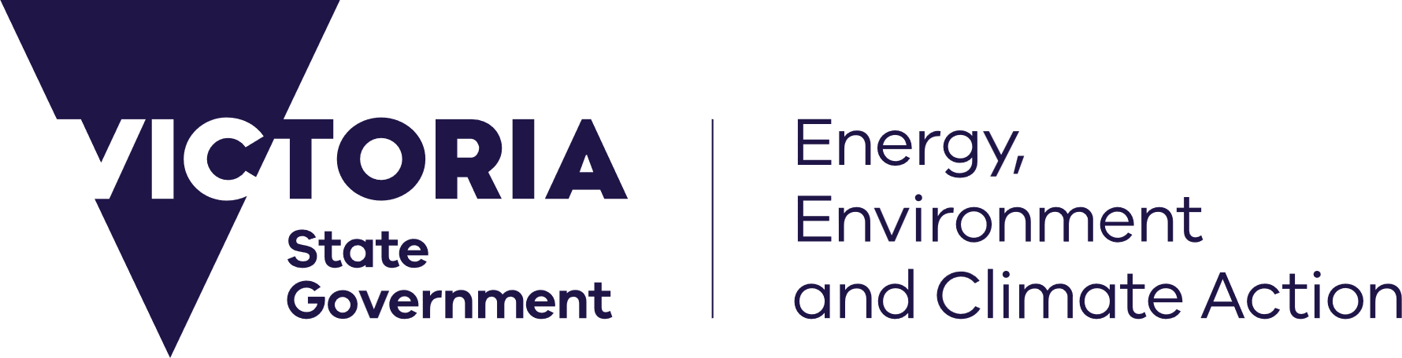





Cover page photo credits
Northern Pacific Seastar – John Lewis, ES Link Services Pty. Ltd.
Gorse Ulex europaeus, Sally Lambourne
Red Fox Vulpes vulpes, Arthur Rylah Institute for Environmental Research


We acknowledge and respect Victorian Traditional Owners as the original custodians of Victoria’s land and waters, their unique ability to care for Country and deep spiritual connection to it.
We honour Elders past and present whose knowledge and wisdom
has ensured the continuation of culture and traditional practices.
DEECA is committed to genuinely partnering with Victorian Traditional Owners and Victoria’s Aboriginal community to progress their aspirations.
© The State of Victoria Department of Energy, Environment and Climate Action, July 2026.
Creative Commons
This work is licensed under a Creative Commons Attribution 4.0 International licence, visit the Creative Commons website (http://creativecommons.org/licenses/by/4.0/).
You are free to re-use the work under that licence, on the condition that you credit the State of Victoria as author. The licence does not apply to any images, photographs or branding, including the Victorian Coat of Arms, and the Victorian Government and Department logos.
Disclaimer
This publication may be of assistance to you but the State of Victoria and its employees do not guarantee that the publication is without flaw of any kind or is wholly appropriate for your particular purposes and therefore disclaims all liability for any error, loss or other consequence which may arise from you relying on any information in this publication.
Accessibility
To receive this document in an alternative format, phone the Customer Service Centre on 136 186, email customer.service@delwp.vic.gov.au, or contact National Relay Service on 133 677. Available at DEECA website (https://www.environment.vic.gov.au/conserving-threatened-species/threatened-list).

Introduction

About the Flora and Fauna Guarantee Act
The Flora and Fauna Guarantee Act 1988 (FFG Act) is the primary piece of Victorian legislation that provides for the conservation of biodiversity and the management of associated potentially threatening processes. Along with the listing of threatened species and communities where they satisfy prescribed criteria in the FFG Act and in the FFG Regulations, the listing of potentially threatening processes has also been a feature of the Act since its inception.

What is a potentially threatening process?
The FFG Act defines a potentially threatening process as ‘a process which may have the capability to threaten the survival, abundance or evolutionary development of any taxon or community of flora or fauna’.

Legislative provision
This document meets the following statutory requirement:
Flora and Fauna Guarantee Act 1988 Part 3, Division 1, section 11:
(1) The Governor in Council, in accordance with this section, must establish and maintain a list of potentially threatening processes.
(2) The Governor in Council may specify in the list under subsection (1) any potentially threatening process that the Minister, under Division 3, recommends should be specified in the list.

Listed potentially threatening processes
- Alteration to the natural flow regimes of rivers and streams.
- Alteration to the natural temperature regimes of rivers and streams.
- Collection of native orchids.
- Degradation and loss of freshwater and estuarine habitats and impact on native fish caused by European Carp (Cyprinus carpio).
- Degradation and loss of habitats caused by feral Horses (Equus caballus).
- Degradation of native riparian vegetation along Victorian rivers and streams.
- Habitat fragmentation as a threatening process for fauna in Victoria.
- High frequency fire resulting in disruption of life cycle processes in plants and animals and loss of vegetation structure and composition.
- Human activity which results in artificially elevated or epidemic levels of Myrtle Wilt within Nothofagus-dominated Cool Temperate Rainforest.
- Inappropriate fire regimes causing disruption to sustainable ecosystem processes and resultant loss of biodiversity.
- Incidental catch (or bycatch) of seabirds during longline fishing operations.
- Increase in sediment input into Victorian rivers and streams due to human activities.
- Infection of amphibians with Chytrid Fungus, resulting in chytridiomycosis.
- Input of organotins to Victorian marine and estuarine waters.
- Input of petroleum and related products into Victorian marine and estuarine environments.
- Input of toxic substances into Victorian rivers and streams.
- Introduction and spread of Spartina to Victorian estuarine environments.

- Introduction of live fish into waters outside their natural range within a Victorian river catchment after 1770.
- Invasion of native vegetation by Blackberry Rubus fruticosus L. agg.
- Invasion of native vegetation by ‘environmental weeds’.
- Invasion of native vegetation communities by Tall Wheat-grass Lophopyrum ponticum.
- Loss of biodiversity as a result of the spread of Coast Wattle (Acacia longifolia subsp. sophorae) and Sallow Wattle (Acacia longifolia subsp. longifolia) into areas outside its natural range.
- Loss of biodiversity in native ant populations and potential ecosystem integrity following invasion by Argentine Ants (Linepithema humile).
- Loss of coarse woody debris from Victorian native forests and woodlands.
- Loss of hollow-bearing trees from Victorian native forests.
- Loss of terrestrial climatic habitat caused by anthropogenic emissions of greenhouse gases.
- Poisoning of native wildlife by anticoagulant rodenticides.
- Predation of native wildlife by the cat, Felis catus.
- Predation of native wildlife by the introduced Red Fox Vulpes vulpes.
- Prevention of passage of aquatic biota as a result of the presence of instream structures.
- Reduction in biodiversity of native vegetation by Sambar (Cervus unicolor).
- Reduction in biodiversity resulting from Noisy Miner (Manorina melanocephala) populations in Victoria.
- Reduction in biomass and biodiversity of native vegetation through grazing by the Rabbit Oryctolagus cuniculus.
- Removal of wood debris from Victorian streams.
- Soil and vegetation disturbance resulting from marble mining.
- Soil degradation and reduction of biodiversity through browsing and competition by feral goats (Capra hircus).
- Soil erosion and vegetation damage and disturbance in the alpine regions of Victoria caused by cattle grazing.
- Spread of Pittosporum undulatum in areas outside its natural distribution.
- The discharge of human-generated marine debris into Victorian marine or estuarine waters.
- The introduction and spread of the Large Earth Bumblebee Bombus terrestris into Victorian terrestrial environments.
- The introduction of exotic organisms into Victorian marine waters.
- The spread of Phytophthora cinnamomi from infected sites into parks and reserves, including roadsides, under the control of a state or local government authority.
- Threats to native flora and fauna arising from the use by the feral honeybee Apis mellifera of nesting hollows and floral resources.
- Use of Phytophthora-infected gravel in construction of roads, bridges and reservoirs.
- Wetland loss and degradation as a result of change in water regime, dredging, draining, filling and grazing.

