|  |
| --- |
| VBA - Generate detailed species lists |
| How to generate a detailed species report in the Victorian Biodiversity Atlas |

## From the Species List & Maps section you can generate a summarised list of the taxa recorded in your chosen area OR the full list of all the detailed records for each species. For the latter you need to be a Registered User and login to the system. Follow these steps to generate detailed species records for an area.

## *Tips*

*Throughout the VBA each window has a* ***?*** *in the top right hand corner – this is window-specific help that will provide further details about how to complete the fields.*

*Make sure that you have allowed pop-ups from your browser (you will need to allow these from the VBA site)*

1. Visit VBA (https://vba.dse.vic.gov.au/vba/) and Login using your Login Name & Password
2. Navigate to the Search section in the top left of the Welcome page and then select Species and Surveys > Species Lists & Maps

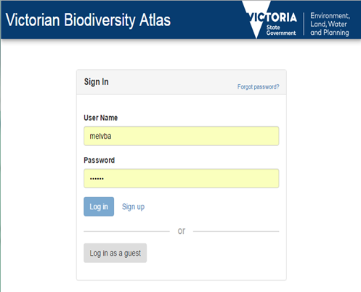

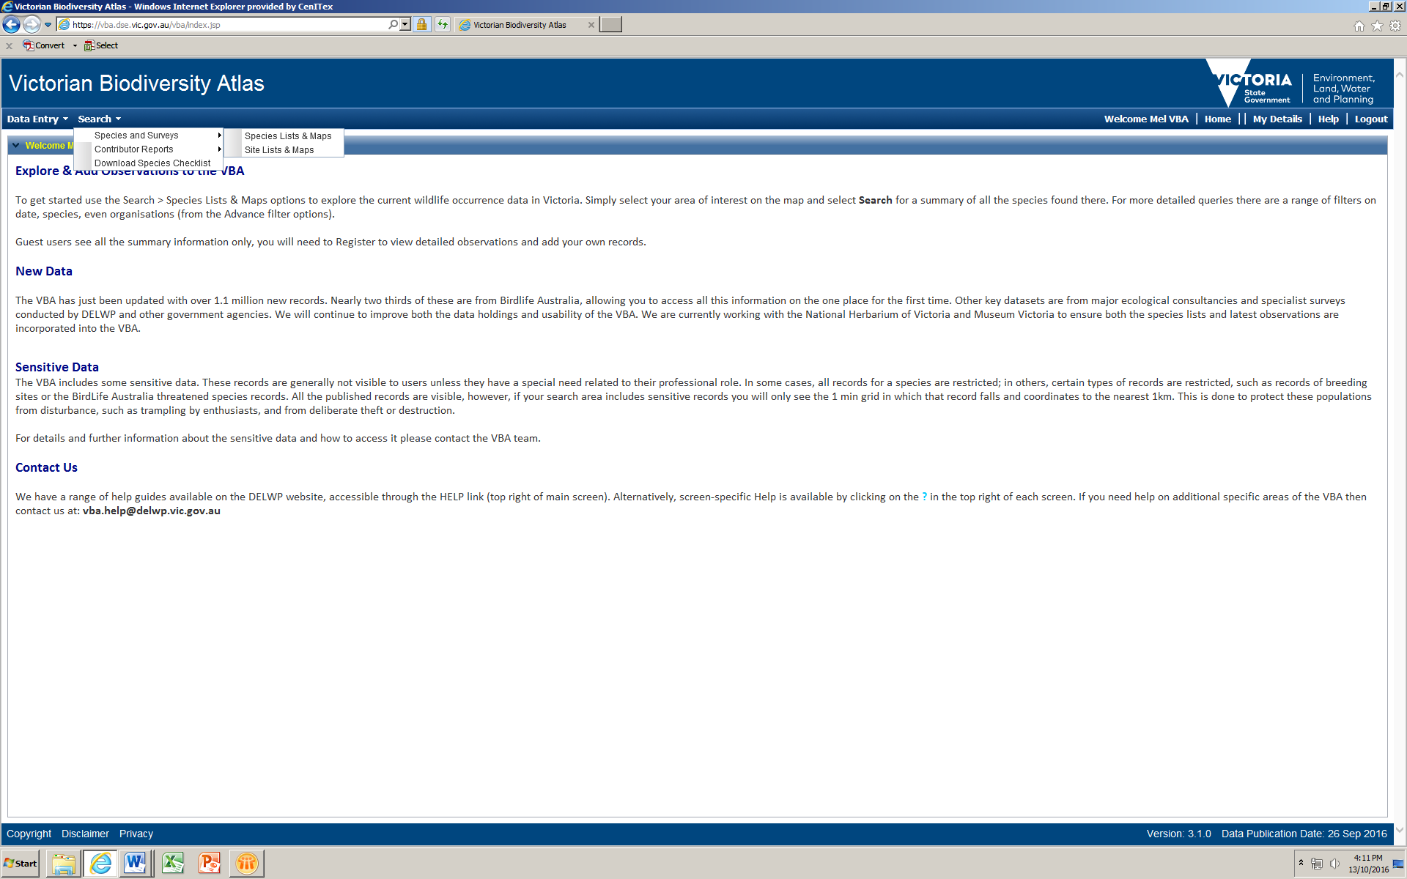

From here you have access to the spatial and non-spatial search elements to query the VBA database. There are multiple ways you can select your search area. You have the option to:

* manually draw your search area (Type = User Polygon; Click then Draw) – after drawing your search area, follow steps 5-8 below
* select from a pre-defined polygon (Type = LGA, DSE Region, CMA, 10 minute Grid, or Parks & Reserves) – refer to steps 3-8 below
* upload your own shapefile, then follow steps 5-8 below
* create a point, line or polygon and buffer it (Type = Buffer – Point, Buffer – Line or Buffer – Polygon; Click then Draw, type in required buffer, Apply Buffer), follow steps 5-8 below

The following steps show you how to use an existing polygon for your search:

1. To select from one of pre-defined polygons, choose the relevant option from the drop-down list – eg Parks & Reserves. Once you select one of these options, you can then select the specific polygon you need – eg Mount Buffalo National Park
2. Next click Zoom To and your map will zoom to that polygon.
3. To focus on a specific species, date range, taxon group (such as ferns or bats), or Conservation Status use the Common Filter section.
4. Select Detailed and click Search.

Note: the maximum number of records the report will return is 20,000. If you chose a large area or select All Victorian Sites the system will force you to search for only one taxon at a time, for this you need the VBA Taxon ID (easily found by first searching in Summary Report).

1. The list of species for that area will appear at the bottom of your screen. Here you can right click on any of the Species table headings to sort and select from the list of fields available.
2. Now you can either Print or Export this list in various formats.



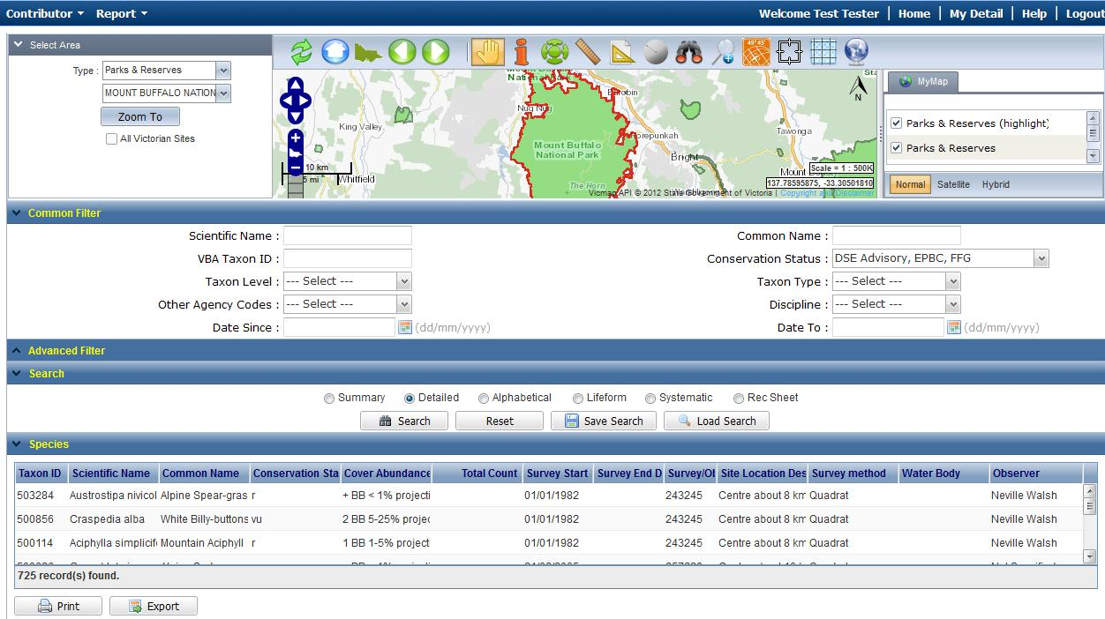

|  |
| --- |
| **Related Quick Help Guides:**   * Search – Summary Species List for an Area * Search – Detailed Statewide Records for Single Species * Contribute – Add a Survey & Species Records to a Project |

|  |  |
| --- | --- |
| © The State of Victoria Department of Environment, Land, Water and Planning 2017  LogoThis work is licensed under a Creative Commons Attribution 4.0 International licence. You are free to re-use the work under that licence, on the condition that you credit the State of Victoria as author. The licence does not apply to any images, photographs or branding, including the Victorian Coat of Arms, the Victorian Government logo and the Department of Environment, Land, Water and Planning (DELWP) logo. To view a copy of this licence, visit http://creativecommons.org/licenses/by/4.0/  Disclaimer  This publication may be of assistance to you but the State of Victoria and its employees do not guarantee that the publication is without flaw of any kind or is wholly appropriate for your particular purposes and therefore disclaims all liability for any error, loss or other consequence which may arise from you relying on any information in this publication. | Accessibility  If you would like to receive this publication in an alternative format, please telephone the DELWP Customer Service Centre on 136186, email [customer.service@delwp.vic.gov.au](mailto:customer.service@delwp.vic.gov.au) or via the National Relay Service on 133 677 [www.relayservice.com.au](http://www.relayservice.com.au). This document is also available on the internet at [www.delwp.vic.gov.au](http://www.delwp.vic.gov.au). |