|  |
| --- |
| VBA – Add a Survey and Species Records to a Project |
| How to add a survey and species records to a project in the Victorian Biodiversity Atlas |

## This is a basic step by step guidance document to help you create a Survey and add your species records to a VBA Project. This guide uses the Survey Method of Species List for a Defined Area as an example. There are many other survey methods to choose from, with minor variations to the process of entering the information. For further support please view the related help documents in the Contribute series.

## *Tips*

*Throughout the VBA each window has a* ***?*** *in the top right hand corner – this is window-specific help that will provide further details about how to complete the fields.*

*Make sure that you have allowed pop-ups from your browser (you will need to allow these from the VBA site)*

*Also, throughout the VBA fields marked with a red dot (●) are mandatory fields and must be completed. The fields marked with a yellow dot (●) are conditional - if you complete one you must complete the others.*

1. Visit VBA (https://vba.dse.vic.gov.au/vba/) and Login using your Login Name & Password (see VBA Registration Help Guide).
2. Go to Data Entry in the top left screen, and select My Projects. Select an existing project from your list of Projects by clicking pen_pad for the relevant Project, or create a new Project (see Create a Project Help Guide)

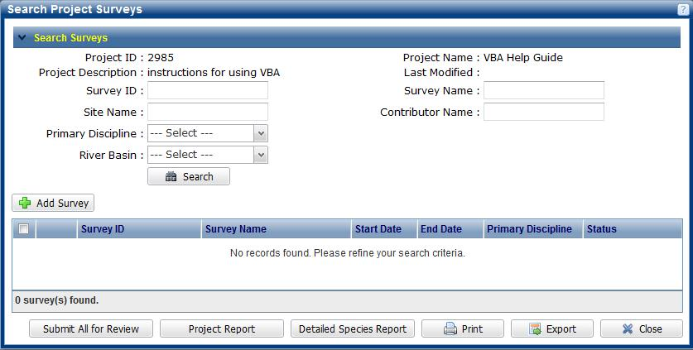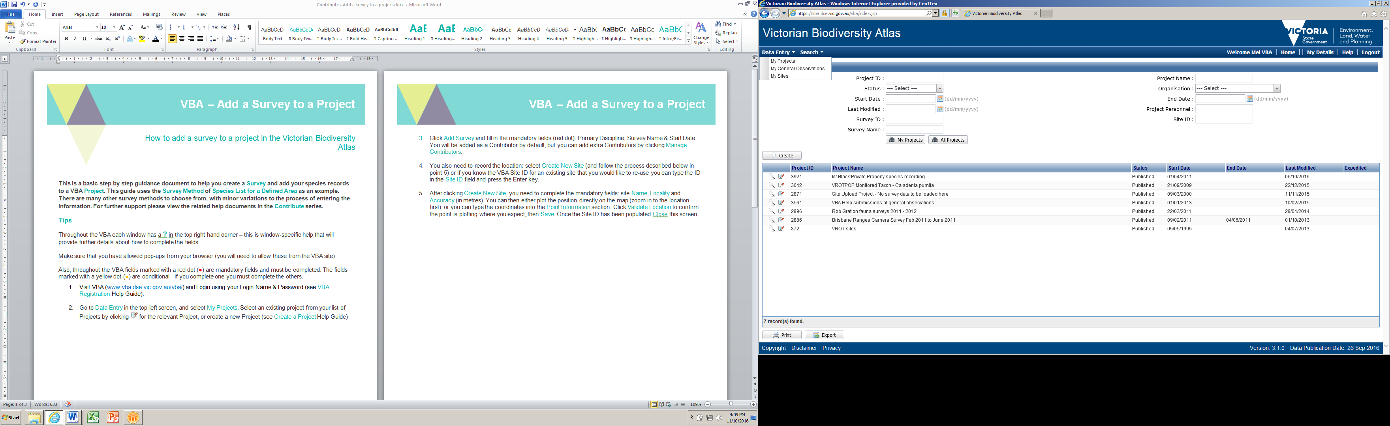

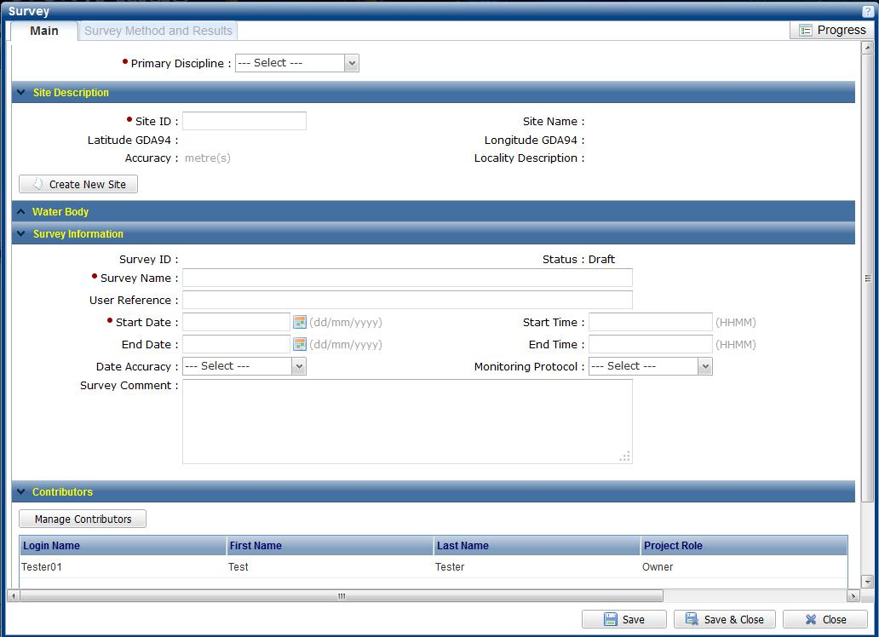









1. Click Add Survey and fill in the mandatory fields (●): Primary Discipline, Survey Name & Start Date. You will be added as a Contributor by default, but you can add extra Contributors by clicking Manage Contributors.
2. You also need to record the location: select Create New Site (and follow the process described below in point 5) or if you know the VBA Site ID for an existing site that you would like to re-use you can type the ID in the Site ID field and press the Enter key.
3. After clicking Create New Site, you need to complete the mandatory fields: site Name, Locality and Accuracy (in metres). You can then either plot the position directly on the map (zoom in to the location first), or you can type the coordinates into the Point Information section. Click Validate Location to confirm the point is plotting where you expect then Save. Once the Site ID has been populated Close this screen.

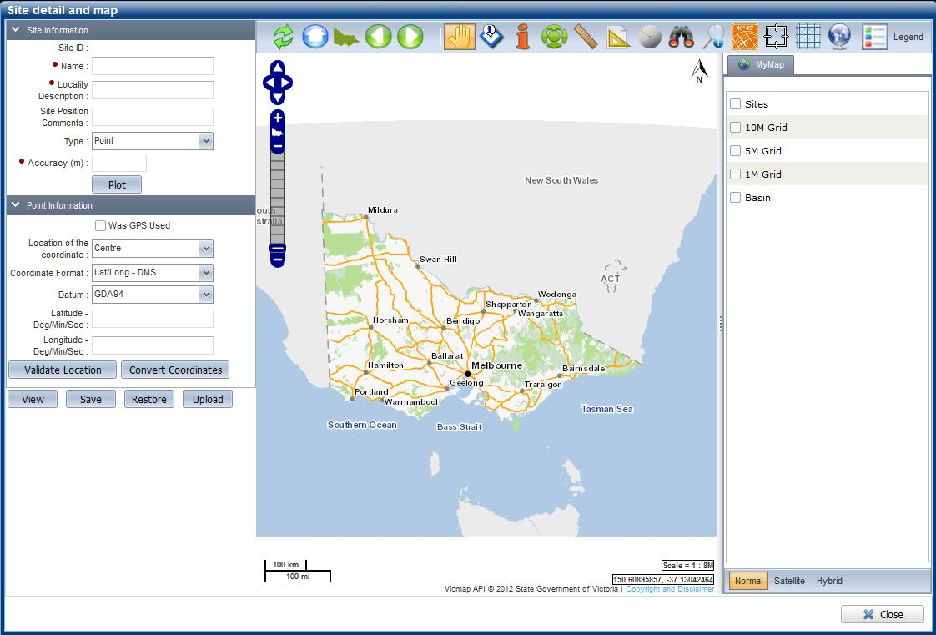

1. Once all the Main information in the Survey has been completed click Save. The Survey Method & Results tab in the top left is now available for you to add your survey method and species records.
2. Click Add Survey Method and select the appropriate Survey method from the drop-down list – in this case, Species List for Defined Area. Optionally, you can enter the length, width and/or number of minutes it took to complete the survey.
3. After clicking Save, the Species Records tab in the top left becomes available and you can now add the species you observed. *Note: you cannot delete a method once you’ve saved it, so please ensure you’ve selected the correct method before saving*.

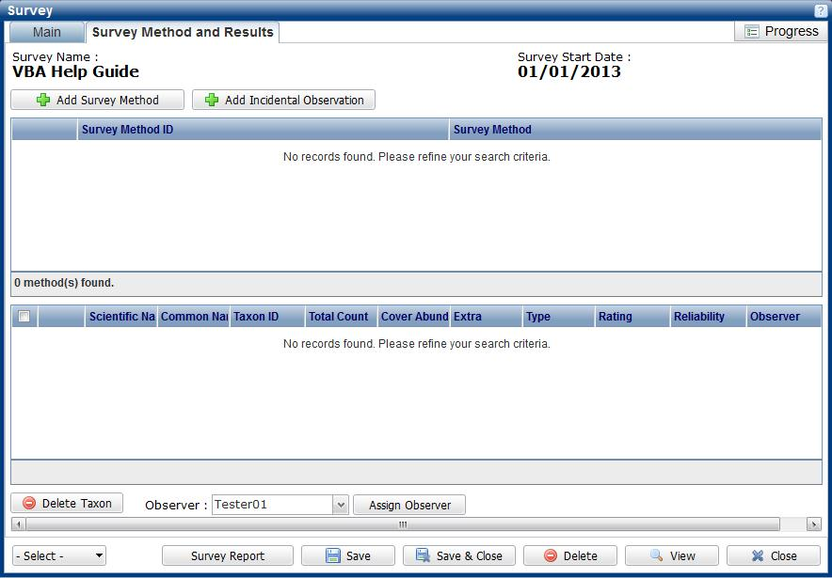

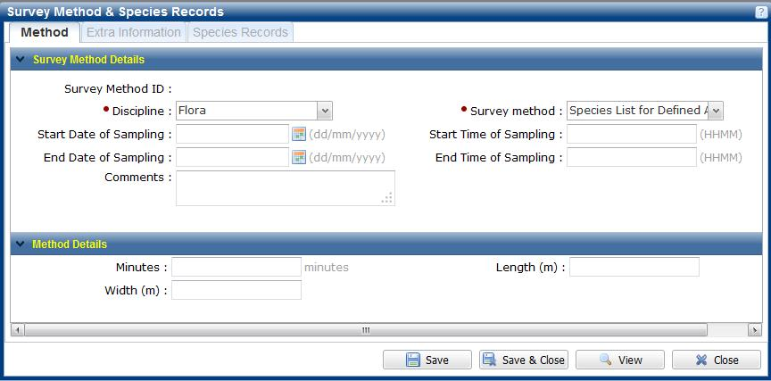

1. Use the Search Taxon box and start typing the scientific name, common name or if known the VBA Taxon ID here and select from the dropdown list. Ensure any counts are captured and the correct observer is selected (or change by clicking on the drop-down list) and click Add. Once you are happy with these details, click Save & Close.
2. You will have now returned to the Survey Method & Results window. From here you have the option to enter additional Methods if required. *Note: If you are returning to an existing survey make sure the window is in Edit mode before you make changes by clicking* Edit.

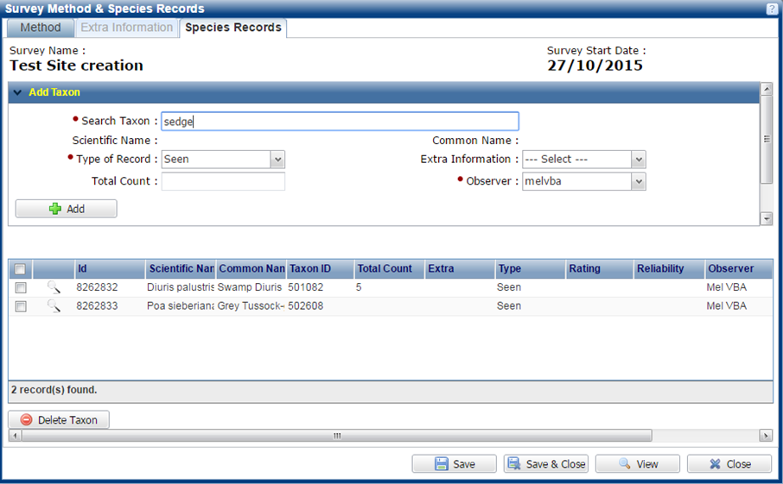

1. Before you submit the data for Expert Review and publication, the VBA requires the records to be validated. To do this go to the Validate and Submit in the bottom left corner – this gives a Rating indicating whether the species has been recorded in the vicinity before.

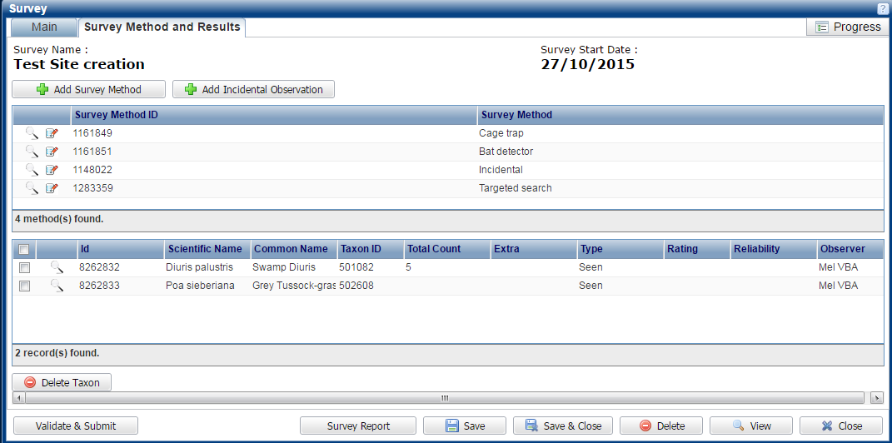

1. Finally, Continue, and your whole survey will be submitted for Expert Review. *Note: You will not be able to make any changes to this Survey until after the Review process has been completed*.
2. Once your records have been reviewed the Reliability field will be completed with either confirmed or acceptable which will lead to the records being published. If further evidence has been requested from you (via email from the VBA) the records will be classified as unconfirmed. Unconfirmed records will remain in draft and not visible to anyone other than the contributor until further evidence has been provided and the records can be re-assessed.

|  |
| --- |
| **Related Quick Help Guides:**   * Contribute - Create a Project * Contribute - Add a Breeding Record * Contribute - Add a Specimen Record * Contribute – Edit Species Records * Contribute – Edit Site Details * Search - Summary Species List for an Area * Search - Detailed Species List for an Area |

|  |  |
| --- | --- |
| © The State of Victoria Department of Environment, Land, Water and Planning 2017  LogoThis work is licensed under a Creative Commons Attribution 4.0 International licence. You are free to re-use the work under that licence, on the condition that you credit the State of Victoria as author. The licence does not apply to any images, photographs or branding, including the Victorian Coat of Arms, the Victorian Government logo and the Department of Environment, Land, Water and Planning (DELWP) logo. To view a copy of this licence, visit http://creativecommons.org/licenses/by/4.0/  Disclaimer  This publication may be of assistance to you but the State of Victoria and its employees do not guarantee that the publication is without flaw of any kind or is wholly appropriate for your particular purposes and therefore disclaims all liability for any error, loss or other consequence which may arise from you relying on any information in this publication. | Accessibility  If you would like to receive this publication in an alternative format, please telephone the DELWP Customer Service Centre on 136186, email [customer.service@delwp.vic.gov.au](mailto:customer.service@delwp.vic.gov.au) or via the National Relay Service on 133 677 [www.relayservice.com.au](http://www.relayservice.com.au). This document is also available on the internet at [www.delwp.vic.gov.au](http://www.delwp.vic.gov.au). |