Introduction
Biodiversity Response Planning (BRP) is a long-term area-based planning approach to biodiversity conservation in Victoria. It is designed to strengthen alignment, engagement and participation between government, Traditional Owners, non-government agencies and the community.
DELWP Regional staff have been working with stakeholders on actions to conserve biodiversity in specific landscapes, informed by the best available science and local knowledge.
These Fact Sheets capture a point in time, reflecting data and knowledge available in 2020. They provide information for many (but not all) landscapes across Victoria, containing general information on the key values and threats in each area, as well as the priority cost-effective actions that provide the best protection of biodiversity. Fact Sheets are intended to provide useful biodiversity information for the community, non-government and government organisations during project planning and development.
Further information and the full list of Fact Sheets is available on the Department’s Environment website.

Landscape description
This 128,694ha area is a mix of cleared and vegetated land (44% native vegetation cover) and is mostly private land (89%). The landscape incorporates the public land around Stawell and Ararat and on the eastern edge of the Grampians National Park.

Habitat Distribution Models identify 38 species with more than 5% of their Victorian range in this landscape
38 Plants
- 4 species which have more than 50% of their Victorian range in the landscape
- Tawny Spider Orchid (86% of Victorian range in landscape, EPBC*-listed Endangered), Elfin Leek-orchid (80% of Victorian range in landscape, endangered), Pomonal Leek-orchid (76% of Victorian range in landscape, EPBC-listed Endangered) and Veined Spider-orchid (73% of Victorian range in landscape, vulnerable)
*Environment Protection and Biodiversity Conservation Act 1999 (Federal)

Strategic Management Prospects
Strategic Management Prospects (SMP) models biodiversity values such as species habitat distribution, landscape-scale threats and highlights the most cost-effective actions for specific locations. More information about SMP is available in NatureKit.

Which landscape-scale actions are most cost-effective in this landscape?
Some areas of this focus landscape (coloured areas on the map) have highly cost-effective actions which provide significant benefit for biodiversity conservation.

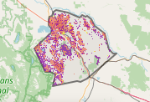
The SMP priority actions which rank among the top 3% for cost-effectiveness of that action across the state are in order:
Control rabbits 14,438ha
Control weeds 9,340ha
Revegetation 8,346ha
Control overabundant kangaroos 2,247ha
Domestic stock grazing control 1,12ha
Permanent protection 604ha

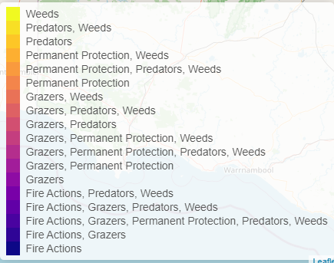

Of the top 10% of cost-effective actions, control rabbits, control weeds, control overabundant kangaroos, and combined fox and cat control ranked the highest.

The most cost-effective actions for flora & fauna
Plants - Control rabbits, control weeds, control kangaroos, control foxes
Birds - Control rabbits, control weeds, combined fox and cat control, control kangaroos
Mammals, Reptiles - Control rabbits, control weeds, combined fox and cat control
Amphibians - Control rabbits

For a further in depth look into SMP for this landscape please refer to NatureKit.

