“We acknowledge the Wadawurrung people of the Kulin Nation as the Original Custodians of the lands which represents the following information. We pay respects to Elders past, present and emerging leaders that continue their obligations to care for Country. We care for Country, Culture and Wadawurrung people”.

Range - East

Introduction
Biodiversity Response Planning (BRP) is a long-term area-based planning approach to biodiversity conservation in Victoria. It is designed to strengthen alignment, engagement and participation between government, the Original Custodians, non-government agencies and the community.
DELWP Regional staff with Wadawurrung Traditional Owners Aboriginal Corporation have been working with stakeholders on actions to conserve biodiversity in specific landscapes, informed by the best available science and local knowledge.
These Fact Sheets capture a point in time, reflecting data and knowledge available in 2020. They provide information for many (but not all) landscapes across Victoria, containing general information on the key values and threats in each area, as well as the priority cost-effective actions that provide the best protection of biodiversity. Fact Sheets are intended to provide useful biodiversity information for the community, non-government and government organisations during project planning and development.
Further information and the full list of Fact Sheets is available on the Department’s Environment website.
This Fact Sheet includes the information from the Strategic Management Prospects (SMP) Output Summary for the Bay zone and the feedback from our stakeholders.

Landscape description
The East Range area is 32,811ha. The native vegetation cover is 60% and the public land cover is 36%.
It is one of three undulating ranges that branch off from the Great Dividing Range in Wadawurrung Country. The predominant bioregion that covers these three ranges is the Central Victorian Uplands. The base of the range is surrounded by the Victorian Volcanic Plains bioregion.
Significant waterways in this zone are the Werribee River, Little River, Sutherland Creek (east and west branch) and Moorabool River. There are also many tributaries. There are no significant wetlands and one reservoir; Upper Stony Creek.
The highest biodiversity values are in the public land blocks.

Cultural importance
Wadawurrung Country holds many values culturally and ecologically throughout the diverse landscape. Mountain country, grassland country, sea and coastal country provides for many flora and fauna species to inhabit the landscapes. Resources were aplenty and managed sustainably by the Wadawurrung. Due to previous land activities such as mining, land fragmentation and the introduction of pest species, the landscapes require good partnerships between Wadawurrung Original Custodians and land managers to reinvigorate Country. Wadawurrung land management practices will be supported and guided by the aspirations of the Wadawurrung Healthy Country Plan.
Initial Wadawurrung Priority Areas identified – Brisbane Ranges cluster (also refer to as Victorian Midlands), Meredith cluster, White Elephant Reserve, Moorabool grassland reserves and high value roadsides.

Landscapes of interest added through feedback process
Geelong City Council – Mt Connata, Steiglitz Historic Park and biosites of high value (roads, Brisbane Ranges National Park (NP)), Jollys Reserve, Manna Gum Place.
Trust for Nature – Victorian Midlands (Steiglitz State Park and Brisbane Ranges NP).
Moorabool Shire Council – Grassland Reserves, High value roadsides (Lady Northcote Recreation Camp, Mount Wallace, Glenmore-Mount Wallace Road, Ingliston Rail Reserve, North Western Railway, Reids Road North, Ironbark Road N, Werribee Gorge Park, Greystones’ Rids Road S, Davisons Lane N, Rowsley-Exford Road S, White Gully Road N, Gluepot Road E, Berembroke Road.

Ecological Vegetation Classes (primary EVCs)
Endangered: Grassy Woodland, Plains Grassy Woodland, Damp Sands Herb-rich Woodland, Wetland Formation, Plains Sedgy Wetland, Sand Forest, Stream Bank Shrubland, Escarpment Shrubland, Alluvial Terraces Herb-rich Woodland.

Ecological Vegetation Classes (secondary EVCs)
Environment Protection and Biodiversity Conservation Act: Grassy Eucalypt Woodland of Victorian Volcanic Plains, Grassy Eucalypt Woodland of Victorian Volcanic Plains, Seasonal Herbaceous Wetlands (Freshwater) of the Temperate Lowland Plains ecological community.
Flora and Fauna Guarantee Act: Western Plains Grasslands Community.

Habitat Distribution Models identify 12 species with more than 5% of their Victorian range in this landscape area (updated 26/07/2020) | The following have been identified as focal species by the Original Custodians and stakeholders
11 plants with more than 5% of Victorian range in area. Notably:  - Golden Bush-pea (rare, 56%), Brisbane Ranges Grevillea (rare, 47%), Gum-barked Bundy (vulnerable, 39%), Brittle Greenhood (endangered, 29%) | 37 plants: Thread Rush, Large Kangaroo Apple, Kangaroo Grass, Hedge Wattle, Sheep’s Burr, Black Wattle, Swamp Gum, Running Postman, Common Tussock-grass, Golden Wattle, Drooping Sheoak, Small-leaved Clematis, Pink Bindweed, Common Spike-sedge, Pale Rush, Small Loosestrife, Narrow-leaf Cumbungi, Lightwood, Cranberry Heath, Silver Banksia, River Bottlebrush, Water Ribbons, Kidney-weed, Weeping Grass, Common Reed, Blackwood, River Red-gum, Prickly Tea-tree, Slender Dock, Silver Wattle, Coarse Dodder-laurel, Cherry Ballart, Austral Crane’s-bill, Common Nardoo, Tall Bluebell, Small-leaf Bramble, Wallaby Grass
1 reptile with more than 5% of Victorian range in area
- Grassland Earless Dragon (critically endangered, 10%)

Strategic Management Prospects
Strategic Management Prospects (SMP) models biodiversity values such as species habitat distribution, landscape-scale threats and highlights the most cost-effective actions for specific locations. More information about SMP is available in NatureKit.

Additional threats
Threats identified (in addition to those modelled in SMP) through the consultation process were illegal tracks, littering, barriers to on-ground management, inappropriate land use, water quality and quantity, native vegetation removal, urban encroachment, wildfire, and Phytophthora cinnamomi.

Which landscape-scale actions are most cost-effective in this landscape?
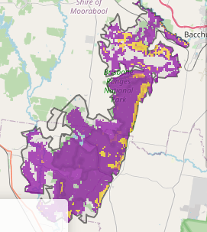
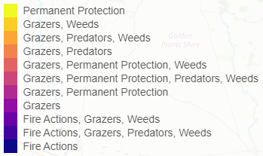
The map shows where the most cost-effective threat control actions in this landscape are. Actions in these areas will maximise biodiversity benefit across Victoria for multiple species.
The very best threat control actions to do in the Top 3% of cost-effective areas are: goats, permanent protection, pigs, and rabbits.
When we bring in the Top 10%, we also add the activities: overabundant kangaroos, weeds, deer, grazing pressure (all grazers), domestic grazing, fox, cat, and ecological burning.
Area available for highly cost-effective revegetation
86ha

For a further in depth look into SMP for this landscape please refer to NatureKit.

Priority Areas Map – Range - East
Base layers: This data is from SMP and represents the best areas to carry out the most cost-effective actions for specific threats (also referred to as the Top 10% of Mean Cost-effectiveness (MCE) actions), and the Top 20% locations (these locations have been given names and are referred to as descriptors)
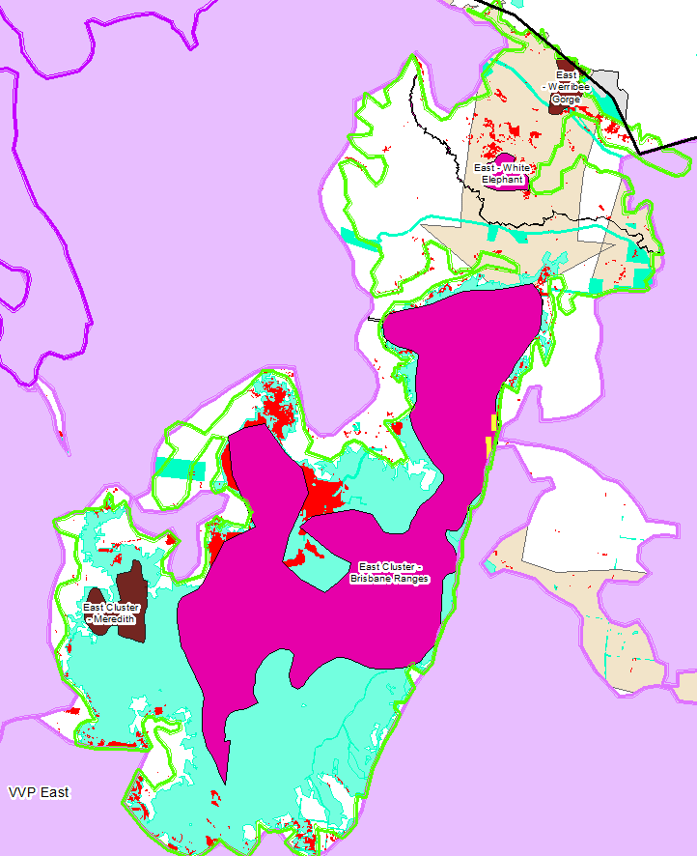
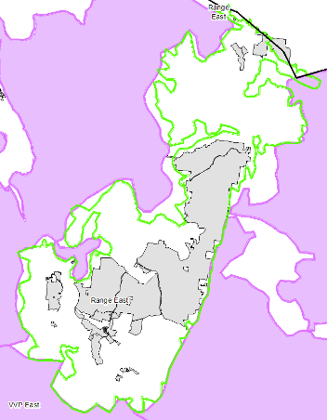
Priority Areas: Wadawurrung Priority Areas, stakeholder’s Landscapes of Interest (LoI), endangered Ecological Vegetation Classes (EVCs), National Parks & Reserves
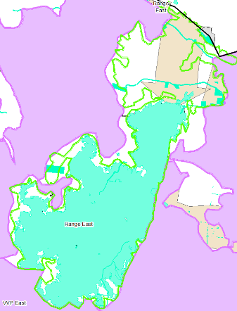
National Parks & Res (grey)

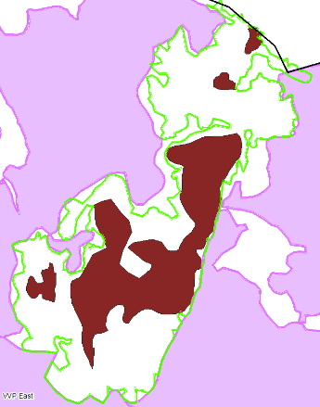
Stakeholder’s LoI (fawn & aqua)

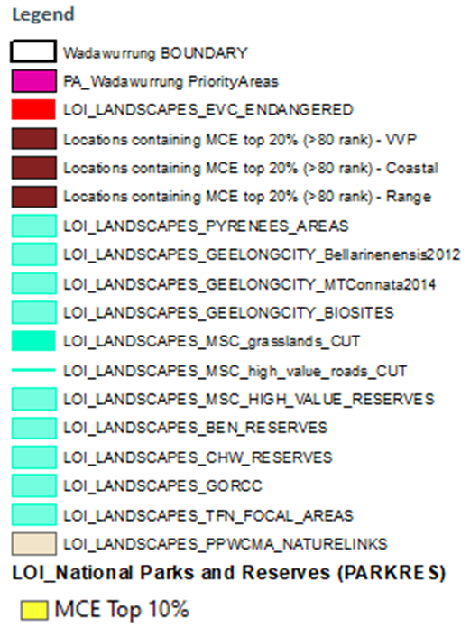

Descriptors (brown)
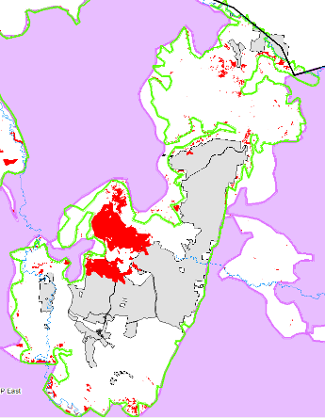

Endangered EVCs (red)
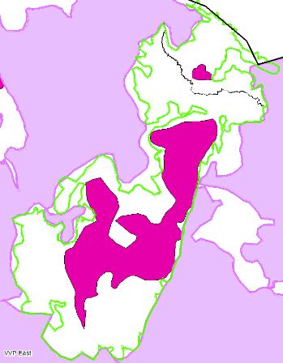

Wadawurrung initial Priority Areas (pink)

