Introduction
Biodiversity Response Planning (BRP) is a long-term area-based planning approach to biodiversity conservation in Victoria. It is designed to strengthen alignment, engagement and participation between government, Traditional Owners, non-government agencies and the community.
DELWP Regional staff have been working with stakeholders on actions to conserve biodiversity in specific landscapes, informed by the best available science and local knowledge.
These Fact Sheets capture a point in time, reflecting data and knowledge available in 2020. They provide information for many (but not all) landscapes across Victoria, containing general information on the key values and threats in each area, as well as the priority cost-effective actions that provide the best protection of biodiversity. Fact Sheets are intended to provide useful biodiversity information for the community, non-government and government organisations during project planning and development.
Further information and the full list of Fact Sheets is available on the Department’s Environment website.

Landscape description
The Kyneton Woodlands landscape is 14,694ha in size, with 36% of the area consisting of native vegetation. The vast majority of the area is private land, with 3% designated as public land.
This landscape has an overlap with the Dja Dja Wurrung Clans Aboriginal Corporation RSA landscape. For more information, please refer to this Fact Sheet in the full list of Fact Sheets.

Cultural importance
We recognise that the entire landscape has high cultural value for Traditional Owners. Landscapes identified as having “notable” cultural importance is based on the density of recorded cultural heritage sites and knowledge shared by Traditional Owners. We also recognise that there are locations important to Traditional Owners not within these landscapes.

Stakeholder interest
As part of the BRP process, in October 2020 stakeholders were asked to nominate focus landscapes and actions of interest. Macedon Ranges Shire Council, Central Victorian Biolinks, and Dja Dja Wurrung all nominated Kyneton Woodlands.
Possible future investment/project development in this landscape will be available to any interested stakeholders in addition to those who nominated this landscape.

0BEcological values identified by Traditional Owners, partners and community within this landscape
Revegetation of Djandak with:
- Buwatji (grasses used for grain)
- Witji (weaving grasses)
- Gatjawil Matorm (tuberous plants with scented flowers)
- Murnang (Yam Daisies) including Kangaroo grass, Lomandra and Dianella species, Chocolate Lily, Vanilla Lily, Bulbine Lily and Yam Daisy
White Box-Yellow Box-Blakely’s Red Gum Grassy Woodland, a nationally threatened ecological community
Wi (cultural fire) authorised and lead by Dja Dja Wurrung on Djandak (Country)

 | Habitat Distribution Models identify 0 species with more than 5% of their Victorian range in this landscape area | Traditional Owners, stakeholders and community groups identified the following species of interest within this landscape
 | Plants | - Matted Flax-lily  - Clover Glycine  - Castlemaine Spider Orchid
 | Mammals | - Brush-tailed Phascogale
 | Birds | - Painted Honeyeater  - Powerful Owl  - Barking Owl  - Brown Treecreeper  - Swift Parrot
 | Amphibians | - Growling Grass Frog  - Brown Toadlet

Traditional Owners, stakeholders and community groups identified the following threats within this landscape
Exclusion of Dja Dja Wurrung leadership (governance)
Lack of enquiry and understanding of Dja Dja Wurrung customs and practice to provide an enabling and supportive environment so that Djaara can reconnect to land and reconnect stories and knowledge to place. Ask “How?” not “Why?”
Degradation of vegetation from human use associated with residential development, weeds including gorse and pest animals including rabbits
Lack of listening, hearing and respect for Dja Dja Wurrung ability to talk to Country – not utilising Dja Dja Wurrung knowledge base tools and the bias toward western science decision support tools
Utilising past learnings and achievement to guide future effort – Dja Dja Wurrung participation in past and future biodiversity planning and delivery below the International Association of Public Participation (IAP2) level of ‘involve’ does not support Dja Dja Wurrung aspirations
Fuel reduction works on public and private land

Strategic Management Prospects
Strategic Management Prospects (SMP) models biodiversity values such as species habitat distribution, landscape-scale threats and highlights the most cost-effective actions for specific locations. More information about SMP is available in NatureKit.

Additional threats
Threats identified (in addition to those modelled in SMP) through the consultation process were:
- alterations to hydrology
- land salinisation
- soil erosion
- habitat degradation due to extremes of climate and weather
- lack of regeneration in some vegetation communities
- recreational activities causing fragmentation
- loss of vegetation, and erosion
- legacy use of public land
- private land use impacting biodiversity
- inappropriate land use planning
- inappropriate fire regimes (planned burning and bushfires)
Some individual threatened species may also require targeted intervention, beyond actions to manage landscape-scale threats, to improve their future prospects.

Which landscape-scale actions are most cost-effective in this landscape?
The coloured areas indicate where the identified landscape-scale actions and locations are most cost-effective and will maximise biodiversity benefit across Victoria for multiple species.
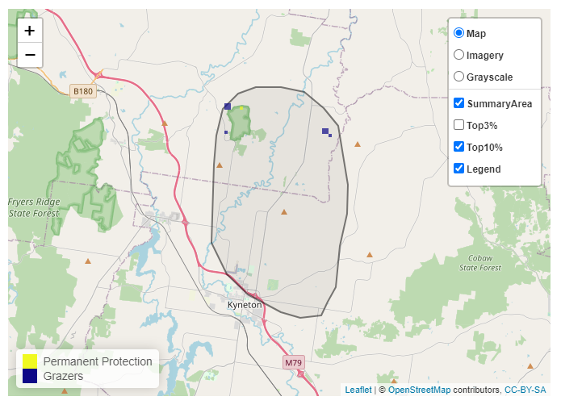
The SMP priority actions which rank among the top 10% for cost-effectiveness of that action across Victoria for much of the landscape are in order of the top 2 actions, see map and list below:
Control rabbits 51ha
Permanent protection 5ha

Of the top 10% of cost-effective actions, control rabbits provides the most cost-effective biodiversity benefits when considering all flora and fauna.
From the nomination process the following additional actions were also suggested for this landscape:
- domestic grazing control
- revegetation
- revegetation (habitat creation/recovery and connectivity restoration)
- cultural fire
- large old tree protection

The most cost-effective action for flora and fauna
Plants, mammals, reptiles, amphibians, birds - Control rabbits

For a further in depth look into SMP for this landscape please refer to NatureKit.

