Introduction
Biodiversity Response Planning (BRP) is a long-term area-based planning approach to biodiversity conservation in Victoria. It is designed to strengthen alignment, engagement and participation between government, Traditional Owners, non-government agencies and the community.
DELWP Regional staff have been working with stakeholders on actions to conserve biodiversity in specific landscapes, informed by the best available science and local knowledge.
These Fact Sheets capture a point in time, reflecting data and knowledge available in 2020. They provide information for many (but not all) landscapes across Victoria, containing general information on the key values and threats in each area, as well as the priority cost-effective actions that provide the best protection of biodiversity. Fact Sheets are intended to provide useful biodiversity information for the community, non-government and government organisations during project planning and development.
Further information and the full list of Fact Sheets is available on the Department’s Environment website.

Landscape description
The Daylesford - Wombat landscape spans 120,812ha and includes significant native vegetation cover of 66%. Significant parcels of public land making up 63% includes the Wombat State Forest and Lerderderg State Park. Refer to the map at the end of this Fact Sheet.
This landscape has an overlap with the Dja Dja Wurrung Clans Aboriginal Corporation RSA landscape. For more information, please refer to this Fact Sheet in the full list of Fact Sheets.

Cultural importance
We recognise that the entire landscape has high cultural value for Traditional Owners. Landscapes identified as having “notable” cultural importance is based on the density of recorded cultural heritage sites and knowledge shared by Traditional Owners. We also recognise that there are locations important to Traditional Owners not within these landscapes.
Notable cultural importance for the Dja Dja Wurrung Clans Aboriginal Corporation is Mount Franklin and Hepburn Regional Park. Baramul (Emu) has a place across Djandak and the persecution and hunting of this Murrup from Djandak has resulted in many issues which continue to damage and degrade the landscape. These continue to impact on the lives and health of our communities and the environment. Many species rely on Baramul to spread their seed, fertilise their germination beds and create homes for them on Djandak. Lalgambook (Mt Franklin) is the Emu’s nest and makes the most sensible place to target efforts to return this spirit to its place on Djandak.

Stakeholder interest
As part of the BRP process, in October 2020 stakeholders were asked to nominate focus landscapes and actions of interest. Macedon Ranges Shire Council, Hepburn Shire Council, DELWP (Public Land), Coliban Water, Parks Victoria, Central Victorian Biolinks, and Dja Dja Wurrung all nominated Daylesford-Wombat.
Possible future investment/project development in this landscape will be available to any interested stakeholders in addition to those who nominated this landscape.

Ecological values identified by Traditional Owners, partners and community within this landscape
Revegetation of Djandak with:
- Buwatji (grasses used for grain)
- Witji (weaving grasses)
- Gatjawil Matorm (tuberous plants with scented flowers)
- Murnang (Yam Daisies) including Kangaroo grass, Lomandra and Dianella species, Chocolate Lily, Vanilla Lily, Bulbine Lily and Yam Daisy
Wi (cultural fire) authorised and lead by Dja Dja Wurrung on Djandak (Country)
The Pyrete Range covers an extensive area of relatively undisturbed old growth forest in steep and rugged terrain and it supports flora and fauna communities of State significance
Forest and woodland thinning in Dja Dja Wurrung Parks (Hepburn Regional Park)
Coliban River catchment, priority for water protection and provision of water benefit
Threatened Ecological Vegetation Classes: Heathy Woodland, Grassy Woodland, Scoria Cone Woodland, Plains Grassy Woodland, Swampy riparian woodlands

 | Habitat Distribution Models identify 26 species with more than 5% of their Victorian range in this landscape area | Traditional Owners, stakeholders and community groups identified the following species of interest within this Landscape
 | 26 Plants; notably:  - Lerderderg Scentbark (Eucalyptus aff. ignorabilis (Lerderderg)), endangered with 100% of its Victorian range in area  - Wombat Bush-pea (Pultenaea reflexifolia), rare with 74% of its Victorian range in area  - Hairy-leaf Triggerplant (Stylidium armeria subsp. pilosifolium), endangered with 48% of its Victorian range in area | - Wombat Bossia  - Wombat Bush-pea  - Wiry Bossiaea  - Dwarf Silver-wattle  - Creeping Grevillea  - Basalt Peppercress  - Brittle Greenhood  - Brooker's Gum
 | Mammals | - Gal Gal (Dingo) at Gal Gal Gundith – approximately in southeast of Recognition and Settlement Agreement (RSA) area which is more heavily populated  - Baramul (Emu) is Lalgambook (Mount Franklin, Hepburn Regional Park)  - Brush-tailed phascogale  - Greater Glider  - Spot-tailed Quoll
 | Birds | - Swift Parrot  - Great Egret  - Powerful Owl  - Masked Owl  - Spotted Quail-thrush
 | Amphibians | - Growling Grass Frog  - Brown Toadlet
Other: | Platypus
Traditional Owners, stakeholders and community groups identified the following threats within this landscape
Exclusion of Dja Dja Wurrung leadership (governance)
Lack of enquiry and understanding of Dja Dja Wurrung customs and practice to provide an enabling and supportive environment so that Djaara can reconnect to land and reconnect stories and knowledge to place. Ask “How?” not “Why?”
Drought
Land use pressure
Pest animals including deer and goats.
Illegal rubbish dumping
Lack of listening, hearing and respect for Dja Dja Wurrung ability to talk to Country – not utilising Dja Dja Wurrung knowledge base tools and the bias toward western science decision support tools.
Utilising past learnings and achievement to guide future effort – Dja Dja Wurrung participation in past and future biodiversity planning and delivery below the International Association of Public Participation (IAP2) level of ‘involve’ does not support Dja Dja Wurrung aspirations
Weeds
Degradation of existing vegetation from human use associated with residential development
Fuel reduction works on public and private land
Trail and mountain bike tracks in public reserves

Strategic Management Prospects
Strategic Management Prospects (SMP) models biodiversity values such as species habitat distribution, landscape-scale threats and highlights the most cost-effective actions for specific locations. More information about SMP is available in NatureKit.

Additional threats
Threats identified (in addition to those modelled in SMP) through the consultation process were:
- alterations to hydrology
- land salinisation
- soil erosion
- habitat degradation due to extremes of climate and weather
- lack of regeneration in some vegetation classes
- recreational activities causing fragmentation
- loss of vegetation, and erosion
- legacy use of public land
- private land use impacting biodiversity
- inappropriate land use planning
- inappropriate fire regimes (planned burning and bushfires).
Some individual threatened species may also require targeted intervention, beyond actions to manage landscape-scale threats, to improve their future prospects.

Which landscape-scale actions are most cost-effective in this landscape?
The coloured areas indicate where the identified landscape-scale actions and locations are most cost-effective and will maximise biodiversity benefit across Victoria for multiple species.
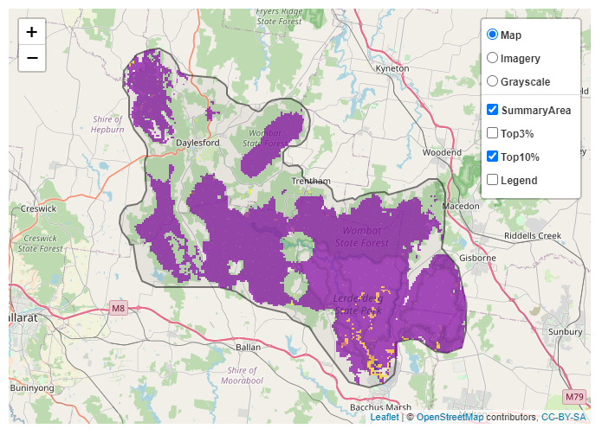
The SMP priority actions which rank among the top 10% for cost-effectiveness of that action across Victoria for much of the landscape are in order of the top 3 actions, see map and list below:
 | Control pigs 65,478ha
 | Control goats 18,655ha
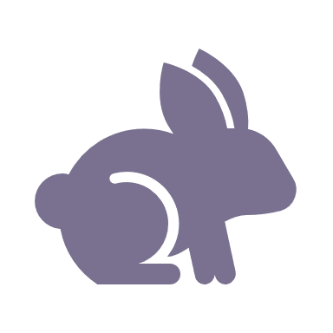 | Control rabbits 5,599ha
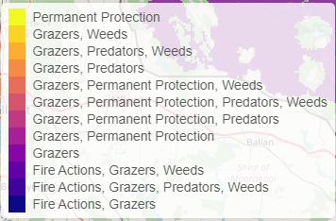
Of the top 10% of cost-effective actions, controlling pigs provides the most cost-effective biodiversity benefits when considering all flora and fauna.
From the nomination process the following additional actions were also suggested for this landscape:
- permanent protection
- managing water extraction
- fire management, weed control
- deer control, fox control
- management of recreational activities and public access
- revegetation
- cultural fire
- large old tree protection

The most cost-effective action for flora and fauna
Plants - Control goats
Mammals, reptiles, amphibians, birds - Control pigs

For a further in depth look into SMP for this landscape please refer to NatureKit.

