Introduction
Biodiversity Response Planning (BRP) is a long-term area-based planning approach to biodiversity conservation in Victoria. It is designed to strengthen alignment, engagement and participation between government, Traditional Owners, non-government agencies and the community.
DELWP Regional staff have been working with stakeholders on actions to conserve biodiversity in specific landscapes, informed by the best available science and local knowledge.
These Fact Sheets capture a point in time, reflecting data and knowledge available in 2020. They provide information for many (but not all) landscapes across Victoria, containing general information on the key values and threats in each area, as well as the priority cost-effective actions that provide the best protection of biodiversity. Fact Sheets are intended to provide useful biodiversity information for the community, non-government and government organisations during project planning and development.
Further information and the full list of Fact Sheets is available on the Department’s Environment website.

Landscape description
This 5,177ha area is situated to the west of Sunbury, and north of Melton. The western boundary of the landscape is along Djerriwarrh Creek. The landscape has 55% native vegetation, and 14% public land.
This landscape has a partial overlap with the much larger Daylesford - Wombat landscape. For more information, please refer to the Daylesford - Wombat Fact Sheet in the full list of Fact Sheets.

Cultural importance
We recognise that the entire landscape has high cultural value for Traditional Owners. Some landscapes have notable cultural importance based on knowledge shared by Traditional Owners.

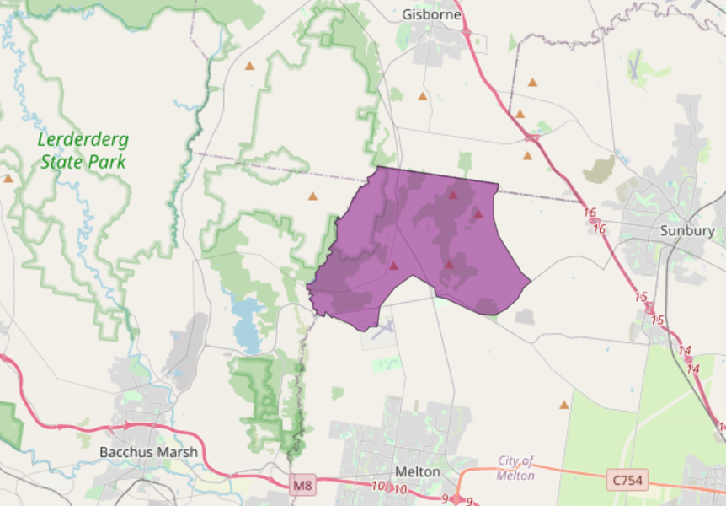
This landscape includes lands of the Wurundjeri people.

Figure 1: Map showing location of Toolern Vale landscape (purple).

Habitat Distribution Models identify 0 species with more than 5% of their Victorian range in this landscape
- 0 Plant species with more than 5% of their Victorian range in this landscape
- Notable species: Brittle Greenhood (endangered, 3.7% statewide range in area), Golden Bush-pea (rare, 3.7% statewide range in area), Bacchus Marsh Wattle (vulnerable, 2.6% statewide range in area), Brisbane Range Grevillea (rare, 2.6% statewide range in area)
- 0 Mammal species with more than 5% of their Victorian range in this landscape
- Notable species: Brush-tailed Phascogale (vulnerable, 0.13% statewide range in area), Koala (0.07% statewide range in area), Common Dunnart (vulnerable, 0.06% statewide range in area)
- 0 Reptile species with more than 5% of their Victorian range in this landscape
- Notable species: Grassland Earless Dragon (critically endangered, 0.93% statewide range in area), Grass skink FORM (P.pag/cry) (0.25% statewide range in area), Cunningham’s Skink (0.21% statewide range in area), Tussock Skink (vulnerable, 0.13% statewide range in area), Little Whip Snake (0.11% statewide range in area)
- 0 Bird species with more than 5% of their Victorian range in this landscape
- Notable species: Speckled Warbler (vulnerable, 0.18% statewide range in area), Black-chinned Honeyeater (0.16% statewide range in area), Chestnut-rumped Heathwren (vulnerable, 0.14% statewide range in area), Diamond Firetail (near threatened, 0.14% statewide range in area), Black-eared Cuckoo (near threatened, 0.12% statewide range in area)
- 0 species of amphibians with more than 5% of their Victorian range in this landscape
- Notable species: Brown Toadlet (endangered, 0.11% statewide range in area), Verreaux’s Tree Frog (0.11% statewide range in area), Pobblebonk Frog (Limnodynastes dumerilii variegatus, 0.10% statewide range in area),

Strategic Management Prospects
Strategic Management Prospects (SMP) models biodiversity values such as species habitat distribution, landscape-scale threats and highlights the most cost-effective actions for specific locations. More information about SMP is available in NatureKit.
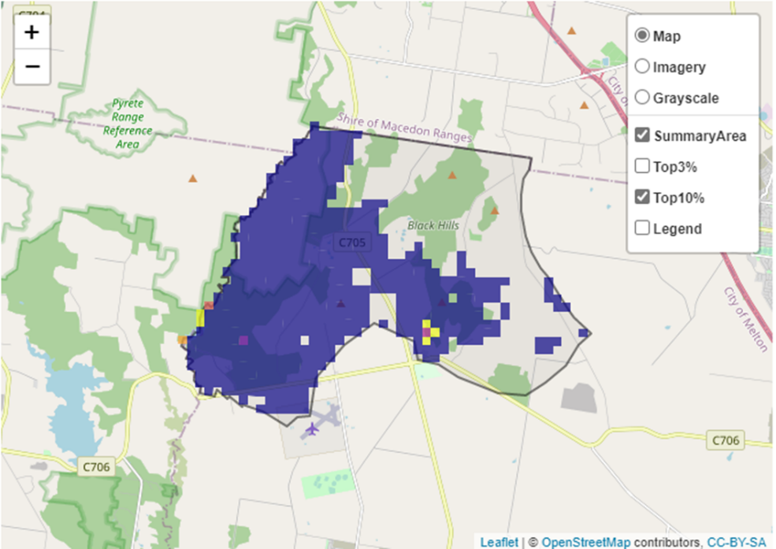
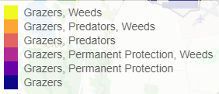
Areas of Toolern Vale shown in Figure 2 have highly cost-effective actions (within the top 10% of cost-effectiveness for that action across the state) that provide significant benefit for biodiversity conservation.
Figure 2: The SMP priority actions which rank among the top 10% for cost-effectiveness of that action across the state. “Grazers” includes deer, domestic grazing, goats, horses, over-abundant kangaroos, pigs, rabbits and total grazing pressure

Actions with area in the top 3% and top 10%
Specific Action | Area in top 3% | Area in top 10%
Control Goats | 385 | 2,234
Control Rabbits | 0 | 1,550
Control Pigs | 0 | 942
Revegetation | 0 | 65
Permanent Protection | 0 | 20
Domestic Grazing Control | 0 | 15
Control All Grazers | 0 | 15
Control Weeds | 0 | 11
Control Foxes | 0 | 5
Control Cats | 0 | 5
Control Deer | 0 | 2

The most cost-effective action for flora & fauna
Plants, Birds, Mammals, and Reptiles – Control goats
Amphibians – Control rabbits

For a further in depth look into SMP for this landscape, please refer to NatureKit.

Current actions in Toolern Vale
Specific Actions | Current actions – top 10% (ha) | Current actions – outside top 10% (ha)
Control Rabbits | 305 | 22
Permanent Protection | 15 | 313
Domestic Grazing Control | 10 | 318
Weed Control | 10 | 318
Control Pigs | 0 | 328
Fox Control | 0 | 328

Current actions – top 10% = The area (ha) of the specific action currently occurring in locations identified by SMP as being in the top 10% for cost-effectiveness for that action across the state
Current actions – outside top 10% = The area (ha) of the specific action currently occurring in locations within this landscape that are not identified by SMP as being in the top 10% for cost-effectiveness for that action across the state

What you told us
SMP is just one tool to use in the process of defining priority landscapes. Feedback from our stakeholders is also vitally important and forms the basis of our understanding of knowledge gaps.

Stakeholder interest

Current activities/programs/partnerships
- Living Melbourne – Our Metropolitan Urban Forest
- Port Phillip and Westernport CMA Regional Catchment Strategy – Naturelinks – Werribee River Biolinks Action Plan Werribee River
- Trust for Nature land covenanting program

Additional threats
No additional threats (beyond those modelled in SMP) were identified through the consultation process.

