Introduction
Biodiversity Response Planning (BRP) is a long-term area-based planning approach to biodiversity conservation in Victoria. It is designed to strengthen alignment, engagement and participation between government, Traditional Owners, non-government agencies and the community.
DELWP Regional staff have been working with stakeholders on actions to conserve biodiversity in specific landscapes, informed by the best available science and local knowledge.
These Fact Sheets capture a point in time, reflecting data and knowledge available in 2020. They provide information for many (but not all) landscapes across Victoria, containing general information on the key values and threats in each area, as well as the priority cost-effective actions that provide the best protection of biodiversity. Fact Sheets are intended to provide useful biodiversity information for the community, non-government and government organisations during project planning and development.
Further information and the full list of Fact Sheets is available on the Department’s Environment website.

Landscape description
This 88,788ha area covers the Yarra Valley region north east of Melbourne, stretching from the eastern slopes of Mount Dandenong and outer north eastern suburbs, extending in the east out to the valleys around Warburton and Powelltown. The northern boundary of the landscape is the Yarra River, between Warrandyte and Healesville. In the south, the landscape extends to the townships of Emerald, Cockatoo and Gembrook. There are some significant areas of public land, including Yellingbo and Warramate Hills Nature Conservation Reserves and the Dandenong Ranges National Park, as well as Silvan Reservoir. The landscape has 44% native vegetation, and 13% public land.

Cultural importance
We recognise that the entire landscape has high cultural value for Traditional Owners. Some landscapes have notable cultural importance based on knowledge shared by Traditional Owners.
The former Coranderrk Aboriginal reserve is situated in the Upper Yarra Valley landscape.
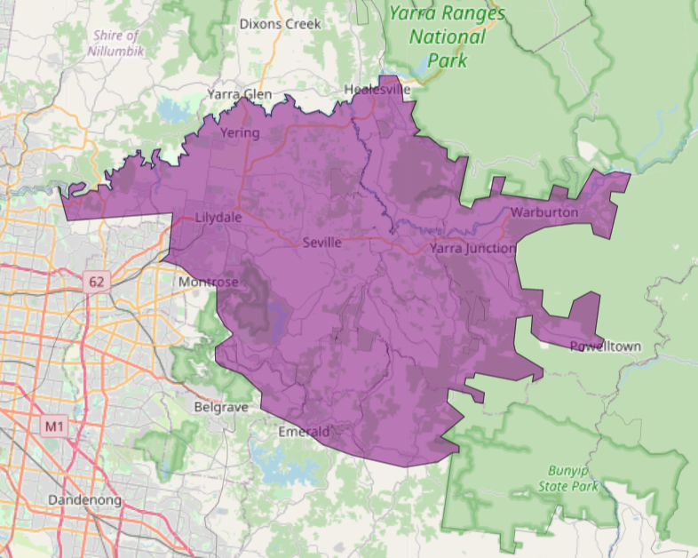
This landscape includes lands of the Wurundjeri people and the Bunurong people.
Figure 1: Map showing location of the Upper Yarra Valley landscape (purple).

Habitat Distribution Models identify 35 species with more than 5% of their Victorian range in this landscape | Traditional Owners, stakeholders and community groups identified the following species of interest
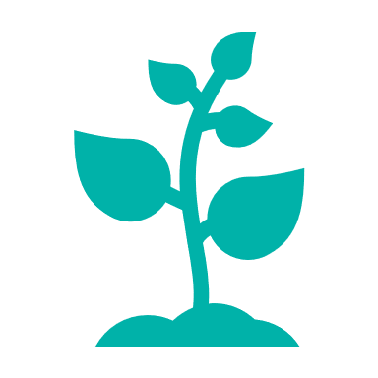  - 34 Plant species  - 15 species with more than 10% of statewide range in area  - Notable species: White Star-bush (endangered, 49% of statewide range in area), Upper Yarra Swamp-gum (endangered, 41% of statewide range in area), Kilsyth South Spider-orchid (endangered, 30% of statewide range in area) | - Endangered species incl: Pomaderris vacciniifolia  - Numerous Victorian Rare or Threatened species incl. Caladenia oenochila, Cardamine papillata, Chiloglottis x pescottiana  - Hairpin Banksia  - Slender Tree-fern, Oval Fork-fern
- 0 Mammal species with more than 5% of their Victorian range in this landscape  - Notable species: Grey-headed Flying-fox (vulnerable, 2.5% of statewide range in area), Eastern Broad-nosed Bat (2.1% of statewide range in area), Eastern Horseshoe Bat (vulnerable, 2.1% of statewide range in area) | - Phascogale  - Platypus  - Lowland Leadbeater’s Possum  - Southern Myotis  - Long-nosed Bandicoot  - Yellow-bellied Glider
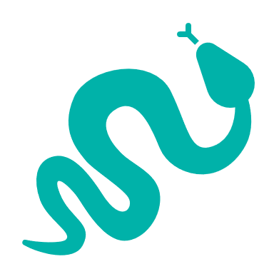  - 0 Reptile species with more than 5% of their Victorian range in this landscape  - Notable species: Metallic Skink (3.4% of statewide range in area), Swamp Skink (vulnerable, 2.2% of statewide range in area) | - Lace Monitor
- 1 Bird species  - 1 species with more than 10% of statewide range in area  - Notable species: Helmeted Honeyeater (critically endangered, 75% statewide range in area) | - Powerful Owl  - Barking Owl  - Swift Parrot  - Helmeted Honeyeater  - Grey Goshawk
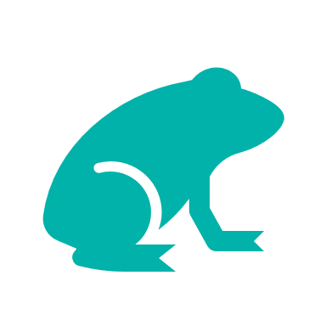
- 0 species of amphibians with more than 5% of their Victorian range in this landscape
- Notable species: Haswell’s Froglet (2.4% statewide range in area), Southern Toadlet (vulnerable, 2.3% statewide range in area)
Other species | - Macquarie Perch  - Native Crayfish  - Australian Grayling  - Pouched Lamprey  - Large Ant-blue Butterfly

Strategic Management Prospects
Strategic Management Prospects (SMP) models biodiversity values such as species habitat distribution, landscape-scale threats and highlights the most cost-effective actions for specific locations. More information about SMP is available in NatureKit.
Areas of Upper Yarra Valley shown in Figure 2 have highly cost-effective actions (within the top 10% of cost-effectiveness for that action across the state) that provide significant benefit for biodiversity conservation.
Figure 2: The SMP priority actions which rank among the top 10% for cost-effectiveness of that action across the state. “Grazers” includes deer, domestic grazing, goats, horses, over-abundant kangaroos, pigs, rabbits and total grazing pressure

Actions with area in the top 3% and top 10%
Specific Action | Area in top 3% (ha) | Area in top 10% (ha)
Control Weeds | 5,677 | 20,309
Control Foxes | 4,849 | 16,752
Control Rabbits | 3,373 | 10,815
Control Overabundant Kangaroos | 1,905 | 10,488
Control Cats | 3,005 | 6,278
Control Deer | 300 | 4,594
Revegetation | n/a | 1,768
Control Domestic Grazing | 367 | 1,676
Permanent Protection | 273 | 1,503
Control Goats | 340 | 658
Total Grazing Pressure | 45 | 377
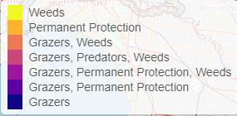
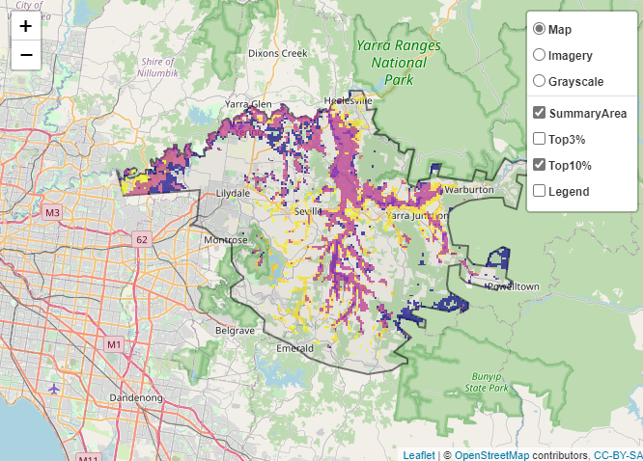

The most cost-effective actions for flora & fauna
Plants – Control weeds
Birds – Control foxes
Mammals, Amphibians and Reptiles – Combined cat and fox control
For a further in depth look into SMP for this landscape, please refer to NatureKit.

Current actions in Upper Yarra Valley
Specific Actions | Current actions – top 10% (ha) | Current actions – outside top 10% (ha)
Rabbit Control | 183 | 435
Weed Control | 49 | 361
Fox Control | 25 | 120
Permanent Protection | 2 | 72
Control Domestic Grazing |  | 117

Current actions – top 10% = The area (ha) of the specific action currently occurring in locations identified by SMP as being in the top 10% for cost-effectiveness for that action across the state
Current actions – outside top 10% = The area (ha) of the specific action currently occurring in locations within this landscape that are not identified by SMP as being in the top 10% for cost-effectiveness for that action across the state

What you told us
SMP is just one tool to use in the process of understanding biodiversity values. Feedback from our stakeholders is also vitally important and forms the basis of our understanding of knowledge gaps.

Stakeholder interest

Important landscapes
- Yellingbo Conservation Area and associated large blocks of public land and streamsides surrounds
- Warrandyte State Park
- Haining Farm
- The Yarra River and smaller creeks
- Anderson Creek
- Woori Yallock Creek
- Olinda Creek
- Coranderrk Nature Conservation Reserve

Additional important communities
- Sedge-rich Eucalytus camphora Swamp

Current activities/programs/partnerships
- Port Phillip and Westernport CMA Regional Catchment Strategy – Naturelinks – Yarra4Life
- Yellingbo Conservation Area Community Reference Group
- Faunal Emblems Program – Helmeted Honeyeater and Leadbeater’s Possum
- Ecological burning and fauna monitoring
- Metropolitan Open Space Strategy
- Central Highlands Eden Program
- Living Melbourne – Our Metropolitan Urban Forest
- Parks Victoria – Native Vegetation Improvement project – deer focus
- Biodiversity Response Planning project 099 – Birds to butterfields – habitat corridor improvements
- Trust for Nature covenanting program
- Eastern Region Pest Animal Strategy
- Various Friends of groups, Landcare groups and other community groups focusing on biodiversity conservation

Additional threats
Threats identified through the consultation process (in addition to those modelled in SMP):
- Inappropriate fire regimes
- Illegal firewood collection and other illegal activities
- Unauthorised 4WD and mountain bike riding
- Peri-urban pressures – garden escapes
- Livestock in waterways
- Dog walking
- Climate change
- Stormwater runoff
- Altered flood regime
- Lack of connectivity
- Willows, blackberry, tree tobacco

