Introduction
Biodiversity Response Planning (BRP) is a long-term area-based planning approach to biodiversity conservation in Victoria. It is designed to strengthen alignment, engagement and participation between government, Traditional Owners, non-government agencies and the community.
DELWP Regional staff have been working with stakeholders on actions to conserve biodiversity in specific landscapes, informed by the best available science and local knowledge.
These Fact Sheets capture a point in time, reflecting data and knowledge available in 2020. They provide information for many (but not all) landscapes across Victoria, containing general information on the key values and threats in each area, as well as the priority cost-effective actions that provide the best protection of biodiversity. Fact Sheets are intended to provide useful biodiversity information for the community, non-government and government organisations during project planning and development.
Further information and the full list of Fact Sheets is available on the Department’s Environment website.

Landscape description
The Western District Lakes Ramsar Wetlands focus landscape is 243,628ha in size with only 28% native vegetation cover remaining. Public land makes up 19% of the area. There are several wetlands within the landscape, nine of which comprise the Ramsar site¹.
The Western District Lakes Ramsar Wetlands focus landscape is within the landlocked Lake Corangamite catchment. Current ecological modelling shows the landscape occurs largely within the Victorian Volcanic Plain Bioregion with a small southern section located within the Warrnambool Plain Bioregion. The landscape has over 15,100ha of threatened Ecological Vegetation Classes (EVC) with fragmented areas of endangered Plains Grassland, Plains Grassy Woodland, Plains Grassy Wetland and Plains Sedgy Wetland EVCs occurring throughout the landscape. The Victorian Biodiversity Atlas has records of 28 federally protected species, 59 state protected species and 105 rare or threatened species on the Victorian Advisory List occurring within the landscape.
The Eastern Maar Aboriginal Corporation are Traditional Custodians of this focus landscape, with current stakeholders including Barwon Water, Birdlife Australia, Colac Otway Shire Council, Corangamite Catchment Management Authority, Corangamite Shire Council, Greening Australia, Lismore Land Protection Group, Parks Victoria, Rural Roads Victoria, Trust for Nature, Upper Barwon Landcare Network and Wannon Water.

Cultural importance
In Meerreengeeye Ngakeepoorryeeyt², the Western District Lakes Ramsar Wetlands focus landscape occurs largely in Lava Flow Country. It acknowledges the richness of the land for its resources and the importance of the volcanos as beacons and meeting places for First Nations people. The importance of the waterways and lakes is also acknowledged in Meerreengeeye Ngakeepoorryeeyt as places where the spirits of the dead would reside².

Stakeholder interest
There are numerous valuable ecological assets present in this focus landscape, including those identified by Traditional Owners, partners and community.

0BEcological Values identified by Traditional Owners, partners and community within this focus landscape
Western District Lakes Ramsar sites: Lake Beeac, Lake Bookar, Lake Colongulac, Lake Corangamite, Lake Cundare, Lake Gnarpurt, Lake Milangil, Lake Murdeduke and Lake Terangpom | Nationally Important Wetlands and other wetlands including Lake Round, Kooraweera Lakes Wildlife Reserve, Lake Colac, Lough Calvert, Lake Martin, Cundare Pool, Tooliorook Lake, Lake Kariah, Lake Koreetnung, Lake Purrumbete, Lake Weeranganuk, Lake Gnotuk, Lake Bullen Merri, Lake Rosine
Grasslands of the Victorian Volcanic Plains including high conservation roadsides | Cressy Flora Reserve
Woady Yaloak River | Dreeite Nature Conservation Reserve
Mt Elephant, Mt Warrion, Mt Sugarloaf and Mt Leura

Habitat Distribution Models identify 100 species with more than 5% of their modelled Victorian range in this focus landscape | Threatened terrestrial species within this focus landscape requiring specific actions other than those identified in Strategic Management Prospects (SMP)
70 plants, notably:  - Spiny Peppercress (Endangered)  - Salt-lake Tussock-grass (Vulnerable)  - Wind-blown Tussock-grass (Endangered) | Corangamite Water Skink
1 mammal
- Fat-tailed Dunnart (Near threatened)
3 reptiles, notably:
- Corangamite Water Skink (Critically endangered)
- Tussock Skink (Vulnerable)
26 birds, notably:
- Freckled Duck (Endangered)
- Curlew Sandpiper (Endangered)
- Brolga (Vulnerable)

Strategic Management Prospects
Strategic Management Prospects (SMP) models biodiversity values such as species habitat distribution, landscape-scale threats and highlights the most cost-effectiveness action for specific locations. For a further in depth look into SMP for this landscape please refer to NatureKit.

Which landscape-scale actions are most cost-effective in this landscape?
The coloured areas in the map below indicate where the identified landscape-scale actions are most cost-effective and will maximise biodiversity benefit across Victoria for multiple species.

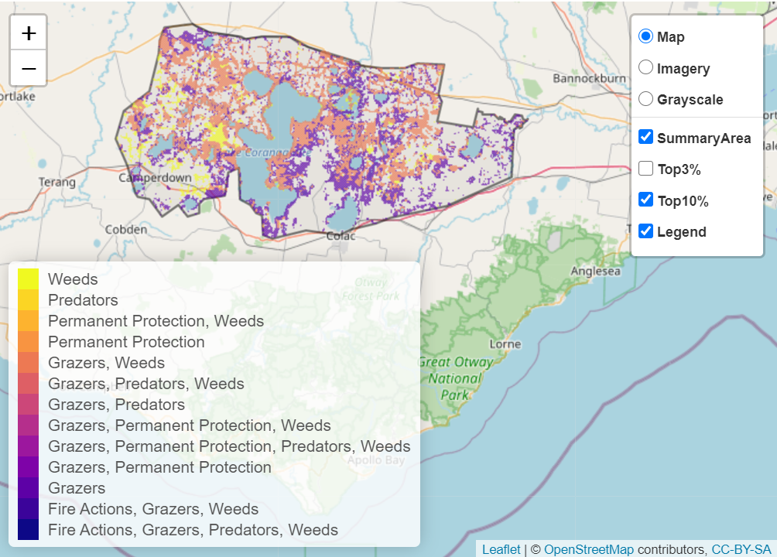
The main SMP priority actions within this focus landscape which rank among the top 10% for cost-effectiveness are listed on the right:
Control Rabbits 99,810ha
Control Weeds 58,092ha
Control Domestic Stock Grazing 33,095ha
Control Pigs 802ha

Within this landscape, rabbit control, weed control, pig control and permanent protection (30ha) were also identified among the top 3% for cost-effectiveness.

Additional threats and considerations
Threats and considerations (in addition to those modelled in SMP) identified by Traditional Owners, partners and community groups during the BRP process for this focus landscape were:
Threats | Ecological processes and values requiring further considerations
Climate change | Wetland hydrology
Stock access to riparian and wetland areas | Ground water dependent ecosystems
Altered hydrology | Aquatic/riparian species and catchment influences
Rock crushing and rock removal | Indicator species and ecosystem engineers

References
- Hale, J. and Butcher, R., 2011. Ecological Character Description for the Western District Lakes Ramsar site. Report to the Department of Sustainability, Environment, Water, Population and Communities, Canberra.
- Eastern Maar Aboriginal Corporation, 2015. Meerreengeeye Ngakeepoorryeeyt, Eastern Maar Country Plan

