|  |
| --- |
| Mapping in ActivityKit |
| **Accurate representation of projects and activities** |

**When mapping projects and activities it is important to draw the shapes consistent with what is delivered**

*ActivityKit* is available for viewing at <https://activitykit.biodiversity.vic.gov.au>

The *ActivityKit* administrators recommend you use Google Chrome to access the Registration site and ActivityKit as results can be unexpected on other browsers.

To add or edit a feature in ActivityKit you must be signed in.

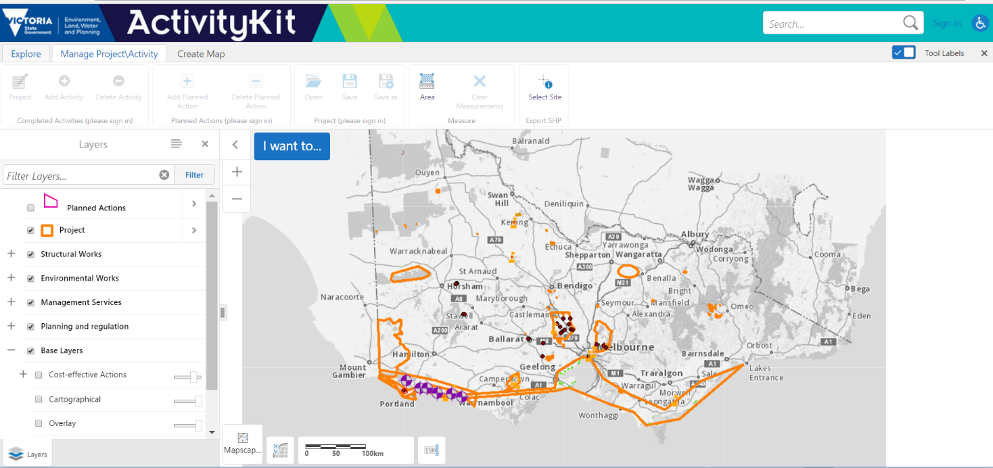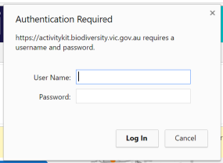Sign in to ActivityKit by clicking the ‘Sign in’ hyperlink located next to the search field at the top right of the screen. Enter your user name and password into the ‘Authentication required’ pop-up box

From the task bar located under the ActivityKit banner click the Project/Activity tab to start adding a project.

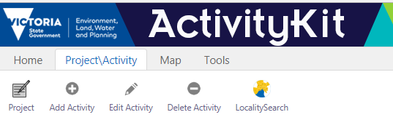

## When mapping your project, you may have one of these scenarios:

## Scenario 1*.* A project may be delivered at one location and may have one or many activities delivered under it. Your project area should be mapped to include those areas where activities are being or will be carried out. The activity areas should accurately reflect where the activities are delivered. It is important that you have activities mapped for your project area.

The picture below illustrates three outputs resulting from activities delivered bounded by a project area.

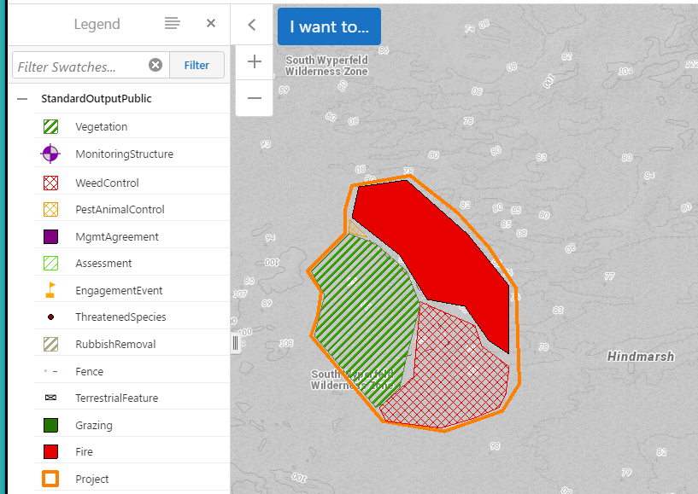

**Scenario 2.** A project may be delivered at more than one location and may have one or many activities delivered under it. Multiple project areas should be mapped separately if the activites delivered are located some distance apart. The picture below illustrates a project is being delivered in three different locations and four types of activites delivered. For every location click Project/Activity then Project / Add New/ draw polygon /Add and Enter Project Information. Project ID and Project Information is the same for all locations.

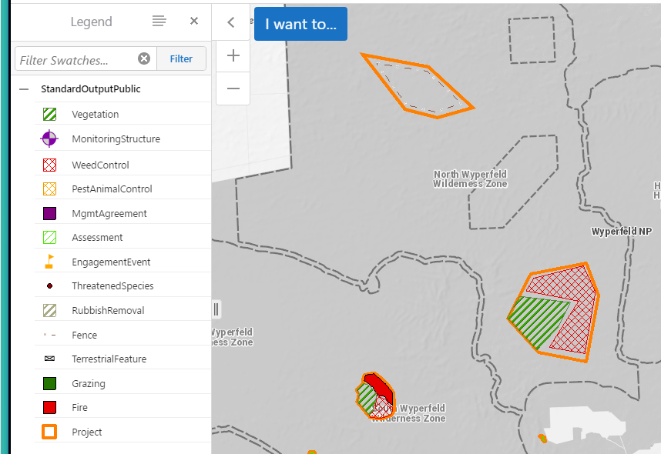

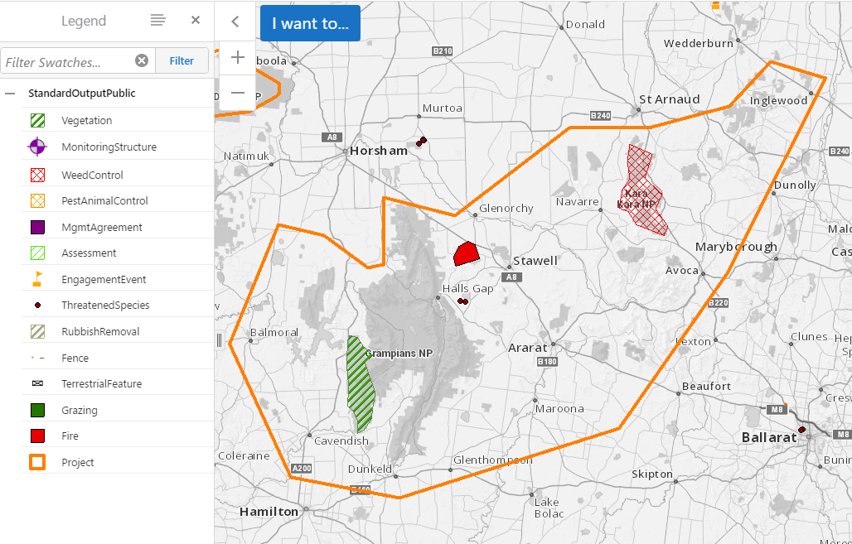Avoid mapping a large project area around activities that are delivered a large distance apart as shown in the illustration below.

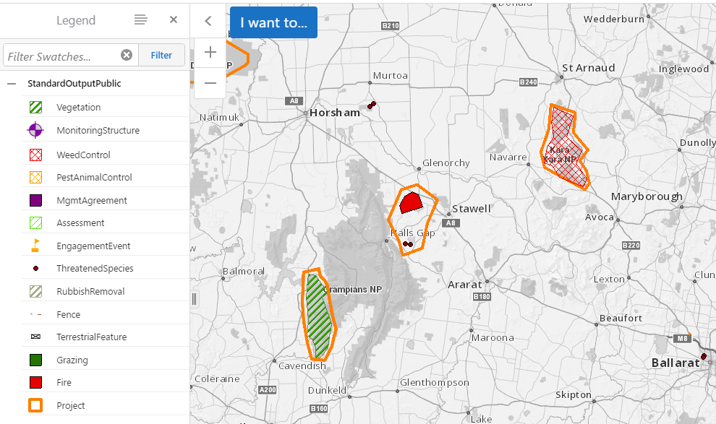Draw multiple project locations instead, using the same Project ID*.*

|  |  |
| --- | --- |
| © The State of Victoria Department of Environment, Land, Water and Planning 2019  LogoThis work is licensed under a Creative Commons Attribution 4.0 International licence. You are free to re-use the work under that licence, on the condition that you credit the State of Victoria as author. The licence does not apply to any images, photographs or branding, including the Victorian Coat of Arms, the Victorian Government logo and the Department of Environment, Land, Water and Planning (DELWP) logo. To view a copy of this licence, visit http://creativecommons.org/licenses/by/4.0/  Disclaimer  This publication may be of assistance to you, but the State of Victoria and its employees do not guarantee that the publication is without flaw of any kind or is wholly appropriate for your particular purposes and therefore disclaims all liability for any error, loss or other consequence which may arise from you relying on any information in this publication. | Accessibility  If you would like to receive this publication in an alternative format, please telephone the DELWP Customer Service Centre on 136186, email [customer.service@delwp.vic.gov.au](mailto:customer.service@delwp.vic.gov.au) or via the National Relay Service on 133 677 [www.relayservice.com.au](http://www.relayservice.com.au). This document is also available on the internet at [www.delwp.vic.gov.au](http://www.delwp.vic.gov.au). |