|  |
| --- |
| VBA - Species Distribution Map |
| How to generate and export a species distribution map using the Victorian Biodiversity Atlas |

### After conducting an area or species search the VBA enables you to generate a Geographic Distribution Map for up to 2 species at a time. Follow these steps to generate your own map.

## Tips

*Throughout the VBA each window has a* ***?*** *in the top right hand corner – this is window-specific help that will provide further details about how to complete the fields.*

*Make sure that you have allowed pop-ups from your browser (you will need to allow these from the VBA site)*

1. Visit VBA (https://vba.dse.vic.gov.au/vba/) and enter as a guest or via your Login Name & Password
2. Navigate to the Search section in the top left of the Welcome page and then select Species and Surveys > Species Lists & Maps

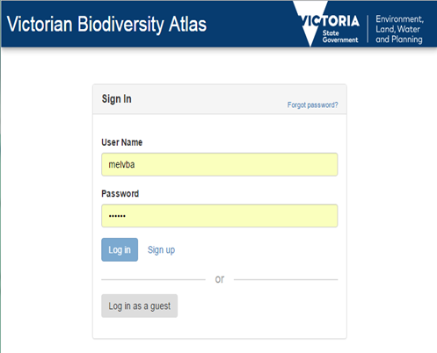

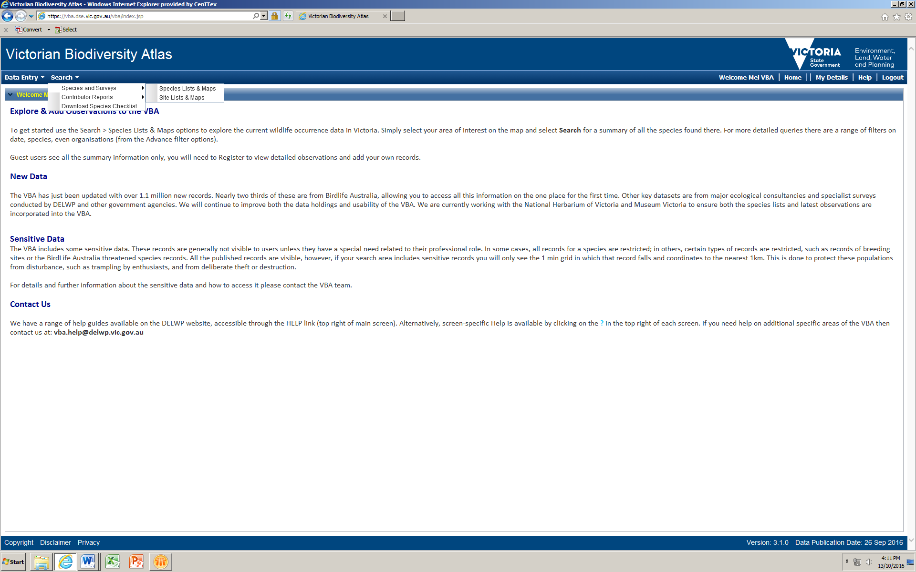

From here you have access to the spatial and non-spatial search elements to query the VBA database.

There are multiple ways you can select your search area. For further details about how to conduct a search, refer to the help guide: *Search - Summary species list for an area*.

Once you’ve conducted your search and obtained a list of species, follow the steps below to generate the map:

1. Select the relevant 1 or 2 species from the list of species by clicking the tick box to the left of the species name.
2. Next click Geographic Distribution Map and a new map window will open displaying the statewide species distribution (as 10 minute grids).
3. Zoom in to your search area and you will be able to see the sites where your selected species has been recorded. *Note: you must be at a scale of 1:500k or better.*

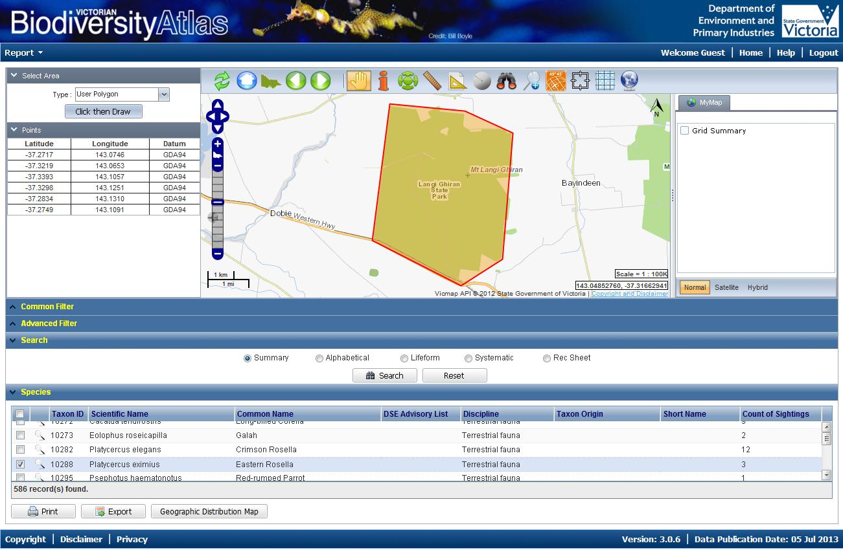

1. Depending on your preferences, you can turn on or off the grids showing the Sites or the grids (Geographic Distribution) in the MyMap section to the right of the map.
2. 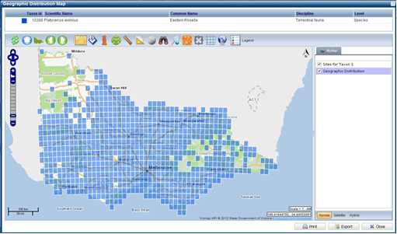You can now either Print or Export this map by using the buttons on the bottom right hand side of the screen

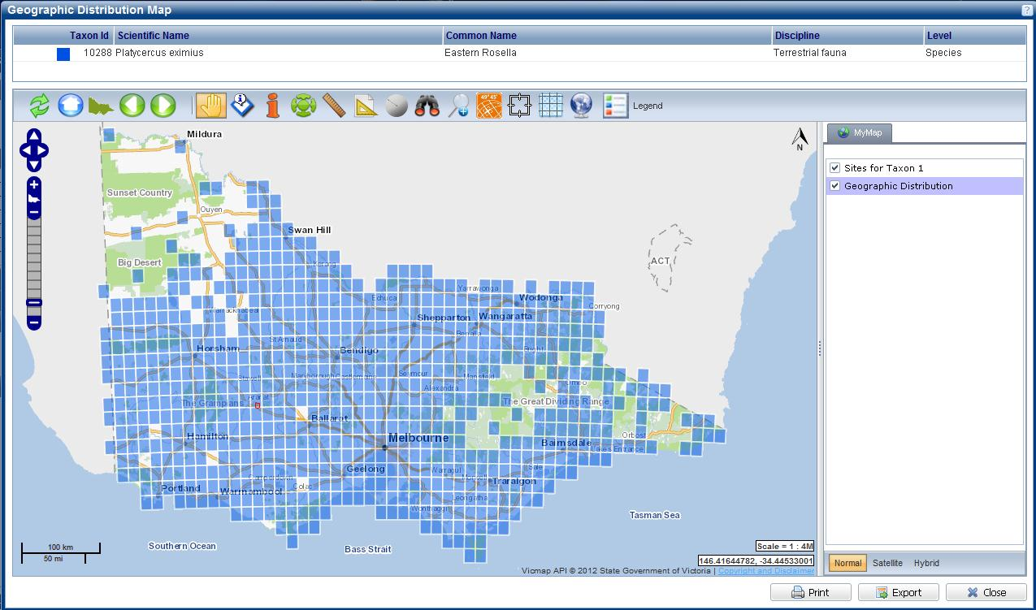

|  |  |
| --- | --- |
| © The State of Victoria Department of Environment, Land, Water and Planning 2017  LogoThis work is licensed under a Creative Commons Attribution 4.0 International licence. You are free to re-use the work under that licence, on the condition that you credit the State of Victoria as author. The licence does not apply to any images, photographs or branding, including the Victorian Coat of Arms, the Victorian Government logo and the Department of Environment, Land, Water and Planning (DELWP) logo. To view a copy of this licence, visit http://creativecommons.org/licenses/by/4.0/  Disclaimer  This publication may be of assistance to you but the State of Victoria and its employees do not guarantee that the publication is without flaw of any kind or is wholly appropriate for your particular purposes and therefore disclaims all liability for any error, loss or other consequence which may arise from you relying on any information in this publication. | Accessibility  If you would like to receive this publication in an alternative format, please telephone the DELWP Customer Service Centre on 136186, email [customer.service@delwp.vic.gov.au](mailto:customer.service@delwp.vic.gov.au) or via the National Relay Service on 133 677 [www.relayservice.com.au](http://www.relayservice.com.au). This document is also available on the internet at [www.delwp.vic.gov.au](http://www.delwp.vic.gov.au). |