|  |
| --- |
| VBA – Voucher Specimens |
| How to create a specimen record in the Victorian Biodiversity Atlas |

## If you have collected a specimen when undertaking a survey then you can note this as a specific record in the VBA. Follow the instructions in this guide for entering voucher specimen records.

## *Tips*

*Throughout the VBA each window has a* ***?*** *in the top right hand corner – this is window-specific help that will provide further details about how to complete the fields.*

*Make sure that you have allowed pop-ups from your browser (you will need to allow these from the VBA site)*

*Also, throughout the VBA fields marked with a red dot (●) are mandatory fields and must be completed. The fields marked with a yellow dot (●) are conditional - if you complete one you must complete the others.*

1. Create your Project then create your Survey. Once you have completed the Main tab fields (Discipline, Site location details, Survey name, Survey date and Contributors) click Save. Then select the Survey Method and Results tab.
2. If this species record is collected primarily as a specimen and you have no other method to record, then choose Specimen from the Survey Method options. Otherwise, continue with the survey method you used to conduct your survey.

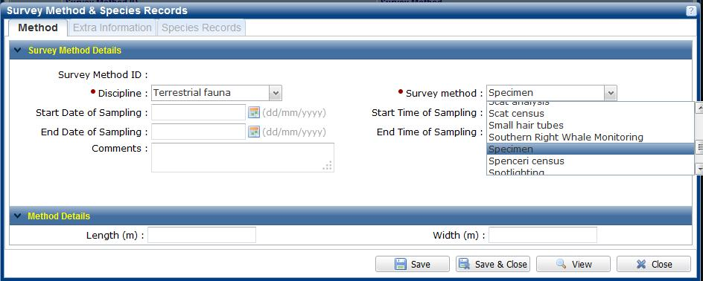

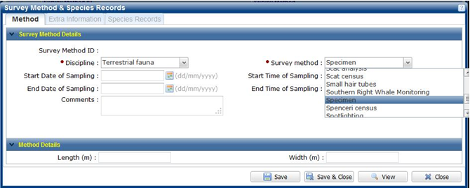

1. Next, select the Species Records tab and add each of your species records.
2. When entering the species record with the specimen, select the Observer and the species, then select the following:
   * Type of Record – Observation with supporting evidence
   * Extra Information – Voucher specimen
3. Click on the blue bar titled Individual Details to expand it and select the appropriate organisation from the drop-down list for Organisation Specimen Sent To and enter the specimen number assigned by that organisation in the field Organisation Specimen Reference Number – click Add (the information is now stored with other information about that species record) and click Save.

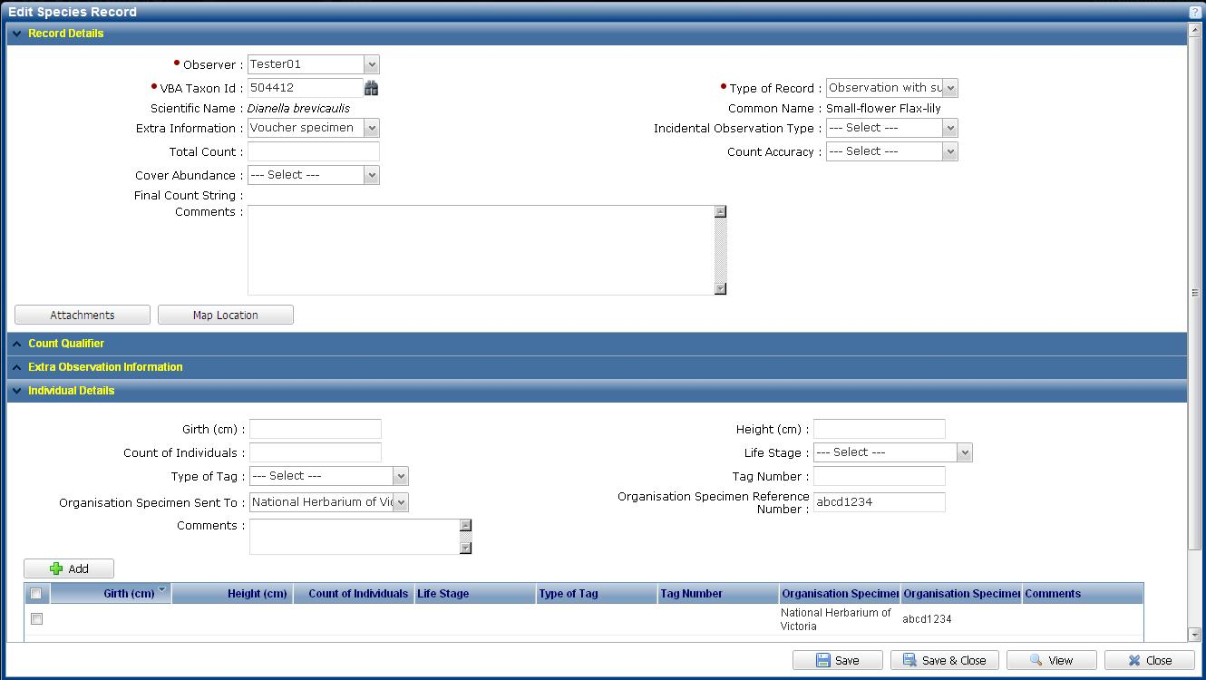

1. Continue entering the remainder of your species and when finished, don’t forget to validate your records by clicking Check Taxon Distribution and Submit for review.

|  |
| --- |
| **Related Quick Help Guides:**   * Contribute - Add a Survey and Species Records to a Project * Contribute - Add a Breeding Record * Search - Summary Species List for an Area * Search - Detailed Species List for an Area |

|  |  |
| --- | --- |
| © The State of Victoria Department of Environment, Land, Water and Planning 2016  LogoThis work is licensed under a Creative Commons Attribution 4.0 International licence. You are free to re-use the work under that licence, on the condition that you credit the State of Victoria as author. The licence does not apply to any images, photographs or branding, including the Victorian Coat of Arms, the Victorian Government logo and the Department of Environment, Land, Water and Planning (DELWP) logo. To view a copy of this licence, visit http://creativecommons.org/licenses/by/4.0/  Disclaimer  This publication may be of assistance to you but the State of Victoria and its employees do not guarantee that the publication is without flaw of any kind or is wholly appropriate for your particular purposes and therefore disclaims all liability for any error, loss or other consequence which may arise from you relying on any information in this publication. | Accessibility  If you would like to receive this publication in an alternative format, please telephone the DELWP Customer Service Centre on 136186, email [customer.service@delwp.vic.gov.au](mailto:customer.service@delwp.vic.gov.au) or via the National Relay Service on 133 677 [www.relayservice.com.au](http://www.relayservice.com.au). This document is also available on the internet at [www.delwp.vic.gov.au](http://www.delwp.vic.gov.au). |