# Sustainability Fund Priority Statement 2024

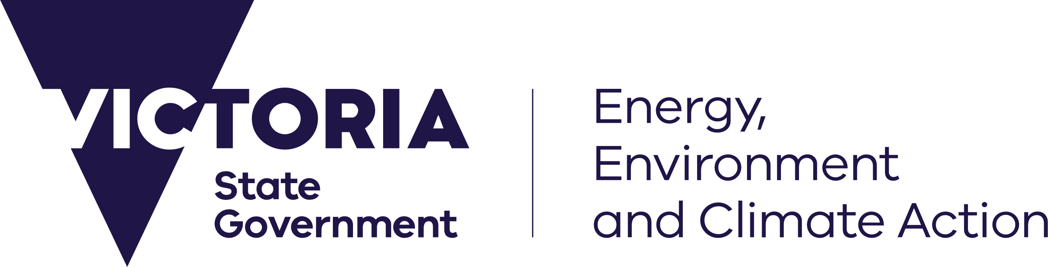



### A healthy environment provides the foundation for our social and economic well-being now and into the future

We need to work together to make sure our environment remains healthy and can support the prosperity of Victorian families now, and into the future. To do this we must minimise our impact on the environment by generating less waste and recovering valuable resources from the waste we do generate. We must prepare for and adapt to the impacts of climate change and reduce the amount of greenhouse gases we emit into our atmosphere.

We all have a role to play in keeping our environment healthy: government, business, communities and individuals. Every time we reduce, reuse or recycle we are generating less waste and reducing greenhouse gases associated with production and landfill.

### The Victorian waste levies and the Sustainability Fund – what will we invest in?

Victoria’s waste levy system has helped us lower our impact on the environment, influenced industry investment in resource recovery infrastructure and encouraged people to find alternative, more innovative ways to dispose of their waste than landfill. The money generated from landfill levies provides funds that support Victorian communities and businesses to reduce negative impacts of waste on the environment and respond to the future impacts of climate change through innovation and stimulating viable industries, creating jobs for Victorians.

The revenue generated from the Municipal and Industrial Waste Levy is allocated by ministerial determination to fund some of our important government environmental agencies such as the Environment Protection Authority, Sustainability Victoria and Recycling Victoria. The remaining funds provide revenue into the Sustainability Fund. The Sustainability Fund Committee provides advice to government on all budget bids seeking funds from the Sustainability Fund.

The Sustainability Fund is set up in legislation to ensure that Victoria is lowering our impact on the environment through reducing impacts from waste, limiting our greenhouse gas emissions, helping our communities and natural environments adapt to climate change and building a more sustainable future. In accordance with the legislation, the Sustainability Fund Priority Statement identifies the strategic priorities the government will direct investment towards.

### The strategic priorities for the Sustainability Fund are as follows, with preference given to initiatives that foster employment, new technology and innovation, resource efficiency and ongoing behaviour change.

| Sustainability Fund’s legislated purpose | |
| --- | --- |
| **Fostering environmentally sustainable uses of resources and best practices in waste management to advance the social and economic development of Victoria** | **Fostering community action or innovation in relation to the reduction of greenhouse gas substance emissions [mitigation] or adaptation or adjustment to climate change in Victoria** |
| **Strategic priorities:**   * making alternatives to landfill more viable and cost competitive through the stimulation, creation and expansion of viable markets for recycled and recovered materials; * facilitating a network of best practice waste and resource recovery infrastructure which minimises public health and environmental impacts and maximises resource recovery opportunities; * providing equity in access to, and reducing impacts of, waste and resource recovery services on communities; * improving waste education and waste management capability to reduce waste generation, recover resources, and prevent littering and illegal dumping; and * modernising the management of legacy contamination or pollution.   Investment will be guided by Victorian government policies, including Victoria’s circular economy policy *Recycling Victoria: a new economy*, recycling infrastructure plans, and other relevant strategies. | **Strategic priorities:**   * supporting individuals, communities and industry to transition to a low carbon economy; * supporting Victorians to adapt to the impacts of climate change, particularly those most vulnerable and least able to do so; * building Victorian communities’ capacity, capability and skills in responding to climate change; and * assisting Victoria's ecosystems and native species to be more resilient to climate change and/or support mitigation outcomes.   Investment will be guided by Victorian government legislation, strategies and policies that contribute to Victoria’s climate action objectives, including the Climate Change Act 2017, Victoria’s Climate Change Strategy, emissions reduction targets and pledges, adaptation priorities and adaptation plans, Energy Efficiency and Productivity Statement, Renewable Energy Action Plan, biodiversity plan and other relevant strategies. |

“Sustainability Fund” means the fund established and maintained by the Department of Energy, Environment and Climate Action under section 449 of the Environment Protection Act 2017.

**Hon JACINTA ALLAN MP STEVE DIMOPOULOS MP**

**Premier Minister for Environment**