“We acknowledge the Wadawurrung people of the Kulin Nation as the Original Custodians of the lands which represents the following information. We pay respects to Elders past, present and emerging leaders that continue their obligations to care for Country. We care for Country, Culture and Wadawurrung people”.

Range - West

Introduction
Biodiversity Response Planning (BRP) is a long-term area-based planning approach to biodiversity conservation in Victoria. It is designed to strengthen alignment, engagement and participation between government, the Original Custodians, non-government agencies and the community.
DELWP Regional staff with Wadawurrung Traditional Owners Aboriginal Corporation have been working with stakeholders on actions to conserve biodiversity in specific landscapes, informed by the best available science and local knowledge.
These Fact Sheets capture a point in time, reflecting data and knowledge available in 2020. They provide information for many (but not all) landscapes across Victoria, containing general information on the key values and threats in each area, as well as the priority cost-effective actions that provide the best protection of biodiversity. Fact Sheets are intended to provide useful biodiversity information for the community, non-government and government organisations during project planning and development.
Further information and the full list of Fact Sheets is available on the Department’s Environment website.
This Fact Sheet includes the information from the Strategic Management Prospects (SMP) Output Summary for the Bay zone and the feedback from our stakeholders.

Landscape description
The West Range area is 27,915ha. The native vegetation cover is 54% and the public land cover is 26%.
It is one of three undulating ranges that branch off from the Great Dividing Range in Wadawurrung Country. The predominant bioregion that covers these three ranges is the Central Victorian Uplands. The base of the range is surrounded by the Victorian Volcanic Plains bioregion.
The significant waterway in this zone is the Trawalla Creek. There are also many tributaries and two reservoirs: Musical Gully and Troys.
Areas with the highest biodiversity values are on public land are to the north and south of Beaufort. Several waterways create important linkages between the high biodiversity value areas.

Cultural importance
Wadawurrung Country holds many values culturally and ecologically throughout the diverse landscape. Mountain country, grassland country, sea and coastal country provides for many flora and fauna species to inhabit the landscapes. Resources were aplenty and managed sustainably by the Wadawurrung. Due to previous land activities such as mining, land fragmentation and the introduction of pest species, the landscapes require good partnerships between Wadawurrung Original Custodians and land managers to reinvigorate Country. Wadawurrung land management practices will be supported and guided by the aspirations of the Wadawurrung Healthy Country Plan.

Landscapes of interest added through feedback process
Trust for Nature – Victorian Midlands (Chute, Waterloo, Raglan, Main Lead and Beaufort).
Central Highlands Water – Musical Gully Reservoir and Troys Reservoir.

Ecological Vegetation Classes (primary EVCs)
Endangered: Creekline Grassy Woodland, Alluvial Terraces Herb-rich Woodland, Grassy Woodland/Heathy Dry Forest Complex.

Ecological Vegetation Classes (secondary EVCs)
Environment Protection and Biodiversity Conservation Act: Natural Temperate Grasslands of the Victorian Volcanic Plains, Grassy Eucalypt Woodland of Victorian Volcanic Plains, Seasonal Herbaceous Wetlands (Freshwater) of the Temperate Lowland Plains ecological community.
Flora and Fauna Guarantee Act: Western Plains Grasslands Community.

Habitat Distribution Models identify 2 species with more than 5% of their Victorian range in this landscape area (updated 26/07/2020) | The following have been identified as focal species by the Original Custodians and stakeholders
2 plants with more than 5% of Victoria range in area  - Ben Major Grevillea (vulnerable, 52%), Mount Cole Grevillea (rare, 28%) | 27 plants: Snow Gums, Kangaroo Grass, Hedge Wattle, Sheep’s Burr, Black Wattle, Swamp Gum, Running Postman, Golden Wattle, Pink Bindweed, Common Spike-sedge, Pale Rush, Small Loosestrife, Narrow-leaf Cumbungi, Cranberry Heath, Silver Banksia, River Bottlebrush, Water Ribbons, Kidney-weed, Weeping Grass, Common Reed, Blackwood, River Red-gum, Prickly Tea-tree, Slender Dock, Silver Wattle, Cherry Ballart, Austral Crane’s-bill, Tall Bluebell

Strategic Management Prospects
Strategic Management Prospects (SMP) models biodiversity values such as species habitat distribution, landscape-scale threats and highlights the most cost-effective actions for specific locations. More information about SMP is available in NatureKit.

Additional threats
Threats identified (in addition to those modelled in SMP) through the consultation process were illegal tracks, littering, barriers to on-ground management, inappropriate land use, water quality and quantity, native vegetation removal, urban encroachment, wildfire, Phytophthora cinnamomi, Armillaria, fire timing, bypass impacts (light increase and water run-off) and firewood collection.

Which landscape-scale actions are most cost-effective in this landscape?
The map shows where the most cost-effective threat control actions in this landscape are. Actions in these areas will maximise biodiversity benefit across Victoria for multiple species.
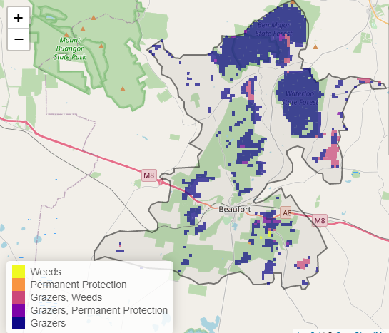

The very best threat control action to do in the Top 3% of cost-effective areas is: permanent protection.
When we bring in the Top 10%, we also add the activities: pigs, rabbits, overabundant kangaroos, deer, weeds, and domestic grazing control.

For a further in depth look into SMP for this landscape please refer to NatureKit.

Priority Areas Map – Range - West
Base layers: This data is from SMP and represents the best areas to carry out the most cost-effective actions for specific threats (also referred to as the Top 10% of Mean Cost-effectiveness (MCE) actions), and the Top 20% locations (these locations have been given names and are referred to as descriptors)
Priority Areas: Wadawurrung Priority Areas, stakeholder’s Landscapes of Interest (LoI), endangered Ecological Vegetation Classes (EVCs), National Parks & Reserves
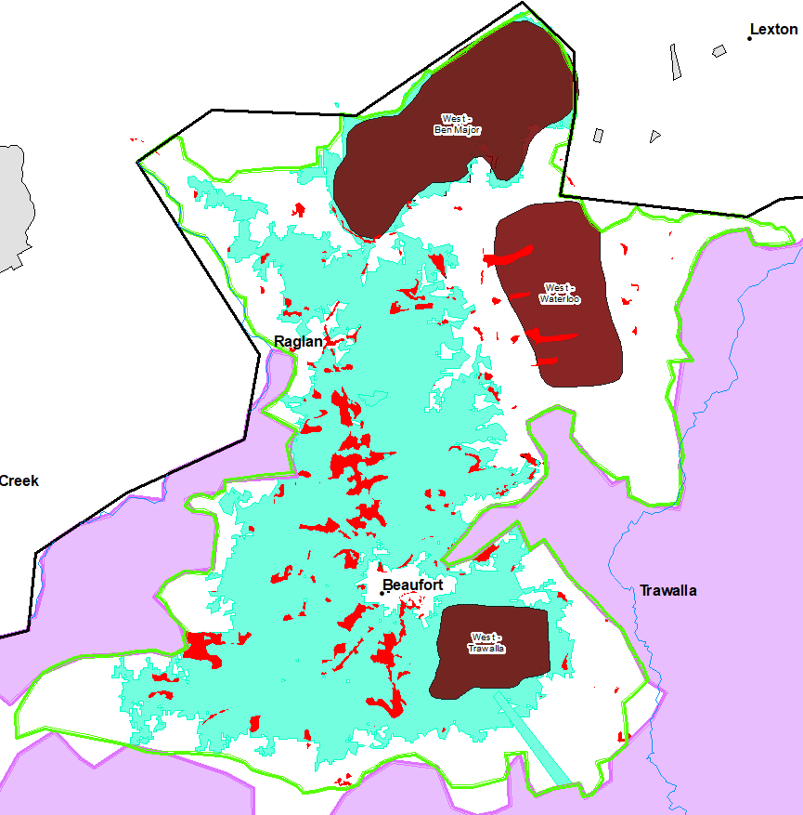
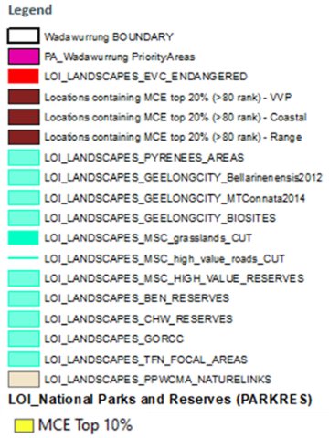
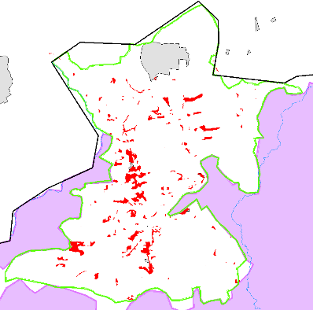
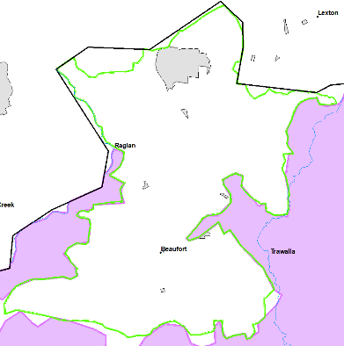
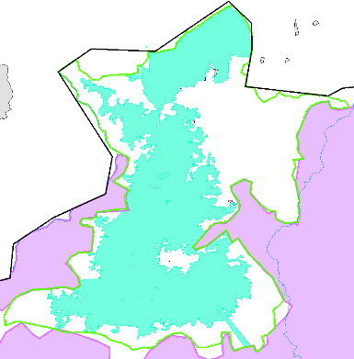
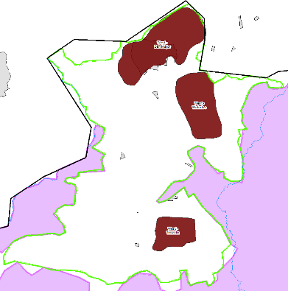
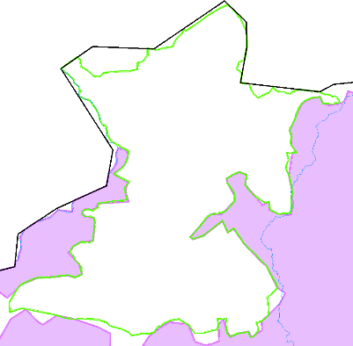
5
4
1
2
3
1/ National Parks & Reserves (grey); 2/ Stakeholder’s LoI (aqua); 3/ Descriptors (brown); 4/ Endangered EVCs (red); 5/ Wadawurrung initial Priority Areas (pink)

