Introduction
Biodiversity Response Planning (BRP) is a long-term area-based planning approach to biodiversity conservation in Victoria. It is designed to strengthen alignment, engagement and participation between government, Traditional Owners, non-government agencies and the community.
DELWP Regional staff have been working with stakeholders on actions to conserve biodiversity in specific landscapes, informed by the best available science and local knowledge.
These Fact Sheets capture a point in time, reflecting data and knowledge available in 2020. They provide information for many (but not all) landscapes across Victoria, containing general information on the key values and threats in each area, as well as the priority cost-effective actions that provide the best protection of biodiversity. Fact Sheets are intended to provide useful biodiversity information for the community, non-government and government organisations during project planning and development.
Further information and the full list of Fact Sheets is available on the Department’s Environment website.

Landscape description
The Patho Plains area is 117,179ha, with 23% of the area covered in native vegetation. Public land makes up 6% of the area which includes several parcels of Terrick Terrick National Park. Refer to the map at the end of this Fact Sheet.
This landscape has an overlap with the Dja Dja Wurrung Clans Aboriginal Corporation RSA landscape. For more information, please refer to this Fact Sheet in the full list of Fact Sheets.

Cultural importance
We recognise that the entire landscape has high cultural value for Traditional Owners. Landscapes identified as having “notable” cultural importance is based on the density of recorded cultural heritage sites and knowledge shared by Traditional Owners. We also recognise that there are locations important to Traditional Owners not within these landscapes.
This landscape has been identified as a landscape of key value for the Yorta Yorta Nations Aboriginal Corporation.

Stakeholder interest
As part of the BRP process, in October 2020 stakeholders were asked to nominate focus landscapes and actions of interest. Campaspe Shire Council, Loddon Plains Landcare Network, Northern Plains Conservation Management Network, Trust for Nature, North Central Catchment Management Authority, Coliban Water, Agriculture Victoria (North Central Irrigation Program), Parks Victoria, Central Victorian Biolinks, Barapa Country Aboriginal Corporation and Dja Dja Wurrung all nominated Patho Plains.
Possible future investment/project development in this landscape will be available to any interested stakeholders in addition to those who nominated this landscape.

0BEcological values identified by Traditional Owners, partners and community within this landscape
Revegetation of Djandak with:
- Buwatji (grasses used for grain)
- Witji (weaving grasses)
- Gatjawil Matorm (tuberous plants with scented flowers)
- Murnang (Yam Daisies) including Kangaroo grass, Lomandra and Dianella species, Chocolate Lily, Vanilla Lily, Bulbine Lily and Yam Daisy
The Patho Plains is one component of the Northern Plains Grasslands, which are part of the ‘Natural Grasslands of the Murray Valley Plain’ ecological community, listed as critically endangered under the Environment Protection and Biodiversity Conservation Act 1999 (EPBC)
Significant Woodland bird community
Wi (cultural fire) authorised and lead by Dja Dja Wurrung on Djandak (Country)
On Victoria’s Northern Plains, approximately 95% of native grasslands have been lost. Few remnant grasslands remaining, particularly on private land
White Cypress Pine community in the woodlands of the Terrick Terrick National Park

 | Habitat Distribution Models identify 24 species with more than 5% of their Victorian range in this landscape area | Traditional Owners, stakeholders and community groups identified the following species of interest within this landscape
 | 22 Plants, notably:  - Soft Sunray (Leucochrysum molle), vulnerable with 25% of Victorian range in area  - Annual Buttons (Leptorhynchos orientalis), endangered with 21% of Victorian range in area  - Turnip Copperburr (Sclerolaena napiformis), endangered with 11% of Victorian range in area | - Spiny Rice-flower  - Turnip Copperburr  - Slender Darling Pea  - Red Swainson Pea
 | Mammals | - Fat-tailed Dunnart
 | 1 Reptile:  - Curl Snake, with 5% of its Victorian range in area | - Hooded Scaly-foot
 | 1 Bird:  - Plains-wanderer, critically endangered with 20% of its Victorian range in area | - Plains-wanderer

Traditional Owners, stakeholders and community groups identified the following threats within this landscape
Exclusion of Dja Dja Wurrung leadership (governance)
Lack of enquiry and understanding of Dja Dja Wurrung customs and practice that provide an enabling and supportive environment so that Djaara can reconnect to land and reconnect stories and knowledge to place. Ask “How?” not “Why?”
Cultivation of remnant grasslands
Lack of biomass management – undergrazing
Weed control (for example, African Boxthorn, Gazania)
Lack of awareness on the value and importance of grasslands
Lack of listening, hearing and respect for Dja Dja Wurrung ability to talk to Country – bias toward western science-based decision support tools and not Dja Dja Wurrung knowledge-based tools
Utilising past learnings and achievement to guide future effort – Dja Dja Wurrung participation in past and future biodiversity planning and delivery below the IAP2 level of ‘involve’ does not support Dja Dja Wurrung aspirations
Lack of compliance of non-permitted clearing of grasslands
Overgrazing (lack of biomass present)
Owners of grassland being older and losing all the knowledge of the grasslands and how best to manage them

Strategic Management Prospects
Strategic Management Prospects (SMP) models biodiversity values such as species habitat distribution, landscape-scale threats and highlights the most cost-effective actions for specific locations. More information about SMP is available in NatureKit.

Identified Threats
Threats identified (in addition to those modelled in SMP) through the consultation process were:
- alterations to hydrology
- land salinisation
- soil erosion
- habitat degradation due to extremes of climate and weather, and lack of regeneration in some vegetation classes
- recreational activities causing fragmentation
- loss of vegetation, and erosion
- legacy use of public land
- private land use impacting biodiversity
- inappropriate land use planning
- inappropriate fire regimes (planned burning and bushfires)
Some individual threatened species may also require targeted intervention, beyond actions to manage landscape-scale threats, to improve their future prospects.

Which landscape-scale actions are most cost-effective in this landscape?
The coloured areas indicate where the identified landscape-scale actions and locations are most cost-effective and will maximise biodiversity benefit across Victoria for multiple species.
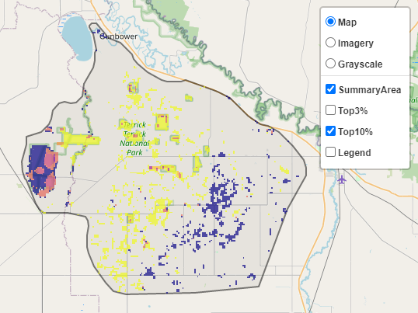
The SMP priority actions which rank among the top 10% for cost-effectiveness of that action across Victoria for much of the landscape are in order of the top 3 actions, see map and list below:
 | Control weeds 11,046ha
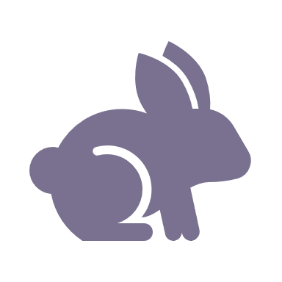 | Control rabbits 7,103ha
 | Control overabundant kangaroos 1,635ha
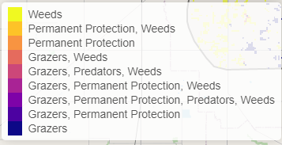

Of the top 10% of cost-effective actions, controlling weeds provides the most cost-effective biodiversity benefits when considering all flora and fauna.

From the nomination process the following additional actions were also suggested for this landscape:
- revegetation
- fox control
- permanent protection
- not permitting clearing of grasslands
- remnant protection
- action planning
- monitoring
- education
- enforcement
- cultivation
- appropriate management of recreational activities and public access
- biomass management
- maintaining optimal grassland habitat
- domestic grazing control
- cultural fire
- habitat creation/recovery and connectivity restoration

The most cost-effective action for flora and fauna
 | Plants - Control weeds
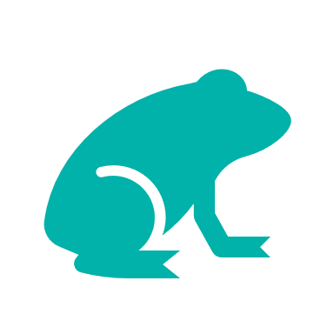 | Mammals, birds, amphibians, reptiles - Control rabbits

For a further in depth look into SMP for this landscape please refer to NatureKit.

