Introduction
Biodiversity Response Planning (BRP) is a long-term area-based planning approach to biodiversity conservation in Victoria. It is designed to strengthen alignment, engagement and participation between government, Traditional Owners, non-government agencies and the community.
DELWP Regional staff have been working with stakeholders on actions to conserve biodiversity in specific landscapes, informed by the best available science and local knowledge.
These Fact Sheets capture a point in time, reflecting data and knowledge available in 2020. They provide information for many (but not all) landscapes across Victoria, containing general information on the key values and threats in each area, as well as the priority cost-effective actions that provide the best protection of biodiversity. Fact Sheets are intended to provide useful biodiversity information for the community, non-government and government organisations during project planning and development.
Further information and the full list of Fact Sheets is available on the Department’s Environment website.

Landscape description
This 59,721ha area covers some of Melbourne’s outer northern suburbs, and extends into peri-urban and rural areas. The landscape has 59% native vegetation, and 4% public land.
Note: the landscape is bisected by the Maribyrnong Valley landscape. See the full list of Fact Sheets for information about that landscape.

Cultural importance
We recognise that the entire landscape has high cultural value for Traditional Owners. Some landscapes have notable cultural importance based on knowledge shared by Traditional Owners. This landscape includes lands of the Wurundjeri people.

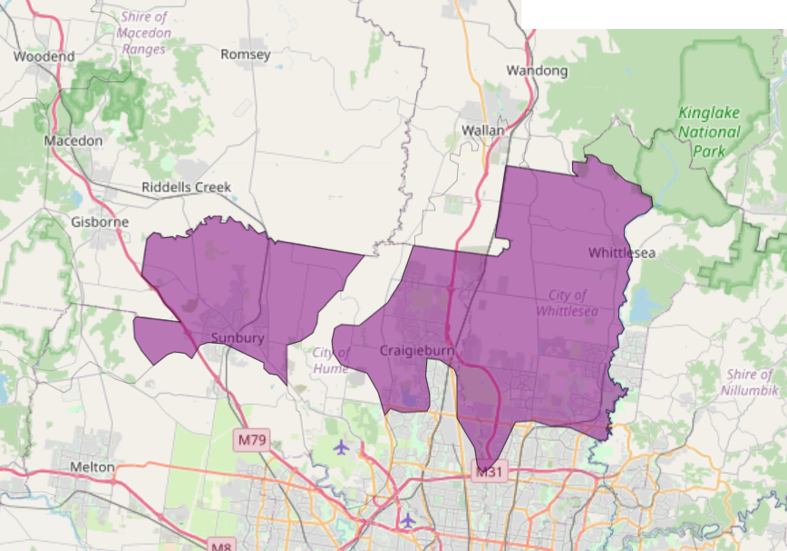
Figure 1: Map showing location of Central Grassy Woodlands Plain landscape (purple).

Habitat Distribution Models identify 9 species with more than 5% of their Victorian range in this landscape | Traditional Owners, stakeholders and community groups identified the following species of interest
- 7 Plant species  - 2 species with more than 10% of statewide range in area  - Notable species: Oval Wedge-fern (endangered, 67% statewide range in area), Small-flower Wood-sorrel (10% statewide range in area), Large-flower Crane’s-bill (endangered, 9.7% statewide range in area) | - Button Wrinklewort  - Spiny Rice Flower  - Sunshine Diuris  - Large-fruit Groundsel  - Matted Flax-lily  - Small Scurf-pea  - Curly Sedge  - Small Milkwort
- 45 Mammal species | - Fat-tailed Dunnart
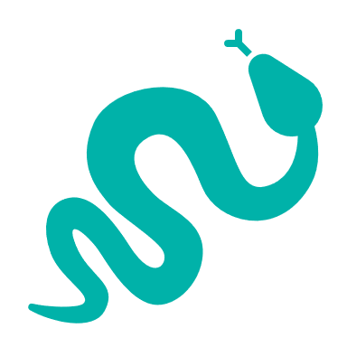  - 2 Reptile species  - 0 species with more than 10% of statewide range in area  - Notable species: Grass skink FORM (P.pag/cry) (6.0% statewide range in area), Grassland Earless Dragon (critically endangered, 5.9% statewide range in area) | - Striped Legless Lizard  - Grassland Earless Dragon
- 0 Bird species with more than 5% of statewide range in area
- Notable species: Purple-crowned Lorikeet (1.3% statewide range in area), Diamond Firetail (near threatened, 1.2% statewide range in area)
- 0 species of amphibians with more than 5% of statewide range in area  - Notable species: Pobblebonk Frog (Limnodynastes dumerilii variegatus, 1.7% statewide range in area), Growling Grass Frog (endangered, 1.1% statewide range in area), Brown Toadlet (endangered, 1.0% statewide range in area) | - Growling Grass Frog
Other species | - Golden Sun Moth

Strategic Management Prospects
Strategic Management Prospects (SMP) models biodiversity values such as species habitat distribution, landscape-scale threats and highlights the most cost-effective actions for specific locations. More information about SMP is available in NatureKit.
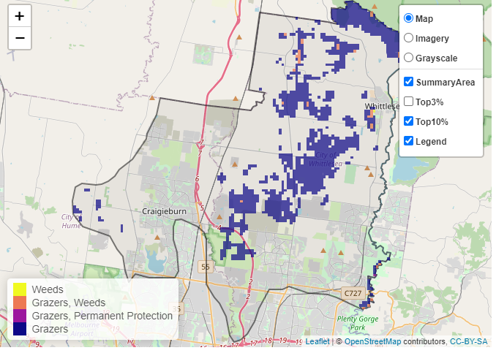
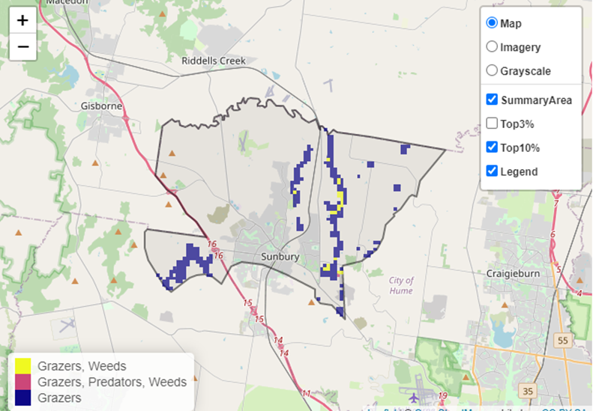
Areas of Central Grassy Woodlands Plain shown in Figures 2 and 3 have highly cost-effective actions (within the top 10% of cost-effectiveness for that action across the state) that provide significant benefit for biodiversity conservation.
Figures 2 and 3: The SMP priority actions which rank among the top 10% for cost-effectiveness of that action across the state. “Grazers” includes deer, domestic grazing, goats, horses, over-abundant kangaroos, pigs, rabbits and total grazing pressure

Actions with area in the top 3% and top 10%
Specific Action | Area in top 3% (ha) | Area in top 10% (ha)
Control Rabbits | 0 | 6,725
Control Goats | 249 | 1,254
Control Pigs | 530 | 799
Revegetation | n/a | 638
Control Weeds | 0 | 194
Domestic Grazing Control | 0 | 63
Control Overabundant Kangaroos | 0 | 29
Permanent Protection | 0 | 10
Control Deer | 0 | 2

For a further in depth look into SMP for this landscape, please refer to NatureKit.
The most cost-effective action for flora & fauna
Plants, Birds, Mammals, Amphibians and Reptiles - Control rabbits

Current actions in Central Grassy Woodlands Plain
Specific Actions | Current actions – top 10% (ha) | Current actions – outside top 10% (ha)
Weed Control | 9 | 257
Control Rabbits | 56 | 228
Control Pigs | 0 | 86
Permanent Protection | 0 | 83
Domestic Grazing Control | 0 | 83
Revegetation | 0 | 39

Current actions – top 10% = The area (ha) of the specific action currently occurring in locations identified by SMP as being in the top 10% for cost-effectiveness for that action across the state
Current actions – outside top 10% = The area (ha) of the specific action currently occurring in locations within this landscape that are not identified by SMP as being in the top 10% for cost-effectiveness for that action across the state

What you told us
SMP is just one tool to use in the process of understanding biodiversity values. Feedback from our stakeholders is also vitally important and forms the basis of our understanding of knowledge gaps.

Stakeholder interest

Important landscapes
- Quarry Hills Regional Parkland
- Maribyrnong River
- Plenty River Gorge
- Cooper Street Grassland Nature Conservation Reserve (NCR)
- Mt Ridley NCR
- Merri Creek
- Darebin Creek
- Greenvale Reservoir
- Galada Tambore
- Yarra Catchment storm water treatment wetlands
- Small grassland reserves across northwest Melbourne, such as Evans Street Grassland Reserve
- The potential Wallan Regional Park (based around Hernes Swamp)
- The interurban break proposed in the Beveridge North West Precinct Structure Plan
- Epping Cemetery
- Northern Landfill Conservation Reserve
- Nicola Davis Conservation Reserve, South Morang
- Growling Frog Golf Course
- Mirrabucca Conservation Reserve

Current activities/programs/partnerships
- Living Melbourne – Our Metropolitan Urban Forest
- Port Phillip and Western Port CMA Regional Catchment Strategy – Naturelinks – Merri Creek and Environs strategy
- Port Phillip and Western Port CMA Regional Catchment Strategy – Naturelinks – Meeting of the minds to manage the Maribyrnong
- Greening the Maribyrnong
- Emu Creek Woody Weed works
- Metropolitan Open Space Strategy
- Ecological burning – Forest Fire Operations (DELWP)
- Melbourne Strategic Assessment
- Biodiversity Response Planning project 018 – Whittlesea integrated pest animal management and monitoring program (WIPAMMP)
- Biodiversity Response Planning project 096 – Deepening connections – engaging communities and enhancing habitat of the Deep Creek
- Various Friends of groups, Landcare groups and other community groups focusing on biodiversity conservation
- Trust for Nature land covenanting program

Additional threats
Threats identified through the consultation process (in addition to those modelled in SMP):
- High development pressure
- Weed pressure
- Abundant kangaroos causing grazing pressure and adverse interactions with humans

