Introduction
Biodiversity Response Planning (BRP) is a long-term area-based planning approach to biodiversity conservation in Victoria. It is designed to strengthen alignment, engagement and participation between government, Traditional Owners, non-government agencies and the community.
DELWP Regional staff have been working with stakeholders on actions to conserve biodiversity in specific landscapes, informed by the best available science and local knowledge.
These Fact Sheets capture a point in time, reflecting data and knowledge available in 2020. They provide information for many (but not all) landscapes across Victoria, containing general information on the key values and threats in each area, as well as the priority cost-effective actions that provide the best protection of biodiversity. Fact Sheets are intended to provide useful biodiversity information for the community, non-government and government organisations during project planning and development.
Further information and the full list of Fact Sheets is available on the Department’s Environment website.

Landscape description
Discovery Bay Coast focus landscape is 23,567ha in size with 55% native vegetation cover remaining. Public land makes up 49% of the area.
Current ecological modelling shows the Discovery Bay Coast focus landscape occurs largely in the Bridgewater Bioregion, with the eastern extent falling within the Glenelg Plain Bioregion. The landscape has over 3,200ha of threatened Ecological Vegetation Classes (EVC) and is largely dominated by Coastal Alkaline Scrub, Deep Freshwater Marshes, small sections of Damp Sands Herb-rich Woodland and large areas of Coastal Dune Scrub and Herb-rich Foothill Forest EVCs. There are also Heathy Woodland/Damp Heathy Woodland/Damp Heathland Mosaic EVCs within the eastern extent of the landscape. The Victorian Biodiversity Atlas has records of 50 federally protected species, 77 state protected species and 175 rare or threatened species on the Victorian Advisory List occurring within the landscape.

Cultural importance
The Discovery Bay Coast focus landscape is recognised by its Traditional Owners as occurring on Nyamat Mirring (Sea Country)¹. Nyamat Mirring includes the submerged lands that bear the footprints of Gunditjmara ancestors. It is a place where the spirits of Gunditjmara ancestors cross over the sea to Deen Maar (Lady Julia Percy Island)¹. The landscape contains a high number of registered cultural sites.

Stakeholder interest
There are numerous valuable ecological assets present in this focus landscape, including those identified by Traditional Owners, partners and community.

0BEcological Values identified by Traditional Owners, partners and community within this focus landscape
Glenelg Estuary and Discovery Bay Ramsar Site | Discovery Bay Marine National Park
Discovery Bay Coastal Park | Narrawong Coastal Reserve
Nelson Bay Coastal Reserve | Portland Bushland Reserve
Cape Nelson State Park | Portland West State Forest
Great South West Walk | Nationally Important Wetlands including Long Swamp, Lake Mombeong and Swan Lake.
Cape Bridgewater Australian Fur Seal colony | Southern Right Whales
Mellblom's Spider-orchid (Caladenia hastata) and Coast Dandelion (Taraxacum cygnorum) | Ancient Greenling (Hemiphlebia mirabilis)
Karst Springs and Associated Alkaline Fens of the Naracoorte Coastal Plain Bioregion

Habitat Distribution Models identify 42 species with more than 5% of their modelled Victorian range in this focus landscape | Threatened terrestrial species within this focus landscape requiring specific actions other than those identified in Strategic Management Prospects (SMP)
37 plants, notably:  - Coast Ixodia (Vulnerable)  - Coastal Leek-orchid (Vulnerable)  - Coast Ground-berry (Rare) | Orange-bellied Parrot  Rufous Bristlebird
5 birds, notably:
- Rufous Bristlebird (Near threatened)
- Sanderling (Near threatened)
- Hooded Plover (Vulnerable)
- Orange-bellied Parrot (Critically endangered)

Strategic Management Prospects
Strategic Management Prospects (SMP) models biodiversity values such as species habitat distribution, landscape-scale threats and highlights the most cost-effectiveness action for specific locations. For a further in depth look into SMP for this landscape please refer to NatureKit.

Which landscape-scale actions are most cost-effective in this landscape?
The coloured areas in the map below indicate where the identified landscape-scale actions are most cost-effective and will maximise biodiversity benefit across Victoria for multiple species.
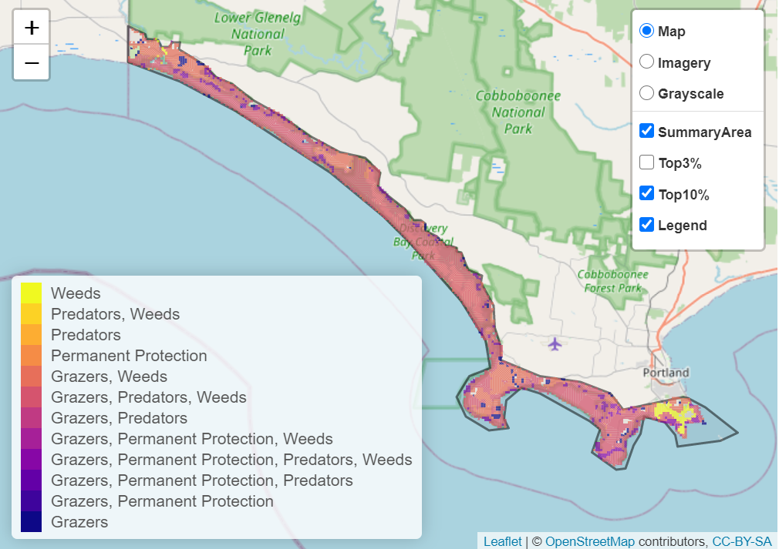

The main SMP priority actions within this focus landscape which rank among the top 10% for cost-effectiveness are listed on the right:
Control Weeds 18,627ha
Control Rabbits 18,432ha
Control Pigs 16,404ha
Control Goats 15,416ha
Control Foxes 14,2761ha
Control Cats 12,531ha
Control Deer 11,839ha

Within this landscape, pig control, rabbit control, goat control, weed control, overabundant kangaroo control, total grazing pressure control, deer control and permanent protection were also identified among the top 3% for cost-effectiveness.

Additional threats and considerations
Threats and considerations (in addition to those modelled in SMP) identified by Traditional Owners, partners and community groups during the BRP process for this focus landscape were:
Threats | Ecological processes and values requiring further considerations
Climate change | Coastal and estuarine systems
Damage to coastal vegetation through unregulated access | Wetland hydrology
Koala over-browsing | Aquatic/riparian species and catchment influences
 | Appropriate burning regimes
 | Indicator species and ecosystem engineers
 | Groundwater-dependant ecosystems

References
1. Parks Victoria, 2015. Ngootyoong Gunditj Ngootyoong Mara-South West Management Plan.

