delwp.vic.gov.au

|  |
| --- |
| Biodiversity Knowledge Framework  Version 1 |
|  |
| March 2020 |

|  |  |
| --- | --- |
|  |  |

|  |  |  |  |
| --- | --- | --- | --- |
|  |  |  |  |
|  |  |  |  |

|  |
| --- |
| Acknowledgment  We acknowledge and respect Victorian Traditional Owners as the original custodians of Victoria's land and waters, their unique ability to care for Country and deep spiritual connection to it. We honour Elders past and present whose knowledge and wisdom has ensured the continuation of culture and traditional practices.  We are committed to genuinely partner, and meaningfully engage, with Victoria's Traditional Owners and Aboriginal communities to support the protection of Country, the maintenance of spiritual and cultural practices and their broader aspirations in the 21st century and beyond. |
| © The State of Victoria Department of Environment, Land, Water and Planning 2019  LogoThis work is licensed under a Creative Commons Attribution 4.0 International licence. You are free to re-use the work under that licence, on the condition that you credit the State of Victoria as author. The licence does not apply to any images, photographs or branding, including the Victorian Coat of Arms, the Victorian Government logo and the Department of Environment, Land, Water and Planning (DELWP) logo. To view a copy of this licence, visit <http://creativecommons.org/licenses/by/4.0/>  ISBN 978-1-76105-117-3 (Print)  ISBN 978-1-76105-038-1 (pdf/online/MS word)  Disclaimer  This publication may be of assistance to you but the State of Victoria and its employees do not guarantee that the publication is without flaw of any kind or is wholly appropriate for your particular purposes and therefore disclaims all liability for any error, loss or other consequence which may arise from you relying on any information in this publication.  Accessibility  If you would like to receive this publication in an alternative format, please telephone the DELWP Customer Service Centre on 136186, email [customer.service@delwp.vic.gov.au](mailto:customer.service@delwp.vic.gov.au), or via the National Relay Service on 133 677 [www.relayservice.com.au](http://www.relayservice.com.au). This document is also available on the internet at [www.delwp.vic.gov.au](http://www.delwp.vic.gov.au). |

|  |
| --- |
| Biodiversity Knowledge Framework  Version 1 |

|  |
| --- |
|  |

|  |
| --- |
| Department of Environment, Land, Water and Planning  8 Nicolson St East Melbourne VIC 3002  Website: www.delwp.vic.gov.au |

Contents

1. Introduction 3

2. Improving the rigour of decision-making and the effectiveness of actions through prioritised knowledge acquisition 5

Overview 5

Online biodiversity knowledge framework 8

3. Research questions to address priority knowledge gaps 9

4. Causal models 10

4.1 Terrestrial environment 13

4.2 Marine environment 25

4.3 Threatened species 27

Appendix A A systematic approach to prioritisation 39

A.1 Documenting our current understanding and uncertainty 39

A2.2 Causal models of scenario 42

A2.3 Translating knowledge gap to a research question 43

A2.4 Knowledge acquisition activities to address the research question 43

Appendix B Worst-case causal models 45

# Introduction

Protecting Victoria’s Environment – Biodiversity 2037 (Biodiversity 2037) is Victoria’s twenty-year plan for the future of Victoria’s biodiversity. It sets the ambitious and achievable task of stopping the decline of, and seeking a net improvement in the outlook across all species by 2037, while sustaining the state’s strong economy.

While Biodiversity 2037 is a twenty-year plan, the Implementation Cycle provides for planning and continuous improvement in its delivery. The Five core components of the Biodiversity 2037 Implementation Cycle (Figure 1) are:

* + - The strategy itself (Biodiversity 2037) and its review after 20 years
    - The enabling environment and planning process, including work that DELWP does to provide tools and systems, regulations and standards, access to land; collaborative planning, area-based identification of projects, locations and actions etc.
    - Everyone undertaking actions that contribute to the targets of Biodiversity 2037 – this includes all the contributions of individuals, community groups, Traditional Owners, non-government organisations and government agencies
    - **Monitoring, evaluating, reporting and improving how we do things. This will embed continuous improvement into planning and implementation of actions and support the refresh of Biodiversity 2037 every 5 years**
    - Five-yearly refresh of Biodiversity 2037.

Applying an adaptive management approach through this Implementation Cycle will ensure that delivery of the biodiversity outcomes is continuously improved and the implementation of Biodiversity 2037 is designed and delivered efficiently and effectively and is responsive to emerging issues.

Supporting this Implementation Cycle, the Biodiversity 2037 Monitoring, Evaluation, Reporting and Improvement Framework (Biodiversity 2037 MERF) has been developed to demonstrate the progress of the collaborative efforts to deliver the outcomes and targets and underpin adaptive management to ensure the vision that Victoria’s biodiversity is healthy, valued and actively cared for, is delivered in the most cost effective and efficient way. It will support whole-of-government transparency and accountability. It is a key input to updating the contributing targets and processes and the five-yearly refresh of Biodiversity 2037. The Biodiversity 2037 MERF provides an overarching framework embeds continuous improvement in Biodiversity 2037, biodiversity conservation and management and the tools we use for modelling, mapping, making decisions and reporting.

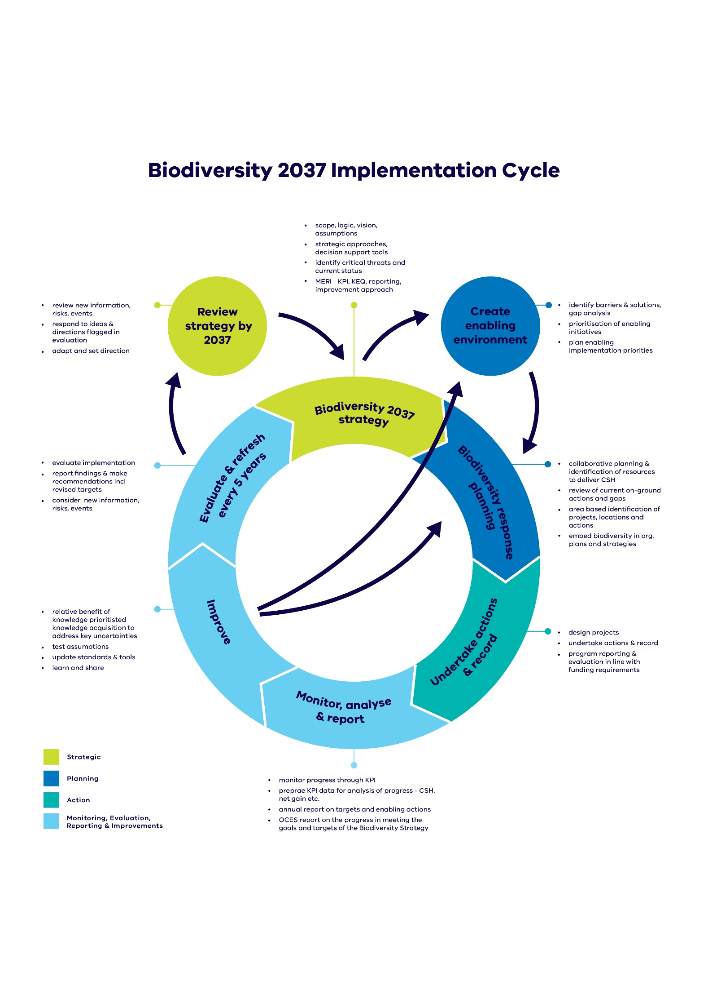

Figure 1: Biodiversity 2037 cycle. Light blue boxes indicate Biodiversity 2037-MERF

Improving the rigour of decision-making and the effectiveness of actions through prioritised knowledge acquisition

## Overview

Biodiversity 2037 – Protecting Victoria’s Environment emphasises that to deliver on the outcomes of the plan, there needs in be an increase in targeted data collection for evidence-based decision-making of both management actions and actions to increase Victorians connection to nature and encourage them to act for biodiversity. This includes progressively filling critical knowledge gaps, through targeted research and data gathering and ensuring that information is integrated across all environments (marine, waterway and terrestrial). Testing our assumptions, understanding the consequences of environmental change, management and human land use are essential components in protecting Victoria’s environment and ensuring continuous improvement. This is reinforced through the State of the Environment 2018 report which notes that Victoria’s science and data capability is diminished by a lack of coordination and a strategic approach to investing in the critical research that will enable better, and timelier, decision making and policy interventions.

Victoria’s biological heritage is diverse, as are those who research and manage it. Because of this, there are a broad range of views on Victoria’s research priorities, multiple approaches to addressing these research priorities and many important partners and stakeholders that can participate in addressing these knowledge gaps.

Both human behaviours and biodiversity conservation and management in Victoria is also complex, with many potential interacting components (e.g. food webs, unintended consequences of management), and so in identifying knowledge gaps it is important to take an integrated, whole-of-ecosystem approach. This means not just considering individual species or management actions, but also the relationship between them and other species, feedbacks and ecological processes that occur in Victoria’s ecosystems.

The changing nature and scale of both private and public investment in biodiversity conservation demands a systematic approach to improving our understanding the benefits of a management action, intervention or policy approach and risks that knowledge gaps and uncertainty associated with that intervention may have on Biodiversity 2037 in achieving its outcomes and vision.

A consistent, quantifiable and systematic approach is required to a) identify knowledge gaps and b) prioritise research investment to ensure that the research being invested in is strongly linked to policy and decision-making with a focus on strengthening Victoria’s ability to deliver on the vision of Biodiversity 2037.

The Biodiversity Knowledge Framework provides the approach to identifying and prioritising knowledge gaps and uncertainties and has been developed to:

* Describe our shared understanding through causal models of a threat or disturbance process to a species or ecosystem, or barriers to human behavioural change; identify options for intervention, policy or management and predicted benefit or impact of those options. New models can be added as they are developed.
* Identify, compare and prioritise knowledge gaps across management actions/ interventions, environments (marine, freshwater and terrestrial) and systems (through an index describing the Relative Benefit of Knowledge). The prioritisation approach can also be used to assess proposals and project concepts for knowledge gaps that haven’t yet been identified.
* Provide a platform for partners and stakeholders to identify and include projects that are helping to address knowledge gaps and a process to update our understanding and causal models; and provide standards and tools as new knowledge is acquired that verifies or refutes assumptions and resolves uncertainty.
* Although uncertainty is pervasive in biodiversity conservation, only a subset of knowledge gaps are likely to be critical to effective management. To meet the challenge of identifying knowledge gaps and prioritising research investment, the Biodiversity Knowledge Framework provides an approach for systematically describing uncertain elements in system understanding and those of higher priority through the Relative Benefit of Knowledge. The broad approach of the Framework is outlined in Figure 2 with details provided in Appendix 1.

|  |
| --- |
| Relative Benefit of Knowledge  This index enables comparison of knowledge gaps both within a causal model and across problem-response scenarios. Candidate research projects will typically aim to resolve a small subset of contrasting links documented in best- and worst-case causal models. The value of resolving uncertainty in a subset of links can be estimated by multiplying the expected gain in benefit that would be achieved by resolving the uncertainty for a problem-response scenario (i.e. resolving *all* contrasting links) by the proportional reduction in distance between best and worst-case that could potentially be achieved by resolving the target link or subset of link(s) to be addressed by a candidate project.  Relative Benefit of Knowledge  **Expected gain** in Suitable Habitat from resolving all uncertain elements  **Proportional reduction** in uncertainty from resolving target elements.  =  x   1. **Figure: Calculation of the index of Relative Benefit of Knowledge for resolving a knowledge gap**   *Expected gain* provides an assessment to quantify how the additional information can improve the predicted biodiversity benefit. It is the expected difference in the benefit (in this case the weighted sum of Change in Suitable Habitat) as a result of the management action, with and without the knowledge acquisition to resolve any uncertainties.  *Proportional reduction* identifies the amount of uncertainty resolved by calculating the improvement in proportional distance between the best and worst-case causal models, assuming the knowledge acquisition succeeds in resolving the knowledge gap. |

* A systematic approach has been developed to work through the identification and prioritisation of knowledge gaps (Figure 2 with details provided in Appendix 1)**.** Under this approach, **Problem-response scenarios** describe particular biodiversity management scenarios that may benefit from knowledge acquisition. These scenarios inform the development of **causal models**. Causal models describe the relationship between the important biodiversity values and management or intervention (e.g. control method, effect of disturbance) components within the scenario. Developing causal models for each scenario ensures that in assessing **knowledge gaps**, a whole-of-ecosystem view of the management problem is used. By describing the relative uncertainty of links in each causal model via best case and worst-case models, and the potential gain in benefit (Change in Suitable Habitat) from resolving the uncertainty, a ranking of knowledge gaps can be obtained according to an index of **Relative Benefit of Knowledge.**
* Highly ranked knowledge gaps are then expressed as priority research questions which could be stronger candidates for resolving uncertainty that is directly linked to better management outcomes. The most appropriate form of knowledge acquisition can then be identified and undertaken as a knowledge acquisition project with the results of the project directly feeding back to improve policies, standards and decision-support tools such as Change in Suitable Habitat and Strategic Management Prospects.

A screenshot of a cell phone

Description generated with very high confidence

1. **Figure 2: A systematic approach to improving the rigour of decision-making and the effectiveness of actions**

Knowledge is conceived to be broad and knowledge gaps may require different approaches to resolve them. The types of activity to resolve priority knowledge gaps may include inductive and deductive scientific research, taxonomy, evaluation and assessment, studies of a species ecology, Traditional Knowledge, data collection, social research, inventory, monitoring, surveys, investigating new technologies, citizen science and data synthesis and analysis. In some cases, a multi-disciplinary approach will be important.

## Online biodiversity knowledge framework

An online interactive portal will be developed to provide a platform for collating causal models and associated information. This will also enable partners and stakeholders to identify and include projects that are helping to address knowledge gaps and a process to update our understanding and causal models.

This will include several additions and refinements designed to make it more comprehensive, more user-friendly and have the ability to feed new knowledge into management decision systems (such as SMP).

Over time, the online portal will enable the ability to:

* select problem-response scenarios to view
* View the benefit and uncertainty for the scenario
* View the causal model for the scenario with clickable links
* Add notes on research projects currently underway or completed that address a specific link
* Comment or question a particular link or part of the causal model
* Update and refine the causal model based on research results or other information
* Progressively add new causal models for other problem-response scenarios
* Identify knowledge gaps and research questions, ranked against Relative Biodiversity of Knowledge scores

Research questions to address priority knowledge gaps

The highly ranked knowledge gaps across the first set of causal models have been translated into the following research questions (Table 1). In identifying these research questions, consideration was given to whether other research was already being undertaken for example current research funded through an Arc-Linkage grant or Biodiversity Response Planning capability projects (such as on deer and cat control method).

1. **Table 1. Research questions**

|  |  |
| --- | --- |
|  |  |
| Does fox control reduce fox densities to a point where there can be substantial benefit for small to medium sized ground dwelling mammals? What circumstances influence the success of fox control (e.g. disturbances, alternative prey availability)? | Current research project |
| To what extent do dogs/dingos take fox bait? What are the broader ecosystem implications of reduced dog/dingo densities? | Current research project |
| Does deer control reduce deer densities to a point where the following taxonomic groups substantially benefit:   * Native grasses and forbs AND/OR * Native trees and shrubs AND/OR * Frogs AND/OR * Reptiles AND/OR * Medium-large macropods AND/OR * Small to medium sized mammals AND/OR * Ground dwelling and mound building birds?   How do deer wallows impact native herbs and grasses? | Current research project addressing native trees and shrubs |
| Does goat control reduce goat densities to a point where the following taxonomic groups substantially benefit:   * Native plants AND/OR * Ground-dwelling and mound building birds AND/OR * Reptiles   How does the impact of a drying climate affect native plants, particularly in relation to the impact of goat control on the above groups? |  |
| How does the presence of rabbits interreact with weed and/or goat control in efforts to protect ground-dwelling and mound building birds from predation by introduced predators? |  |
| How does the cover of woody vegetation impact the amount of insolation available for reptile thermoregulation where goats are being controlled goat control? |  |
| How do deer and horses interact to impact alpine bogs and fens? More specifically:   * To what extent do does deer wallowing and trampling impact the condition of bogs and fens? * What is the impact of reducing horse density on deer density? |  |

Causal models

Causal models will be progressively added to the Biodiversity Knowledge Framework over time, and updated as new information becomes available. Experts are encouraged to develop causal models using this approach, seeking input from other relevant experts, and submit them for inclusion in the Knowledge Framework.

Decisions about how to identify which models to build will depend on the specific objectives. The process for Nevertheless, there are some general guidelines for deciding on building the models:

* High uncertainty in the impact of landscape scale interventions on particular species groups (guilds) coupled with potentially high benefits for these groups
* Priorities identified due to emerging threats, changes to land use, policy or legislation
* The imperative to develop a shared understanding of an ecosystem, and the values, threats, and uncertainties identified by different interest groups.

In order to launch the Biodiversity Knowledge Framework and start the library of causal models, The initial problem-response scenarios for development were identified through an analysis of the broadscale actions in the Strategic Management Prospects tool (Figure 3). This analysis identified the action-guild combinations where there was most uncertainty about the benefit of the action. DELWP and University of Melbourne worked with experts to develop causal models for these more uncertain scenarios.

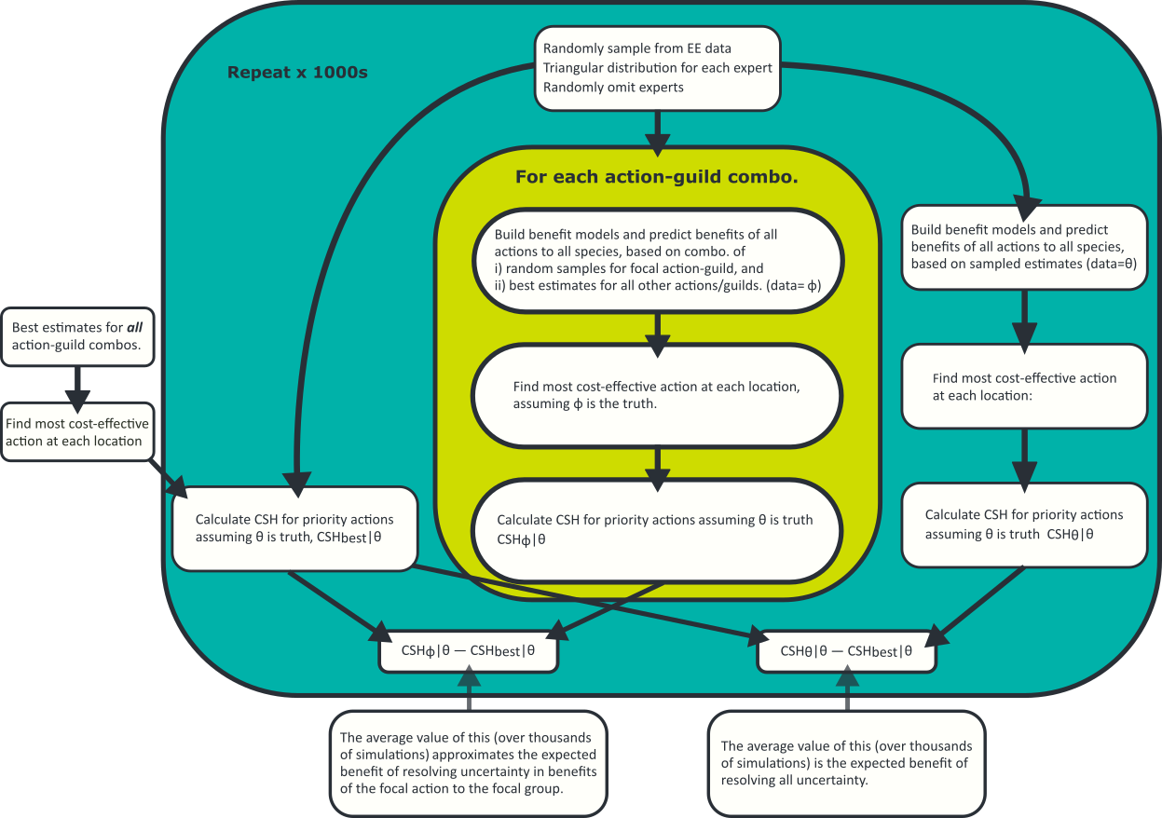

**Figure 3: Diagram describing analysis of the Strategic Management Prospects tool to identify most uncertain action-guild combinations.**

Causal models for marine problem-response scenarios are currently being develop as part of the Marine and Coastal program(Marine Knowledge Framework). Bayesian Networks developed for the Icon Species program may provide the basis for causal models for a number of threatened species.

Causal models for several problem-response scenarios have been included in this section. The models below describe the best causal models with links shown in blue indicating plausible best-case associations (see Appendix 2 for the worst-case models with links shown in red indicating plausible worst-case associations. The contrasting links and pathways between the best and worst-case causal models represent priority knowledge gaps. Note that the few links coloured in black indicate elements which are relatively free of uncertainty (i.e. they are not knowledge gaps). Under worst-case scenarios, management actions are unlikely to be effective. Under best-case scenario there is a positive aspect to the uncertainty in terms of the possibility of greater than anticipated conservation outcomes.

**Table 2. List, calculations and status of causal models**

| Model | Status |
| --- | --- |
| **Terrestrial environment** |  |
| The impacts of fox control on small to medium sized ground dwelling mammals | Version 1 complete |
| The impacts of cat and fox control on ground-dwelling birds | Version 1 complete |
| The impacts of deer control on macropods | Version 1 complete |
| The impacts of deer control on small to medium size mammals | Version 1 complete |
| The impacts of deer control on plants | Version 1 complete |
| The impacts of deer control on frogs | Version 1 complete |
| The impacts of deer control on reptiles | Version 1 complete |
| The impacts of goat control on plants | Version 1 complete |
| The impacts of goat control on reptiles | Version 1 complete |
| The impacts of weed control on ground-dwelling birds | Version 1 complete |
| The impacts of horse control on bogs | Version 1 complete |
| **Marine Environment** |  |
| The impacts of management actions on sub-tidal reefs | Unparamaterised draft |
| **Threatened species** |  |
| The impacts of management actions on the Regent Honeyeater | Unparamaterised draft |
| The impacts of management actions on the Leadbeater’s Possum (Lowland) | Unparamaterised draft |
| The impacts of management actions on the Mountain Pygmy-possum | Unparamaterised draft |
| The impacts of management actions on the Eastern Barred Bandicoot | Unparamaterised draft |
| The impacts of management actions on the Helmeted Honeyeater | Unparamaterised draft |
| The impacts of management actions on the Brush-tailed Rock Wallaby | Unparamaterised draft |
| The impacts of management actions on the Baw Baw Frog | Unparamaterised draft |
| The impacts of management actions on the Orange-bellied Parrot | Unparamaterised draft |
| The impacts of management actions on the Plains Wanderer | Unparamaterised draft |
| The impacts of management actions on the Hooded Plover | Unparamaterised draft |

## Terrestrial environment

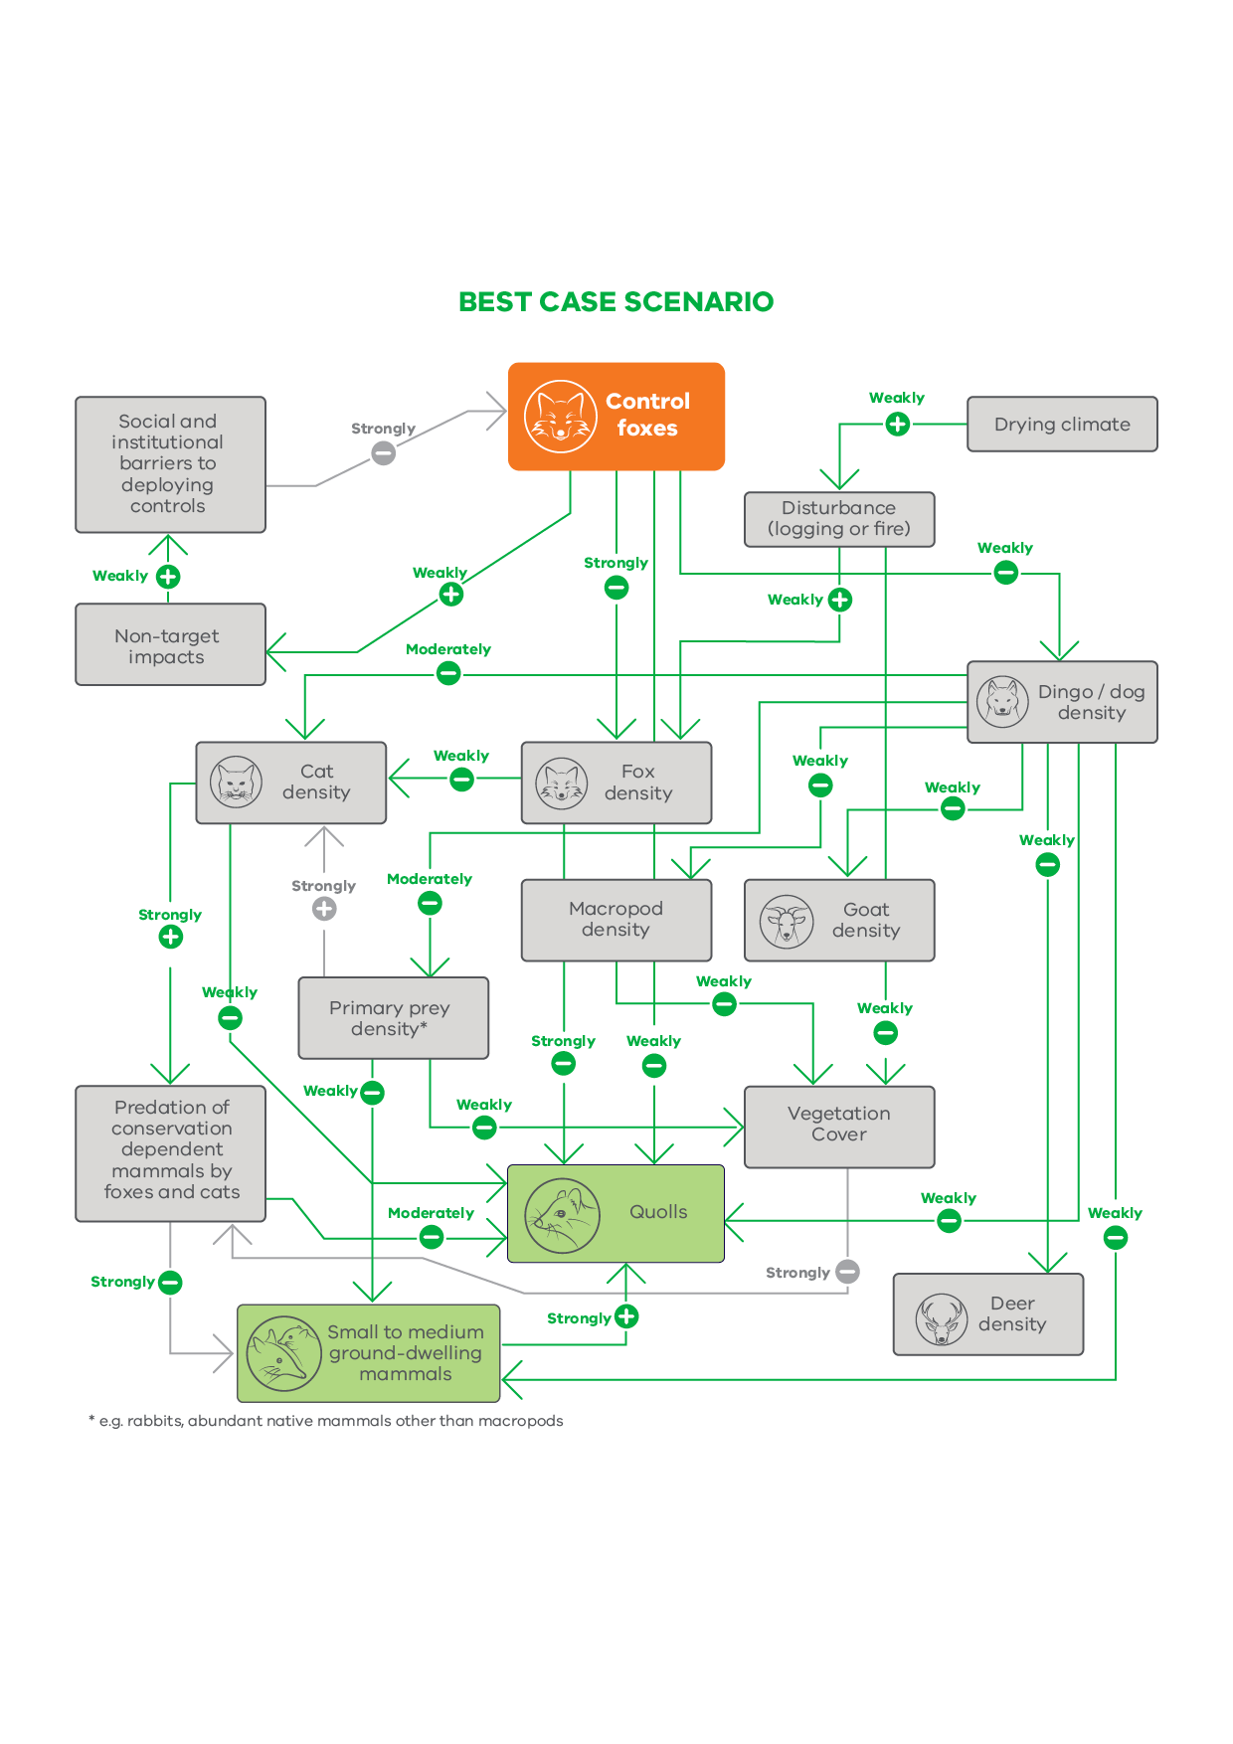**Figure 4. Best case scenario causal model developed with experts of the impacts of fox control on small to medium sized ground dwelling mammals**

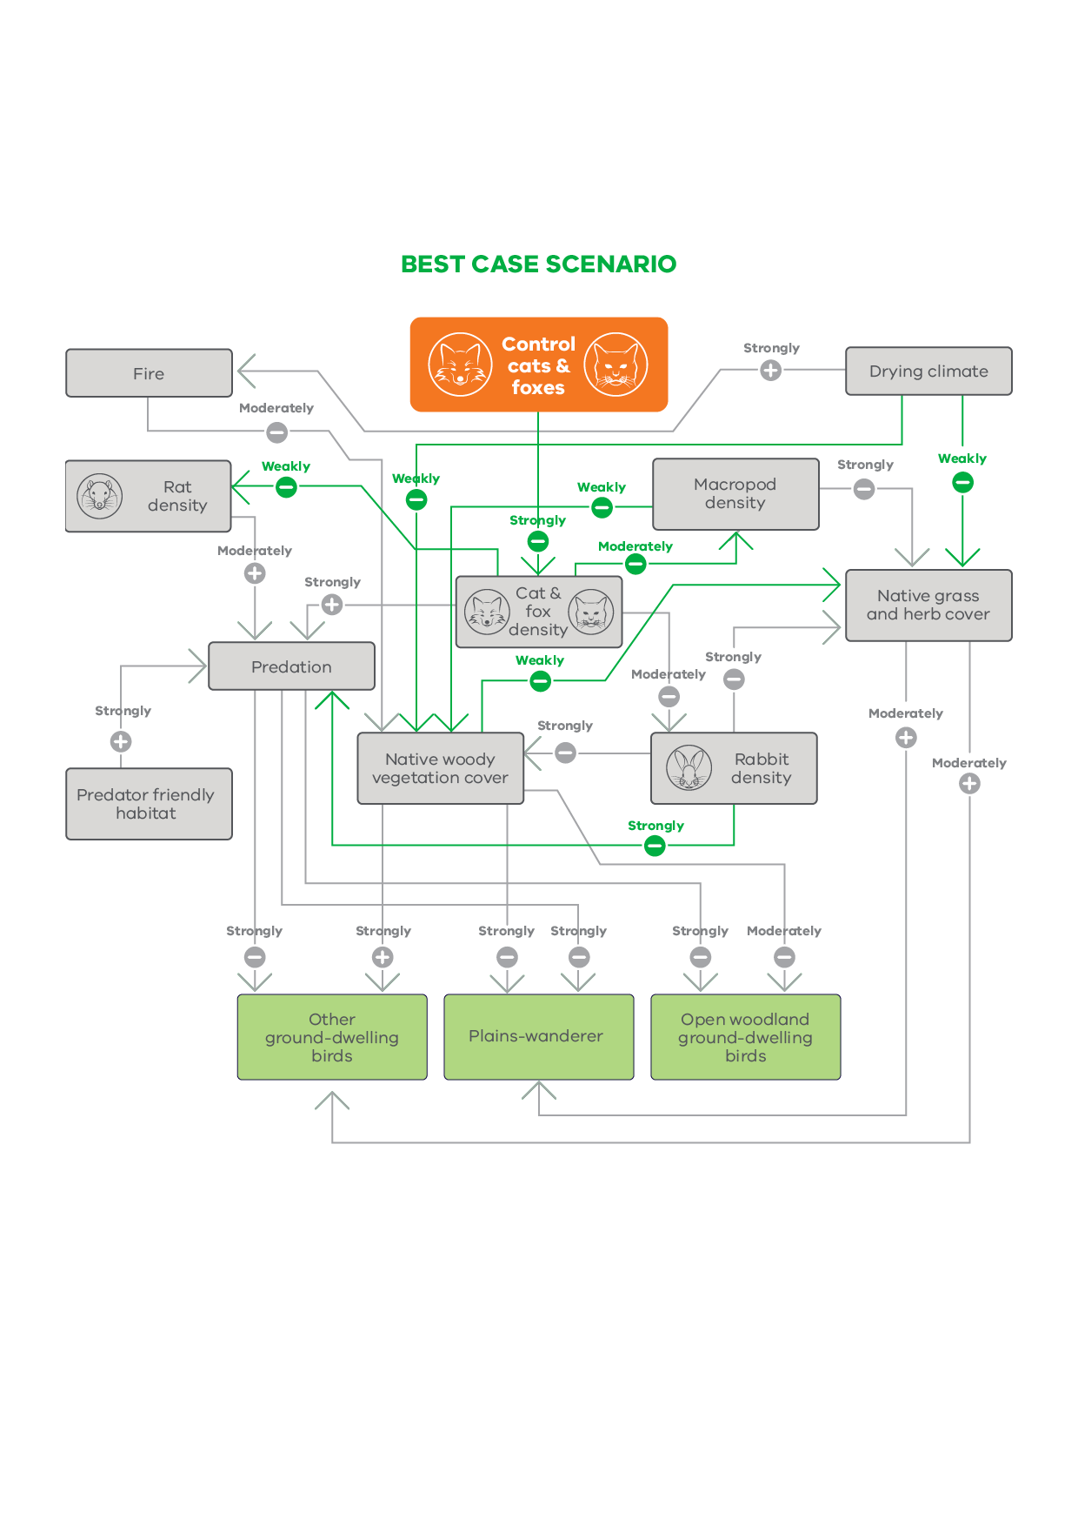

**Figure 5. Best case scenario causal model developed with experts of the impacts of cat and fox control on ground-dwelling birds**

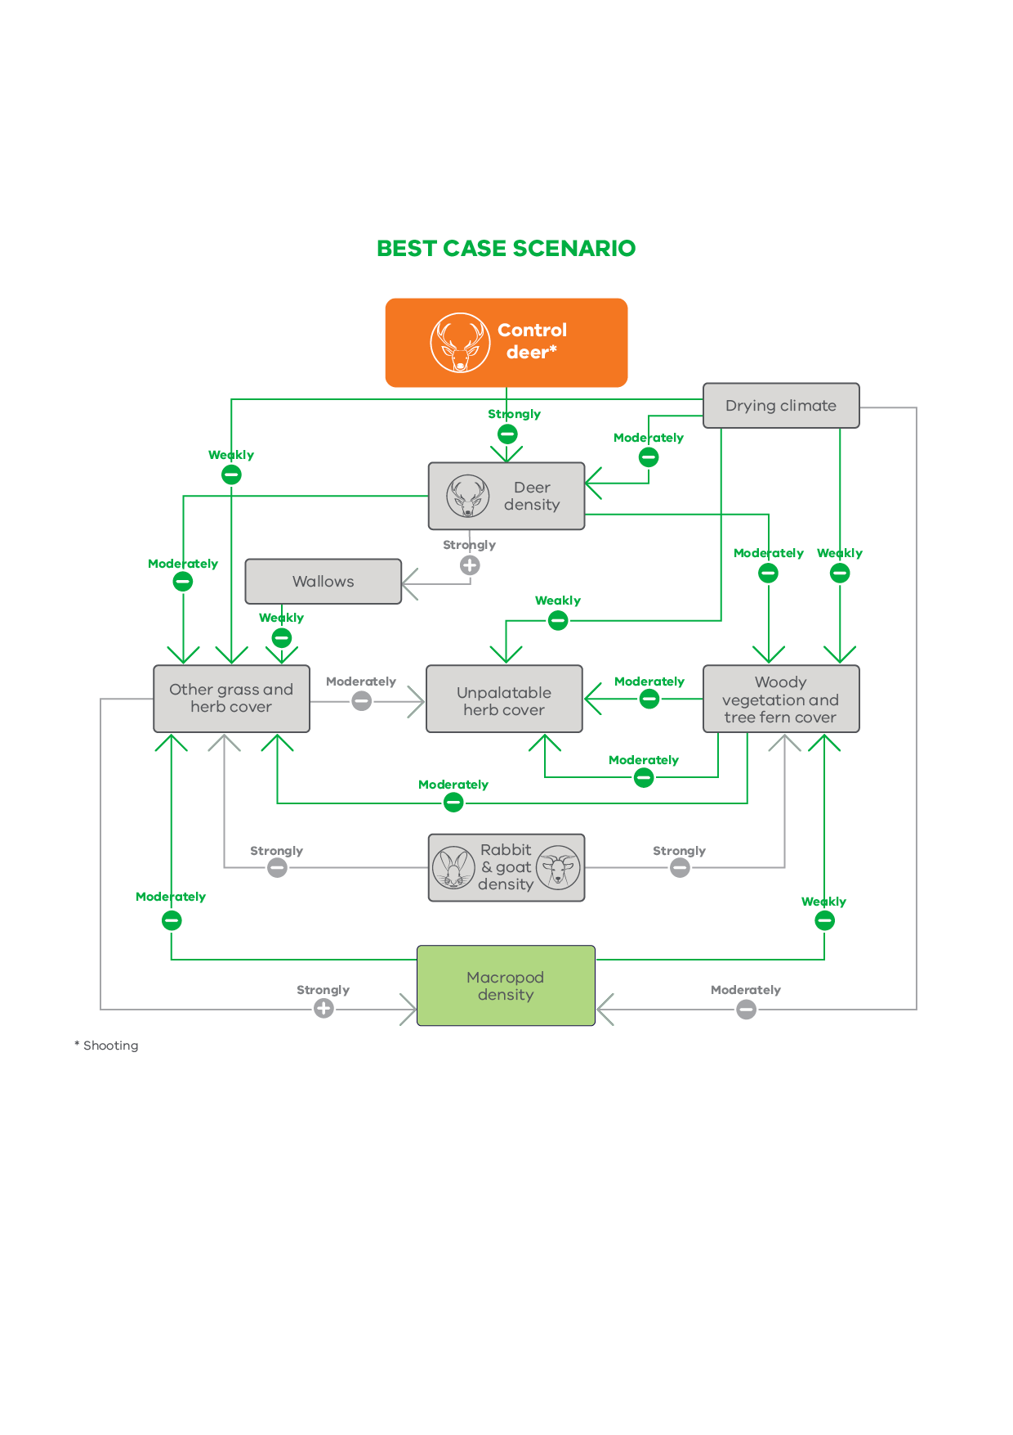**Figure 6. Best-case causal model of the impacts of deer control on macropods**

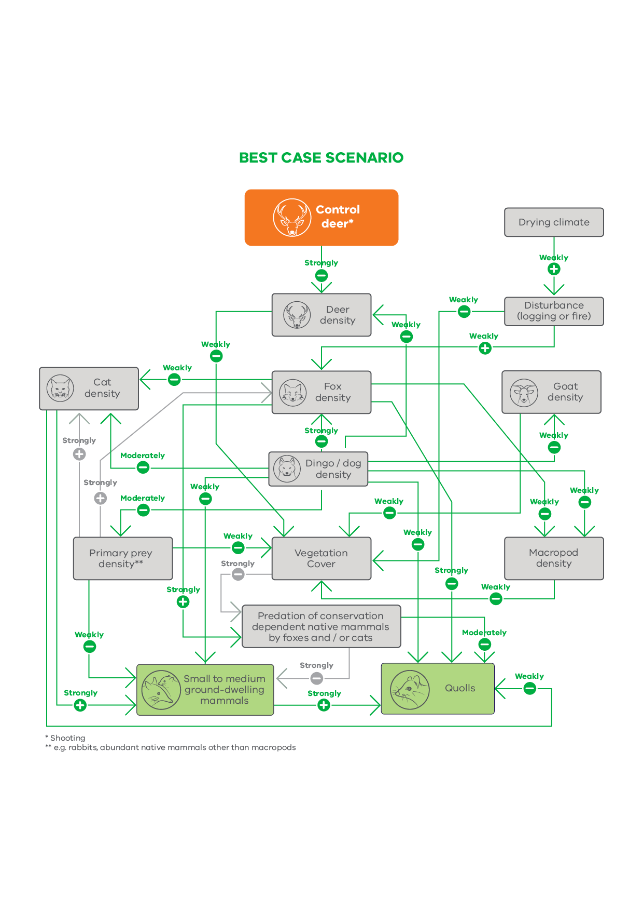

**Figure 7. Best-case causal model for the impacts of deer control on small to medium size ground dwelling mammals**

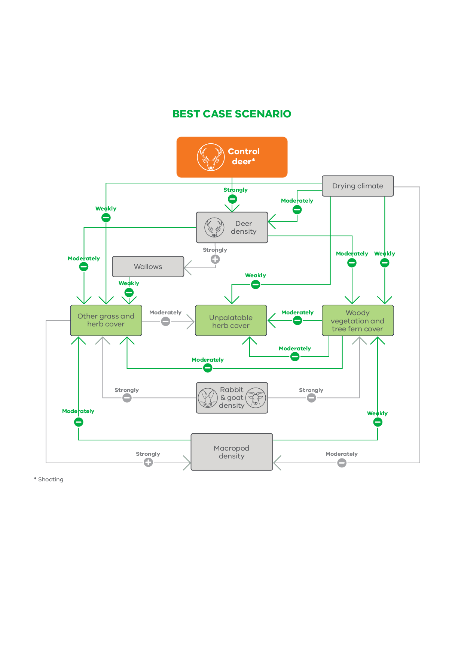**Figure 8. Best-case causal model for the impacts of deer control on plants**

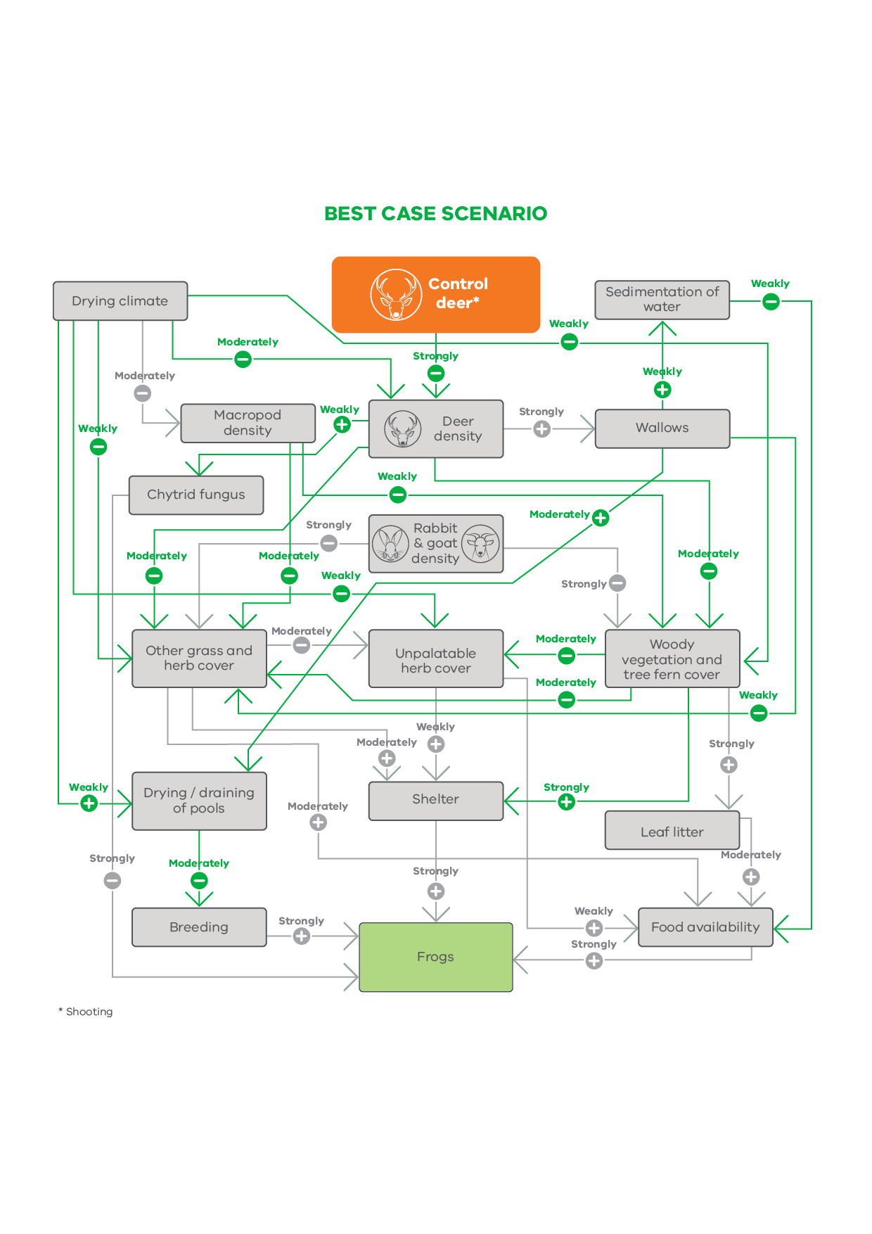

**Figure 9. Best-case causal model for the impacts of deer control on frogs**

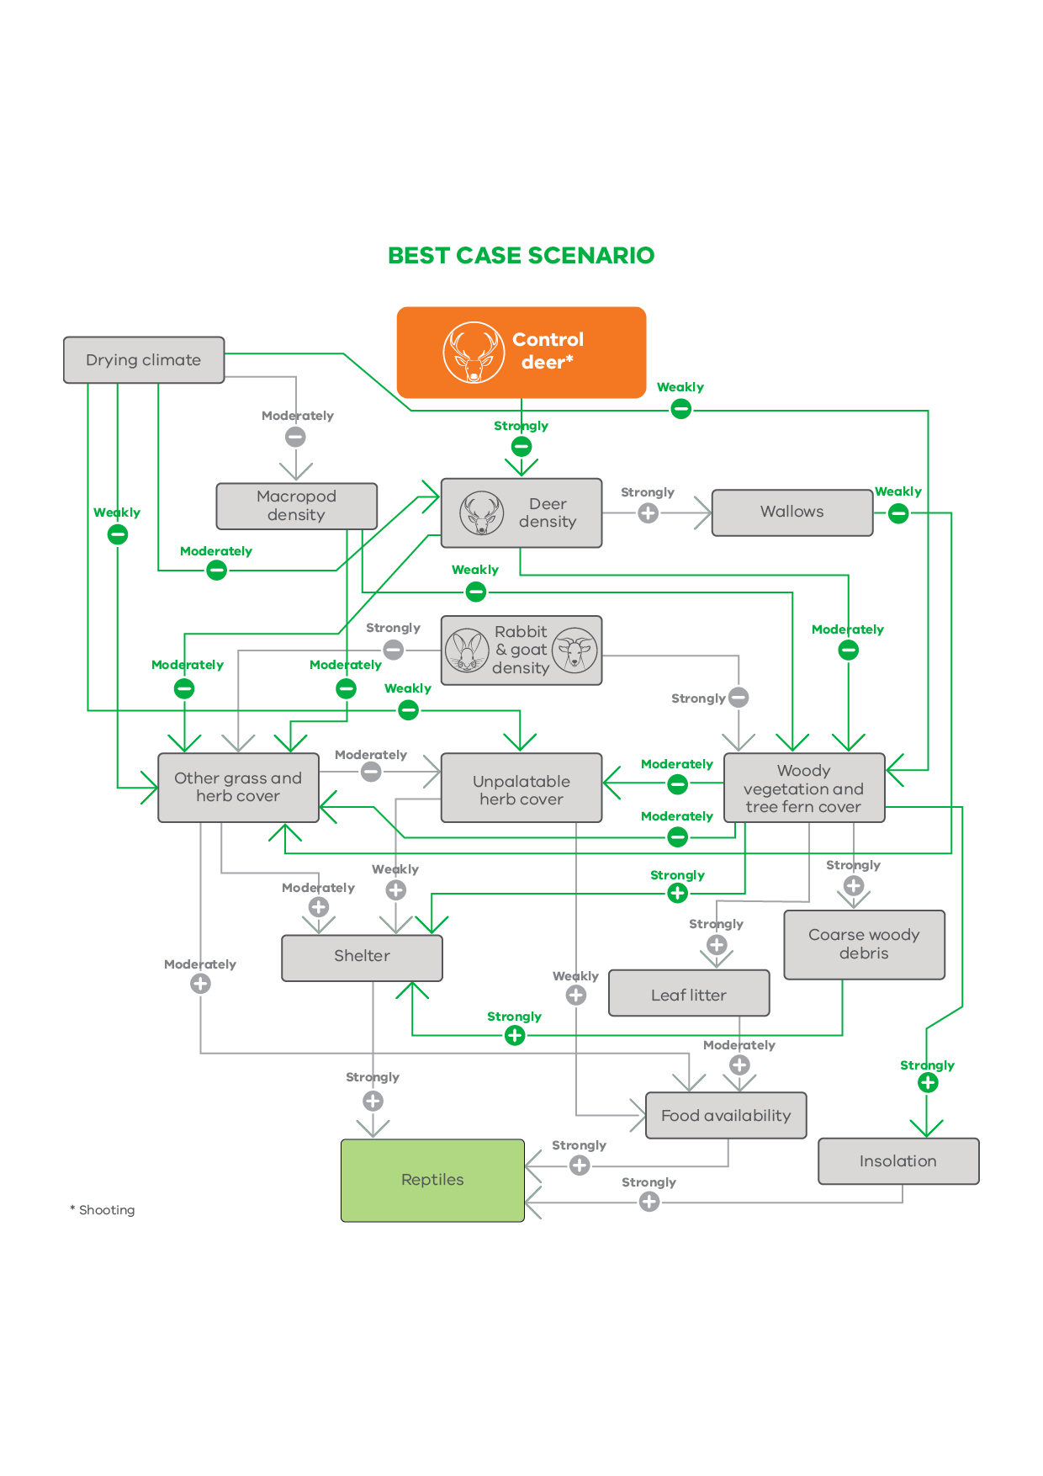

**Figure 10. Best-case causal model for the impacts of deer control on reptiles**

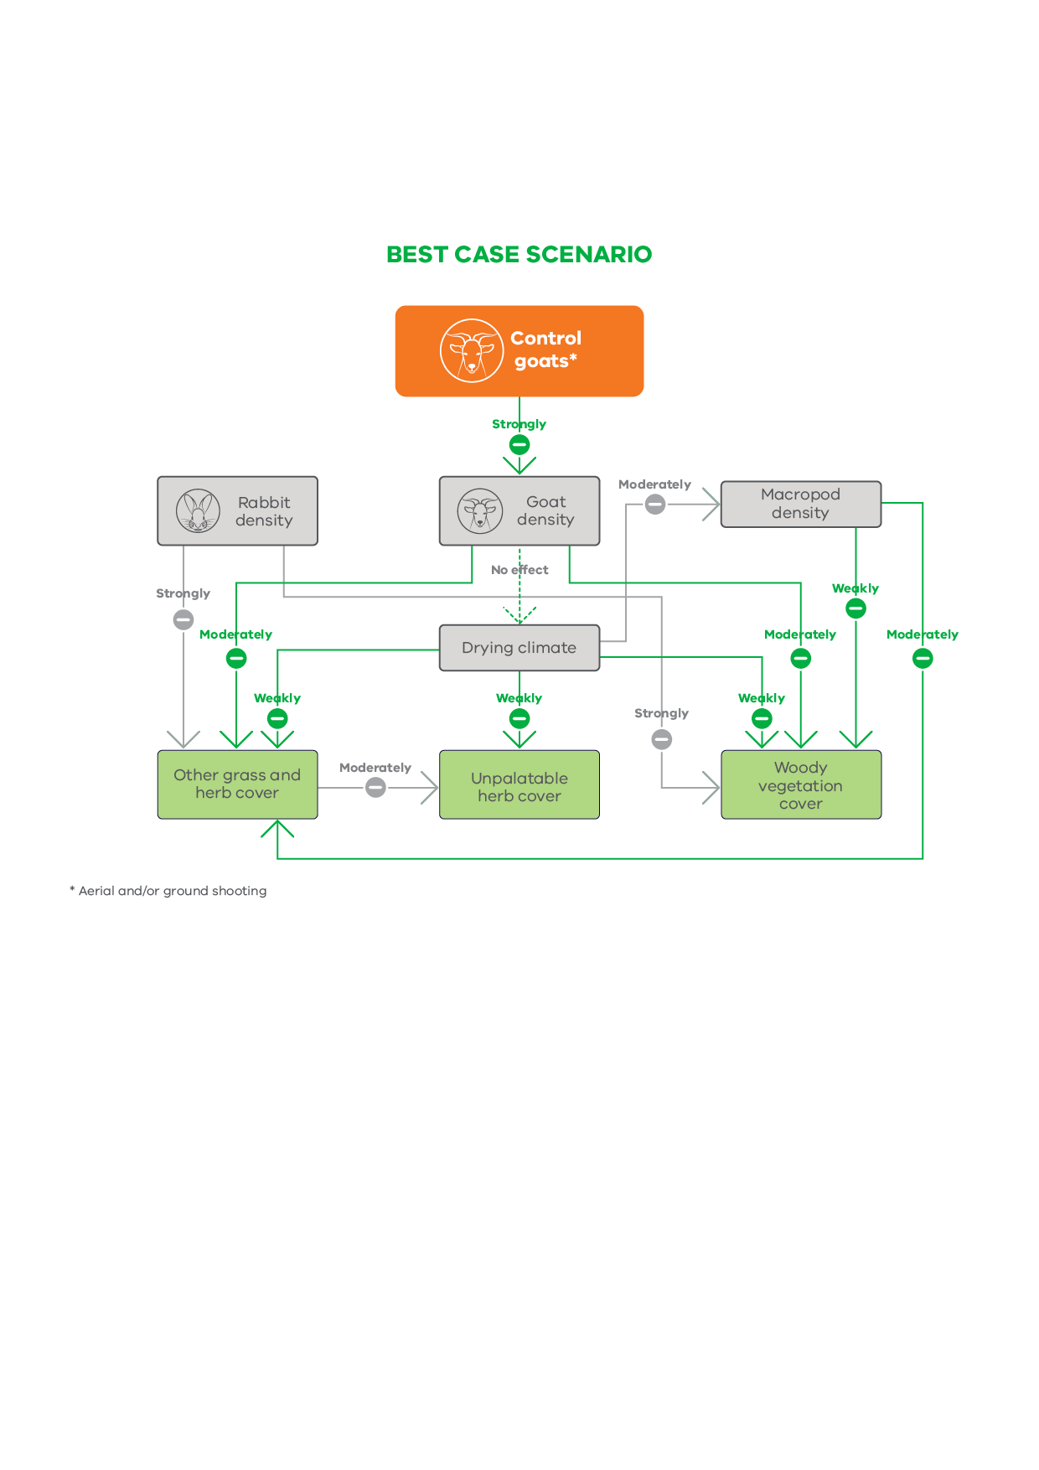

**Figure 11. Best-case causal model for the impacts of goat control on plants**

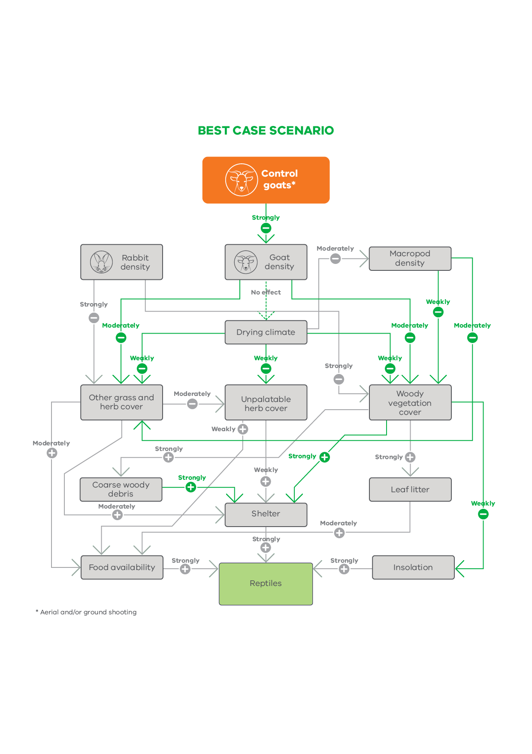**Figure 12. Best-case causal model for the impacts of goat control on reptiles**

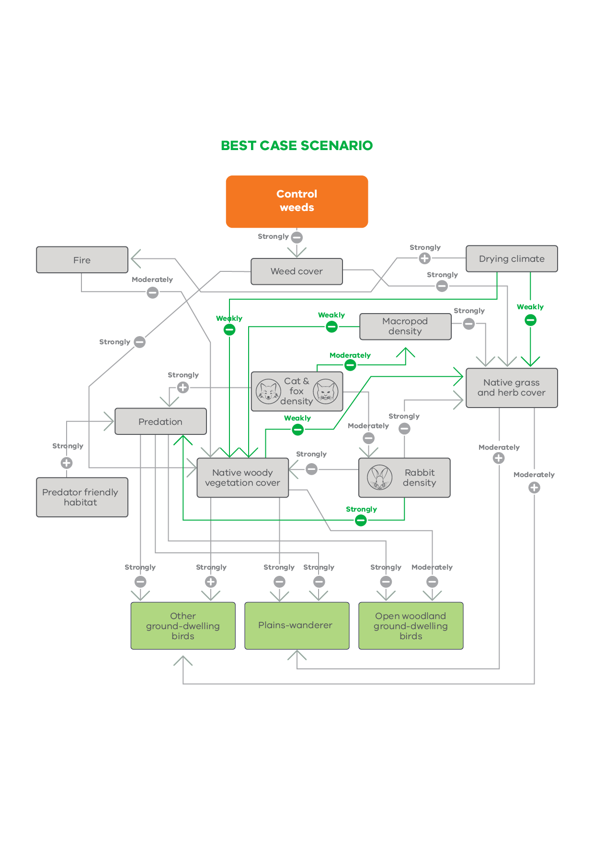**Figure 13. Best-case causal model for the impacts of weed control on ground-dwelling birds**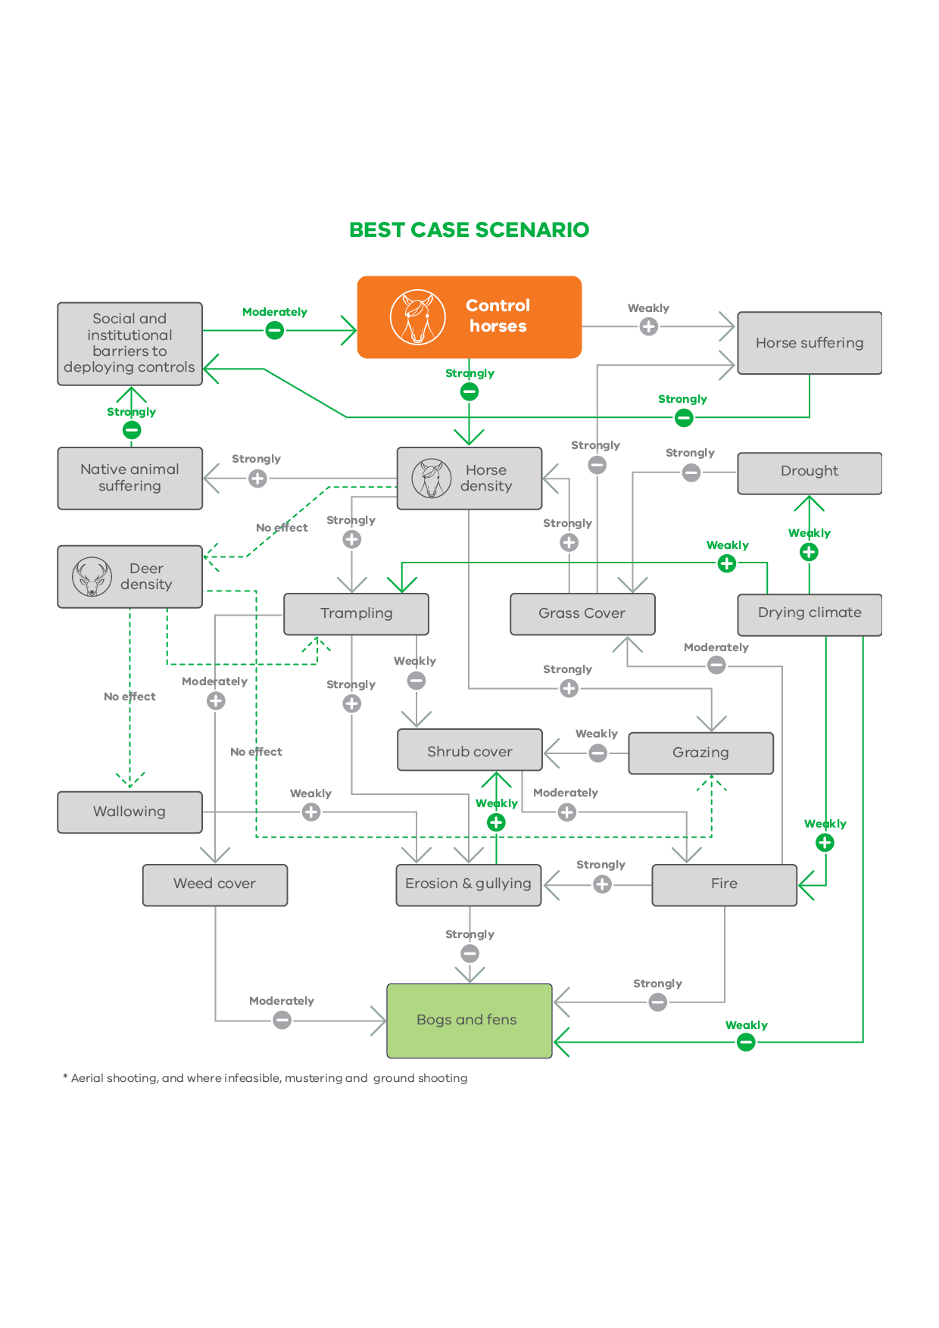

**Figure 14. Best case causal model for the impacts of horse control on bogs**

## Marine environment



**Figure 15. Unparameterised draft causal model of the impact of management on sub-tidal reefs**

## Threatened species



**Figure 16. Unparameterised draft causal model of the impact of management actions on the Regent Honeyeater (adapted from Icon Species model)**



**Figure 17. Unparameterised draft causal model of the impact of management actions on the Leadbeater’s Possum (Lowland) (adapted from Icon Species model)**



**Figure 18. Unparameterised draft causal model of the impact of management actions on the Mountain Pygmy-possum (adapted from Icon Species model)**



**Figure 19. Unparameterised draft causal model of the impact of management actions on the Eastern Barred Bandicoot (adapted from Icon Species model)**



**Figure 20. Unparameterised draft causal model of the impact of management actions on the Helmeted Honeyeater (adapted from Icon Species model)**



**Figure 21. Unparameterised draft causal model of the impact of management actions on the Brush-tailed Rock Wallaby (adapted from Icon Species model)**



**Figure 22. Unparameterised draft causal model of the impact of management actions on the Baw Baw Frog (adapted from Icon Species model)**



**Figure 23. Unparameterised draft causal model of the impact of management actions on the Orange-bellied Parrot (adapted from Icon Species model)**



**Figure 24. Unparameterised draft causal model of the impact of management actions on the Plains Wanderer (adapted from Icon Species model)**



**Figure 25. Unparameterised draft causal model of the impact of management actions on the Hooded Plover (adapted from Icon Species model)**

1. A systematic approach to prioritisation

## A.1 Documenting our current understanding and uncertainty

**Describing the problem-response scenario**

**Problem-response scenarios** describe particular biodiversity management scenario that may benefit from knowledge acquisition. They are a structured description of a given scenario, considering the relevant biodiversity values (e.g. threatened species, species guild, ecological community), the problem (e.g. threatening processes, emerging issues, pest plants and animals, policy barriers, lack of awareness, low connection to nature etc.), the response (e.g. on-ground management actions, communications campaign, school education activity, policy interventions) and quantified estimates of the potential benefits of implementing the response for the biodiversity values, and the level of uncertainty associated with the response. These estimates are measured in terms of Change in Suitable Habitat and can be calculated from the library of species responses to management in Strategic Management Prospects or elicited separately using the Specific Needs framework.

The scale of the scenario is flexible. It may be broad, for example based on an ecosystem or threatening process where broadscale management actions may apply, or it may be targeted towards a threatened species requiring specific threat management to that situation.

**Measuring benefits and uncertainty of a management action, intervention or policy**

Interventions under Biodiversity 2037 seek to deliver a particular outcome, given the available budget. This may be to increase the ability of a species to persist in the wild or an increased connection to nature. To plan and prioritise which management actions, behaviour change activities or policy interventions we will do, and where, we want to know how a particular response activity could impact the desired outcome.

While a measure to quantify the benefits of activities to encourage people to connect and value nature is yet to be developed, a new measure – Change in Suitable Habitat - was developed under Biodiversity 2037 and is used for looking at biodiversity (species) benefits. In the case of biodiversity, we want to know how particular management actions benefit different species of plants and animals in different locations, and how that benefit may vary across species and locations.

Change in Suitable Habitat was developed to provide a consistent measure of the relative contribution of management actions to habitat quality and populations’ persistence across many different species. It provides a transparent, comparable and consistent measure of the benefit of different conservation actions for individual or groups of species. The anticipated Change in Suitable Habitat gained by a species from an action is calculated using elicited expert judgments of a species’ likelihood of persistence at a location under management and under no management, and then extrapolated spatially using a model of the species’ distribution. The magnitude of anticipated Change in Suitable habitat is sometimes known with precision, but it can be highly uncertain. Uncertainty implies the possibility of windfall outcomes for conservation alongside the possibility of abject failure. The Biodiversity Knowledge Framework seeks to identify key elements of uncertainty that improve prospects for success and limit exposure to failure.

By estimating anticipated Change in Suitable Habitat, uncertainty in expert judgements is also explicitly captured, where experts have provided plausible lower and upper bounds of changes in persistence probability for a species and action. Quantifying the benefits and uncertainty of each action allows us to identify which actions we can be relatively more certain about having a positive outcome for biodiversity and actions for which the consequences are uncertain.

To quantify this appropriately a standard set of information is required. Where do the biodiversity assets occur across the state? What are the threats or disturbance processes operating at those locations? Which of these threats can be addressed directly through management and what are the potential benefits of those management actions for the biodiversity assets?

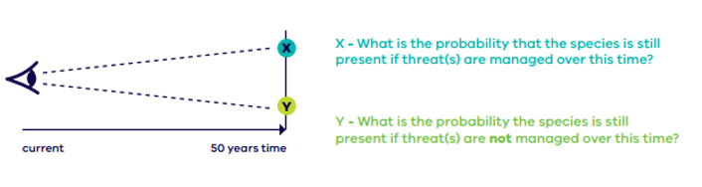

**Figure 26. Quantifying benefits through formal elicitation of expert judgment.**

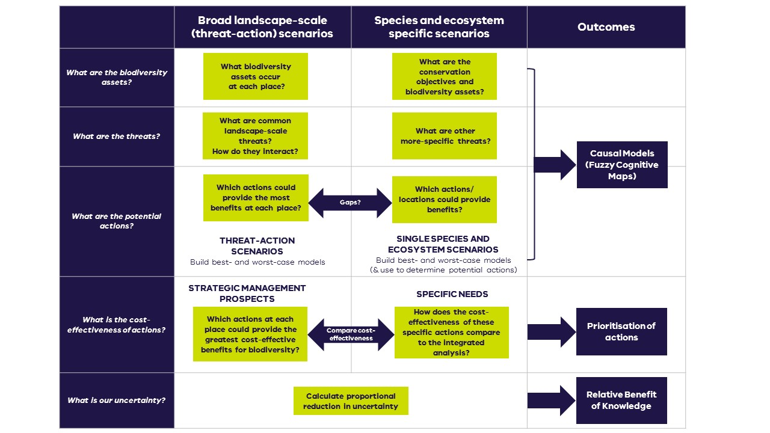Biodiversity 2037 provides two pathways for quantifying the benefits and uncertainties of an action. A number of broadscale terrestrial management actions have been included in the Strategic Management Prospects decision-support tool (SMP) where the benefits and uncertainty of actions have already been quantified. For actions not in SMP, a specific needs assessment (Figure 8) can be undertaken to quantify the benefits and uncertainties of the intervention. The specific needs process follows the same method used to collect expert judgements for the landscape-scale actions in SMP but focuses on bespoke actions and how they benefit a particular species in more specific locations. Because it uses the same method and quantifies benefit in the same manner as SMP, the results (and their uncertainty) can be directly compared.

**Figure 27: Steps for developing problem-scenarios, identifying actions and knowledge gaps.**

Strategic Management Prospects

For management actions in SMP, benefit and uncertainty information can be identified from the expert elicited species responses to management actions. These data exist for fourteen landscape scale actions and their benefits for all Victorian terrestrial vertebrates and nearly all vascular plants ([see here](https://www.environment.vic.gov.au/__data/assets/pdf_file/0035/82997/5-NaturePrint-Strategic-Management-Prospects-inputs.pdf) for more information). These data are represented as the expected change in persistence probability for a species in a location as a result of a management action, as well as the plausible range (level of uncertainty) that change in persistence probability could fall within (Figure 28).

Actions that have high benefits (i.e. relatively large change in persistence probability scores) and high uncertainty (i.e. wide upper and lower plausible bounds) are likely to have a relatively high value of information. That is, resolving the uncertainty around these actions will have a significant positive influence on biodiversity decision making.

The library of spatially explicit benefit of action data for a range of species in SMP provides a strong basis for which to identify where research projects can help to resolve the uncertainty most influential in biodiversity decision making.

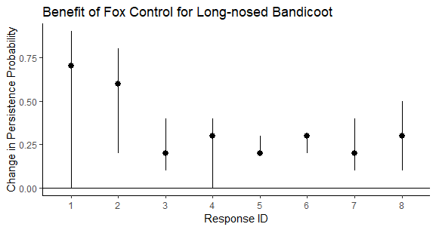

**Figure 28: Expert estimates for the benefit of fox control for the long-nosed bandicoot for different scenarios across Victoria. Dots represent the best guess, and the lines represent the plausible bounds that experts suggested that benefit values could fall between.**

Specific Needs

Management actions that are not currently considered in Strategic Management Prospects (e.g. genetic rescue, translocation, artificial habitat creation, regulatory actions, marine or freshwater management actions) will also need to be considered in the portfolio of possible research questions and knowledge gaps. These actions will require a ‘specific needs’ analysis. The specific needs process follows the same method used to collect expert judgements for the landscape-scale actions in SMP but focuses on bespoke actions and how they benefit a particular species in more specific locations. Because it uses the same method and quantifies benefit in the same manner as SMP (i.e. expected change in persistence probability for a species), the results (and their uncertainty) can be directly compared (Figure 29).

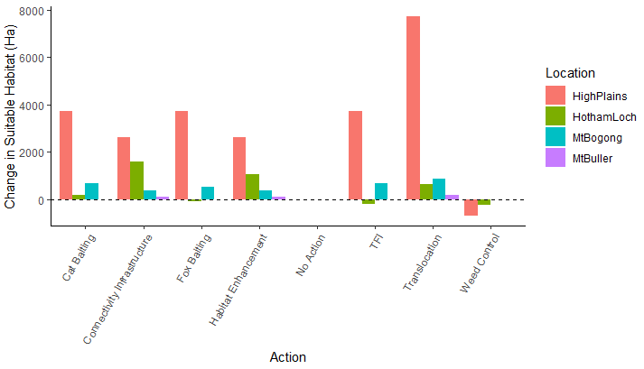

**Figure 29: Anticipated Change in Suitable Habitat for the Mountain Pygmy Possum in different locations across its range for a set of bespoke and landscape scale actions.**

## A2.2 Causal models of scenario

After identifying the broad actions and species for which we are most uncertain (e.g. the benefit of fox control on small and medium sized mammals), a deeper dive into the ecological and human mechanisms influencing this uncertainty is required to identify knowledge gaps and therefore research questions. This is achieved through the development of causal models that map the causal relationships between ecological and human components relevant to the benefit of an action being realised. This is done using a technique called fuzzy cognitive mapping.

Causal models (describing the difference between the best and worst-case causal models) (Figure 1) represent our shared understanding of the management action, and uncertainty in that understanding, and how drivers and threats, and other relevant processes interact to influence the availability of Suitable Habitat for the species.  Causal models are graphical representations in which key concepts are nodes and causal relationships are the links between them. The models reflect a narrative of cause and effect, summarising what experts believe to be the key elements of a system, their dependencies and interactions. Positive links indicate a direct relationship between parent and child notes (as the parent increases, so too does the child, or as the parent decreases so too does the child). Negative links indicate inverse relationships (as the parent increases the child decreases or as the parent decreases the child increases). The strength of the association between parent and child nodes is captured qualitatively (e.g. weak, moderate, strong) and assigned a corresponding numerical descriptor (1, 2, or 3).

The sign and strength of causal links between the nodes allow coarse inferences of the influence of actions throughout the system under best-case and worst-case understandings.

Contrasts between best-case and worst-case causal models can be characterised by a distance metric derived from graph theory. The proportional reduction in the distance metric between the best and worst-case causal models will be calculated for each contrasting link (i.e. knowledge gap) in the models. Contrasts in links between best case and worst-case models may be small (e.g. weakly negative versus moderately negative, -1 vs -2) or large (strongly negative versus strongly positive -3 vs +3). In general, larger contrasts represent higher priority knowledge gaps than lesser contrasts.

**A2.3 Comparing and prioritising knowledge gaps**

Consistent with the Biodiversity 2037 approach to comparing across actions to identify those that are most cost-effective, it is important to be able to compare across knowledge gaps in different systems to identify the best candidates for investment in knowledge acquisition. This will be done on the basis of the index of **relative benefit of knowledge** as a proxy for value of information (Figure 30). This is to ensure that the knowledge gain will translate into a practical outcome and improve current practice and policy.

This index enables comparison of knowledge gaps both within a causal model and across problem-response scenarios. Candidate research projects will typically aim to resolve a small subset of contrasting links documented in best- and worst-case conceptual models. The value of resolving uncertainty in a subset of links can be estimated by multiplying the expected gain in benefit that would be achieved by resolving the uncertainty for a problem-response scenario (i.e. resolving *all* contrasting links) by the proportional reduction in distance between best and worst-case that could potentially be achieved by resolving the target link or subset of link(s) to be addressed by a candidate project.

Relative Benefit of Knowledge

**Expected gain** from resolving all uncertain elements

**Proportional reduction** in uncertainty from resolving target elements.

=

x

**Figure 30: Calculation of the index of Relative Benefit of Knowledge for resolving a knowledge gap.**

*Expected gain* provides an assessment to quantify how the additional information can improve the predicted biodiversity benefit. It is the expected difference in the benefit (in this case the weighted sum of Change in Suitable Habitat) as a result of the management action, with and without the knowledge acquisition to resolve any uncertainties.

*Proportional reduction* identifies the amount of uncertainty resolved by calculating the improvement in proportional distance between the best and worst-case causal models, assuming the knowledge acquisition succeeds in resolving the knowledge gap.

## A2.3 Translating knowledge gap to a research question

Highly ranked knowledge gaps are then expressed as **priority research questions** which could be subject to funding. For instance, an uncertain relationship between fire and the effect of a weed control method on weed density could be expressed as the following research question: “What is the most effective, in terms of long-term reduction in weed density, fire-age to undertake weed control in location X.”

## A2.4 Knowledge acquisition activities to address the research question

Researchers seeking to address the knowledge gap can then identify the most **appropriate form of knowledge acquisition** and design a knowledge acquisition or research project, with the results of the project directly feeding back to improve policy, management standards, program design and decision-support tools such as Strategic Management Prospects. Knowledge activities may include:

* Manipulative ‘management experiments or trials’ or natural experiments
* Data synthesis and analysis, meta-analysis, systematic review
* Species surveys or monitoring (incl. long term monitoring)
* Ecological studies
* Collation of Traditional Knowledge
* Questionnaires, evaluation and experimental assessment
* Testing new innovations and technology
* Citizen science (which may use some of the approaches listed here)
* Pilot or proof of concept studies, scenario analyses, reviews, case studies etc.

1. Worst-case causal models

The following diagrams show the contrasting worst-case causal models for the best-case scenarios described in the previous section.

In the following models, links shown in red links indicate plausible worst-case associations. The contrasting links and pathways between the best and worst-case causal models represent priority knowledge gaps. Note that the few links coloured in black indicate elements which are relatively free of uncertainty (i.e. they are not knowledge gaps). Under worst-case scenarios, management actions are unlikely to be effective. Under best-case scenario there is a positive aspect to the uncertainty in terms of the possibility of greater than anticipated conservation outcomes.

##### 

**Figure 31. Worst-case causal model of the impacts of fox control on small to medium sized ground dwelling mammals**

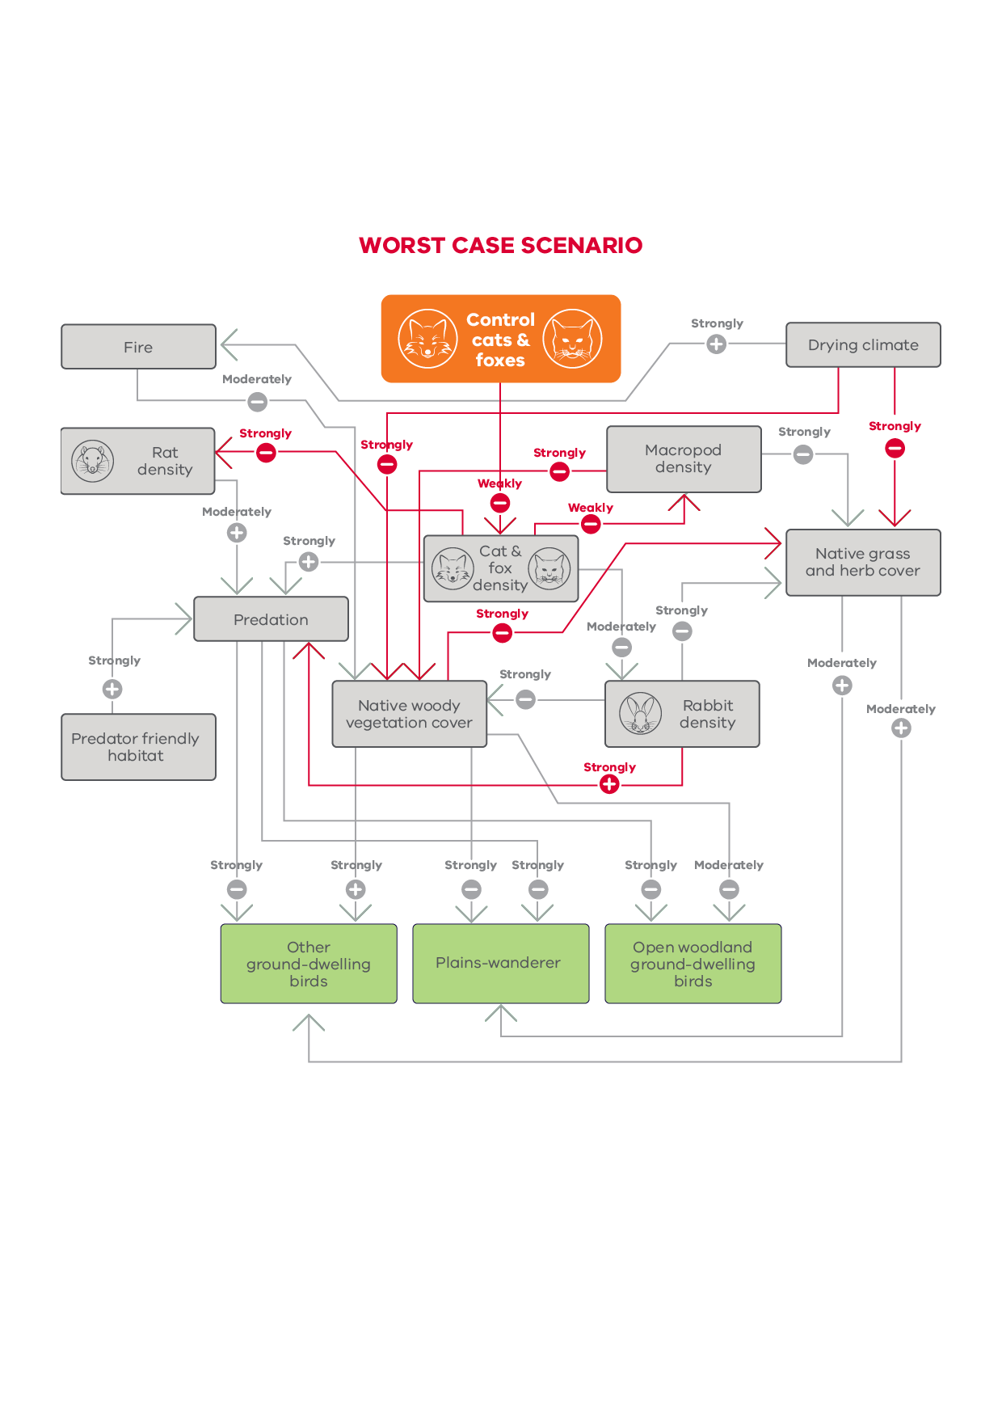

**Figure 32. Worst-case causal model of the impacts of cat and fox control on ground-dwelling birds**

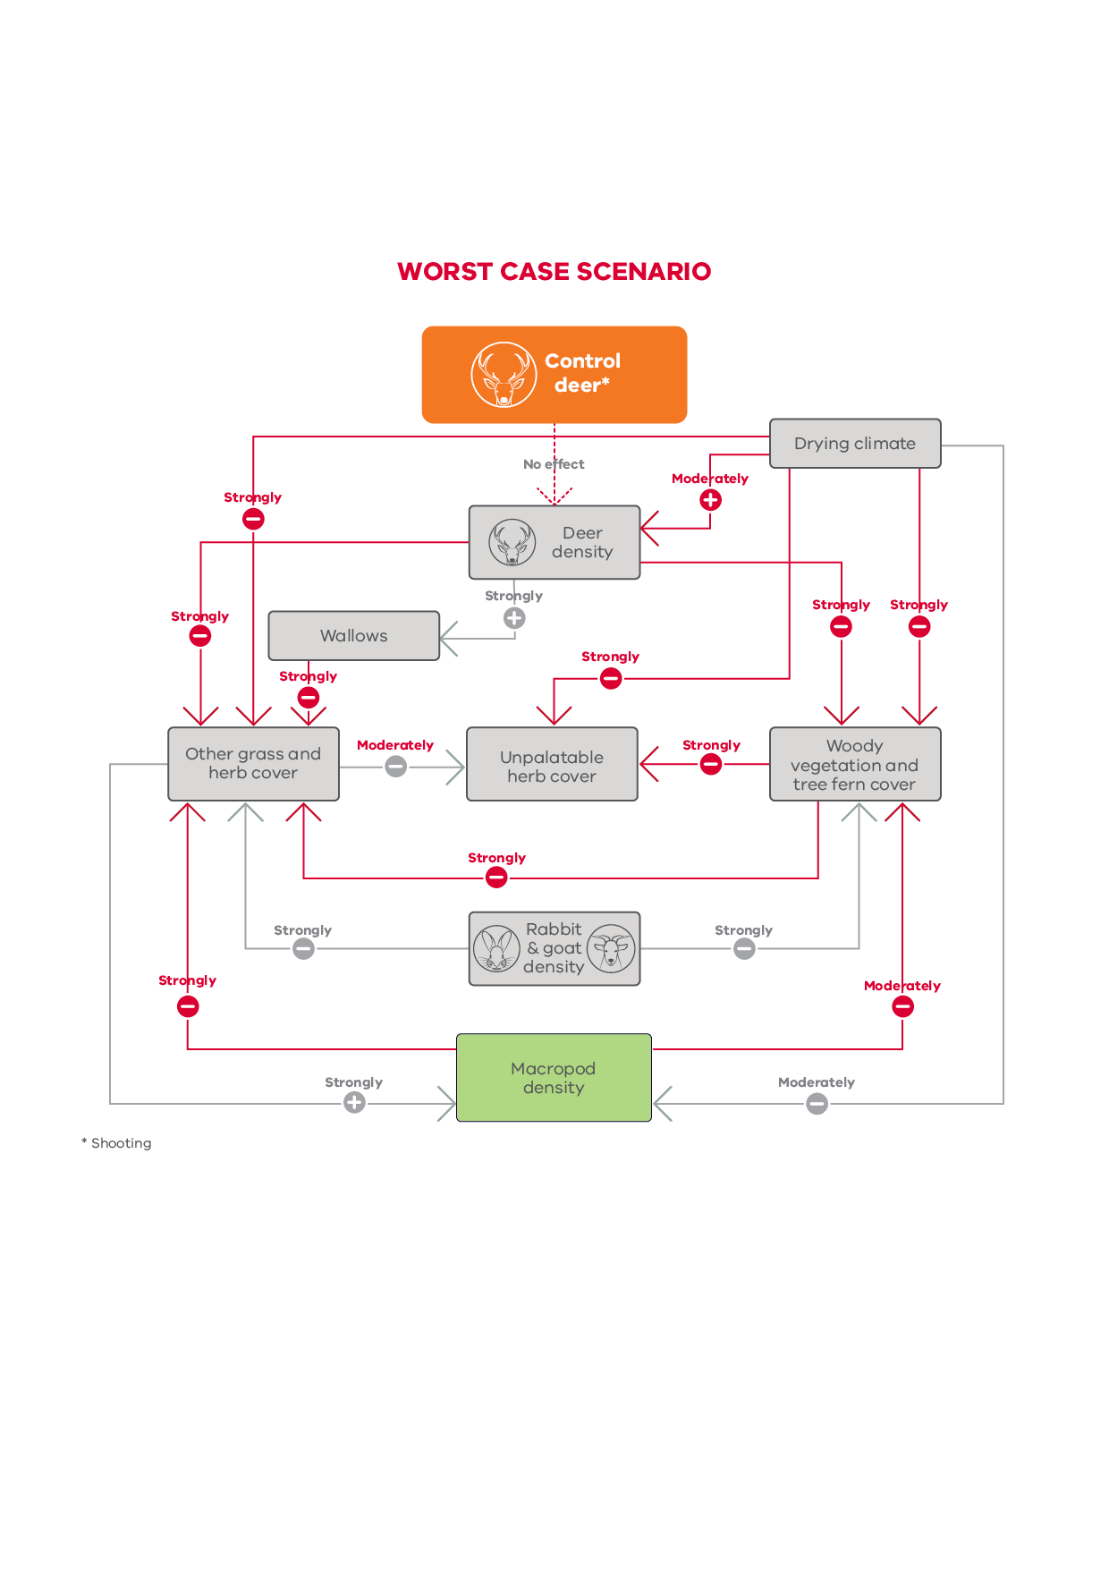

**Figure 33. Worst-case causal model of the impacts of deer control on macropods**

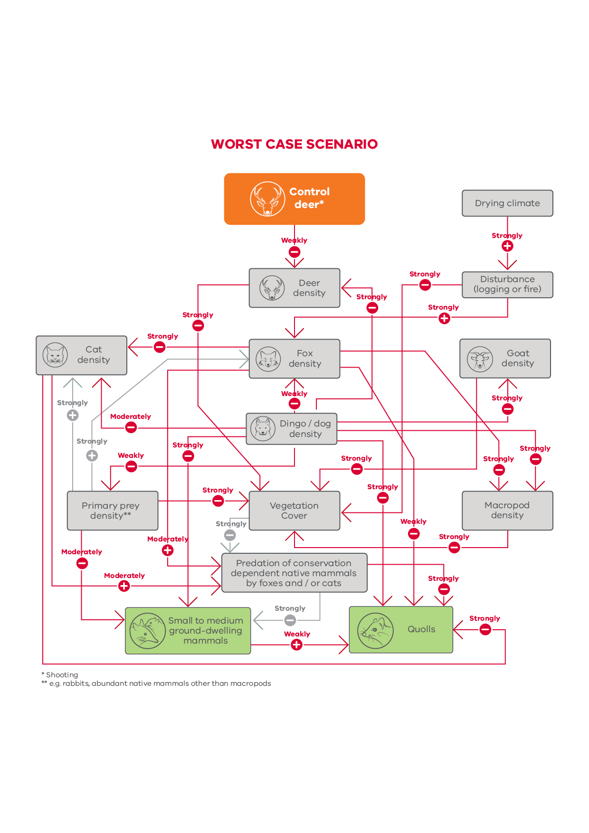

**Figure 34. Worst-case causal model of the impacts of deer control on small to medium sized ground dwelling mammals**

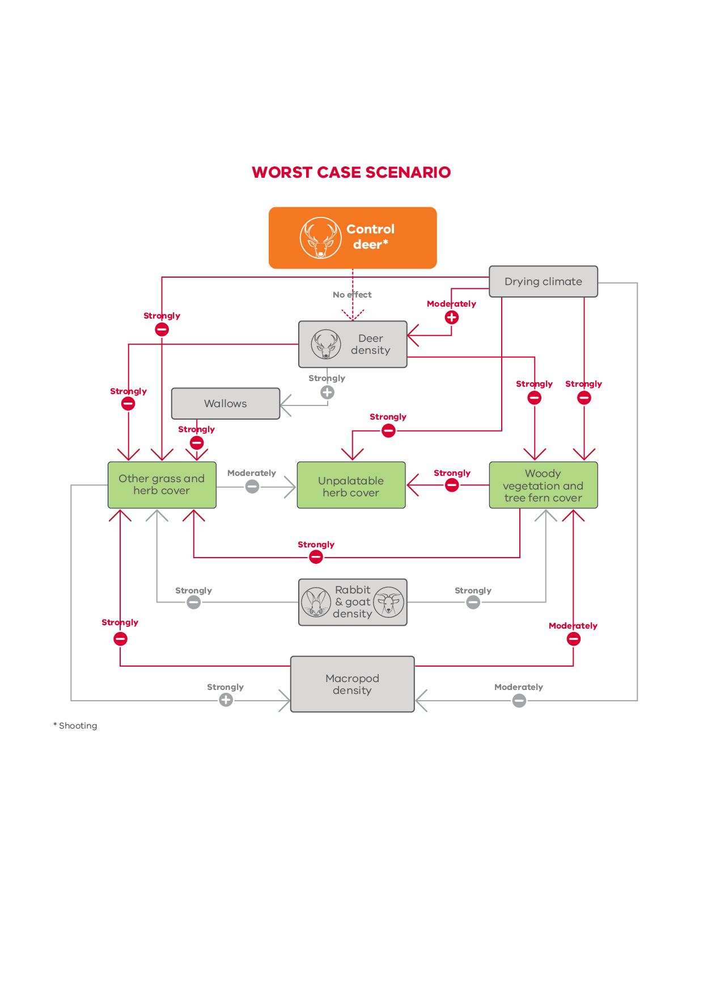

**Figure 35. Worst-case causal model of the impacts of deer control on plants**

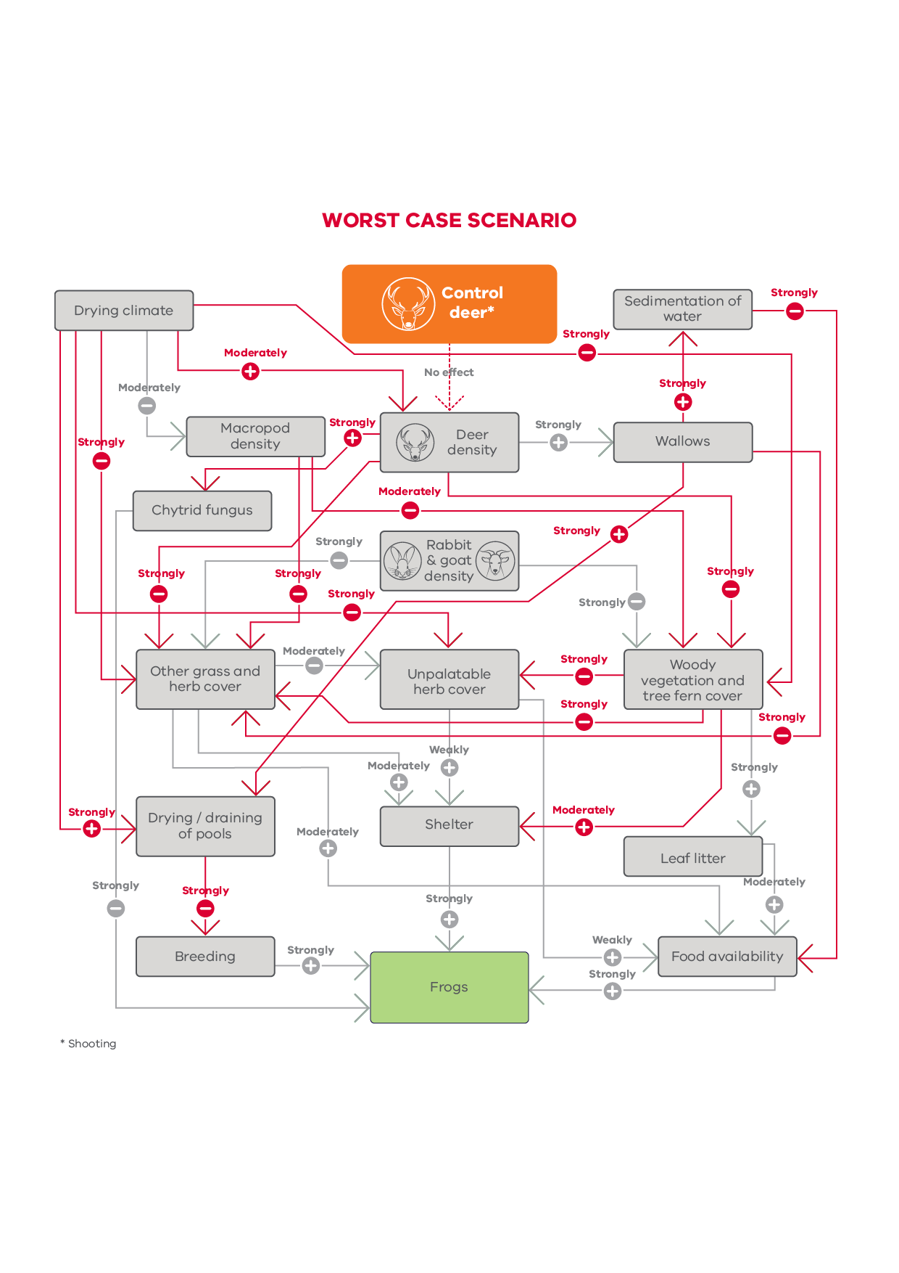

**Figure 36. Worst-case causal model of the impacts of deer control on frogs**

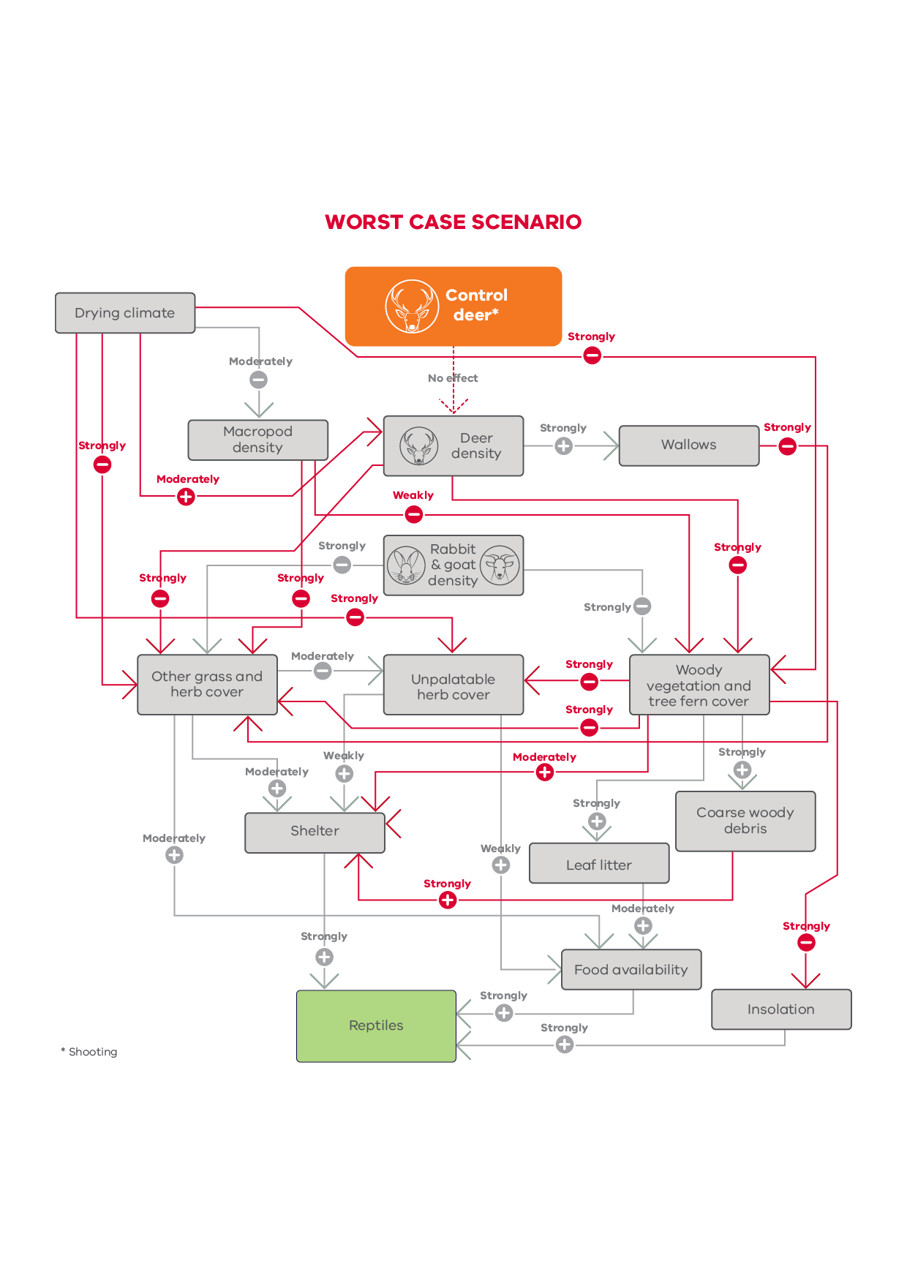**Figure 37. Worst-case causal model of the impacts of deer control on reptiles**

**Figure 38. Worst-case causal model of the impacts of goat control on plants**

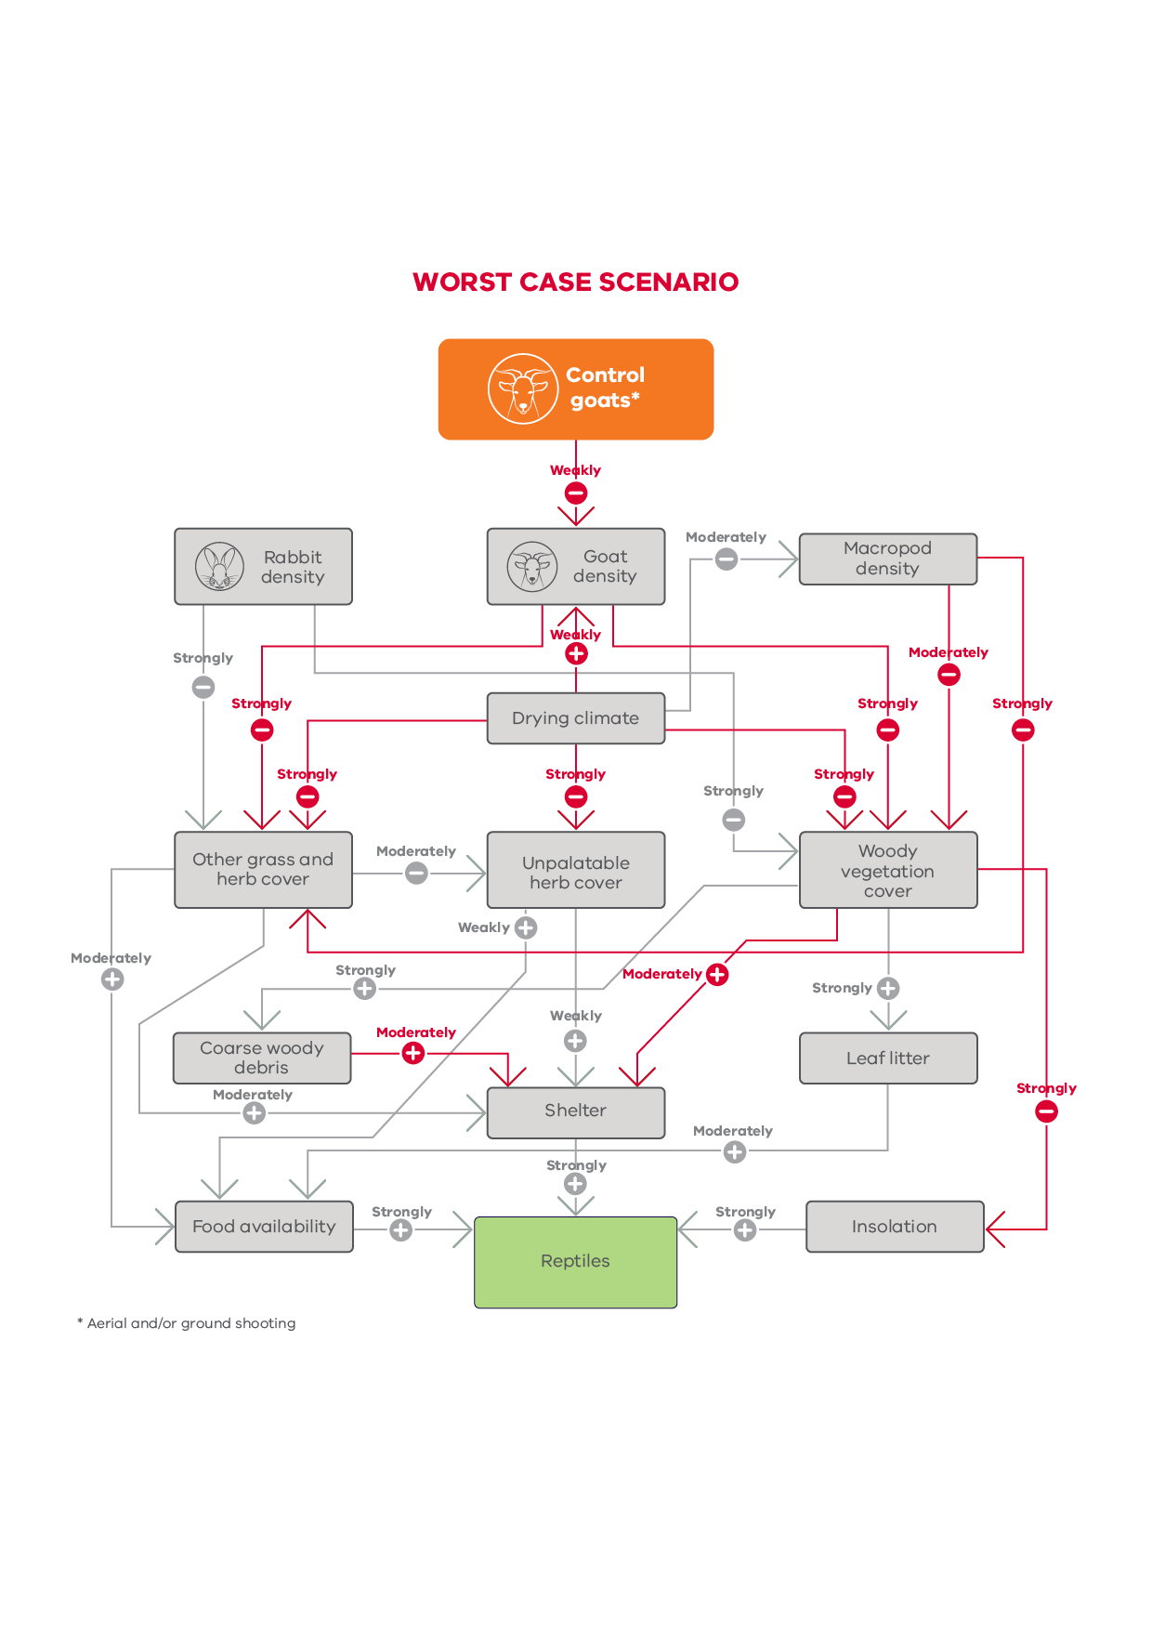

**Figure 39. Worst-case causal model of the impacts of goat control on reptiles**

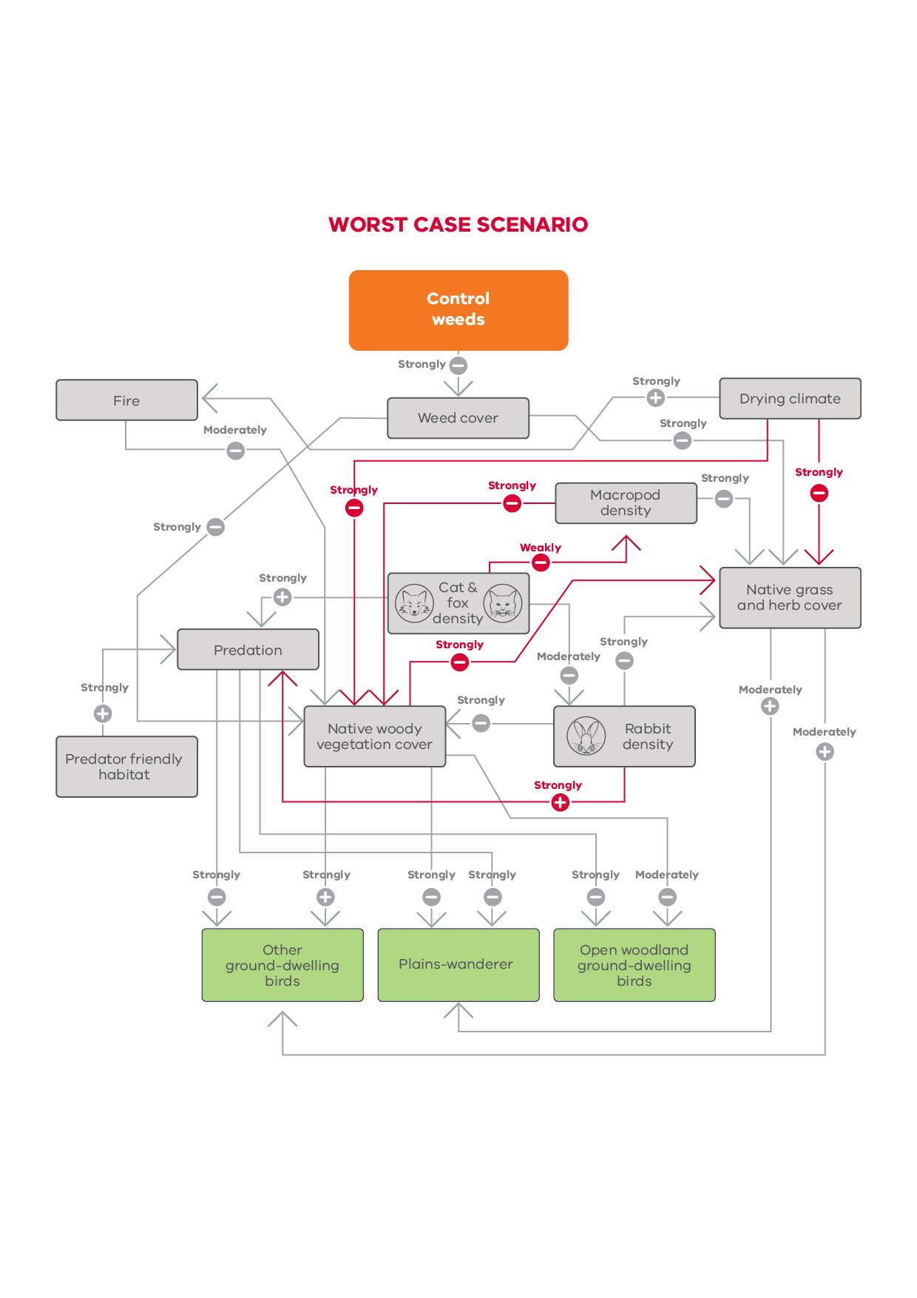

**Figure 40. Worst-case causal model of the impacts of weed control on ground-dwelling birds**

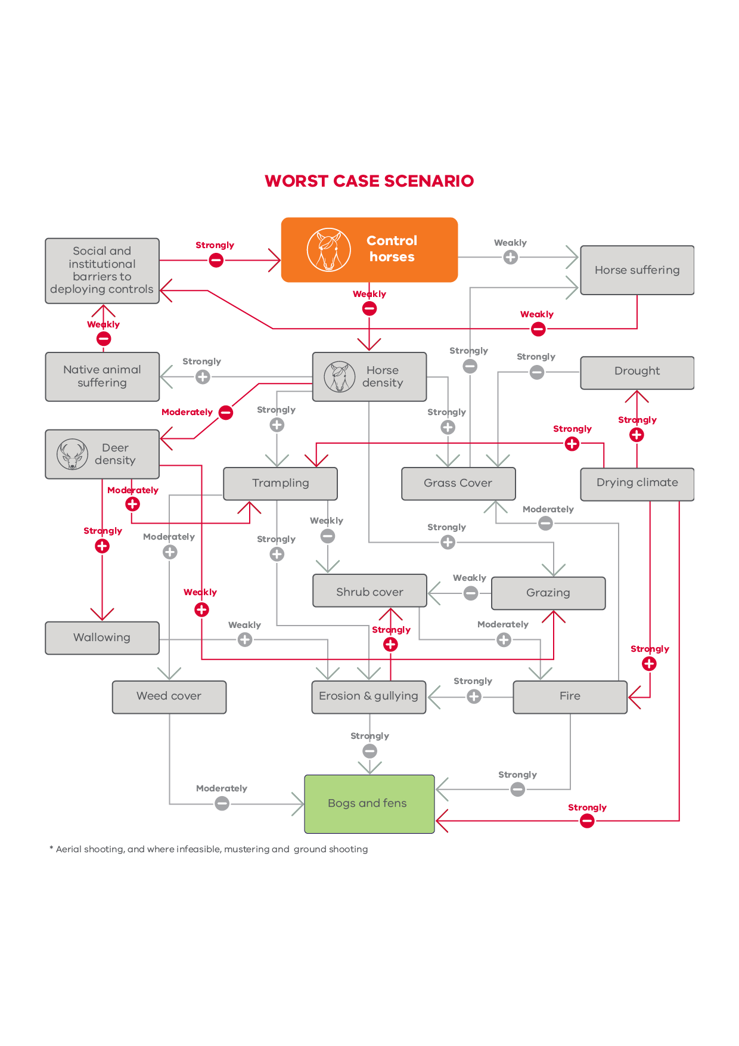

**Figure 41. Worst case causal model of the impacts of horse control on bogs**