|  |
| --- |
| VBA – Mapping |
| How to personalise the MyMap pane in the Victorian Biodiversity Atlas |

### This is a basic step by step guidance document to help you create a Project in preparation for recording your wildlife sightings in the VBA

***Tips:***

*Throughout the VBA each window has a ? in the top right hand corner – this is window-specific help that will provide further details about how to complete the fields.*

*Make sure that you have allowed pop-ups from your browser (you will need to allow these from the VBA site)*

1. You can enter as a Guest or Login using your login name & password (https://vba.dse.vic.gov.au/vba/)
2. Navigate to the Search section in the top left of the Welcome page and then select Species and Surveys > Species Lists & Maps. This can also be done in the Sites Lists & Maps section. On the right hand side of the window you will see a panel labelled MyMap. This is where your map layers can be personalised.
3. MyMap_globeTo add or remove map layers click on the Data Catalogue tool

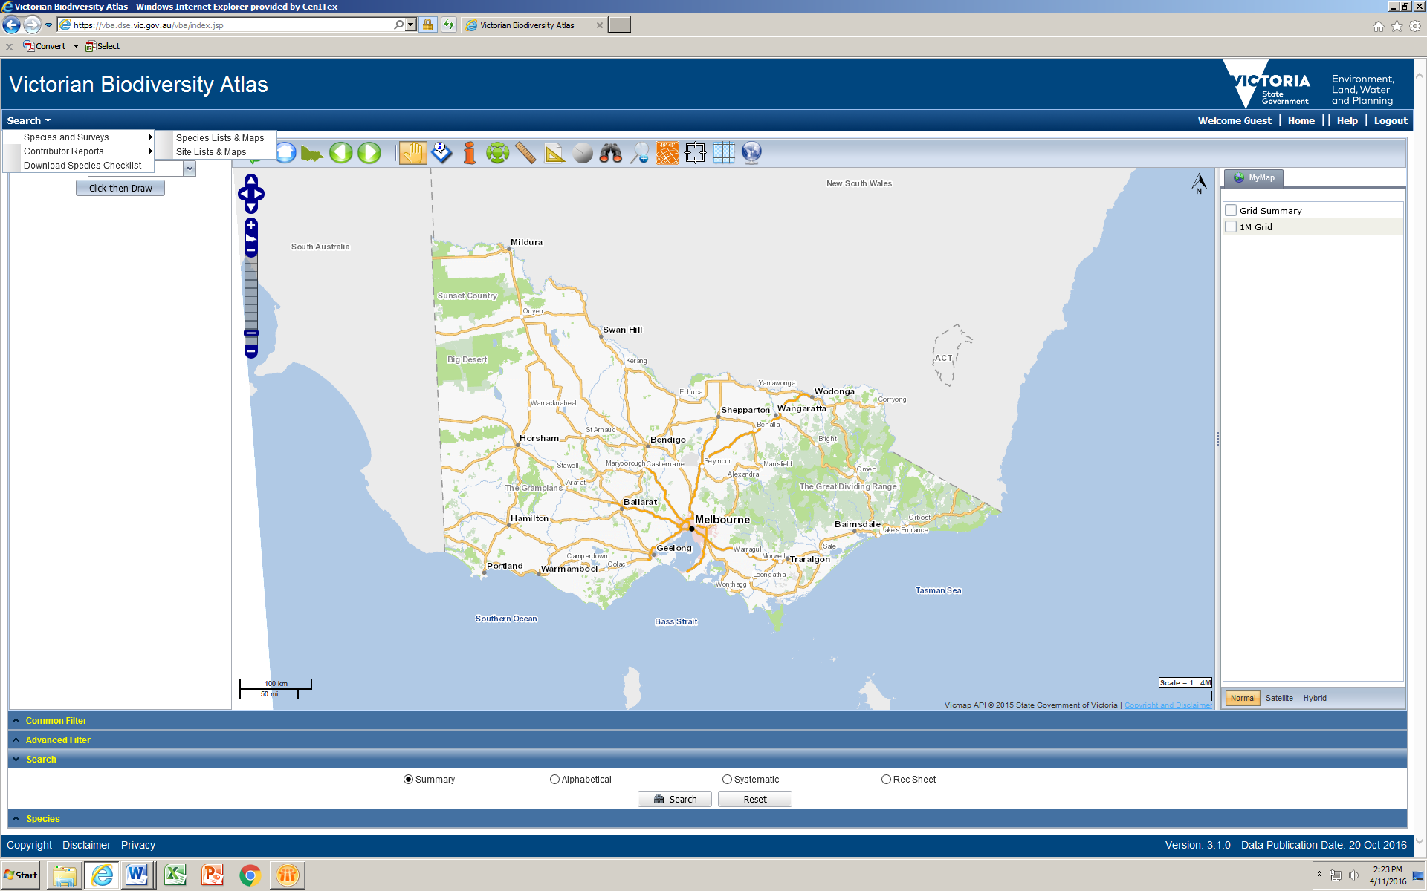

1. From the Data Catalogue window, search for the layer you’re interested in and tick the box to add the layer. To remove the layer, click the **x** in the Selected Layers section. Click OK to return to the main mapping window.

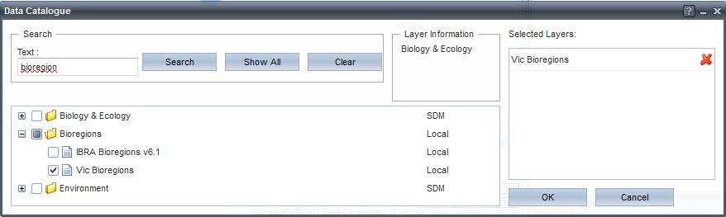

1. To adjust the look of the layers in the MyMap pane, right click on the layer name – a pop-up window will give you the option to: increase/decrease layer transparency (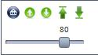) , move the layers above/below other layers (), or to the top or bottom of all the layers ().
2. You can turn on or off the layers by ticking the box next to the layer name. To remove the layer completely, open the Data Catalogue again and click on the **x** next to the layer you want to remove then click OK.

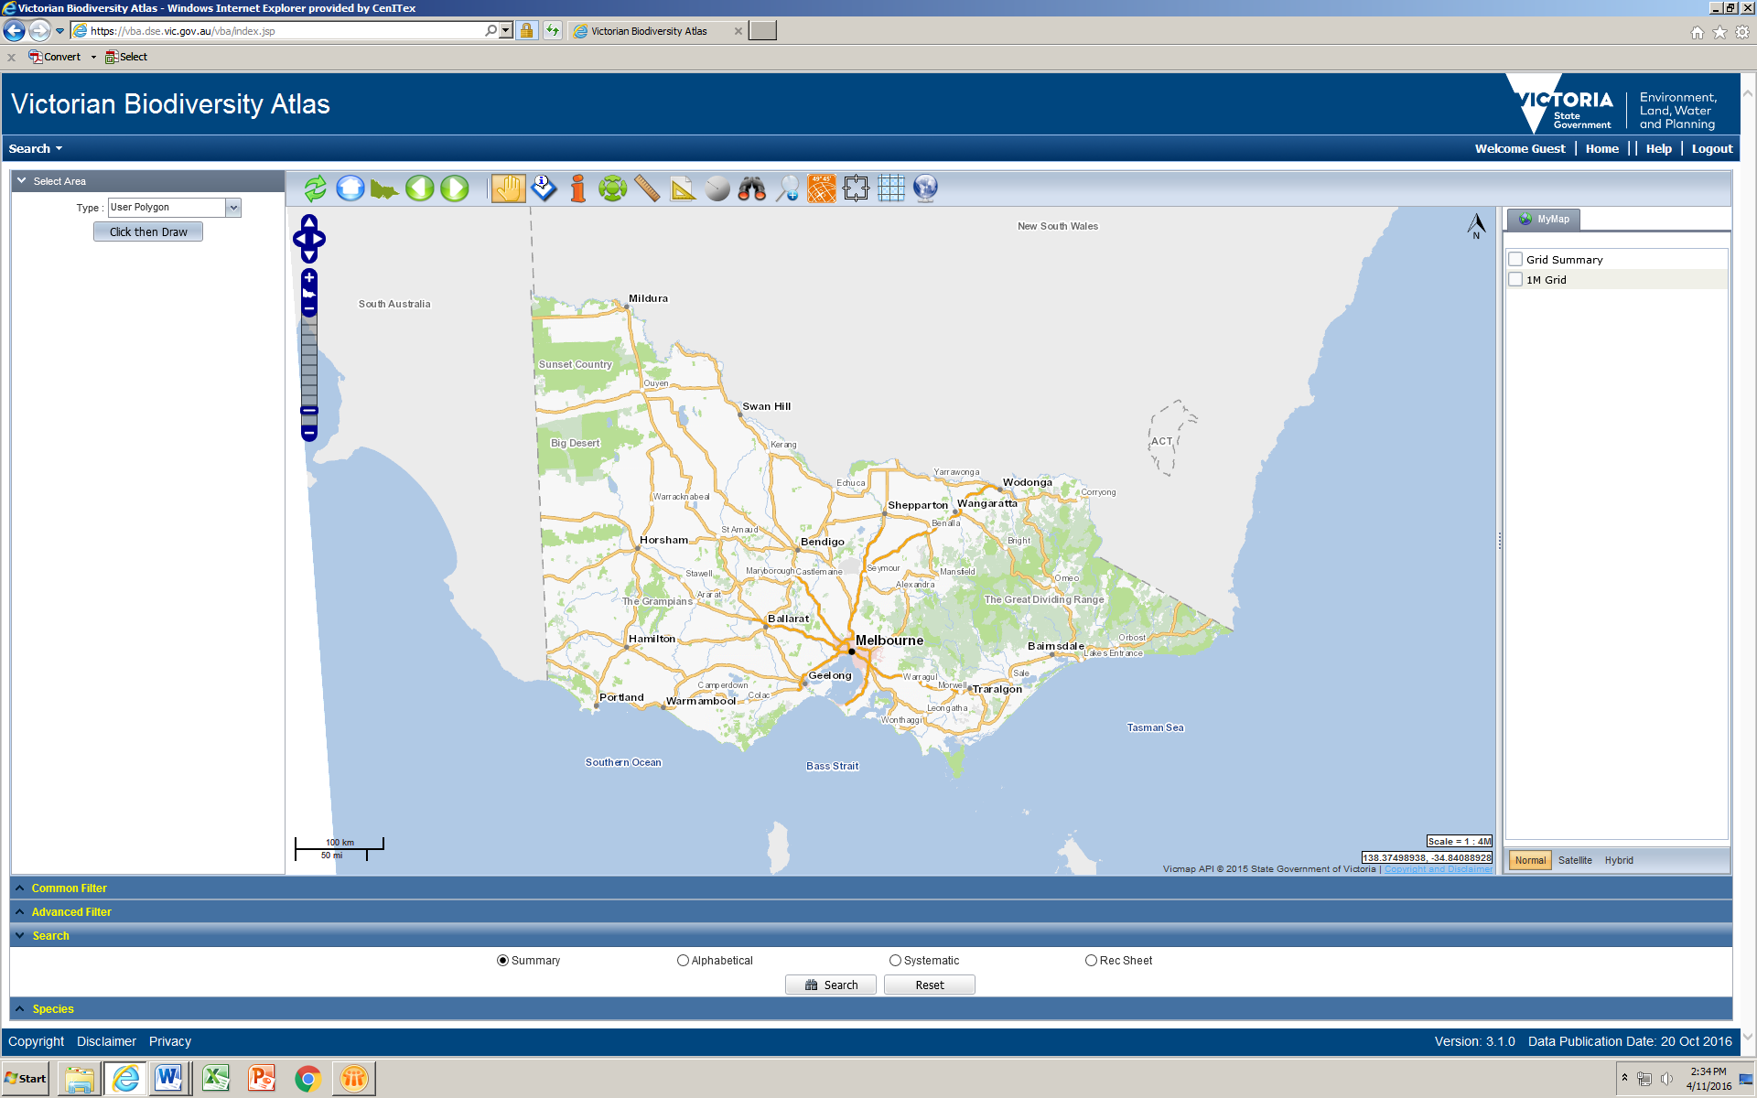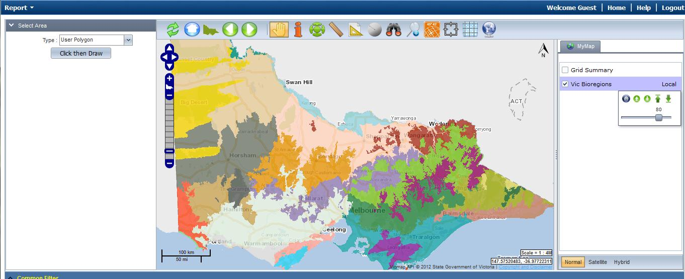

|  |  |
| --- | --- |
| © The State of Victoria Department of Environment, Land, Water and Planning 2017  LogoThis work is licensed under a Creative Commons Attribution 4.0 International licence. You are free to re-use the work under that licence, on the condition that you credit the State of Victoria as author. The licence does not apply to any images, photographs or branding, including the Victorian Coat of Arms, the Victorian Government logo and the Department of Environment, Land, Water and Planning (DELWP) logo. To view a copy of this licence, visit http://creativecommons.org/licenses/by/4.0/  Disclaimer  This publication may be of assistance to you but the State of Victoria and its employees do not guarantee that the publication is without flaw of any kind or is wholly appropriate for your particular purposes and therefore disclaims all liability for any error, loss or other consequence which may arise from you relying on any information in this publication. | Accessibility  If you would like to receive this publication in an alternative format, please telephone the DELWP Customer Service Centre on 136186, email [customer.service@delwp.vic.gov.au](mailto:customer.service@delwp.vic.gov.au) or via the National Relay Service on 133 677 [www.relayservice.com.au](http://www.relayservice.com.au). This document is also available on the internet at [www.delwp.vic.gov.au](http://www.delwp.vic.gov.au). |

|  |
| --- |
| **Related Quick Help Guides:**   * Search - Summary Species List for an Area * Search - Species Distribution Map * Search - Detailed Species List for an Area * Search - Detailed Statewide Records for Single Species |