|  |
| --- |
| VBA Breeding Records |
| How to add a breeding record in the Victorian Biodiversity Atlas |

This is a basic step by step guidance document to help you enter breeding records into the VBA (via **General** **Observations** and via **Projects >Surveys**).

Noting life stage and breeding evidence is a useful tool to confirm active populations and suitable supporting habitat for fauna records. There are many other survey methods to choose from, with minor variations to the process of entering the information. For further support please view the related help documents in the Contribute series listed at the end of this guide.

## *Tips*

*Throughout the VBA each window has a* ***?*** *in the top right hand corner – this is window-specific help that will provide further details about how to complete the fields.*

*Make sure that you have allowed pop-ups from your browser (you will need to allow these from the VBA site)*

*Also, throughout the VBA fields marked with a red dot (●) are mandatory fields and must be completed. The fields marked with a yellow dot (●) are conditional - if you complete one you must complete the others.*

## For General Observations:

1. Create your General Observation, complete the mandatory fields (Discipline, Site location details, Survey name, and Survey date) > Save then select the Species tab at the top left.
2. Add each of your species records by clicking Add Taxon.
3. For the species observed as breeding, select Extra Information – *Breeding* and click Save

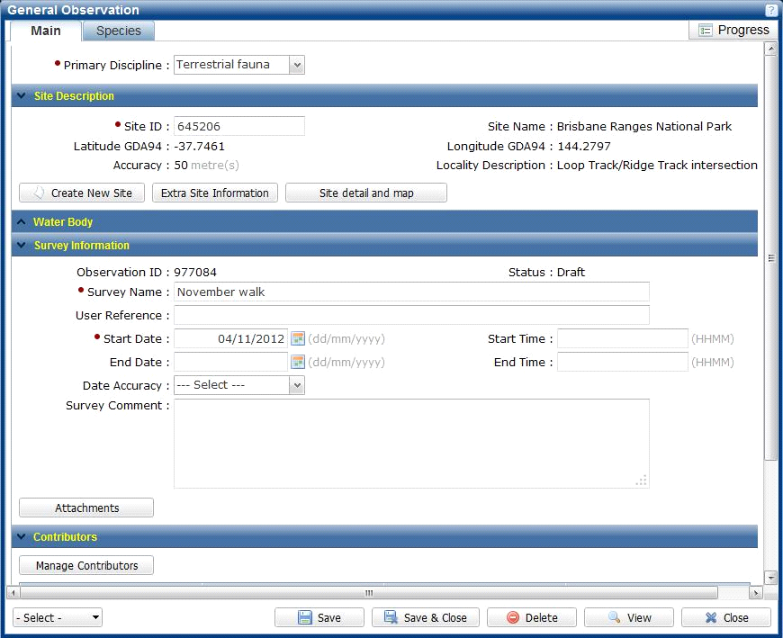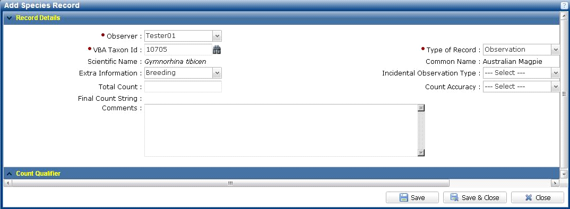

## For structured Surveys:

1. Create your Project, then create your Survey, once you have completed the Main tab fields (Discipline, Site location details, Survey name, Survey date and Contributors) Save and select the Survey Method and Results tab. Add your Survey Method and Save. Select the Species Records tab and add your species.
2. For the species observed as breeding, select Extra Information – *Breeding* from the drop down list.
3. Click on the blue bar titled Individual Details to expand it and select Life Stage – *Breeding*, click Add (the information is now stored with other information about that species record) and click Save.

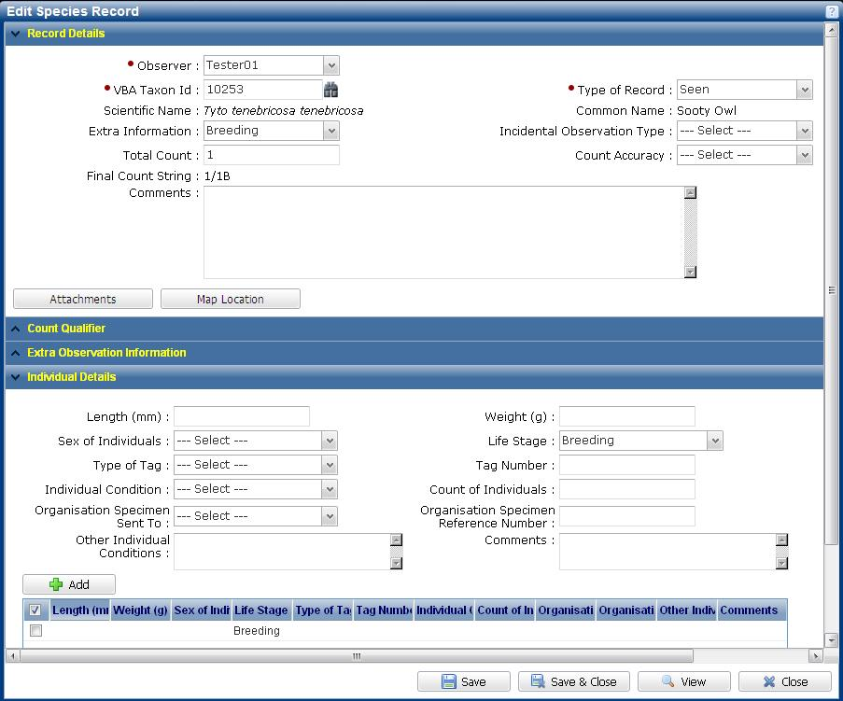

1. You can now Save & Close and complete the rest of your survey data entry

|  |
| --- |
| **Related Quick Help Guides:**   * Contribute - Create a Project * Contribute - Add a Survey and Species Records to a Project * Contribute - Add a Specimen Record * Search - Summary Species List for an Area * Search - Detailed Species List for an area |

|  |  |
| --- | --- |
| © The State of Victoria Department of Environment, Land, Water and Planning 2017  LogoThis work is licensed under a Creative Commons Attribution 4.0 International licence. You are free to re-use the work under that licence, on the condition that you credit the State of Victoria as author. The licence does not apply to any images, photographs or branding, including the Victorian Coat of Arms, the Victorian Government logo and the Department of Environment, Land, Water and Planning (DELWP) logo. To view a copy of this licence, visit http://creativecommons.org/licenses/by/4.0/  Disclaimer  This publication may be of assistance to you but the State of Victoria and its employees do not guarantee that the publication is without flaw of any kind or is wholly appropriate for your particular purposes and therefore disclaims all liability for any error, loss or other consequence which may arise from you relying on any information in this publication. | Accessibility  If you would like to receive this publication in an alternative format, please telephone the DELWP Customer Service Centre on 136186, email [customer.service@delwp.vic.gov.au](mailto:customer.service@delwp.vic.gov.au) or via the National Relay Service on 133 677 [www.relayservice.com.au](http://www.relayservice.com.au). This document is also available on the internet at [www.delwp.vic.gov.au](http://www.delwp.vic.gov.au). |