Strategic Management Prospects version 4
Development update – July 2023
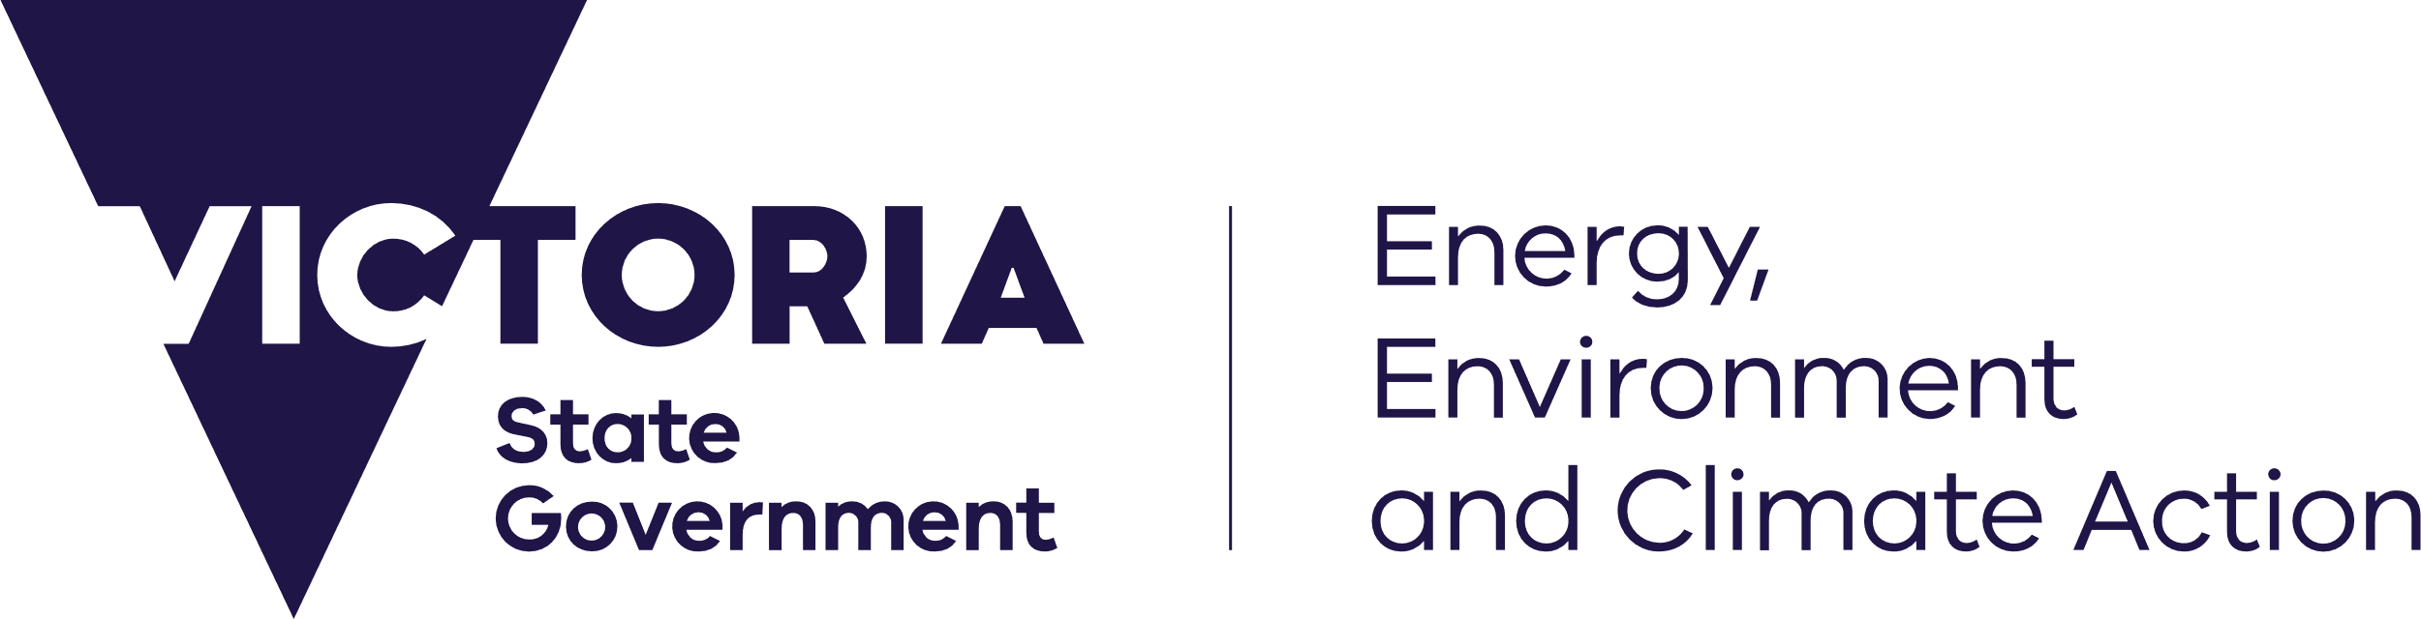

deeca.vic.gov.au

Strategic Management Prospects (SMP) has been updated in NatureKit. SMP version 4 (SMPv4) includes new models and a range of updates to existing models.

New weed models
SMPv4 uses new weed modelling with improved consideration of weed types and control methods (Table 1). These new models contribute to three new management actions in SMP:
- All Weed Control
- Woody Weed Control
- Non-Woody Weed Control

In prior versions of SMP, transformer weeds were included in a single model. Previous versions of SMP used likelihood of occurrence for the weed threat model. The new weed threat models in SMPv4 use predictions of life form ‘abundance’, as represented by proportional cover, to provide a better indication of weediness extent at a site.
The cost models for all weed types no longer include cost considerations of search and detection, consistent with the current approach for the treatment of other threats in SMP. Low-intensity, opportunistic surveillance is still expected to occur when weed management actions are applied.
The new weed models will provide land managers with a more detailed assessment of specific weed threats and the benefits, costs and cost-effectiveness of targeted management actions at any location.
Table 1: New weed models in SMPv4
Model | Weed sub-types
All Weed Control | - Woody weeds with persistent seedbank  - Woody weeds with transient seedbank  - Non-woody weeds with persistent seedbank  - Non-woody weeds with transient seedbank  - Geophytes
Woody Weed Control | - Woody weeds with persistent seedbank  - Woody weeds with transient seedbank
Non-Woody Weed Control | - Non-woody weeds with persistent seedbank  - Non-woody weeds with transient seedbank  - Geophytes
Improved consideration of aquatic species and habitats
SMPv4 models have been updated with data for aquatic species and habitats. For the first time, SMP includes benefits to fish species for some actions.
The estimated benefits of revegetation and permanent protection in riparian areas now includes specific benefits to aquatic species, in addition to terrestrial species that use riparian habitats.
SMPv4 also includes a new management action specific to aquatic species – wetland hydrology restoration, targeted at wetlands that have had their hydrology altered by drain construction. The management action would involve blocking or filling of drainage ditches.
Habitat Distribution Models (HDMs) have been added for over 20 fish species, including 16 listed in the Flora and Fauna Guarantee (FFG) Act (Table 2). Recent updates to HDMs for aquatic reptiles and mammals have also been incorporated into SMPv4, including the vulnerable Platypus, Rakali and the critically endangered Murray River turtle.
Updated models
New and updated habitat mapping has been incorporated for over 100 species, based on stakeholder feedback and/or significant new Victorian Biodiversity Atlas (VBA) records.
Threat models for wild deer, feral goats and feral pigs have been updated to better represent their current distribution, based on feedback from invasive species experts and new data from the VBA and Feral Scan.
With the inclusion of new actions, and more species and habitats being included in SMP’s analyses, the biodiversity benefit and cost-effectiveness rankings of all actions at all locations have been re-run. This has altered the benefit and benefit-cost models in SMPv4 when compared to SMPv3.
New Biodiversity 2037 priority area maps show where undertaking specific actions will contribute to annual reporting on the Biodiversity 2037 Contributing Targets. Priority area maps show the most beneficial locations to undertake each action.
The purpose of the Biodiversity 2037 Priority Areas are to inform reporting against the targets of Biodiversity 2037. The maps are not intended to be used for further analysis or investment decisions outside of this context.

When did the update occur?
SMPv4 was released in NatureKit in July 2023.

What about SMPv3?
With the SMPv4 release, NatureKit includes v4 datasets only. We recommend data from previous versions of SMP is managed with the understanding it is no longer the latest information available.
Want to learn more?
Visit Choosing actions for nature on the DEECA website or contact nature.print@delwp.vic.gov.au.
Table 2: New fish Habitat Distribution Models in SMPv4
Common name (Scientific name) | FFG listing
Silver perch (Bidyanus bidyanus) | Endangered
Murray hardyhead (Craterocephalus fluviatilis) | Critically Endangered
Unspecked Hardyhead (Craterocephalus stercusmuscarum fulvus) | -
River blackfish (Gadopsis marmoratus) | -
River blackfish (upper Wannon River form) (Gadopsis marmoratus (upper Wannon)) | Critically Endangered
Barred galaxias (Galaxias fuscus) | Critically Endangered
Dwarf galaxias (Galaxiella pusilla) | Endangered
Mountain galaxias (Galaxias olidus) | -
Flat-headed galaxias (Galaxias rostratus) | Vulnerable
Striped gudgeon (Gobiomorphus australis) | -
Trout cod (Maccullochella macquariensis) | Endangered
Murray cod (Maccullochella peelii) | Endangered
Golden perch (Macquaria ambigua) | -
Macquarie perch (Macquaria australasica) | Endangered
Murray-Darling rainbowfish (Melanotaenia fluviatilis) | Endangered
Southern purple-spotted gudgeon (Mogurnda adspersa) | Critically Endangered
Yarra pygmy perch (Nannoperca obscura) | Vulnerable
Variegated pygmy perch (Nannoperca variegate) | Endangered
Australian mudfish (Neochanna cleaver) | Endangered
Australian grayling (Prototroctes maraena) | Endangered
Tupong (Pseudaphritis urvillii) | -
Freshwater catfish (Tandanus tandanus) | Endangered

We acknowledge Victorian Traditional Owners and their Elders past and present as the original custodians of Victoria’s land and waters and commit to genuinely partnering with them and Victoria’s Aboriginal community to progress their aspirations.
© The State of Victoria Department of Energy, Environment and Climate Action July 2023.
Creative Commons
This work is licensed under a Creative Commons Attribution 4.0 International licence, visit the Creative Commons website (http://creativecommons.org/licenses/by/4.0/).
You are free to re-use the work under that licence, on the condition that you credit the State of Victoria as author. The licence does not apply to any images, photographs or branding, including the Victorian Coat of Arms, and the Victorian Government and Department logos.
ISBN 978-1-76136-353-5 (pdf/online/MS word)
Disclaimer
This publication may be of assistance to you but the State of Victoria and its employees do not guarantee that the publication is without flaw of any kind or is wholly appropriate for your particular purposes and therefore disclaims all liability for any error, loss or other consequence which may arise from you relying on any information in this publication.
Accessibility
To receive this document in an alternative format, phone the Customer Service Centre on 136 186, email customer.service@delwp.vic.gov.au, or contact National Relay Service on 133 677. Available at DEECA website (www.deeca.vic.gov.au).
This section is intentionally left blank.

