Communications Toolkit
For Victoria’s Environmental Volunteering Groups and Landcarers

Contents

- Attract new volunteers – p.1
- Motivate current volunteers – p.4
- Promote your impact – p.6
- Create a campaign – p.9
- Appendix 1: Communications Plan template – p.13
- Appendix 2: Example persona – p.14
- Appendix 3: Case study template – p.15
- Appendix 4: Media release & alert template – p.15

Attract new volunteers

Knowing who you want to attract and their communication preferences is key to encouraging people to volunteer with you.

Step 1: Create personas

Get specific about the people you’d like to encourage to volunteer with you by creating a short half-page persona for each person/volunteer.

Each persona outlines a fictional character, which you create to represent the different types of people who might be likely to volunteer with you. Your personas might include:
- Matt- Local university student
- Sally – Recently retired
- Pavi- Local business owner

In each persona, you’ll include a character’s age, location, hobbies, time available for volunteering and also their communication preferences. You can then create communications targeted directly at meeting your personas needs. This is more likely to be effective in encouraging people to join you. Learn more: Example persona

Step 2: Outline opportunities

Map your volunteering opportunities and programs to each persona. Do you have specific opportunities that meet your persona’s time availability and needs? If not, you may need to pause and create some before you think about encouraging more people to join you. Then create your list, for example:

Key opportunities for Matt – local uni student
- Join a roster to manage our social media for 1 day a month
- Get a free ticket to the local xx (big name) music festival, by joining our litter squad there. Volunteer 5 hours each day – the rest of the time, head to the stage!

Step 3: Create key messages

Guided by your personas and available opportunities, you’ll now have a good starting point to communicate. But first, you should define what you’re going to say.
Create a few key messages for each persona – no more than 5 straightforward sentences that outline the key reasons that people should join you. The tone and language should be guided by the persona.

Here’s an example:

Key messages for Pavi – local business owner
- Over the past 5 years, volunteers from 10 local businesses have helped us achieve (insert key impacts here), an incredible effort.
- But there’s so much more to do - (insert key local environmental need here)
- You and your employees can make a big difference with just a small amount of time.
- We make team-building corporate volunteering days rewarding and fun – right on your doorstep.
- Join our business volunteering program today, we can design a program just for you – contact us volunteering@yourorganisation.org or call Erin on 04xx xxx xxx.
- You’ll copy and paste these key messages into the content you’ll soon create.

Step 4: Select communication channels

Make a quick list of the places your persona is likely to see your messages.
Here’s some examples:

Channels for Matt – Local university student
- Instagram
- Facebook marketplace
- WhatsApp
- Stall at local market, footy or festival.

Compare this to:

Channels for Sally – Recently retired
- Facebook
- Local newspaper (hardcopy and online)
- Local ABC radio
- Email
- Poster at local doctors, supermarket, church, community hall, library. From your list, think about what’s achievable for you. Can you:
• Create a poster and distribute this for display?
• Set up a stall at a local market?
• Call your local ABC radio and local newspaper and ask a reporter to consider doing a story on your group?

Or do you have a small budget you can use to advertise? You can target ads on Instagram and Facebook directly to people in your target age group and location. A budget of $40 spread across just 2 days of advertising may generate some results.

Step 5: Create and distribute content

Now that you’ve selected the communication channels that best reach your persona, create content for those channels based on your specific opportunities. Your content should be guided by your key messages and follow your brand guidelines to present a consistent and recognisable look.

Here’s an example:

Content for Matt – Local university student
- Poster – include photos of other young volunteers, highlight key opportunity. Distribute to local uni, supermarket, pub
- Sponsored Instagram post – feature photo of young person, key opportunity Creating audience-focused and visually appealing content is easy with a range of free or freemium (offers free or paid option) software.

Here’s some popular software, but there are many others that might better suit your needs.

Popular online content creation tools

There are many useful text, image, graphics and video creation tools available online. Search for stock videos, stock photos Victoria, newsletter creators and easy graphic design.

Step 6: Onboarding communications

It’s important to make it as easy as possible for a new volunteer to join your group and feel welcomed – without too much paperwork or time required.

Ask your new volunteer to fill out a brief form asking a few quick questions about who they are and why they’re joining you. Ask them to attach a photo.

You’ll then have some welcoming content for your social media and e-newsletters to coincide with your new volunteer joining you.

Motivate current volunteers

Keeping your volunteers excited about your cause and impact is key to encouraging them to continue volunteering with you – and strong communications can help.

Step 1: Timing is everything

Time your volunteer communications and activities around your volunteers’ lives and likely availability. Unsure when is best? Ask your volunteers via a quick and informal in-person poll or online survey.

For young volunteers, avoid periods like school and university exams. For businesses and corporate volunteers, avoid End of Financial Year, but think about increasing communications and activities around March. Many businesses have corporate volunteer days that may expire on 30 June, so March might be a good time to connect.

Be aware of key dates for both multicultural and Indigenous volunteers. For example, Ramadan commitments may make it difficult for Muslim volunteers to connect with you during this time, as might NAIDOC Week commitments for Aboriginal volunteers.

Step 2: Keep it simple

Make it quick and easy for your volunteers to know what activities are coming up, what specifically you need help with and what the outcome will be. Avoid jargon, make dates and times easy for people to see first, and be clear about the impact your volunteers can achieve by getting involved.

You might do this via a monthly email newsletter, a WhatsApp or Facebook group, or by sending out a quick group text message.
It’s important to make visually appealing content that catches the interest of your volunteers. Here are some free and freemium online tools to get your started:

Popular online creation tools
There are many useful websites, apps and content generation tools available online. Search for stock videos, stock photos Victoria, newsletter creators, infographic creators and easy graphic design.

Step 3: Celebrate and reward

It’s easy to acknowledge your volunteers and say thank you often – both in person and online. A personal FaceTime or video message from the head of your group to a particular volunteer after an activity will be valued and motivating.

Nominating your volunteers for local, state or national awards is also incredibly motivating.
An end-of-project lunch or end-of-year celebration/ awards ceremony are other common ways of communicating your appreciation and building social connections among your volunteers.

Quick social media shout outs of thanks where you tag your volunteers or a short website blog post are other common ways of expressing gratitude via communications.

Step 4: Take feedback

Ask your volunteers how they feel about your communications and how you could improve. Big organisations might do this via a survey, but for others – a simple chat is best. Look for common themes in what volunteers tell you and take action.

If needed, propose a new way of communicating that better suits your volunteers’ needs and test this for a month. Ask for more feedback and fine tune what you’re doing.

Step 5: Keep it flowing, but not overdone

Dedicate some of your volunteer roles to communications activities. Create some short communication channel guidelines that include processes and timelines.

Train up some volunteers in your social media and e-newsletter and create a roster to share the load wherever possible.

Keeping communications flowing to your volunteers is a great way to boost engagement. Don’t overdo it – one email a month is usually enough, as are a few WhatsApp messages a week. Any more frequent may become a burden and people do switch off.

Step 6: Share the love

If your organisation is out there promoting your impact, you may start to see a little acknowledgement in your community or other positive reinforcement. Always share any positive media coverage or online coverage of award nominations or wins with your group.

Or, a volunteer might win an industry, education, or workplace award or a sports competition. Even if it’s not related to your group, acknowledging a volunteer’s other successes is a great motivator.

Promote your impact

Demonstrating success is a great way to draw people to your group and keep volunteers motivated. They know they’re spending their time wisely with an organisation that is driving positive change.

Step 1: Acknowledge your funders

Keep your funders across your progress and achievements – well before grant acquittals.

Received a grant? Some philanthropic support? Thank these organisations regularly in your social media posts, e-newsletters and other communications. Request their logos and ask if you could include these on any communications about your project.

Step 2: Before and after

Always ensure you have enough photos and videos at the start of any project that clearly demonstrate the problem your volunteer project/activity is going to help address.
Then, take a few more photos and videos on the first day of your project.

At the end of the project, taking some final photos and videos will give you a strong visual journey through your project from inception, delivery and right through to impact.

These before and after communications can make great timelapse videos, website sliders and social media graphics that really quickly visualise impact. These are also useful for grant acquittals, too.

Step 3: The numbers game

Numbers are an easy way for people to quickly understand achievement – which is why data collection is so important. Numbers of rubbish bags collected during a beach clean up – numbers create simple ways to demonstrate impact.

Turn the data you collect from each program, project or initiative into bite-sized infographics that you can share via your social media, e-newsletters, website, in reports and on posters.

Free and freemium software tools like Canva can help you create graphics and short animated videos easily, while software like Infogram can help you create interactive infographics and data visualisations that are great for websites and apps.

Online infographic creation software:

There are many useful graphic design tools available online. Search for infographic creators and easy graphic design.

Step 4: Collect volunteer stories

Use a case study brief template to collect information from volunteers involved in your project, program or initiative.

Where the numbers game will provide you with hard data, these story briefs will help you share the human side of impact and achievement.

You’ll be able to source a range of interesting information from your volunteers, plus photos or videos that will help you promote your impact, attract new volunteers and retain current volunteers.
Step 5: Create impact reports

Depending on the scale of your organisation, how you use your before and after content, data and story briefs to demonstrate your impact will vary.

For smaller groups, you might use the information you collect to create short social media-sized infographics, outlining a specific project and its outcomes.

For larger organisations, partnerships or networks, you might create an annual impact report document or webpage/microsite outlining a series of larger initiatives and successes – bringing in substantial before and after content and numbers and balancing these with your volunteer stories.

Online report creators:
There are many useful report creators available online. Search for publication creator or easy report creator.

Step 6: Get nominating
You’ll likely be familiar with a range of local, statewide, national or even international industry, sector and/or volunteering awards you might be eligible to nominate for. But always check awards program websites, as categories often change from year to year.

Impact reports and infographics from your ‘numbers game’ work will provide great inclusions to nominations, as will information you collect from story briefs submitted by your volunteers.

Being named as a finalist or winning an award is a great way to demonstrate your achievement and impact.

There may also be funding grants you might only just now apply for, equipped with your new impact content that might make you more competitive.

Step 7: Sing out to your stakeholders

Let your funders, supporters and industry bodies know about your impact. A short standalone email, or an item in a regular e-newsletter are easy ways to promote your impact, while also acknowledging your funders, volunteers and supporters.

Step 8: Generate media

It’s easy to create a media alert and invite media along to cover an interesting activity your group is undertaking, but it’s harder to remember to circle back to media at a later time to demonstrate impact.

Use a case study brief template to collect information from your volunteers/project team to create a short media release, of no more than one page.

Google search for media outlets you think might be interested in your story. Local and industry media often are, but it’s more difficult to attract the interest of larger media outlets. To do so, you need to demonstrate something new, different, novel or quirky.

Always watch or read the media outlet’s most recent stories about your topic. You’ll then get an understanding of the types of stories they tell and if your story might be a good fit.

If you’ve done your research and think you have a story that is a good fit for a particular media outlet, Google their editorial or newsroom contact details. You’ll get an email and a phone number. Email them your media release first, but always follow up with a phone call.

Media outlets receive huge numbers of media releases each day, so a phone call follow up will help you stand out and potentially catch the interest of a chief of staff, editor or reporter.

If you have a media outlet wanting to interview your group’s leader and a volunteer, you can use a spokesperson brief template to provide them with the information they need to participate in a successful media interview.

- Case study brief template
- Media alert template
- Media release template

Create a campaign

Campaigns are intensive and time-bound bursts of communication that target specific audiences to help solve problems, highlight opportunities and drive positive change

Step 1: Problem identification
All good campaigns have a compelling reason to exist at a particular time. This could be when a problem arises that your group can help address, or, to amplify an issue at a relevant time of public interest – such as during an awareness week or day of significance.

When considering creating a campaign, begin by writing a one-sentence problem statement that clearly outlines the issue your campaign can help address. Keeping it short and simple makes it easier for people to understand what you’re doing – and to ultimately support you.

An example problem statement may be: ‘We currently don’t have enough volunteers to help deliver the projects we’re receiving grant funding for.’

Then, write one sentence outlining a possible campaign to help address this problem.
‘We will run a volunteer drive around International Volunteer Day in December.’ Keeping it simple is key.

Step 2: Do your research

Jump online and search for similar problems and associated campaigns. Chances are, something has been done before.

Analyse these and see what they did well. Who were they targeting? What messages did they create? What channels did they use? What results did they achieve?

If you can quickly see that a similar campaign has been successful, you may be able to build upon some elements from that campaign while creating your own. Not recreating the wheel can save you an enormous amount of time.

Step 3: Create a campaign plan
Channels list
Here are some common communication channels you might consider for your campaign:

Digital
- Social media – Instagram, Facebook (+ Messenger, Marketplace), YouTube, TikTok
- Ads – including Google ads
- eNewsletters
- Your website
- Stakeholder/partner websites & social media
- Media/publicity - online newspapers, radio, podcasts
- Online listings websites

Offline
- Events
- Posters
- Advertising – outdoor billboards, on transport
- Media/publicity – print, newsletters
- Brochures
- Fact sheets/information sheets
- Kids’ activity packs
- Merchandise

Advocacy
- Submissions to parliamentary inquiries
- Letters to MPs & Ministers
- Letters to parliamentary committees, parliamentary friends groups
- Petitions

Digital
- Social media – Instagram, Facebook (+ Messenger, Marketplace), YouTube, TikTok
- Ads – including Google ads
- eNewsletters
- Your website
- Stakeholder/partner websites & social media
- Media/publicity - online newspapers, radio, podcasts
- Online listings websites
Offline
- Events
- Posters
- Advertising – outdoor billboards, on transport
- Media/publicity – print, newsletters
- Brochures
- Fact sheets/information sheets
- Kids’ activity packs
- Merchandise
Advocacy
- Submissions to parliamentary inquiries
- Letters to MPs & Ministers
- Letters to parliamentary committees, parliamentary friends groups
- Petitions

Creating a short campaign plan document that isn’t too long makes it easier for people to help you take your campaign from idea to reality.

Your campaign plan should include the following:

- Campaign overview: Problem statement, campaign purpose, name, duration
- Goals
- Target audiences
- Messages
- Talent/spokespeople
- Risks/mitigations
- Communication channels
- Tactics
- Activity plan
- Evaluation approach.

Tactics list

Here are some tactics you might consider for your campaign:

Digital
- Social media posts calendar – with text and graphics
- 1-minute campaign overview video
- Other short videos
- eNewsletter each week of campaign
- Advertising – via social media or Google
- Creating and distributing a campaign kit where supporters, stakeholders & media can easily access key facts, graphics and cut-and- paste text for download

Offline
- Engaging an ambassador/ influencer (this can be unpaid)
- Holding your own event – including a media event
- Having a tent/space at another event
- Creating posters & distributing to local pub, uni, supermarket noticeboard, community centre
- Creating and distributing a media release, participating in media interviews
- Creating branded merchandise, such as a Keep Cup

Advocacy
- Writing a submission to a parliamentary inquiry
Letters to MPs, Ministers, Local councillors
- Writing a letter to a parliamentary friends group
- Letters to parliamentary committees; council committees

Step 4: Begin production

Your campaign plan will outline a list of items for production. You should begin by creating an overarching visual design for your campaign (the ‘creative’ look-and-feel), which is aligned with your brand.

You can then use the campaign creative to rollout graphic design and videos for social media, eNewsletters and other channels.

For most social media, you’ll need to create some videos to go with your posts and stories; for a media launch event, you might need a pull-up banner that people getting interviewed stand in front of.

Graphic designers and videographers will help your campaign look and stories come to life, so think visual first.

You should now also begin to collect stories from your spokespeople and case studies. Use the case study brief template to help you do this.

These story briefs should provide you with the content you need to create any media events or media releases and also strong social media content.

Step 5: Go live

Follow your campaign plan to successfully launch your campaign. This may be a launch through social media, or via a media event. You’ll often follow up your launch with an eNewsletter, a steady stream of social media as per your social media calendar and other media throughout the duration of your campaign.

Keep your supporters updated as you progress through the campaign and share your results.
Once your campaign is over, use digital analytics from your social media channels, eNewsletter and website analytics to help evaluate your success. Also include offline metrics like event attendees, or results generated by your advocacy work.

Websites, apps, software

There are many useful websites, apps and content generation available online. Search for stock videos, stock photos Victoria, newsletter creators, infographic creators and easy graphic design.

Appendices

Appendix 1: Communications Plan template

CAMPAIGN OVERVIEW
Brief overview here. Include:
• Problem statement
• Campaign purpose
• Campaign name
• Concept overview (main campaign idea)
• Duration
CAMPAIGN GOALS
If successful, from xx/xx/2023 to xx/xx/2023, this campaign will achieve: 1. xxx 2. xxx 3. xxx
AUDIENCES
Target audiences: 1. xxx 2. xxx
KEY MESSAGES
General key messages:
(Limit to 8 if possible) • Xxx • Xxx
Call-to-action:
(Ends each communication, often a link to webpage)
• xxxx
Hashtags:
• #xxx

TALENT / SPOKESPEOPLE
- Your organisation spokesperson: xxx
- Case study: xxx
- Ambassador: xxx
- Influencers: xxx
RISKS & MITIGATIONS
- Risk 1:
- Mitigation:

- Risk 2:
- Mitigation:
COMMUNICATION CHANNELS
List here
KEY TACTICS
List top 5 here
MEDIA ACTIVITIES
ACTIVITY | WHO | WHEN | ON AIR / PUBLISH
NEWSLETTER ACTIVITIES
ACTIVITY | WHO | WHEN | ON AIR / PUBLISH
SOCIAL MEDIA ACTIVITIES
ACTIVITY | WHO | WHEN | ANGLE
Kick off post
Case study post
Toolkit post

Appendix 2: Example persona

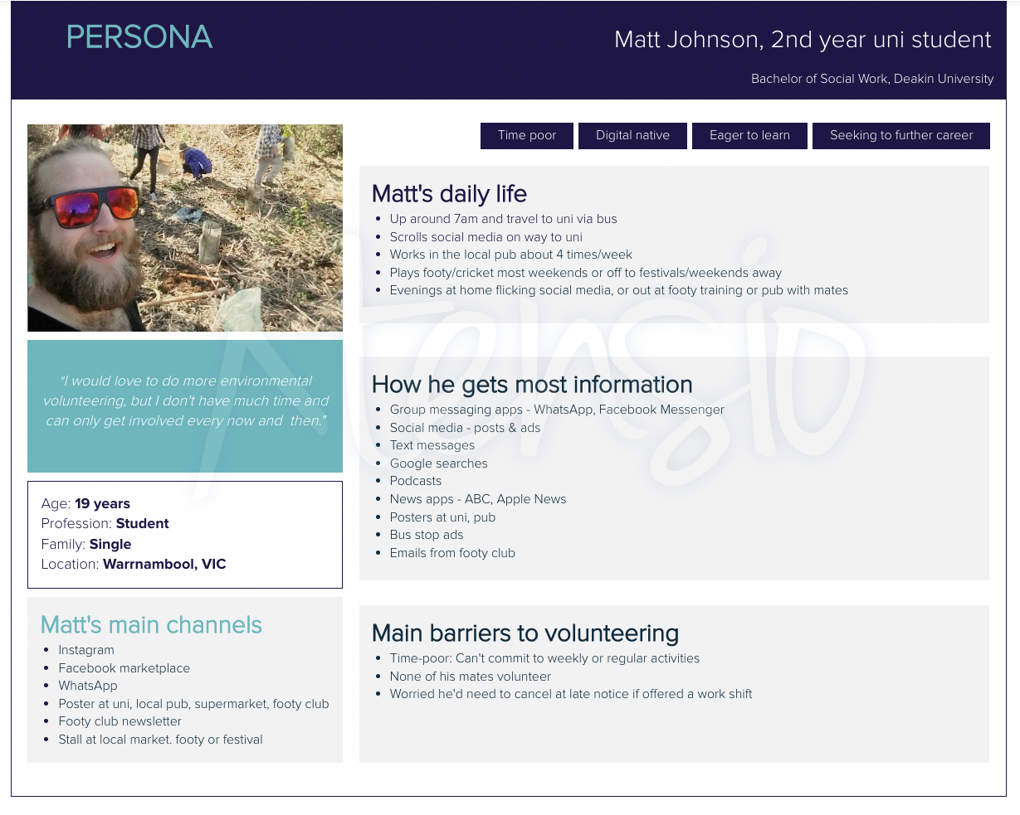

Appendix 3: Case study template

Case study brief
xxxx (name of project)
We’re collecting stories from volunteers and others to help us communicate about who we are, what we do and the impact we’re creating. Information from this document may be used by us to create social media posts, newsletter content or materials for media.

If you have any questions, please contact xxxx

Your name, age, location & profession
Contact details
Your role with us
When did you first become involved with us and why?
How often do you volunteer with us? | E.g – a few times a week/month/year
Name of this project you’re involved in
Briefly outline the project | 3 dot points here
Please provide your top 3 highlights of working on this project | 1 xx 2 xxx 3 xxx
Direct quotes x 2 sentences we can use in the case study stories (e.g. what are your hopes for the future of xxx) | Quote 1: “ Quote 2: “
Please attach a minimum of 4 relevant photos and 1 video (if you have one) that we can use | Please attach photos or videos to your email response
Links to more info | Please include links to any newsletters or online articles and news reports about this project

Appendix 4: Media release template
YOUR LOGO HERE

Media Release
Friday xx August 2023

Headline here
Subheading here

XXXX (Your organisation name) is celebrating/marking xxx (main point here).

Maximum 4 sentences here describing who, what, where, when, how, why.

Quotes from xxx (name), xxx (role at your organisation): “xxxx. “xxxxxxx.”
Quotes from xxx (name), xxx (e.g volunteer/case study)): “xxxx. “xxxxxxx.”

Media contact: xxx – 04xx xxx xxx - email

Appendix 5: Media alert template
YOUR LOGO HERE

Media Invite
Friday xx August 2023

**Media alert** Headline here
Media are invited to join xxx (your organisation name here) at the launch of xxxx

WHAT: Launch of xxx
DATE & TIME: Friday xx/09/23: 10.00am-10.30am
LOCATION: Address here
ONSITE CONTACT: Name, role, mobile, email address

AVAILABLE FOR VISION/ PICS:
• xxx
• xxx

PLEASE USE THE FOLLOWING IN YOUR REPORT: Your website link here MEDIA CONTACT: Name 04xx xxx xxx I email here

