delwp.vic.gov.au

|  |
| --- |
| Threatened Species and Communities Risk Assessment  Tranche 1 Permanent Protections |

September 2022

|  |  |
| --- | --- |
|  |  |

Photo credit

Giant Burrowing Frog in East Gippsland. Photo Credit: Nick Clemann, DELWP.

|  |
| --- |
| Acknowledgment  We acknowledge and respect Victorian Traditional Owners as the original custodians of Victoria's land and waters, their unique ability to care for Country and deep spiritual connection to it. We honour Elders past and present whose knowledge and wisdom has ensured the continuation of culture and traditional practices.  We are committed to genuinely partner, and meaningfully engage, with Victoria's Traditional Owners and Aboriginal communities to support the protection of Country, the maintenance of spiritual and cultural practices and their broader aspirations in the 21st century and beyond. |
| © The State of Victoria Department of Environment, Land, Water and Planning 2022  LogoThis work is licensed under a Creative Commons Attribution 4.0 International licence. You are free to re-use the work under that licence, on the condition that you credit the State of Victoria as author. The licence does not apply to any images, photographs or branding, including the Victorian Coat of Arms, the Victorian Government logo and the Department of Environment, Land, Water and Planning (DELWP) logo. To view a copy of this licence, visit <http://creativecommons.org/licenses/by/4.0/>  **ISBN** 978-1-76136-069-5 **(pdf/online/MS word)**  Disclaimer  This publication may be of assistance to you but the State of Victoria and its employees do not guarantee that the publication is without flaw of any kind or is wholly appropriate for your particular purposes and therefore disclaims all liability for any error, loss or other consequence which may arise from you relying on any information in this publication.  Accessibility  If you would like to receive this publication in an alternative format, please telephone the DELWP Customer Service Centre on 136186, email [customer.service@delwp.vic.gov.au](mailto:customer.service@delwp.vic.gov.au), or via the National Relay Service on 133 677 [www.relayservice.com.au](http://www.relayservice.com.au). This document is also available on the internet at [www.delwp.vic.gov.au](http://www.delwp.vic.gov.au). |

Contents

1. Introduction 3

1.1 Updated data 3

1.2 Future risk assessments 3

1.3 Definitions 3

1.4 New information 3

1.5 Methods 4

2. Terrestrial fauna – Mammals 5

2.1 Leadbeater's Possum (*Gymnobelideus leadbeateri*) 5

2.2 Smoky Mouse (*Pseudomys fumeus*) 7

2.3 Southern Greater Glider (*Petauroides volans*) 8

3. Terrestrial fauna – Birds 13

3.1 Glossy Black-Cockatoo (*Calyptorhynchus lathami*) 13

3.2 Masked Owl (*Tyto novaehollandiae*) 16

4. Terrestrial fauna – Reptiles 17

4.1 Diamond Python (*Morelia spilota spilota*) 17

4.2 Eastern She-oak Skink (*Cyclodomorphus michaeli*) 18

5. Terrestrial fauna – Amphibians 19

5.1 Giant Burrowing Frog (*Heleioporus australiacus flavopunctatus*) 19

5.2 Martin’s Toadlet (*Uperoleia martini*) 22

5.3 Watson’s Tree Frog (*Litoria watsoni*) 23

6. Aquatic fauna 25

6.1 Alpine Spiny Crayfish (*Euastacus crassus*) 26

6.2 Barred Galaxias (*Galaxias fuscus*) 28

6.3 Curve-tail Burrowing Crayfish (*Engaeus curvisuturus*) 30

6.4 Orbost Spiny Crayfish (*Euastacus diversus*) 32

6.5 Tapered Galaxias (*Galaxias lanceolatus*) 34

7. Plants 35

7.1 Colquhoun Grevillea (*Grevillea celata*) 35

7.2 Grampians Bitter-pea (*Daviesia laevis*) 36

7.3 Mount Cole Grevillea (*Grevillea montis–cole* subsp. *montis–cole*) 37

7.4 Round-leaf Pomaderris (*Pomaderris vacciniifolia*) 38

7.5 Slender Tree-fern (*Cyathea cunninghamii*) 39

7.6 Tall Astelia (*Astelia australiana*) 40

8. Ecological communities 41

8.1 Ecological communities 41

8.2 Cool Temperate Rainforest 43

8.3 Cool Temperate Mixed Forest 44

8.4 Warm Temperate Rainforest (East Gippsland Alluvial Terraces) 45

8.5 Warm Temperate Rainforest (Far East Gippsland) 47

8.6 Warm Temperate Rainforest (Strzelecki Ranges) 48

9. Species not requiring additional protections 49

10. References 53

Appendix 1 – Methods 55

Appendix 2 – Soil absorption of EVCs 57

Appendix 3 – Maps 58

List of figures

**Figure 1.** Area of suitable habitat for Southern Greater Gliders in East Gippsland in 1980s (top) and current (bottom) (Wagner *et al.* 2020) 10

**Figure 2.** Diagram of proposed Future Code amendment 14

**Figure 3.** Example detection of a threatened aquatic species, existing Code minimum buffers and filter strips (example from sites with low water quality risk), and additional buffering from proposed prescriptions (example from galaxiid species in environments with high soil absorption capacity). Dashed line indicates 1 km radius around detections, red line shows how the 1 km radius has been modified in response to local hydrological conditions. 27

**Figure 4.** Table 16 in the Code of Practice for Timber Production related to buffer widths for Rainforest Sites of Significance 41

# Introduction

Victoria’s five modernised Regional Forest Agreements (RFAs) include a range of objectives and commitments relating to listed species and communities. Clause 25K of the Central Highlands RFA (and related clauses in the other RFAs) provides the requirements of Victoria in relation to the Threatened Species and Communities Risk Assessment (TSCRA). The RFAs state:

*(Victoria will) … use reasonable endeavours to implement permanent protections and any other changes to the Forest Management System required for the Listed Species or Community within 24 months (of the relevant date).*

The “Tranche 1” risk assessment comprises 79 species and communities that were listed under Victoria’s *Flora and Fauna Guarantee Act 1988* (FFG Act) or the Commonwealth *Environment Protection and Biodiversity Conservation Act 1999* (EPBC Act), at the time of the commencement of the modernised agreements. It includes many high-profile species and communities including Leadbeater’s Possum; Southern Greater Glider; large forest owls; Long-footed Potoroo; Giant Burrowing Frog; Cool Temperate Rainforest; and aquatic species – freshwater crayfish and Galaxiids (small native fish).

A risk assessment was completed for these species and communities in October 2020. Where required, interim protections were approved in April 2021. Permanent protections and management actions now need to be implemented in the Victorian Forest Management System (VFMS).

## Updated data

The original risk assessment was based on the 2015 forestry operations “net harvest area” spatial layer, which identified ~400,000 ha of available and merchantable forest across eastern Victoria. Estimates of each species’ potential “exposure” to timber harvesting was based on these data. New data, the 2022 “operable area” spatial layer, refined the potential suitable area for forestry operations to ~160,000 ha across eastern Victoria, based on forest type and forest age. DELWP has re-assessed the potential exposure to species and communities from forestry operations using this layer. The risk rating from the original 2020 assessment has not been amended, instead proposed interim and permanent protections have been reconsidered based on the revised potential exposure to forestry operations.

## Future risk assessments

The “Tranche 2” risk assessments, triggered by the listing of more than 1,300 species as threatened under the FFG Act in May 2021, have also been completed. The TSCRA Tranche 2 report recommends interim protections for 19 species potentially at risk from forestry operations in the short term. Interim protections are proposed to be implemented concurrently with Tranche 1 permanent protections. Permanent protections for Tranche 2 species are due to be implemented by May 2023, in accordance with the RFAs. The TSCRA process is an ongoing requirement under Victoria’s RFAs. As species or communities are added to either the EPBC or FFG Threatened Lists, or their conservation status changes, a new risk assessment is triggered. This will continue while the RFAs are in place.

## Definitions

*Listed species and communities* means a species, taxon, or community:

listed under Part 13 of the EPBC Act; or Part 3 of the FFG Act; and

that is, or has the potential to be, impacted by Forestry Operations.

*Permanent protections* are interpreted as longer-term (compared to interim) measures that are regulatory in nature – in this case, relating to the forest zoning scheme or Victorian *Code of Practice for Timber Production 2014* (the Code). For some measures, formalisation of permanent protections will occur at the next available opportunity (e.g. through future Code variations). The proposed permanent protections have been informed by scientific literature, expert opinion, and spatial analysis.

## New information

Recommended protections outlined in this document are intended to be ongoing yet also adaptive where appropriate. Victoria’s renewed RFAs have embedded review requirements, such as the TSCRA process itself and the requirement to undertake a comprehensive review of the Code by December 2023, which include consideration of threatened species protections.

Under the RFAs, Victoria recognises that priorities can change in light of new information and science. This includes new research on listed species and communities, forest ecosystems and threatening processes. As new information arises regarding the distribution and abundance of listed species, the extent and condition of listed communities, the response of listed species and communities to disturbance or the effectiveness of current protection measures, changes to the permanent protections would be considered where there is clear evidence of the need for change, noting that decisions to amend the Code lie with the Minister and government.

DELWP is currently undertaking survey and research projects that will inform some of the recommended protections (e.g. a sedimentation research study to understand appropriate buffer widths). It is expected this will continue and new information may arise over the life of the RFAs that may lead to amendments to the permanent protections.

## Methods

The methods used in the 2020 risk assessment are summarised in the report for that risk assessment ([available online](https://www.environment.vic.gov.au/__data/assets/pdf_file/0040/499936/Threatened-species-and-communities-risk-assessment.pdf)). Risk rating, consequence and likelihood descriptors are provided in the methods document. Experts were asked to provide a rating based on the information available to them and using their expert judgement. Experts were provided with the details of any Code prescription that applied. In general, published literature on the effectiveness or otherwise of Code prescriptions is limited; experts were required to use their judgement to inform the selection of the effectiveness ratings. The independent scientific reviews (conducted by Woinarski, Dell and Casanova in 2020) determined that the approach and methodologies applied were appropriate to inform whether interim protections and management should be undertaken, and that the methods represented a standard and appropriate approach to risk assessment and consideration of mitigation options.

A follow-up expert consultation process was undertaken in October 2021 to determine whether any new information relevant to the original assessment had arisen and to assess the impact this new information might have on the risk assessment outcomes and any proposed permanent protections. Where new information was available, this has been described in the relevant section for that species or community. A total of 28 DELWP staff contributed to the second round of expert consultation. Contributing staff included Natural Environment Programs staff in DELWP’s regions and the Arthur Rylah Institute for Environmental Research (ARI). More detail on these methods is available in Appendix 1.

##### Structure of this document

The following sections provide a summary of the key findings of the risk assessments and the recommended protections for the species and communities at risk from forestry operations. The summaries are organised by broad groupings: terrestrial fauna, aquatic fauna, plants and ecological communities. Terrestrial fauna is further divided into mammals, birds, reptiles and amphibians. The summaries are then ordered alphabetically according to common name within each group.

# Terrestrial fauna – Mammals

## Leadbeater's Possum (*Gymnobelideus leadbeateri*)

### Status

A total of 406,715 hectares (ha) falls within the modelled habitat for this species. The species is listed as Critically Endangered in Australia (FFG Act and EPBC Act). The species was not impacted by the 2019-20 bushfires but was significantly impacted by the 2009 Black Saturday bushfires.

### Exposure

A risk assessment was conducted for the Leadbeater’s Possum in October 2020. The species was assessed as being at significant risk from forestry operations in the Central Highlands RFA Region. This was based on the modelled habitat containing 87,500 ha (22%) of merchantable timber based on the 2015 net harvest area layer. No interim protections were deemed necessary at the time of the 2020 risk assessment for forestry operations.

Using the revised operable area layer, the modelled habitat contains 42,746 ha of merchantable timber (11%). This includes 41,382 ha (11%) in the Central Highlands RFA Region, 1,063 ha (5%) in the Gippsland RFA Region, and 302 ha (4%) in the North East RFA Region. Permanent protections were still deemed necessary.

There are Code prescriptions for the species in Central Highlands FMAs:

Colony - Apply a protection area of 200 m radius centred on each Leadbeater's Possum colony.

Zone 1A Habitat - Apply a protection area over areas of Zone 1A habitat where there are more than 10 hollow-bearing trees per 3 ha in patches greater than 3 ha. (Ensure Zone 1A habitat is not salvage logged).

Zone 1B Habitat - Apply a protection area over Zone 1B habitat where there are more than 12 hollow-bearing trees per 3 ha in patches greater than 10 ha and wattle density exceeds 5 m2/ha. This prescription applies until either of the two Zone 1B attributes: 1. the presence of dead mature or senescent living trees; or 2. wattle understorey no longer exists.

### Expert advice

Experts considered that the protection of colonies with the 200 m buffer has been effective, in part as it has led to increased surveys (including by VicForests, government and the community), which have located more colonies than may have been expected. The Zone 1 habitat prescriptions (including 2014 amendments) have protected few additional areas due to the scarcity of this habitat in areas available for harvesting. Zone 1 habitat is now scarce in areas available for harvesting because most of it has already been zoned as Special Protection Zone (SPZ). This prescription currently only applies within the Central Highlands RFA Region. While it is voluntarily applied within the Gippsland RFA Region, it would be useful to formalise this arrangement, and consider applying it to the North East RFA Region if future detections occur there. There are currently no records of the species in the North East, but suitable habitat has been modelled and the species may be located there with further survey work.

Further research is warranted to assess the persistence of colonies within SPZs, especially in landscapes that have experienced fire or timber harvesting. The post-fire recovery of Leadbeater’s Possum populations is positively associated with the presence of nearby unburnt refugia and recolonisation likely occurs from within the fire footprint (J Cripps pers. comm. 2021). Recent work (Nitschke *et al.* 2020) found that while bushfire has a greater influence than timber harvesting on habitat availability for the species, timber harvesting is likely to lead to landscape homogeneity (and decreased habitat suitability) when more than 200-300 ha of Leadbeater’s Possum habitat is harvested annually.

The Commonwealth Department of Agriculture, Water and the Environment published an updated conservation advice for Leadbeater’s Possum in 2019 (DAWE 2019). Among the conservation and management actions in the conservation advice was the following statement: *Retain and protect, with appropriate buffers, all live and dead trees that are either large (>150 cm DBH) or hollow-bearing (where >80 cm DBH) in montane Ash forests within the distribution of Leadbeater’s Possum.* Consideration should be given toaligning the Code requirements with the conservation advice and any future approved recovery plan. At present, live hollow-bearing trees are retained but not necessarily buffered. This leaves the tree exposed and many collapse before the regeneration around them is sufficiently developed to provide some protection from wind. A buffer of unharvested vegetation is likely to provide more protection. Less protection is currently provided to dead hollow-bearing trees on coupes; however these are critical denning sites. If left standing and protected by a buffer of trees around them in a harvested coupe, the presence of these den sites would enable more rapid recolonisation when the regeneration is old enough to provide foraging habitat (at around 10 years post-disturbance).

### Conclusion

The critically endangered status of the species and its endemic nature warrant further permanent protections. Currently, only minor changes are proposed to formalise existing arrangements and improve connectivity across roads. If the national recovery plan prepared by the Commonwealth Department of Agriculture, Water and the Environment is approved, additional permanent protections for large and hollow-bearing trees could be considered to align with measures set out in the recovery plan.

### Interim protection

No interim protections were deemed necessary at the time of the 2020 risk assessment for forestry operations.

### Recommended protections

##### Future Code amendment

The current Code prescription that applies to Leadbeater’s Possum colonies and habitat in the Central Highlands FMAs should be extended to Gippsland RFA Region and potentially to the North East RFA Region.

Consideration should also be given to additional protections for large and hollow-bearing trees and the need to extend the Central Highlands RFA Region prescription to retain hollow-bearing trees.

### Priority management actions

* Assess persistence of colonies within SPZs, especially in burnt/ harvested landscapes;
* Assess effectiveness of different sized buffers around colonies;
* Develop spatial population viability models to determine probable minimum population size and to identify areas of highest habitat value over the next 50 years under various scenarios (climate change, timber harvesting, bushfires, planned burning).

## Smoky Mouse (*Pseudomys fumeus*)

### Status

A total of 1,962,580 ha falls within the modelled habitat for this species. The species is listed as Endangered in Australia under the FFG Act and EPBC Act. The species was impacted by the 2019-20 bushfires (22% of modelled habitat within the 2019-20 bushfire footprint, 13% burnt by high severity fire).

### Exposure

A risk assessment was conducted for the Smoky Mouse in October 2020. The species was assessed as being at medium risk from forestry operations in the Central Highlands, East Gippsland, Gippsland and North East RFA Regions. This was based on the modelled habitat containing 160,239 ha (8%) of merchantable timber based on the 2015 net harvest area layer.

Using the revised operable area layer, the modelled habitat contains 69,692 ha of merchantable timber (4%). This includes 38,651 ha (8%) in the Central Highlands RFA Region, 9,260 ha (5%) in the East Gippsland RFA Region, 10,349 ha (2%) in the Gippsland RFA Region, 9,119 ha (2%) in the North East RFA Region, and 2,312 ha (2%) in the West RFA Region. Permanent protections were still deemed necessary.

There are Code prescriptions for the species in Central Highlands, Gippsland, North East and Portland-Horsham FMAs: Apply a management area of approximately 100 ha over records incorporating the detection site wherever possible. Conduct a site inspection and detailed planning in consultation with the Department to ensure the species is adequately protected during timber harvesting operations or road construction commencement, incorporating any relevant information from studies of the species. Note: The Secretary intends to review this strategy when 10 Smoky Mouse SMZ are established or in light of further research regarding the conservation status of the species and its response to disturbance.

### Expert advice

Post-2019-20 bushfire monitoring detected the species at three of 83 sites with historical records. Two sites were in unburnt habitat on the edge of the fire scar, while the third was in severely burnt habitat 2 km from the fire perimeter. The species was not detected in three of the five historically occupied areas. Detection rates were low, suggesting low abundance even at occupied sites (Burns, 2021).

While the importance of the Central Highlands populations to the persistence of the species was emphasised, no additional permanent protections were nominated. Instead, experts identified the need to develop an information package to support the development of SMZ plans covering detection sites.

As the species no longer occurs in merchantable forests in the Portland-Horsham FMAs, the existing prescription could be removed in the area.

### Conclusion

The endangered status of the species, restricted range and bushfire impacts mean this species requires ongoing permanent protections.

### Interim protection

No interim protections were deemed necessary at the time of the 2020 risk assessment for forestry operations.

### Recommended protections

##### Future Code amendment

Consider the inclusion of greater detail as to how the species should be protected within management areas established under the Code.

### Priority management actions

* Continue predator control in the vicinity of occupied sites.
* Research occupancy of Special Management Zones by Smoky Mouse post-timber harvesting and whether the applied SMZs continue to provide suitable habitat.

## Southern Greater Glider (*Petauroides volans*)

### Status

This species is considered widespread with 4,290,202 ha falling within the modelled habitat. The species is listed as Vulnerable in Victoria (FFG Act) and was upgraded to Endangered in Australia (EPBC Act) in July 2022. The species was impacted by the 2019-20 bushfires (30% of modelled habitat within the 2019-20 bushfire footprint, 17% burnt by high severity fire).

### Exposure

A risk assessment was conducted for the Southern Greater Glider in October 2020. The species was assessed as being at significant risk from forestry operations in the Central Highlands, East Gippsland, Gippsland, and North East RFA Regions, and medium in West RFA Region. This was based on the modelled habitat containing 392,054 ha (9%) of merchantable forest based on the 2015 net harvest area layer.

Using the revised operable area layer, the modelled habitat contains 160,596 ha of merchantable timber (4%). This includes 53,714 ha (7%) in the Central Highlands RFA Region, 67,769 ha (7%) in the East Gippsland RFA Region, 19,625 ha (2%) in the Gippsland RFA Region, 15,772 ha (1%) in the North East RFA Region, and 3,761 ha (3%) in the West RFA Region. With the revised forestry operations footprint, the species was assessed as being at high risk from forestry operations in East Gippsland RFA Region, significant to high risk in the Central Highlands, medium to significant risk in Gippsland and North East RFA Regions and medium risk in the West RFA Region in June 2022.

There is a Code prescription for the species in East Gippsland FMA: Apply a protection area of approximately 100 ha of suitable habitat where records report a relative abundance of more than 10 individuals per spotlight kilometre (equivalent to more than two individuals per hectare or more than 15 individuals per hour of spotlighting), or where substantial populations are located in isolated or unusual habitat. Note: Assumed rate of spotlighting per kilometre is 100 minutes per 1 km and visible range either side of transect for this species is 25 m, equating to assumed minimum survey area of 5 ha.

In addition to the Code prescription, the 2019 FFG action statement for this species included the following intended management action: Retain at least 40% of the basal area of eucalypts across each timber harvesting coupe, prioritising live, hollow-bearing trees, wherever a density of Greater Gliders equal to or greater than five individuals per spotlight kilometre (or equivalent measure) is identified.

The 2019 action statement coincided with the creation of Immediate Protection Areas (IPAs) in East Gippsland, South Gippsland, the Central Highlands and the Strathbogie Ranges, with timber harvesting excluded from 96,000 ha. The majority of the IPAs in East Gippsland were affected by the 2019-20 bushfires. Further to the risk assessment conducted in 2020, surveys were undertaken in the East Gippsland Immediate Protection Areas which were set aside in November 2019 prior to the 2019-20 bushfires. The Southern Greater Glider was not detected at any of the ~30 sites in or adjacent to the East Gippsland IPAs (DELWP, 2022).

### Expert advice

##### Habitat Distribution Model

Experts identified that while the habitat distribution model indicates potential habitat, it does not represent the extent of currently occupied habitat. This is because the species has undergone substantial range contractions since the 1980s. This change is particularly marked in East Gippsland, where the species has declined in or retreated from lower elevation sites. Wagner *et al.* (2020) attributed this retreat to climate change induced temperature and humidity shifts. There is therefore uncertainty about how much currently occupied habitat is potentially exposed to forestry operations.

To refine the HDM, ARI has conducted further work to generate a habitat-density model for predicting statewide abundance. Initial results from this unpublished work indicate around 16% of the Victorian population was within the fire perimeter of the 2019-20 bushfires. The model shows that the North East RFA Region contains the highest estimate of greater gliders (44% of the total estimated greater glider population), followed by the Central Highlands RFA Region (26%). Other predicted areas of high glider abundance include the Strathbogie Ranges, much of the north slopes of the Great Dividing Range, parts of the Wombat State Forest (near the extreme westerly limit of the species’ range) and the wet Mountain Ash (*E. regnans* and *E. delegatensis*) forests of the Central Highlands (J Cripps, pers. comm., 2021).

##### Adequacy of current controls

###### SPZ in East Gippsland

The prescription to apply a 100 ha SPZ in East Gippsland where >10 animals are detected per spotlight km was assessed as being applied consistently when the trigger is reached, but that is because this threshold is reached so infrequently, it does not protect much of the population within East Gippsland, the only RFA Region where it applies. There has also been limited monitoring of the effectiveness of this prescription in facilitating the persistence of the species within harvested landscapes. However, where this control is triggered, it was identified as important in protecting remnant high-density populations.

###### Action Statement intended management action

The 2019 action statement included a detection-based prescription of 40% basal area retention where five or more animals were detected per spotlight kilometre. While experts identified that this control was adequate in the West RFA Region, they raised several issues about its application in other RFA Regions.

The action statement does not specify that retention of 40% basal area applies to the net or gross coupe area, and so the on-ground application varies. Practically, this makes compliance challenging to assess. While experts acknowledged that general Code prescriptions and exemptions provide some protection for the species, there is currently no requirement for the 40% retention to specifically target Southern Greater Glider habitat. A recent paper has highlighted the importance of the spatial arrangement of resources for greater gliders (Wagner *et al.* 2021). The ability of greater gliders to establish populations and persist under disturbance depended on the spatial aggregation of habitat resources and the type and severity of disturbance. When disturbances were spatially clumped, greater glider habitat features persisted at higher densities, even when only small areas remained undisturbed. Experts emphasised that gliders only persist in harvested landscapes when their home ranges are intact (Wagner *et al.* 2021).

As this is a relatively new prescription, there has been no long-term monitoring to identify if the species persists within coupes subject to this treatment. The retention of 40% basal area is at the lower end of what was required to maintain the species according to Kavanagh (2000), and recent work has suggested that 60% basal area retention is a more precautionary approach (Wagner *et al.* 2021). Furthermore, experts identified that 40% basal area retention does not address other threats associated with forestry operations, which include direct mortality when ~60% of trees are felled. Southern Greater Gliders are also still exposed to increased predation risks, altered microclimate, and population fragmentation where 40% retention is applied, even if it is applied in an aggregated way that targets appropriate habitat.

Concerns have been raised that the population density threshold for triggering 40% BAR is set at a level which is not met in most circumstances. Forest Protection Survey Program (FPSP) data were analysed to determine the proportion of occupied sites at which the modified harvesting requirement was triggered. The median detection number was generated using FPSP data from December 2018 to June 2019 then April 2020 to September 2021. Transects with zero detections were excluded from the analysis. It was assumed that all transects were 1 km in length as per the survey standard. On transects where any Southern Greater Gliders were detected, the survey replicate with greatest number of detections was extracted. Only one survey replicate per transect per night contributed to the data set for analysis. Using this analysis, the median number detected was three greater gliders.

To assess how often the prescription would be triggered using three individuals rather than five, FPSP data from April 2020 to Sept 2021 were used as these data contained absence records. Data from 278 coupes was cleaned to identify the highest number of greater gliders detected on any survey within a coupe. Each coupe contributed only one row of data to the analysis. The maximum number of gliders detected on a transect ranged from 0 to 20. Most surveys (154/278) detected no greater gliders (55%). Using the current trigger of five gliders, the prescription would have been triggered in 62/278 coupes (22%). If the threshold was decreased to the median detection number of three, the prescription would have been triggered in an additional 22 coupes (84/278 coupes or 30% of coupes). In 40 coupes, only one or two gliders were detected so the prescription was not triggered even under the proposed lower threshold.

###### Other protections

Experts acknowledged that general Code exclusions (such as waterway buffers/ filter strips, rainforest protections, steep slope prescriptions) provide some protection for the species within harvested landscapes. However, more detailed monitoring is needed to understand the influence these retention areas have on meta-population processes as their retention is not specifically targeted towards Southern Greater Gliders. The size of retained patches, as well as their connectivity with other retained areas, influences persistence of the species in post-harvest landscapes.

Similarly, experts identified that VicForests’ High Conservation Values Management Systems approach protects important hollow-bearing trees. However, this control is not targeted at Southern Greater Glider habitat more broadly, particularly feed trees, and the size of retained clumps is generally at a small scale (0.2 - 0.5 ha). This is therefore unlikely to be an effective mitigation for the impacts of forestry operations during the risk assessment timeframe (the next 20 years) but may be a beneficial contribution to the longer-term retention of hollow-bearing trees at a multi-decade timescale.

###### RFA-specific assessments

The risk assessments relating to forestry operations to Southern Greater Gliders varied substantially across Victoria’s five RFA Regions. Factors that influenced experts’ assessment of risk included disturbance history (particularly fire and past harvesting), recent climate change induced range contractions, predicted population density, and future exposure to forestry operations as indicated by the operable area.

Within East Gippsland RFA Region, recent bushfires (especially 2019-20) and population contractions due to climate (Figure 1. Wagner *et al.* 2020), mean that relatively small areas of habitat are currently suitable within this region and the remaining areas with substantial populations are therefore critical to their survival. These factors led to the elevation of risk in this RFA Region relative to the 2020 assessment. Experts noted that some of these important refuges overlap with the operable area. These overlaps are more important to consider than the RFA Region-scale of overlap between the HDM and operable area. At an RFA Region level, the impact of harvesting would be much higher if harvesting was concentrated in higher elevation climate refugia locations. Conversely, if harvesting occurred in lower elevation forests, the impact would be lower. Uncertainty about the intersection of planned harvesting with climate refugia therefore led to greater uncertainty in the assessment of risk within this RFA Region.

Figure 1. Area of suitable habitat for Southern Greater Gliders in East Gippsland in 1980s (top) and current (bottom) (Wagner *et al.* 2020)

The unpublished ARI habitat-density model predicts high abundance of Southern Greater Gliders within Central Highlands RFA Region. Experts assessed the risk for the species in this RFA Region higher than in 2020 due to the impacts of fires across Gippsland and East Gippsland. As habitat within the Central Highlands has not been recently burnt, it has increased in overall importance for the persistence of the species. This landscape carries effects of historical timber harvesting and past high severity fires. Effects from the 2009 bushfires are still occurring, and there is evidence of low occupancy of forest burnt in 2009 (Lindenmayer *et al.* 2022). Stag collapse rates are also increasing and will continue to increase over the next 20 years. Experts identified that it is therefore important to increase protections for relatively undisturbed habitat in this RFA Region.

A high proportion (22%) of potential Southern Greater Glider habitat within Gippsland RFA Region has been burnt since 2000. This contributed to the assessment of medium to significant risk within this region. Southern Greater Glider density is lower in burnt habitats (e.g. Lindenmayer *et al.* 2020, May-Stubbles *et al.* 2022) and these effects can persist for many years post-fire. While the unpublished ARI habitat-density model suggests lower suitability in this region, there have been fewer surveys. There is therefore increased uncertainty in the model and in identifying where occupied habitat occurs. Some recent records fall within the operable area, indicating potential harvesting impacts on occupied habitat.

Within the North East RFA Region, the unpublished ARI habitat-density model predicts the highest statewide abundance of the species. While there is uncertainty about where the currently occupied habitat intersects with the operable area, this contributed to the assessment of medium to significant risk in this region. Compared to other RFA Regions, there have been lower levels of past harvesting. The populations are currently likely to be more robust to fragmentation impacts associated with future forestry operations. Future fires could substantially alter this situation though. Indeed, the eastern areas of this RFA Region were burnt severely in 2019-20 fires. Some of previously occupied habitats have not had post-fire detections and on ground assessments indicate that the habitat may not be suitable.

Both the 2020 and 2022 risk assessments assigned the species a medium risk in the West RFA Region. This was largely due to the lower levels of past harvesting in this RFA Region and the minimal footprint of future harvesting. However, recent windstorm events may have impacted on this species, and these effects would interact with forestry operations impacts where they occurred in the same or adjacent locations.

### Conclusion

The Southern Greater Glider is in decline in parts of its Victorian range and in other parts of Australia. According to the revised assessment, the species was at medium to high risk in Central Highlands RFA Region, significant to high risk in East Gippsland RFA Region, medium to significant risk in Gippsland and the North East RFA Regions, and medium risk in the West RFA Region. This means that the current risk mitigation is considered to be sufficient in the West RFA Region, may be sufficient in Gippsland and North East RFA Regions, unlikely to be sufficient in Central Highlands RFA Region and insufficient in East Gippsland RFA Region.

### Protection objectives

In developing additional protective measures to reduce high and significant risks in each RFA Region, experts concluded that three objectives were worthy of pursuit. Each of these objectives operates on a different timescale and can be achieved using a combination of protective measures.

At the longest timescale (50-plus years), it is important to protect high quality habitat in areas likely to provide longer-term climate refuges. These areas are predominantly at high elevation (>500m a.s.l. in Central Highlands and >700m a.s.l. in East Gippsland) and can be identified using multiple models (recent climate model (Wagner *et al.* 2020), ARI habitat density model (unpublished) and the HDM). Future climate refugia will be protected using a combination of protection and management zones.

In the medium-term (10- 50 years), it is necessary to maintain suitably connected and extensive areas of habitat across the distribution of the species within the RFA Region. In these areas, habitat subject to harvesting is managed to retain feed tree species and large hollow-bearing trees such that it is suitable for recolonisation post-harvesting. At a landscape-scale, habitat connectivity can be achieved through a combination of protection and management zones. At a coupe-scale, habitat connectivity is maintained through the application of varying basal area retention targeted at Southern Greater Glider habitat components (i.e. preferred feed trees and hollow-bearing trees) and the application of appropriate buffers to detections of individual animals within coupes.

At the most immediate timescale (less than ten years), habitat also needs to be managed at the coupe level to maintain the occupancy and survival of individual resident animals through harvesting operations. Experts identified that previous protections did not adequately address this objective. Higher levels of basal area retention (60% BAR and up) are more likely to achieve this outcome than 40% BAR. This is because gliders only persist in harvested landscapes when their home ranges are intact (Wagner *et al.* 2021).

To identify where additional protection and management zones should apply, forest blocks that were the most important for the species were selected. Selected forest blocks had high proportions of the top 20% of HDM habitat, <60% of the species’ modelled habitat in the CAR reserve system (based on the JANIS target of 60% as a guide for what is sufficient), and <50% of modelled habitat within the 2019-20 bushfire footprint. Within the selected blocks, areas of forest were selected that contained merchantable timber logged no later than 2000, had not been burned more than twice since 2000, were connected to other areas of CAR reserve, and contained recent detections. The rationale is to meet ecologically sustainable forest management objectives including maintenance of viable populations throughout the range of the species. The proposed additional protection areas were then further refined with input from field staff and species experts.

During the risk assessment review, experts considered that a robust process was used to identify candidate sites, and that the East Gippsland SPZ sites had sufficient patch area and connectivity to maintain viable populations of the species over time in East Gippsland RFA Region. The proposed SPZs for other RFA Regions were developed after the risk assessment review but were informed by expert input and identified using the same process.

### Interim protection

The species was assigned the following interim protection in East Gippsland RFA Region: Ensure survey of all unburnt and low severity burnt coupes in the top 20% of habitat; Tailored Adaptive response (part of VicForests precautionary principle approach): Where a coupe intercepts with modelled high quality habitat: Apply 40% retention of coupe basal area; Retain undisturbed habitat patches containing hollow-bearing trees and a variety of feed tree species within the harvestable area; Protect patches from harvesting and regeneration activities.

The interim protection also included the use of Special Management Zones to mitigate risk from timber harvesting in specific forest compartments. This SMZ occurs in 50 forest compartments in the East Gippsland RFA Region, which have been identified as high value modelled habitat. In these forest compartments, a high proportion of modelled high-quality habitat (top 20% of temporal HDM for the species) is predominantly outside the reserve system (<60% in Parks or Special Protection Zones) and with limited impact from the 2019-20 fires (majority unburned or low severity burn). Eighty-five % of the total area of high-quality habitat in each compartment (calculated from the extent in parks, reserves and in areas available to timber harvesting) should be excluded from harvesting. Following this, 15% of the area can be harvested, though any type of silviculture counts toward the total (including less intensive harvesting approaches, e.g. single tree selection and thinning). Within these 50 compartments, an SMZ has been applied to areas where GMZ and SMZ intersect with the high-quality habitat. Very small and isolated (0.5 ha) patches of modelled high-quality habitat have not been included in this zoning and will not count toward the total.

### Recommended protections

##### Forest zoning amendments

The Secretary will establish Special Protection Zones in East Gippsland, Gippsland, North East and Central Highlands RFA Regions targeting areas with high habitat value (see Maps 1a, 1b, 1c and 1d (All maps are available in Appendix 3)).

The Secretary will establish Special Management Zones in East Gippsland and Central Highlands RFA Regions with the following conditions: Apply 60% basal area retention in accordance with habitat retention guidelines to be prepared based on the findings of Wagner *et al.* (2021). Habitat retention will target resident animals (see Maps 1a and 1b).

##### Future Code amendment

Consider introducing the following prescriptions:

Where verified detections of three or more individuals per spotlight kilometre are made according to the FPSP survey standard, apply 40% basal area retention in accordance with guidelines to be prepared based on the findings of Wagner *et al.* (2021). Habitat retention will target resident animals. This proposed amendment would apply in areas of State Forest available for timber harvesting in East Gippsland RFA Region outside of Special Management Zones established for the species.

Where verified detections of five or more individuals per spotlight kilometre are made according to the FPSP survey standard, apply 40% basal area retention in accordance with guidelines to be prepared based on the findings of Wagner *et al.* (2021). Habitat retention will target resident animals. This proposed amendment would apply in areas of State Forest available for timber harvesting in Central Highlands, Gippsland, North East and West RFA Regions outside of Special Management Zones established for the species.

### Priority management actions

* Assess pre- and post-harvest survey data, including data collected by VicForests, to identify outcomes in unburnt or low burn severity coupes in top 20% of habitat that have been harvested since the 2019-20 bushfires;
* Investigate the effectiveness of variable retention (including 40% basal area retention) in maintaining resident Southern Greater Glider in harvested areas;
* Develop spatial population viability models to determine probable minimum population size and to identify areas of highest habitat value over the next 50 years under various scenarios (climate change, timber harvesting, bushfires, planned burning);
* Continue to implement restoration of “nutritional landscapes” in areas retired from timber harvesting, guided by findings of Australian National University research in progress; and
* Conduct on-going monitoring (including genetic sampling) of the population across its range, including the CAR reserve system, to understand status and trends.

# Terrestrial fauna – Birds

## Glossy Black-Cockatoo (*Calyptorhynchus lathami*)

### Status

A total of 354,189 ha falls within the modelled habitat for this species although the habitat distribution model requires updating. The species has a limited extent of occurrence of 17,313 km² and is listed as Critically Endangered in Victoria (FFG Act) and has recently been listed as Vulnerable in Australia under the EPBC Act. The species was impacted by the 2019-20 bushfires (64% of catchment within the 2019-20 bushfire footprint, 30% burnt by high severity fire).

### Exposure

A risk assessment was conducted for the Glossy Black-Cockatoo in October 2020. The species was assessed as being at significant risk from forestry operations in the East Gippsland and Gippsland RFA Regions. This was based on the modelled habitat containing 65,181 ha (18%) of merchantable timber based on the 2015 net harvest area layer.

Using the revised operable area layer, the modelled habitat contains 23,921 ha of merchantable timber (7%). This includes 23,525 ha (8%) in the East Gippsland RFA Region, and 397 ha (1%) in the Gippsland RFA Region. Permanent protections were still deemed necessary.

There is a Code prescription for the species in Gippsland and East Gippsland FMAs: Apply a management area of 250 m radius over each nesting site. Within 250 m of nest tree, exclude timber harvesting operations, road construction and burning during the breeding season (December to May). Search the surrounding forest for other active nest sites (the species is known to nest in clusters). Apply a protection area with a 100 m radius around nest trees. Where Black Sheoak stands are identified during timber harvesting operations (including post harvesting burning), new roading activities will be conducted in a manner that avoids damage to the stand. The definition of a Black Sheoak stand is a group or groups of trees with a basal area equal to or greater than 10 m2 in an area of 0.25 ha.

### Expert advice

Advice from experts used in preparing the proposed permanent protections incorporates information from the Glossy Black-Cockatoo Conservation Advice as well as newer scientific information. Given the extreme impacts on the food supply for Glossy Black Cockatoos in Victoria from the 2019-20 bushfires, which will persist for a long time, expert advice is that greater protections than are specified in the Conservation Advice are required for persistence of this species.

This species’ habitat was significantly impacted during the 2019-20 bushfires. Experts are concerned that unburned stands of the key feeding resource, Black Sheoak, may not be adequate to support the species until burned stands recover and mature to produce seed cones. Before the fires, 35.7% of randomly selected Black Sheoak stands showed feeding sign of Glossy Black-Cockatoo. After the fires, the rate of feeding sign presence in burnt areas had declined to 6.4%. Glossy Black Cockatoos did not appear to relocate to adjacent unburned areas post-fire (Menkhorst *et al.,* 2022). Given the low reproductive rate of the species (one egg laid per breeding attempt), the species is slow to recover from disturbances.

The distances for the radius of the SPZ and SMZ were nominated by species experts at BirdLife based on data from other species of black cockatoos in Western Australia and Glossy Black Cockatoos on Kangaroo Island.

### Conclusion

The critically endangered status of the species, limited extent of occurrence, and bushfire impacts mean this species needs strengthened ongoing protections. The species’ extreme dietary specialisation means that its food resource (Black Sheoak) as well as nesting sites urgently require increased protections. There is currently only one known cluster of nest trees in State Forest that requires the application of this prescription. Other known sites are within the CAR reserve system. The intention of applying 40% basal area retention in part of the protection is to retain flight pathways between foraging areas.

### Interim protection

The species was assigned the following interim protection in East Gippsland RFA Region: Where a coupe intercepts with modelled high-quality habitat or catchment buffer polygon; Protect mature stands of Black Sheoak from harvesting and regeneration activities. Retain undisturbed habitat patches containing hollow-bearing trees within the harvestable area; Protect patches from harvesting and regeneration activities.

### Recommended protections

##### Forest zoning amendments

The Secretary will establish a SPZ with 250 m radius plus a surrounding SMZ of 1500 ha for the known location of nest sites in State Forest comprising the most suitable Black Sheoak stands with the following conditions: stands of mature Black Sheoak are to be retained and protected from timber harvesting operations including regeneration activities and timber harvesting operations must retain at least 40% basal area within a coupe (See Map 2).

##### Future Code amendment

Consider amending the current prescription as follows:

Within the East Gippsland and Gippsland RFA Regions, for all verified Glossy Black-Cockatoo fledgling sightings or nest trees the following measures must be applied:

Within a 3 km search radius of the verified detection:

* a protection area of 250 m radius will be applied to any other verified Cockatoo fledgling sighting or nest trees; and,
* a management area will be established of 1500 ha comprising the most suitable Black Sheoak stands and encompassing the protection area with the following conditions:
  + Stands of mature Black Sheoak are to be retained and protected from timber harvesting operations including regeneration activities.
  + Timber harvesting operations must retain at least 40% basal area within a coupe.

If any other verified detections occur further than 1 km away from the original detection site an additional 1500 ha SMZ (which may overlap any existing SMZ) will be established that encompasses the most suitable Black Sheoak stands. Figure 2 below provides a graphical example of the proposed Code amendment.

Note: The definition of a Black Sheoak stand is a group or groups of trees with a basal area equal to or greater than 4 m2 in an area of 0.25 ha. This definition is subject to review on advice from the East Gippsland Glossy Black-Cockatoo Reference Group. Note this differs from previous definitions provided as part of the Office of the Conservation Regulator (OCR) Species of Concern advice and is based on better understanding following post-fire assessments. For use in regulatory measures a definable metric is required as described above and has reverted to the metric used in the Glossy Black-Cockatoo Action Statement (with a reduced basal area requirement).

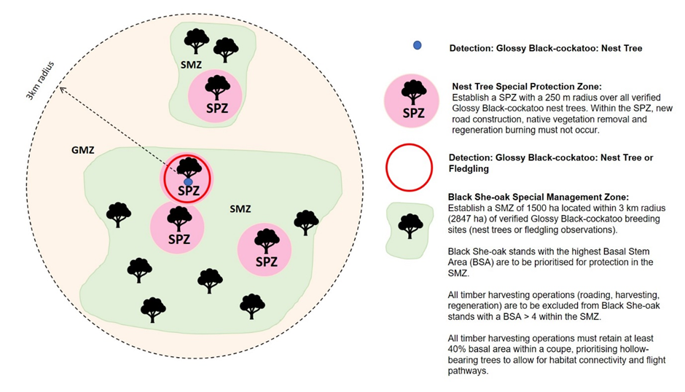

Figure 2. Diagram of proposed Future Code amendment

### Priority management actions

* Improve the mapping of Black Sheoak stands, including stands recovering from bushfires; and
* Assess the feasibility of providing artificial nest hollows – implement as appropriate.

## Masked Owl (*Tyto novaehollandiae*)

### Status

A total of 1,164,225 ha falls within the modelled habitat for this species. The species has a limited extent of occurrence of 1,085 km². The species is listed as Critically Endangered in Victoria (FFG Act). The species was impacted by the 2019-20 bushfires (46% of modelled habitat within the 2019-20 bushfire footprint, 25% burnt by high severity fire).

### Exposure

A risk assessment was conducted for the Masked Owl in October 2020. The species was assessed as being at significant risk from forestry operations in the East Gippsland and Gippsland RFA Regions, and medium risk in Central Highlands RFA Region. This was based on the modelled habitat containing 156,371 ha (13%) of merchantable timber based on the 2015 net harvest area layer.

Using the revised operable area layer, the modelled habitat contains 58,847 ha of merchantable timber (5%). This includes 5,968 ha (3%) in the Central Highlands RFA Region, 46,835 ha (8%) in the East Gippsland RFA Region, 1,883 ha (1%) in the Gippsland RFA Region, and 4,161 ha (3%) in the West RFA Region. Permanent protections were still deemed necessary.

There are Code prescriptions for the species in several FMAs: 3 ha/ 250-300 m radius over each nesting and roosting site utilised recently and frequently and located outside a Masked Owl Management Area, unless already protected. This prescription varies across FMAs. Other protections for the species include Masked Owl Management Areas (MOMAs) and habitat-specific protections.

### Expert advice

The low detectability of this species makes it difficult to assess the impacts of the bushfires. However, surveys undertaken by DELWP in East Gippsland since the 2019-20 fires did not detect any masked owls (Cripps *et al.*, 2022). Surveys undertaken by the East Gippsland Conservation Management Network near Nowa Nowa-Waygara in areas subject to low-moderate fire severity detected only one masked owl from over 40 call playback surveys (J. Cripps, pers. comm., 2021).

To facilitate the recovery of the species from low population numbers, experts identified that the cap on MOMAs of 150 sites should be removed (Bilney & L’Hotellier 2013), as it has been met. This should at least be applied in East Gippsland where the bushfire impacts are greatest. The species nests and roosts in dead or partially dead hollow-bearing trees, which are particularly susceptible to fire impacts.

The current prescriptions specify to protect habitat elements such as old hollow-bearing trees within the MOMAs. To maximise the benefit of MOMAs, more explicit specification of the minimum habitat requirements is necessary.

### Conclusion

The critically endangered status of the species, limited modelled habitat, and bushfire impacts mean this species requires ongoing permanent protections.

### Interim protection

The species was assigned the following interim protection in East Gippsland RFA Region: Where a coupe intercepts with modelled high-quality habitat or catchment buffer polygon, retain undisturbed habitat patches containing dense understorey and hollow-bearing trees within the harvestable area; Protect patches from harvesting and regeneration activities.

### Recommended protections

##### Forest zoning amendment

Consider removing the current cap on the number of MOMAs in East Gippsland to establish one for every pair with a verified detection. Consideration should be given to more explicit specification of minimum habitat requirements within each MOMA.

### Priority management actions

* Continue predator control as this assists in maintaining populations of prey species.

# Terrestrial fauna – Reptiles

## Diamond Python (*Morelia spilota spilota*)

### Status

A total of 229,899 ha falls within the modelled habitat for this species. The species has a limited area of occupancy of 113 km². The species is listed as Critically Endangered in Victoria (FFG Act). The species was impacted by the 2019-20 bushfires (85% of modelled habitat within the 2019-20 bushfire footprint, 48% burnt by high severity fire).

### Exposure

A risk assessment was conducted for the Diamond Python in October 2020. The species was assessed as being at significant risk from forestry operations in the East Gippsland RFA Region. This was based on the modelled habitat containing 31,944 ha (14%) merchantable forest based on the 2015 net harvest area layer.

Using the revised operable area layer, the modelled habitat contains 11,298 ha of merchantable timber (5%), all of which is in the East Gippsland RFA Region. Permanent protections were still deemed necessary.

There is a Code prescription for the species in East Gippsland FMA: Apply a protection area of 100 ha of suitable habitat for each locality of this species. Note: The Secretary intends to review this strategy when 50 sites have been located.

### Expert advice

This subspecies is highly cryptic and individuals have large home ranges. There is no survey protocol for the subspecies. The infrequency of records and the failure to detect this snake during most surveys within its range suggests detection-based prescriptions are not likely to offer adequate protection.

While juveniles disperse from natal areas, the adults of the subspecies show strong site fidelity (subject to disturbances like timber harvesting and fire). For this reason, records of the subspecies post-1970 still reflect where the subspecies might reasonably occur.

### Conclusion

The critically endangered status of the subspecies, restricted status, and bushfire impacts mean this subspecies needs strengthened ongoing protections that do not rely on new detections. Because 62% of the subspecies’ HDM falls within the CAR reserve system (142,027 ha), only one post-1970 record requires buffering for additional protections.

### Interim protection

No interim protections were deemed necessary at the time of the 2020 risk assessment for forestry operations.

### Recommended protections

##### Forest zoning amendment

Within the East Gippsland RFA Region, the Secretary will establish Special Protection Zone(s) of 100 ha of suitable habitat over individual or clusters of post-1970 VBA records (records with an accuracy of 100 m or better (See Map 3)).

### Priority management actions

* Establish monitoring sites and collect baseline data at key locations.

## Eastern She-oak Skink (*Cyclodomorphus michaeli*)

### Status

This restricted species does not currently have a habitat distribution model, but there are 7,330 ha of habitat mapped within DELWP’s important populations dataset. The species is listed as Critically Endangered in Victoria (FFG Act). The species was impacted by the 2019-20 bushfires (87% of Important Populations within the 2019-20 bushfire footprint, 51% burnt by high severity fire).

### Exposure

A risk assessment was conducted for the Eastern She-oak Skink in October 2020. The species was assessed as being at medium risk from forestry operations in the East Gippsland RFA Region. This was based on the Important Populations layer indicating 1,036 ha (14%) merchantable forest based on the 2015 net harvest area layer.

Using the revised operable area layer, 290 ha (4%) of the species' important populations and 2 ha (1%) of its VBA points contain merchantable timber, all of which is in the East Gippsland RFA Region. Permanent protections were still deemed necessary.

There is no current Code prescription.

### Expert advice

In the October 2020 risk assessment, experts rated the current controls of general Code prescriptions and the CAR reserve system as poor. This is because there is no species-specific prescription. However, habitat retention provides some level of protection and the species’ preferred habitat is within Heathland and Coastal Dune Scrub, both of which are unlikely to be significantly impacted by timber harvesting. The potential mitigation suggested was to identify important habitat and avoid disturbance in key locations. Because this species does not currently have a reliable HDM, VBA points are the best available information. Similarly to the Diamond Python, this species is rarely detected so a detection-based prescription is unlikely to be effective.

### Conclusion

The critically endangered status of the species, restricted status, bushfire impacts, and lack of a species-specific Code prescription mean this species needs strengthened ongoing protections. Because 60% of the species’ VBA records falls within the CAR reserve system, only three post-1970 records require buffering for additional protections. The buffer width of 250 m was taken from the prescription for Swamp Skink.

### Interim protection

No interim protections were deemed necessary at the time of the 2020 risk assessment for forestry operations.

### Recommended protections

##### Forest zoning amendment

Within the East Gippsland RFA Region, the Secretary will establish Special Management Zone(s) over individual or clusters of post-1970 VBA records (records with an accuracy of 100 m or better) with the following conditions: The managing authority is required to apply a 250 m buffer to the record (See Map 4).

##### Future Code amendment

Consider introducing the following prescription: Within the East Gippsland RFA Region, establish a management area where one or more individuals have been verified; apply a 250 m buffer to the record.

### Priority management actions

* Establish monitoring sites and collect baseline data at key locations.

# Terrestrial fauna – Amphibians

## Giant Burrowing Frog (*Heleioporus australiacus flavopunctatus*)

This subspecies was formerly known as the Giant Burrowing Frog *Heleioporus australiacus.*

### Status

This species has recently been split into two subspecies. Prior to the taxonomic split (Mahony *et al.*, 2021), the parent species was considered Restricted (Area of Occupancy 129 km²). The parent species is listed as Vulnerable (EPBC Act). The parent species is listed as Critically Endangered in Victoria (FFG Act). After the taxonomic split, Mahony *et al.* (2021) identified that both subspecies qualify for EPBC Act listing as Endangered under criteria (A2(c)B2(a)(b)).

A total of 1,249,548 ha falls within the modelled habitat for this subspecies. The subspecies was impacted by the 2019-20 bushfires (69% of modelled habitat within the 2019-20 bushfire footprint, 37% burnt by high severity fire).

### Exposure

A risk assessment was conducted for the Giant Burrowing Frog in October 2020. The species was assessed as being at significant risk from forestry operations in the Gippsland and East Gippsland RFA Regions. This was based on the modelled habitat containing 218,603 ha (17%) merchantable forest based on the 2015 net harvest area layer.

Using the revised operable area layer, the modelled habitat contains 74,738 ha of merchantable timber (6%). This includes 65,532 ha (7%) in the East Gippsland RFA Region and 9,206 ha (3%) in the Gippsland RFA Region. With the revised forestry operations footprint, the species was assessed as being at significant to high risk from forestry operations in the Gippsland and East Gippsland RFA Regions in June 2022.

Experts noted that because the species is so cryptic and there are few detection records, the species’ habitat distribution model is imperfect. Therefore, the extent of overlap between forestry operations and the species’ occurrence might vary substantially compared to current estimates.

There is a Code prescription for the subspecies in Gippsland and East Gippsland Forest Management Areas:

Where records of Giant Burrowing Frog are located on first-order streams or sites away from streams, apply a protection area of 50 ha (preferably the entire sub catchment unit). Where records of Giant Burrowing Frog are located on second or higher order streams, apply a protection area of 100 m width each side of the stream for 1 km upstream and downstream of the detection site. For off-stream records where evidence of this value is found in the field, apply a protection area of 50 ha over the record or equivalent area of suitable habitat nearby. Avoid new roading in the protection area. Note: The Secretary intends to review this strategy when 50 sites are located in Victoria.

### Expert advice

The subspecies that occurs within Victoria now has a much smaller range than the species was known to have prior to the taxonomic split. Due to very low detectability, experts have no certainty about population trends of this subspecies in Victoria. During the first year of the Forest Protection Survey Program, the species was only detected at one of 30 sites it was surveyed for (Cripps *et al.* 2019). Experts believe that similarly to other threatened frogs, the Victorian subspecies appears to be declining more quickly than the northern subspecies. Threatening processes include the fungal disease chytridiomycosis, and mechanical disturbance through timber harvesting and roading (Hunter *et al.*, 2018). Concerns about population sizes are so great that a dedicated *ex situ* insurance population is currently being established.

Most experts rated the current detection-based Code prescription as poor for the following reasons:

* The species is extremely cryptic, so difficult to detect. A protection that relies on detections is therefore unlikely to be very effective. The one expert that rated this control as satisfactory still noted that where individuals are undetected, this control is poor.
* The detection-based approach generally only considers habitats where the species congregates, such as breeding sites. It is possible the species occupies more of the forest than is currently known and at much greater distances away from detection sites. This concern applies to both on-stream and off-stream detections under the current Code prescription.
* While detected breeding areas are protected under this control, there is no consideration of more strategic protection of connectivity between breeding sites or non-breeding habitats (where individuals spend most time).
* There is uncertainty around the effectiveness of a 100 m buffer as it does not protect non-breeding habitat, which may be >100 m from breeding sites. This buffer is limited to 1 km upstream and downstream of detection and there may be downstream effects of harvesting beyond this buffer.
* Individuals detected in one sub-catchment may also use the adjacent sub-catchment. Two recent records occurred on ridges or spur-lines (in Bonang and Brookvale), and it was not clear which sub-catchment should be protected.
* As there has been no targeted monitoring of the species’ persistence in harvested landscapes subject to this prescription, there is no evidence that these measures are effective.

It was agreed that while the CAR reserve system, general Code prescriptions and VicForests’ High Conservation Values Management System provide some general protections from timber harvesting, these controls do not go far enough in addressing the risks associated with forestry operations because they are not specifically targeted at the habitat requirements of the species.

While the detection-based prescription is rarely triggered, there was a new record as recently as late September 2021. Mt Alfred, Nowa Nowa/Bruthen and Merremingga State Forest remain important locations as evidenced by recent breeding.

The interim protections established in April 2021 focussed on known breeding sites. Expert advice since that time is that this approach is still necessary, but that greater protections need to be applied to non-breeding habitat. These protections should not be reliant on detections. While this subspecies was not targeted during the Bushfire Biodiversity Response and Recovery program, observations were made of the subspecies in burnt habitat near Nowa Nowa and Mallacoota (Tscharke & Heard, 2022).

### Conclusion

The critically endangered status of the subspecies, restricted status, cryptic nature, and 2019-20 bushfire impacts mean this species needs strengthened ongoing protections that do not rely on detections. According to the revised assessment, the species was at medium to high risk in East Gippsland and Gippsland RFA Regions. This means that the current risk mitigation is unlikely to be sufficient.

To identify sites for additional permanent protections based on recent (post-1970) detections, the same 21 sub-catchments where existing breeding locations are known or are in proximity were selected as those covered by the Interim Protections. On expert advice, additional recent or significant records have had the approach described above applied (regardless of breeding or non-breeding records). New sub-catchments were mapped for these records. These sub-catchments are proposed as new SPZ.

Additional protection areas outside of detections were selected to identify 20 SPZ sites across the distribution of the species. This approach was intended to maximise the chance that the sites would be resilient in the face of future disturbances and facilitate regional population persistence. A total of 20 sites was identified by experts as an appropriate number of sites. To identify high-value sites for protection that were not reliant on recent detections, forest compartments that were the most important for the species were selected. Selected compartments had high proportions of the top 20% of HDM habitat, <60% of the species’ modelled habitat in CAR reserve system (based on the JANIS target of 60% as a guide for what is sufficient), and <50% of modelled habitat within the 2019-20 bushfire footprint. Within the selected compartments, sub-catchments were mapped to encompass the best available habitat within areas of forest that were harvested no later than 2000, had not been burned more than twice since 2000, and were connected to other areas of CAR reserve. The rationale is to meet ecologically sustainable forest management objectives including maintenance of viable populations throughout the range of the species. The proposed additional protection areas were then further refined with input from field staff and species experts.

To provide broader landscape-scale protection from timber harvesting and reduce disturbance across greater areas of high-value and/or occupied sites, a 1 km buffer was applied to the sub-catchments subject to SPZ. Much of the recently gained information on this subspecies after the taxonomic split has not yet been published or formally reported. However, prior to the taxonomic split, the species was known to travel up to 500 m from breeding sites. The subspecies may also make infrequent, but critically important, longer-distance movements that help maintain genetic diversity. The larger a frog species is, the more likely it is to cover large distances. Species that are smaller than Giant Burrowing Frogs (e.g. Growling Grass Frogs *Litoria raniformis* and Pobblebonks *Limnodynastes dumerilii*) can move distances of around 1 km. It is therefore reasonable to expect that this subspecies, which is even larger, would do likewise. Within this buffer, sub-catchments were mapped to appropriate topographical features (e.g. ridgelines, stream networks). In some cases, the sub-catchments were larger or smaller than the 1 km buffer, depending on local topography. Within these sub-catchments, 100m buffers are recommended to be applied to permanent and temporary streams to protect wetter areas of the landscape where frogs are more likely to occur.

### Interim protection

The subspecies was assigned the following interim protection: In specific sub-catchments where existing breeding locations are known or in proximity, Special Management Zones will be utilised to mitigate risk from timber harvesting. This SMZ applies to 21 specific sub-catchments in Gippsland and East Gippsland RFA Regions which have been identified as important population sites. These specified sub-catchments are where existing breeding locations are known, or within 500 m of an existing breeding location. Locations for these are Merremingga State Forest, Bruthen Cluster and Mt Alfred State Forest.

### Recommended protections

##### Forest zoning amendments

Within the East Gippsland and Gippsland RFA Regions, the Secretary will establish Special Protection Zones over localised sub-catchments of the Giant Burrowing Frog which have been identified as important population sites and/ or high-value habitat (See Map 5).

Within the East Gippsland and Gippsland RFA Regions, the Secretary will establish Special Management Zones over localised sub-catchments of the Giant Burrowing Frog which have been identified as important population sites and/ or high-value habitat with the following conditions:

* Apply 100 m buffers either side of all mapped and unmapped permanent streams and temporary streams within the sub-catchment;
* No new road, snig track, in-coupe road, coupe driveway, coupe infrastructure or stream crossing shall be constructed within or through any buffer without an approved exemption from the Secretary (See Map 5).

##### Future Code amendment

The adequacy of the existing detection-based Code prescription should be considered as part of any future amendments to the Code.

##### Modification of survey standard

Current survey standards should be modified to include minimum number and intensity of rain events in the recording period and the density of recorders required to confirm presence.

### Priority management actions

* Develop eDNA sampling protocols to improve detectability;
* Establish monitoring sites and collect baseline data at key locations;
* Investigate population structure, non-breeding habitat use and responses to disturbance; and
* Conduct targeted surveys to improve understanding of current distribution and improve the reliability of the habitat distribution model.

## Martin’s Toadlet (*Uperoleia martini*)

### Status

A total of 386,422 ha falls within the modelled habitat for this species. The species has a restricted area of occupancy of 144 km². The species is listed as Critically Endangered in Victoria (FFG Act). The species was impacted by the 2019-20 bushfires (34% of modelled habitat within the 2019-20 bushfire footprint, 18% burnt by high severity fire).

### Exposure

A risk assessment was conducted for the Martin’s Toadlet in October 2020. The species was assessed as being at medium risk from forestry operations in the East Gippsland and Gippsland RFA Regions. This was based on the modelled habitat containing 27,244 ha (7%) of merchantable timber based on the 2015 net harvest area layer.

Using the revised operable area layer, the modelled habitat contains 11,894 ha of merchantable timber (3%). This includes 9,102 ha (5%) in the East Gippsland RFA Region and 2,792 ha (2%) in the Gippsland RFA Region. Permanent protections were still deemed necessary.

There is no current Code prescription.

### Expert advice

The species is still recovering from droughts in the early 2000s, which reduced populations. It is recorded infrequently and likely spends much time away from breeding waterbodies (similar species are recorded up to 1 km away) and then migrates to aquatic habitats during breeding season. Toadlet species have lower dispersal abilities, so recolonisation post-impact is more difficult. Just over a third of known sites were burnt in the 2019-20 fires, and sites at the far-western end of the range were burnt in the 2018/19 fire season (notably at Holey Plains National Park).

Although only 3% of their potential habitat contains merchantable timber, given the potential population impacts following the recent fires all remaining unburnt habitat, particularly in East Gippsland, is important. Recent post-fire monitoring detected the species at only four of 11 survey sites (Ewing’s Morass Wildlife Reserve, wetlands adjacent to the East Wingan Road and in the vicinity of Dock Inlet). A maximum of 10 individuals was recorded at any site (Tscharke & Heard, 2022).

### Conclusion

The critically endangered status of the species, restricted habitat, bushfire impacts, and lack of a Code prescription mean this species should be considered for strengthened ongoing protections.

### Interim protection

No interim protections were deemed necessary at the time of the 2020 risk assessment for forestry operations.

### Recommended protections

##### Forest zoning amendment

Within the East Gippsland and Gippsland RFA Regions, the Secretary will establish Special Protection Zones of 28 ha containing suitable habitat that includes the detection site (adult, sub-adult, tadpole, or egg cluster) over individual or collections of post-1970 VBA records (records with an accuracy of 100 m or better) (See Map 6).

##### Future Code amendment

Consider amending the Code as follows: Within the East Gippsland and Gippsland RFA Regions: the managing authority will apply a 28-ha protection area over verified detections with the following conditions: protection areas must include the detection site (adult, sub-adult, tadpole or egg cluster) and contain suitable habitat.

### Priority management actions

* Establish monitoring sites and collect baseline data at key locations.

## Watson’s Tree Frog (*Litoria watsoni*)

This species was formerly known as the Large Brown Tree Frog (*Litoria littlejohni*).

### Status

This species has recently been split into two species. Prior to the taxonomic split (Mahony *et al.*, 2020), the parent species was considered to have a restricted extent of occurrence of 4,903 km² and was listed as Vulnerable (EPBC Act). The Victorian populations are entirely the southern species, Watson’s Tree Frog, which is listed as Critically Endangered in Victoria (FFG Act).

A total of 478,497 ha falls within the modelled habitat for this species. The Victorian species was impacted by the 2019-20 bushfires (87% of modelled habitat within the 2019-20 bushfire footprint, 48% burnt by high severity fire).

### Exposure

A risk assessment was conducted for the Large Brown Tree Frog in October 2020 (prior to the taxonomic split). The species was assessed as being at significant risk from forestry operations in the East Gippsland RFA Region. This was based on the modelled habitat containing 117,908 ha (25%) of merchantable timber based on the 2015 net harvest area layer.

Using the revised operable area layer, the modelled habitat contains 36,684 ha of merchantable timber (8%), all within the East Gippsland RFA Region. With the revised forestry operations footprint, the species was assessed as being at significant to high risk from forestry operations in the East Gippsland RFA Region in June 2022.

Experts noted that because the species is so cryptic, and there are few detection records, the species’ HDM is imperfect. Therefore, the extent of overlap between forestry operations and the species’ occurrence is potentially larger than current estimates suggest.

There is a Code prescription for the species in East Gippsland FMAs: Apply a protection area of 28 ha that includes the detection site (adult, sub-adult, tadpole, or egg cluster).

### Expert advice

Like the Giant Burrowing Frog, this species is difficult to detect. Recent survey work occurred through the best parts of the species’ habitat based on the HDM, but only a small number of frogs were detected (N. Clemann, pers. comm. 2021). Because the species is so difficult to detect even when surveys are conducted in the ideal conditions (warm nights after rainfall), the current detection-based prescription is unlikely to afford adequate protection from forestry operations. Most frog detections occur at breeding sites (calling males, females responding to males and laying eggs, or the presence of eggs/ tadpoles). Experts are increasingly detecting frogs spending the winter long distances from breeding habitats and aquatic areas. Better protections are required for non-breeding habitats.

Expert advice is that the current Code prescription of a 28 ha SPZ does not adequately protect sub-catchments. The species has transient breeding locations and occurs at low density. While the current measures protect waterbodies, the species spends much of its time away from these areas. Almost all experts rated the current detection-based Code prescription as poor for the following reasons:

* The species is extremely cryptic, so difficult to detect. A protection that relies on detections is therefore unlikely to be very effective. The one expert that rated this control as satisfactory still noted that where individuals are undetected, this control is poor.
* The detection-based approach generally only considers habitats where the species congregates, such as breeding sites. It is possible the species occupies more of the forest than is currently known and at much greater distances away from detection sites.
* While detected breeding areas are protected under this control, there is no consideration of more strategic protection of connectivity between breeding sites or non-breeding habitats (where individuals spend most of their time).
* There is uncertainty around the effectiveness of a 28-ha exclusion zone as the spatial ecology of the species is poorly known. While 28 ha may protect detected individuals during harvesting, it is unclear if this area will provide long-term protection. This control also provides limited protection for downstream effects or habitat fragmentation.
* As there has been no targeted monitoring of the species’ persistence in harvested landscapes subject to this prescription, there is no evidence that these measures are effective.

The advantage of the current detection-based prescription is that three new sites have recently been added through the FPSP, a significant increase given the species only occurs at around 30 sites in Victoria.

It was generally agreed that while the CAR reserve system, general Code prescriptions and VicForests’ High Conservation Values Management System provide some general protections from timber harvesting, these controls do not go far enough in addressing the risks associated with forestry operations because they are not specifically targeted at the habitat requirements of the species.

Concerns about population sizes are so great that a dedicated *ex situ* insurance population is currently being established.

### Conclusion

The critically endangered status, restricted distribution, and bushfire impacts mean this species needs strengthened ongoing protections. According to the revised assessment, the species was at significant to high risk in East Gippsland RFA Region. This means that the current risk mitigation is clearly insufficient.

To identify sites for additional permanent protections based on recent detections, sub-catchments were mapped around all post-1970 records for the species. These sub-catchments are proposed as new SPZ.

To provide broader landscape-scale protection from timber harvesting and reduce disturbance across greater areas of high-value and/ or occupied sites, a 1 km buffer was applied to the sub-catchments subject to SPZ. Much of the recently gained information on this species after the taxonomic split has not yet been published or formally reported. However, other frog species (e.g. Growling Grass Frogs *Litoria raniformis* and Pobblebonks *Limnodynastes dumerilii*) can move distances of around 1 km. It is therefore reasonable to expect that this species may do likewise. Within this buffer, sub-catchments were mapped to appropriate topographical features (e.g. ridgelines, stream networks). In some cases, the sub-catchments were larger or smaller than the 1 km buffer, depending on local conditions. Within these sub-catchments, 100 m buffers are recommended to be applied to permanent and temporary streams to protect wetter areas of the landscape where frogs are more likely to occur.

### Interim protection

The following interim protection was applied: Where coupe intercepts with modelled high-quality habitat or catchment buffer polygon, apply a 20 m buffer to waterbodies away from streams that may be potential breeding sites; Protect buffers from harvesting and regeneration activities.

### Recommended protections

##### Forest zoning amendment

Within the East Gippsland and Gippsland RFA Regions, the Secretary will establish Special Protection Zones over sub-catchments containing post-1970 VBA records (with location accuracy of 250 m or better) (See Map 7).

Within the East Gippsland and Gippsland RFA Regions, the Secretary will establish Special Management Zones over localised sub-catchments of the Watson’s Tree Frog which have been identified as important population sites with the following conditions:

* Apply 100 m buffers either side of all mapped and unmapped permanent streams and temporary streams within the sub-catchment;
* No new road, snig track, in-coupe road, coupe driveway, coupe infrastructure or stream crossing shall be constructed within or through any buffer without an approved exemption from the Secretary (See Map 7).

##### Future Code amendment

The adequacy of the existing detection-based Code prescription should be considered as part of any future amendments to the Code.

##### Modification of survey standard

Current survey standards should be modified to include minimum number and intensity of rain events in the recording period and the density of recorders required to confirm presence.

### Priority management actions

* Establish a long-term monitoring program to evaluate the effectiveness of protective measures;
* Research species-specific dispersal distances to inform effective buffer sizes;
* Continue to develop and maintain the *ex-situ* breeding program;
* Investigate population structure, non-breeding habitat use and responses to disturbance; and
* Undertake targeted surveys to identify sites of significance and to refine the habitat distribution model.

# Aquatic fauna

For each of the five aquatic species discussed below, increased sediment input to streams is considered the main mechanism of impact from forestry operations. DELWP commissioned research into the issue of sediment transport under different conditions which answered the specific question: How far does surface runoff, that carries sediment, travel through vegetation in different environmental situations before it is absorbed in the ground (Nyman *et al.*, 2022).

Buffers refer to a continuous border of riparian vegetation left at the boundary between harvesting compartments and streams to help protect aquatic ecosystems. Buffers act to maintain stream channel stability, provide habitat, regulate light and temperature in the stream environment, and slow down surface runoff from coupes and forest roads so that sediment can deposit before it reaches the stream (Shelley *et al.* 2002). Buffers typically work via infiltration of runoff, rather than by directly trapping sediment. Therefore, the effectiveness of buffers depends on the hydraulic properties of the soils within the buffer. When soils are poorly structured (low porosity) or are burned, the runoff may not infiltrate. In these cases, the buffer is less effective as it allows silt and clays transported by runoff to penetrate buffers and move into the drainage network (Nyman *et al.*, 2022).

In the study (Nyman *et al.*, 2022), the effectiveness of buffers in reducing sediment delivery to streams was determined using the concept of hydrological connectivity. Connectivity describes the likelihood that sediment will be transported from its source (e.g. a snig track, road, or general coupe area) to a waterway. The higher the connectivity, the higher the likelihood of sediment reaching a waterway. Nyman *et al.* (2022) combined field measurements (using 185 datapoints from 42 sites collected over nearly 20 years) and modelling to assess the level of connectivity across different hydrological settings and evaluated the implications for the buffer widths required to minimize impacts from timber harvesting activities on waterway health).

The experimental approach of Nyman *et al.*, (2022) was based on the concept of volume to breakthrough (vbt). The vbt is the volume of runoff that enters an area before discharge is observed at the downslope boundary of the area. The volume is a combination of water lost to overland flow through infiltration, water stored above ground in depressional storage and water in transit between the upper and lower boundary of the area (Hairsine et al, 2002). As a metric of connectivity, vbt has been successfully applied in a range of forest settings to determine the likelihood of pollutants being transported across buffers and into waterways (e.g. Lane et al, 2006).

The analysis of Nyman *et al.* (2022) of overland flow plumes demonstrated that there are important environmental controls on the hydrological function of buffers. There was large variation in the capacity of buffers to decouple drainage networks from erosion related to timber harvesting activities. The variation was driven by soil and vegetation properties in the riparian areas. Ecological Vegetation Class (EVC) provided a useful tool for classifying the system based on hydrological function. Consistent with previous studies (e.g. Lane et al 2006), the analysis indicated that slope does not impact on the length of overland flow plumes and may not be a useful input into the prescription of buffer widths. The analysis did not model direct impacts of fire on buffer function, but sampled vegetation with a range of fire histories. In general, it is likely that bushfire will reduce the capacity of buffers to accommodate runoff, because of low vegetation cover and low infiltration rates, caused by water repellent soils (Nyman et al, 2010).

The study concluded that there are two distinct hydrological functional units (HFUs) which form a basis for assigning variable buffer widths across forests with contrasting hydrological attributes. EVCs within the study site, which focussed on the Orbost Spiny Crayfish Special Management Zone, were assigned into HFUs based on field data. Other EVCs that occur within VicForests’ Operable Area layer were assigned to HFUs based on a combination of existing field data and expert judgements about likely functioning.

The study synthesised the performance of buffers into a risk-based framework that was used to develop an outcomes-focused approach to assigning buffer widths. A range of rainfall scenarios (1-in-10 to 1-in-100-year events) were included in modelling buffer efficacy. To assign buffer withs for aquatic fauna, a 10% chance of buffer exceedance was accepted. This threshold means that 10% of the time, for a selected rainfall intensity, some overland flow will breach the selected buffer width. Exceedance does not equate to complete buffer failure, as even when exceedance occurs, much of the overland plume will have infiltrated. A 1-in-20-year rainfall event was used to assign buffer widths for spiny and burrowing crayfish. Because of their likely higher sensitivity to deposited sediment (Shelley *et al.*, 2022), a 1-in-50-year rainfall event was used to assign buffers for galaxiid species.

The buffer widths proposed within this report combine EVC, likely species-specific sensitivity to sediment, rainfall event, and waterway type to deliver enhanced protections for threatened aquatic species that are responsive to local environmental conditions in a risk-based framework.

## Alpine Spiny Crayfish (*Euastacus crassus*)

### Status

The species has a restricted extent of occurrence of 102 km² with 27,263 ha identified within DELWP’s important populations dataset. The species is listed as Endangered in Victoria under the FFG Act. The species was impacted by the 2019-20 bushfires (21% of the important populations area within the 2019-20 bushfire footprint, 14% burnt by high severity fire).

### Exposure

A risk assessment was conducted for the Alpine Spiny Crayfish in October 2020. The species was assessed as being at medium risk from forestry operations in the East Gippsland and Gippsland RFA Regions. This was based on an assessment of the important populations area containing 790 ha (3%) merchantable forest based on the 2015 net harvest area layer. There are no Timber Release Plan (TRP) coupes within this species’ important populations area.

Using the revised operable area layer, 222 ha (1%) of the species’ important populations and 9 ha (2%) of its VBA points contains merchantable timber. For the important populations this includes 16 ha (<1%) in the East Gippsland RFA Region, 38 ha (<1%) in the Gippsland RFA Region, and 168 ha (2%) in the North East RFA Region. For the VBA points, this includes 8 ha (5%) in the Gippsland RFA Region and 2 ha (2%) in the North East RFA Region. Permanent protections were still deemed necessary.

There is no current species-specific Code prescription. General waterway prescriptions offer some protections.

### Expert advice

The species has recently been found outside its previously accepted range within the Alpine National Park. Some of these records have been acquired through the Forest Protection Survey Program in East Gippsland. In 2018-19, the species was detected in seven of 130 surveyed coupes (Cripps *et al.* 2019). This indicates that the species’ exposure to timber harvesting is greater than previously anticipated. Expert advice on aquatic species in general is that current prescriptions for temporary streams and drainage lines are inadequate to protect spiny and burrowing crayfish.

### Conclusion

The endangered status of the species, restricted catchment, bushfire impacts, and lack of species-specific Code prescription mean this species needs strengthened ongoing protections, particularly in drainage lines and temporary streams.

### Interim protection

No interim protections were deemed necessary at the time of the 2020 risk assessment.

### Recommended protections

##### Forest zoning amendments

Within Gippsland, East Gippsland, and North East RFA Regions the Secretary will establish Special Management Zone(s) based on DELWP’s important populations dataset for the Alpine Spiny Crayfish and any additional post-2017 VBA records (with 100 m accuracy or better) with the following conditions:

* Environments with high soil absorption capacity (refer to Appendix 2):
  + Apply 40 m buffers either side of all mapped and unmapped permanent streams and temporary streams upstream and downstream of the value to the watershed boundary (on average 1 km but responsive to local topography; see Figure 3);
  + Apply 30 m buffers plus 10 m filter strips to either side of drainage lines upstream and downstream of the value to the watershed boundary (on average 1 km but responsive to local topography);
* Environments with low soil absorption capacity (refer to Appendix 2):
  + Apply 60 m buffers either side of all mapped and unmapped permanent streams and temporary streams upstream and downstream of the value to the watershed boundary (on average 1 km but responsive to local topography);
  + Apply 40 m buffers plus 20 m filter strips to either side of drainage lines upstream and downstream of the value to the watershed boundary (on average 1 km but responsive to local topography);
* No new road, snig track, in-coupe road, coupe driveway, coupe infrastructure or stream crossing shall be constructed within or through any buffer without an approved exemption from the Secretary (See Map 8).

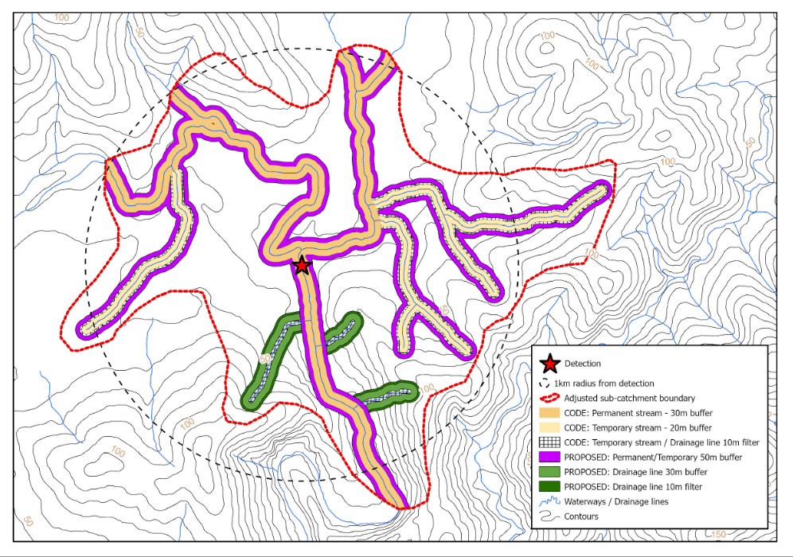

Figure 3. Example detection of a threatened aquatic species, existing Code minimum buffers and filter strips (example from sites with low water quality risk), and additional buffering from proposed prescriptions (example from galaxiid species in environments with high soil absorption capacity). Dashed line indicates 1 km radius around detections, red line shows how the 1 km radius has been modified in response to local hydrological conditions.

##### Future Code amendment

Consider amending the Code as follows: Within the Gippsland, East Gippsland and North East RFA Regions: the managing authority will apply buffers and filter strips to verified detections in accordance with the table below:

Table 1. Buffer and filter strip sizes for verified detections

|  |  |  |
| --- | --- | --- |
| **Soil absorption capacity (refer to Appendix 2)** | **Permanent and temporary streams** | **Drainage lines** |
| High | 40 m buffer | 30 m buffer plus 10 m filter strip |
| Low | 60 m buffer | 40 m buffer plus 20 m filter strip |

### Priority management actions

* Conduct further surveys to define the catchment of this species; and
* Develop eDNA sampling protocols to improve detectability.

## Barred Galaxias (*Galaxias fuscus*)

### Status

The species has a restricted extent of occurrence of 2,708 km² with 23,708 ha falling within the designated catchment polygons. The species is listed as Critically Endangered in Victoria (FFG Act) and listed as Endangered under the EPBC Act. The species was not impacted by the 2019-20 bushfires, but parts of its habitat were impacted by the 2009 Black Saturday bushfires.

### Exposure

A risk assessment was conducted for the Barred Galaxias in October 2020. The species was assessed as being at significant risk from forestry operations in the Central Highlands RFA Region. This was based on an assessment of the catchment containing 8,411 ha (35%) merchantable forest based on the 2015 net harvest area layer.

Using the revised operable area layer, the total catchment area contains 2,844 ha of merchantable timber (12%). This includes 2,454 ha (12%) in the Central Highlands RFA Region and 390 ha (9%) in the North East RFA Region. Permanent protections were still deemed necessary.

There is an existing Code prescription: (Central Highlands FMAs, Gippsland FMAs, North East FMAs): Apply minimum stream buffer and filter strip widths (specified in Table 10) 1 km upstream of new Barred Galaxias populations or in management areas / SMZ for Barred Galaxias. Minimise stream crossings over waterways in catchments containing Barred Galaxias.

### Expert advice

The major threat to this species, and the other galaxiids, is predation by trout. However, in-stream sedimentation is a significant secondary threat to the now small and isolated populations that have no means to avoid such impacts. Expert advice is that current prescriptions for temporary streams and drainage lines are inadequate to protect Barred Galaxias from the impacts of instream sedimentation.

### Conclusion

The critically endangered status of the species and restricted catchment mean this species needs strengthened ongoing protections, particularly in drainage lines and temporary streams.

### Interim protection

No interim protections were deemed necessary at the time of the 2020 risk assessment.

### Recommended protections

##### Forest zoning amendment

Within Central Highlands, Gippsland, and North East RFA Regions, the Secretary will establish Special Management Zones to the catchment of Barred Galaxias with the following conditions:

Where one or more individuals of Barred Galaxias have been verified:

* Environments with high soil absorption capacity (refer to Appendix 2):
  + Apply 50 m buffers either side of all mapped and unmapped permanent streams and temporary streams upstream and downstream of the value to the watershed boundary (on average 1 km but responsive to local topography; see Figure 3);
  + Apply 40 m buffers plus 10 m filter strips to either side of drainage lines upstream and downstream of the value to the watershed boundary (on average 1 km but responsive to local topography);
* Environments with low soil absorption capacity (refer to Appendix 2):
  + Apply 80 m buffers either side of all mapped and unmapped permanent streams and temporary streams upstream and downstream of the value to the watershed boundary (on average 1 km but responsive to local topography);
  + Apply 60 m buffers plus 20 m filter strips to either side of drainage lines upstream and downstream of the value to the watershed boundary (on average 1 km but responsive to local topography);
* No new road, snig track, in-coupe road, coupe driveway, coupe infrastructure or stream crossing shall be constructed within or through any buffer without an approved exemption from the Secretary (See Map 9).

##### Future Code amendment

Consider amending the Code as follows: Within the Central Highlands, Gippsland, and North East RFA Regions: the managing authority will apply buffers and filter strips to verified detections in accordance with the table below:

Table 2. Buffer and filter strip sizes for verified detections

|  |  |  |
| --- | --- | --- |
| **Soil absorption capacity (refer to Appendix 2)** | **Permanent and temporary streams** | **Drainage lines** |
| High | 50 m buffer | 40 m buffer plus 10 m filter strip |
| Low | 80 m buffer | 60 m buffer plus 20 m filter strip |

## Curve-tail Burrowing Crayfish (*Engaeus curvisuturus*)

### Status

The species has a restricted extent of occurrence of 259 km² with 120,657 ha falling within the designated catchment polygon. The species is listed as Endangered in Victoria (FFG Act). The species was not bushfire impacted by the 2019-20 bushfires.

### Exposure

A risk assessment was conducted for the Curve-tail Burrowing Crayfish in October 2020. The species was assessed as being at high risk from forestry operations in the Central Highlands RFA Region. This was based on the catchment containing 15,182 ha (13%) merchantable forest based on the 2015 net harvest area layer.

Using the revised operable area layer, the total catchment area contains 7,703 ha of merchantable timber (6%), all of which is in the Central Highlands RFA Region. Permanent protections were still deemed necessary.

There is no current species-specific Code prescription. General waterway prescriptions offer some protections.

### Expert advice

The distribution of the Curve-tail Burrowing Crayfish is poorly known. It has been recorded from only three sites, one in the upper Yarra catchment at Warburton, and two in the upper La Trobe River near Noojee. Forest Protection Survey Program (FPSP) surveys are ongoing within the range of the species and have continued to increase the resolution of distributional data. The combination of trout predation and sediment infill of juvenile habitat impacts on juvenile survival. In the highly erodible clay soils the species occurs in, sediment can more easily move through existing buffer widths. Mechanical disturbance and stream crossings are important sources of sediment. In the case of burrowing crayfish, expanded riparian buffers also protect the species’ burrows, which can occur some distance from the waterway.

### Conclusion

The endangered status of the species, restricted catchment, and lack of species-specific Code prescription mean this species needs strengthened ongoing protections, particularly in drainage lines and temporary streams. Because the species has a larger catchment with few detections, a detection-based prescription is proposed.

### Interim protection

No interim protections were deemed necessary at the time of the 2020 risk assessment.

### Recommended protections

##### Forest zoning amendment

Within Central Highlands RFA Region, the Secretary will establish a Special Management Zones to verified post-1970 records of Curve-tail Burrowing Crayfish with the following conditions:

* Environments with high soil absorption capacity (refer to Appendix 2):
  + Apply 40 m buffers either side of all mapped and unmapped permanent streams and temporary streams upstream and downstream of the value to the watershed boundary (on average 1 km but responsive to local topography; see Figure 3);
  + Apply 30 m buffers plus 10 m filter strips to either side of drainage lines upstream and downstream of the value to the watershed boundary (on average 1 km but responsive to local topography);
* Environments with low soil absorption capacity (refer to Appendix 2):
  + Apply 60 m buffers either side of all mapped and unmapped permanent streams and temporary streams upstream and downstream of the value to the watershed boundary (on average 1 km but responsive to local topography);
  + Apply 40 m buffers plus 20 m filter strips to either side of drainage lines upstream and downstream of the value to the watershed boundary (on average 1 km but responsive to local topography);
* No new road, snig track, in-coupe road, coupe driveway, coupe infrastructure or stream crossing shall be constructed within or through any buffer without an approved exemption from the Secretary (See Map 10).

##### Future Code amendment

Consider amending the Code as follows: Within the Central Highlands RFA Region: the managing authority will apply buffers and filter strips to verified detections in accordance with the table below:

Table 3. Buffer and filter strip sizes for verified detections

|  |  |  |
| --- | --- | --- |
| **Soil absorption capacity (refer to Appendix 2)** | **Permanent and temporary streams** | **Drainage lines** |
| High | 40 m buffer | 30 m buffer plus 10 m filter strip |
| Low | 60 m buffer | 40 m buffer plus 20 m filter strip |

### Priority management actions

* Develop eDNA sampling protocols to improve detectability; and
* Further survey work to understand the distribution of the species within the broad catchment polygon.

## Orbost Spiny Crayfish (*Euastacus diversus*)

### Status

The species has a restricted extent of occurrence of 653 km² with 116,992 ha falling within the designated catchment polygon. The species is listed as Endangered in Victoria (FFG Act). The species was impacted by the 2019-20 bushfires (81% of catchment within the 2019-20 bushfire footprint, 51% burnt by high severity fire).

### Exposure

A risk assessment was conducted for the Orbost Spiny Crayfish in October 2020. The species was assessed as being at high risk from forestry operations in the East Gippsland RFA Region. This was based on an assessment of the catchment containing 20,739 ha (18%) merchantable forest based on the 2015 net harvest area layer.

Using the revised operable area layer, the total catchment area contains 7,293 ha of merchantable timber (6%), all of which is in the East Gippsland RFA Region. Permanent protections were still deemed necessary

There is an existing Code prescription: Apply a protection area extending 100 m from each bank for 1 km upstream and 1 km downstream of detection sites. Avoid constructing new roads and stream crossings within the protection area. Manage nearby regeneration burns to ensure the protection area is not burnt. Note: The Secretary intends to review this strategy when 20 sites are established.

### Expert advice

Experts were particularly concerned about impacts to temporary streams and drainage lines. Due to the bushfire impacts, the populations are already under greater stress, even in places where buffer zones to protect riparian habitats have been added. Some 23% (or 27,447 ha) of the species’ catchment has been subject to timber harvesting since 1970.

Forest Protection Survey Program (FPSP) surveys detected the species in 86% of surveyed coupes (18/21 coupes) in the period prior to the 2019-20 fires. After the 2019-20 fires, the species was detected in 25% of surveyed coupes (3/12). There have been 18 post-fire detection events (of some 24 individuals).

### Conclusion

The endangered status of the species, restricted catchment, and bushfire impacts mean this species needs strengthened ongoing protections, particularly in drainage lines and temporary streams.

### Interim protection

The species was assigned the following interim protection, which applied to all post 2019-20 bushfire records. For the Orbost Spiny Crayfish, the following measures apply, in addition to Code prescriptions, where one or more individuals of the species are found. For all verified post-2019-20 bushfire records, apply 100m buffers either side to the main stream and tributaries (wet or dry streams) for 1 km upstream and downstream; and apply 50 m buffers to either side of drainage lines (wet or dry) (as defined in the Code) for 1 km up/downstream.

### Recommended protections

##### Forest zoning amendment

Within the East Gippsland RFA Region, the Secretary will establish a Special Management Zone to the catchment of the Orbost Spiny Crayfish with the following conditions:

Where one or more individuals of Orbost Spiny Crayfish have been verified post 2019-20 bushfire:

* Environments with high soil absorption capacity (refer to Appendix 2):
  + Apply 40 m buffers either side of all mapped and unmapped permanent streams and temporary streams upstream and downstream of the value to the watershed boundary (on average 1 km but responsive to local topography; see Figure 3);
  + Apply 30 m buffers plus 10 m filter strips to either side of drainage lines upstream and downstream of the value to the watershed boundary (on average 1 km but responsive to local topography);
* Environments with low soil absorption capacity (refer to Appendix 2):
  + Apply 60 m buffers either side of all mapped and unmapped permanent streams and temporary streams upstream and downstream of the value to the watershed boundary (on average 1 km but responsive to local topography);
  + Apply 40 m buffers plus 20 m filter strips to either side of drainage lines upstream and downstream of the value to the watershed boundary (on average 1 km but responsive to local topography);
* No new road, snig track, in-coupe road, coupe driveway, coupe infrastructure or stream crossing shall be constructed within or through any buffer without an approved exemption from the Secretary (See Map 11).

##### Future Code amendment

Consider amending the Code as follows: Within the East Gippsland RFA Region: the managing authority will apply buffers and filter strips to verified detections in accordance with the table below:

Table 4. Buffer and filter strip sizes for verified detections

|  |  |  |
| --- | --- | --- |
| **Soil absorption capacity (refer to Appendix 2)** | **Permanent and temporary streams** | **Drainage lines** |
| High | 50 m buffer | 40 m buffer plus 10 m filter strip |
| Low | 80 m buffer | 60 m buffer plus 20 m filter strip |

### Priority management actions

* Develop eDNA sampling protocols to improve detectability.

## Tapered Galaxias (*Galaxias lanceolatus*)

### Status

The species has a very restricted extent of occurrence of 8 km² with 7,438 ha falling within the designated catchment polygon. The species is listed as Critically Endangered in Victoria (FFG Act). The species was not bushfire impacted in the 2019-20 bushfires.

### Exposure

A risk assessment was conducted for the Tapered Galaxias in October 2020. The species was assessed as being at high risk from forestry operations in the Gippsland RFA Region. This was based on an assessment of the catchment containing 820 ha (11%) merchantable forest based on the 2015 net harvest area layer.

Using the revised operable area layer, the total catchment area contains 263 ha of merchantable forest (4%), all of which is in the Gippsland RFA Region. Permanent protections were still deemed necessary.

There is no current species-specific Code prescription. General waterway prescriptions offer some protection.

### Expert advice

As for the other galaxiids, the major threats to the species are trout and sedimentation. This species is subject to population fluctuations. In recent years, much of the catchment has dried out and been impacted by two fires. There is little available habitat within the reserve system for translocations, indicating how important currently occupied sites are for the species’ persistence. Post-fire monitoring in March 2021 indicates that the population has recovered slightly in bushfire impacted sections. However, the system still carries large amounts of instream sediment from post-fire debris flow events. Some 30% of the species’ catchment (or 2,210 ha) has been harvested since 1970. The results from a recent study indicate that this species has lost much of its genetic diversity (Weeks *et al.*, 2021). Therefore the species’ evolutionary potential is hampered and its resilience to perturbations is very low (T. Raadik, pers. comm., 2021).

### Conclusion

The critically endangered status of the species, restricted catchment, and lack of a species-specific Code prescription mean this species needs strengthened ongoing protections. Because of the restricted extent of the catchment (~7,000 ha), the limited amount of operable area within the catchment (~260 ha), and the elevated sensitivity of galaxiids to deposited sediment (Shelley *et al.*, 2022) a Special Protection Zone was applied to the mapped catchment for this species rather than the Special Management Zone applied to other aquatic fauna in this report.

### Interim protection

Within the mapped catchment for Tapered Galaxias, 100 m buffers were applied to either side of all mapped and unmapped permanent streams and temporary streams (wet or dry) and a 50 m buffer to either side of drainage lines (wet or dry).

### Recommended protections

##### Forest zoning amendment

Within Gippsland RFA Region, the Secretary will establish a Special Protection Zone to the catchment of Tapered Galaxias (see Map 12).

# Plants

## Colquhoun Grevillea (*Grevillea celata*)

### Status

This species has a very restricted extent of occurrence of 84 km² with 35,508 ha falling within the habitat distribution model. The species is listed as Critically Endangered in Australia (EPBC Act). The species was impacted by the 2019-20 bushfires (54% of modelled habitat within the 2019-20 bushfire footprint, 25% burnt by high severity fire).

### Exposure

A risk assessment was conducted for the Colquhoun Grevillea in October 2020. The species was assessed as being at high risk from forestry operations in the Gippsland and East Gippsland RFA Regions. This was based on the modelled habitat containing 5,473 ha (15%) of merchantable timber based on the 2015 net harvest area layer.

Using the revised operable area layer, the modelled habitat contains 1,461 ha of merchantable timber (4%). This includes 1,389 ha (6%) in the East Gippsland RFA Region, and 73 ha (1%) in the Gippsland RFA Region. Permanent protections were still deemed necessary.

There are Code prescriptions for the species in Gippsland and East Gippsland FMAs. In Gippsland, a SPZ is applied in a 200m radius over each population, whereas this protection only involves a SMZ in East Gippsland.

### Expert advice

Experts emphasised that too-frequent fire is a bigger threat to the species than timber harvesting. This species can resprout after fire, and post-fire monitoring conducted in 2020 and 2021 indicated that the species is recovering well (Tolsma *et al.,* 2022). Another fire before plants set seed risks depleting the seedbank. While the species is well protected in the Gippsland RFA Region, the use of SMZ in East Gippsland RFA Region still exposes the species to risks associated with forestry operations, particularly road construction and maintenance.

### Conclusion

Current management approaches and Code prescriptions appropriately manage the risk in the Gippsland RFA Region but given the restricted distribution and critically endangered status the species requires further protection in the East Gippsland RFA Region.

### Interim protection

The following interim protection was applied in the East Gippsland and Gippsland RFA Regions: Retain undisturbed patches containing suitable understorey habitat within the harvestable area; Protect patches from harvesting and regeneration activities.

### Recommended protections

##### Future Code amendment

Consider extending the current prescriptions that apply in the Gippsland FMAs to the East Gippsland RFA Region (See Map 13).

### Priority management actions

* Comprehensively search likely habitat and map important populations; and
* Establish monitoring sites and collect baseline data.

## Grampians Bitter-pea (*Daviesia laevis*)

### Status

This species has a restricted extent of occurrence of 1,700 km² with 146,995 ha falling within the habitat distribution model. The species is listed as Critically Endangered in Victoria (FFG Act) and Vulnerable under the EPBC Act. The species was not bushfire affected.

### Exposure

A risk assessment was conducted for the Grampians Bitter-pea in October 2020. The species was assessed as being at medium risk from forestry operations in the West RFA Region. This was based on the modelled habitat containing 1,979 ha (1%) of merchantable forest. The updated operable area layer did not change the exposure to forestry operations.

The species has a Code prescription in the Portland-Horsham FMA: Manage occurrences in consultation with the Department unless already protected.

### Expert advice

This species is a short-lived disturbance responder, which relies on soil stored seed for persistence. The main risk comes from repeated disturbance before new seed set can occur. While the FFG Action Statement reports that searches of known sites in 2002 were not successful, more recent work resulted in new records at Mount Cole between 2004 and 2015. Despite the number of recent records, the abundance of this species is unclear and at no location is the species particularly abundant. It is likely that this species has also been adversely affected by the legacy of intensive logging at Mount Cole, which is the largest population outside of the Grampians National Park (Foreman, 2018).

### Conclusion

The restricted distribution, critically endangered status and endemic nature mean the species requires additional permanent protections. Because the species has been poorly surveyed, additional survey work is required before targeted permanent protections can be applied.

### Interim protection

No interim protections were deemed necessary at the time of the 2020 risk assessment.

### Recommended protections

##### Forest zoning amendment

Within the West RFA Region: The Secretary will establish Special Management Zone(s) of 200 m radius over populations of strategic importance as identified through comprehensive surveys.

##### Future Code amendment

Consider the inclusion of greater detail as to how the species should be protected within management areas established under the Code.

### Priority management actions

* Comprehensively search likely habitat and map important populations; and
* Establish monitoring sites and collect baseline data.

## Mount Cole Grevillea (*Grevillea montis–cole* subsp. *montis–cole*)

### Status

This species has a restricted extent of occurrence of 46 km² with 53,258 ha falling within the habitat distribution model. The species is listed as Critically Endangered in Victoria (FFG Act). The species was not affected by the 2019-20 bushfires.

### Exposure

A risk assessment was conducted for the Mount Cole Grevillea in October 2020. The species was assessed as being at medium risk from forestry operations in the West RFA Region. This was based on the modelled habitat containing 668 ha (3%) of merchantable forest. The updated operable area layer did not change the exposure to forestry operations.

The species has a Code prescription in the Midlands FMA: Avoid disturbance to populations within the management area, SMZ and GMZ.

### Expert advice

Current records of the species are restricted to two populations in the Mount Buangor/Mount Cole area. It appears that this species may have undergone a serious decline and geographic contraction of up to 75% in recent decades (Foreman, 2018). The area has been patchily surveyed, so while there appears to be limited overlap with merchantable forest, further survey work may detect the species in areas available for harvesting.

### Conclusion

The very restricted distribution, critically endangered status and endemic nature mean the species requires additional permanent protections. Because the species has been poorly surveyed, additional survey work is required before targeted permanent protections can be applied. The current prescription needs more detail on how the species should be protected within the management area.

### Interim protection

No interim protections were deemed necessary at the time of the 2020 risk assessment.

### Recommended protections

##### Forest zoning amendment

Within the West RFA Region: The Secretary will establish Special Management Zone(s) of 200 m radius over populations of strategic importance as identified through comprehensive surveys.

##### Future Code amendment

Consider the inclusion of greater detail as to how the species should be protected within management areas established under the Code.

### Priority management actions

* Comprehensively search likely habitat and map important populations; and
* Establish monitoring sites and collect baseline data.

## Round-leaf Pomaderris (*Pomaderris vacciniifolia*)

### Status

This species has a restricted area of occupancy of 208 km² with 279,734 ha falling within the habitat distribution model. The species is Critically Endangered in Victoria (FFG Act) and listed as Critically Endangered under the EPBC Act. The species was not affected by the 2019-20 bushfires.

### Exposure

A risk assessment was conducted for the Round-leaf Pomaderris in October 2020. The species was assessed as being at medium risk from forestry operations in the Central Highlands and Gippsland RFA Regions. This was based on the modelled habitat containing 35,660 ha of merchantable forest (13%) based on the 2015 net harvest area layer.

Using the revised operable area layer, the modelled habitat contains 19,016 ha of merchantable timber (7%), all of which is in the Central Highlands RFA Region. Permanent protections were still deemed necessary.

The species has no current Code prescription.

### Expert advice

The species was listed as critically endangered under the EPBC Act in 2014. At the time there were 350 plants known in the wild. This species has a high profile with the local community and the Healesville Environment Watch group.

While plants or populations in the riparian zone are protected through existing riparian buffers, repeated disturbance events, including harvesting and/ or frequent burns, are likely to eliminate this species as it regenerates from seed. The species likely has short range dispersal capability except for water dispersal, and so has limited ability to recolonise.

### Conclusion

The critically endangered status of the species, restricted distribution, and lack of a Code prescription mean this species needs permanent protections. As the species is relatively rare but widespread and easy to identify, a detection-based prescription is appropriate.

### Interim protection

No interim protections were deemed necessary at the time of the 2020 risk assessment.

### Recommended protections

##### Forest zoning amendment

Within the Central Highlands and Gippsland RFA Regions: The Secretary will establish Special Management Zone(s) of 200 m radius over VBA records with 100 m accuracy or better, including a 20 m buffer to exclude machinery disturbance.

##### Future Code amendment

Consider the following amendment: Within the Central Highlands and Gippsland RFA Regions: Apply a management area of 200 m radius over populations with a 20 m buffer. Conduct a site inspection and detailed planning in consultation with the Department to ensure the species is adequately protected during timber harvesting operations (See Map 14).

### Priority management actions

* Investigate the species’ habitat, reproductive ecology, seed dispersal mechanisms and competitive ability and how these compare with more common relatives occurring in the same habitat;
* Comprehensively search likely habitat and map important populations;
* Establish monitoring sites and collect baseline data; and
* Review the habitat distribution model to ensure it encompasses all known populations.

## Slender Tree-fern (*Cyathea cunninghamii*)

### Status

This species has a limited area of occupancy of 532 km² with 359,412 ha falling within the habitat distribution model. The species is Critically Endangered in Victoria (FFG Act). The species was impacted by the 2019-20 bushfires (25% of modelled habitat within the 2019-20 bushfire footprint, 16% burnt by high severity fire).

### Exposure

A risk assessment was conducted for the Slender Tree-fern in October 2020. The species was assessed as being at medium risk from forestry operations in the East Gippsland and Gippsland RFA Regions. This was based on the modelled habitat containing 23,794 ha (7%) of merchantable forest based on the 2015 net harvest area layer.

Using the revised operable area layer, the modelled habitat contains 11,663 ha of merchantable timber (3%). This includes 2,729 ha (7%) in the Central Highlands RFA Region, 5,523 ha (6%) in the East Gippsland RFA Region, 38 ha (<1%) in the Gippsland RFA Region, and 3,372 ha (3%) in the West RFA Region. Permanent protections were still deemed necessary.

The species has a Code prescription in Gippsland and East Gippsland FMAs: Apply a management area (SMZ) of 200 m radius over populations. Conduct a site inspection and detailed planning in consultation with the Department to ensure the species is adequately protected during timber harvesting operations. A less-detailed prescription also applies in the Otways FMA. The species is also protected to some extent by habitat-specific protections for waterways and rainforest. However, occurrences of this species outside of the core habitat also require protection given the limited distribution and bushfire impacts.

### Expert advice

The species can be difficult to identify in the field and may have been overlooked in preharvest surveys. The species has 40,718 ha of modelled habitat in the Central Highlands RFA Region where no Code prescription applies.

### Conclusion

The limited distribution, critically endangered status, and bushfire impacts mean the species requires additional permanent protections. The current prescription should be extended to the Central Highlands RFA Region and needs more detail on how the species should be protected within the management area. Any records of the species in DELWP’s important populations dataset that occur within State Forest and are not appropriately zoned require additional protection.

### Interim protection

No interim protections were deemed necessary at the time of the 2020 risk assessment.

### Recommended protections

##### Forest zoning amendments

Within the Central Highlands RFA Region, the Secretary will establish Special Management Zone(s) of 200 m radius over populations of strategic importance (See Map 15).

##### Future Code amendment

Consider the following amendment: Within the Central Highlands: Apply a management area of 200 m radius over verified detections. Conduct a site inspection and detailed planning in consultation with the Department to ensure the species is adequately protected during timber harvesting operations.

### Priority management actions

* Comprehensively search likely habitat and map important populations; and
* Establish monitoring sites and collect baseline data.

## Tall Astelia (*Astelia australiana*)

### Status

This species has a restricted extent of occurrence of 532 km² with 158,411 ha falling within the habitat distribution model. This species is listed as Endangered in Victoria (FFG Act) and Vulnerable under the EPBC Act. The species was not impacted by the 2019-20 bushfires.

### Exposure

A risk assessment was conducted for the Tall Astelia in October 2020. The species was assessed as being at medium risk from forestry operations in the Central Highlands and West RFA Regions. This was based on the modelled habitat containing 19,131 ha (12%) merchantable forest based on the 2015 net harvest area layer.

Using the revised operable area layer, the modelled habitat contains 10,297 ha of merchantable timber (7%). This includes 8,778 ha (10%) in the Central Highlands RFA Region and 1,519 ha (2%) in the West RFA Region. Permanent protections were still deemed necessary.

The species has a Code prescription in the Central Highlands FMAs:

Apply a 100 m buffer around each Tall Astelia colony. Discovery of a previously unknown colony during harvesting operations will not necessarily cause harvesting to cease, but every reasonable effort will be made to protect it. Where Tall Astelia occurs within Cool Temperate Rainforest or Riparian Thicket EVCs, apply a 100 m buffer around the EVC. Buffer widths may be smaller in cases where existing roads or ridgelines occur within the 100 m. Upstream of Tall Astelia colonies, apply a minimum vegetated buffer of 40 m between the valley floor, or 'wetted zone' and adjacent logging coupes. Where there is no discernible valley floor extend the buffer zone 40 m from the creek itself. Apply a 40 m buffer around isolated plants growing on road batters. No roads or snig tracks may be constructed through Tall Astelia colonies. Avoid constructing roads or snig tracks through Tall Astelia buffers. Any roads or snig tracks that do cross Tall Astelia buffers must be located as far upstream from the Tall Astelia colony as possible, and sedimentation of the Tall Astelia colony must be prevented. Where Tall Astelia occurs on seepage zones immediately below a coupe, snig tracks must be designed to minimise alteration to the site’s normal drainage patterns. A similar prescription applies in the Otways FMA.

### Expert advice

Tall Astelia is relatively well protected by rainforest and waterway prescriptions. The Action Statement also introduced strategic SPZs in each of the major sub-catchments around Dick Hill. However, where Tall Astelia occurs outside Cool Temperate Rainforest or Riparian Thicket EVCs, or in the transition zone from these EVCs, especially upslope of these EVCs, protection within a coupe may not be effective. The species is fire-sensitive, so individual plants and buffered areas are at risk of fire impacts during regeneration burns and in subsequent years from wildfire through dense adjacent coupe regeneration.

There are clusters of observations in the Tarago catchment that are in General Management Zone. The Code prescription requires these to be buffered but there is no requirement to change the zoning.

### Conclusion

The restricted distribution and endangered status mean the species requires additional permanent protections within the Tarago catchment.

### Interim protection

No interim protections were deemed necessary at the time of the 2020 risk assessment.

### Recommended protections

##### Forest zoning amendment

Within the Central Highlands RFA Region, the Secretary will establish Special Protection Zones to protect specific areas within the Tarago River catchment (see Map 16).

### Priority management actions

* Determine the extent of Sambar deer impacts and options to manage if significant; and
* Establish new monitoring sites at important populations and reinstate monitoring at previously monitored sites.

# Ecological communities

## Ecological communities

The following rainforest communities were assessed as part of the Tranche 1 Threatened Species and Communities Risk Assessment:

* Cool Temperate Rainforest
* Cool Temperate Mixed Forest (a component of Cool Temperate Rainforest)
* Warm Temperate Rainforest (Strzelecki Ranges)
* Warm Temperate Rainforest (East Gippsland Alluvial Terraces)
* Warm Temperate Rainforest (Far East Gippsland)

The risk to the five rainforest communities from forestry operations has been reassessed in light of the updated information regarding areas suitable for harvesting until 2030.

### Current protections

Rainforest communities are currently protected in State Forests according to the following prescriptions[1]:

Protect all rainforest stands from timber harvesting operations as follows:

* Exclude nonlinear stands that are 0.1 ha or more in size but less than 0.4 ha from timber harvesting operations. These stands do not require a buffer.
* Exclude linear stands that are at least 0.1 ha but are less than 0.2 ha from timber harvesting operations. These stands do not require a buffer.
* Exclude linear stands that are at least 0.2 ha but are less than 0.4 ha from timber harvesting operations. Protect these stands with a 20 m buffer.
* Exclude all rainforest stands (including linear stands) equal to or exceeding 0.4 ha from timber harvesting operations. Protect these stands with a 40 m buffer except for rainforest stands in the Central Highlands FMAs and the Gippsland FMAs where 4.3.9.2 below must be complied with.
* Distribute slash away from retained rainforest stands or buffers.

In areas categorised as being of National, State or Regional significance in the Sites of Significance for Rainforest spatial layer where evidence of rainforest greater in size than 0.4 ha is found in the field and it isn’t already classified as SPZ, apply a protection area prior to commencement of the timber harvesting operations consistent with management actions listed in Table 16 Buffer widths for Rainforest Sites of Significance by category and priority (See Figure 4).

Figure 4. Table 16 in the Code of Practice for Timber Production related to buffer widths for Rainforest Sites of Significance

### Expert advice

The greatest threat to rainforests is the invasion of eucalypt canopy trees into rainforest edges following disturbance. With climate change leading to more frequent, more severe bushfires, a positive feedback loop is expected, where each fire leads to a drier, more flammable forest that is in turn more likely to burn. Narrow stands with higher edge effects are likely to disappear first, and larger stands will get progressively smaller.

Reconnaissance surveys were undertaken in East Gippsland after the 2019-20 fires (DELWP, 2022) to determine early recovery and threats. Eucalypt invasion was occurring to around 30 m into rainforest stands, with seedling density one year after fire in East Gippsland up to 4,000 per hectare (DELWP, 2022). Density in the Central Highlands (in Cool Temperate Rainforest) 10 years after the 2009 fire was still up to 2000 saplings per hectare (Tolsma *et al.* 2019), suggesting that many eucalypt plants will survive to maturity when fire intensity is high, and the rainforest canopy struggles to recover.

Cool Temperate Rainforest will be most affected by the direct impacts of climate change, as rainfall by 2070 is predicted to fall below its climatic envelope, especially away from the coast. Rainfall may also reduce below the climatic envelope for key rainforest species.

While all rainforest is protected from harvesting under the Code, the extent of individual communities, including the three listed communities of Warm Temperate Rainforest, is not precisely mapped.

Rainforest is particularly at risk in the post 2019-20 bushfire footprint, where the previous extent is unable to be reliably determined on the ground, relying as it does on the application of the differential species approach in the absence of an intact canopy of rainforest species.

It is challenging to map Cool Temperate Mixed Forest from aerial imagery due to the eucalypt overstorey, with stands likely to be currently recorded as Wet Forest or Montane Wet Forest. Work to model Cool Temperate Mixed Forest is currently underway using LiDAR remote sensing data. Cool Temperate Mixed Forest is a sub-community of Cool Temperate Rainforest with an emergent eucalypt canopy and so is protected according to the Code; however, it is plausible that it is overlooked for protection in some circumstances.

Victorian rainforests were mapped using satellite imagery in 2018 (White 2019). This mapping is generally shown to be accurate and should be used as the basis for policy and active management in preference to earlier mapping. It has now been incorporated into the most recent ecological vegetation class modelling for Victoria.

## Cool Temperate Rainforest

### Status

Cool Temperate Rainforest is listed as threatened in Victoria (FFG Act).

### Exposure

Table 5. Extent of various attributes for Cool Temperate Rainforest

|  |  |  |  |  |  |
| --- | --- | --- | --- | --- | --- |
| Attribute | Statewide | Central Highlands | East Gippsland | Gippsland | West[2] |
| Extent of community (ha; % statewide) | 16,545 ha | 4,668 ha  (28%) | 4,241 ha  (26%) | 3,658 ha  (22%) | 3,978 ha  (24%) |
| Extent of community in CAR (comprehensive, adequate, and representative) reserve system | 14,629 ha  (88% total) | 4,393 ha  (94% of RFA) | 3,783 ha  (89% of RFA) | 2,811 ha  (77% of RFA) | 3,641 ha  (92% of RFA) |
| Extent of community protected in the areas earmarked for protection | 72 ha | 44 ha  (1% of RFA) | 28 ha  (<1% of RFA) | 0 ha  (0% of RFA) | 0 ha  (0% of RFA) |
| Extent of community affected by bushfire since 2000 | 3,280 ha | 1,209 ha  (26% of RFA) | 1,707 ha  (40% of RFA) | 355 ha  (10% of RFA) | 9 ha  (<1% of RFA) |
| Extent of community adjacent to areas impacted by timber harvesting since 1970 | 5.6% | 5.6% | 12.9% | 0.7% | 4.4% |
| Extent of community adjacent to areas available for harvesting (operable area) | 2.6% | 2.5% | 5.2 | 0.4% | 2.9% |

### Expert advice

The finding of the re-assessment of risk from forestry operations in light of the updated spatial data was that the level of risk under the current controls was medium in the Central Highlands, Gippsland and East Gippsland RFA Regions. The risk was not assessed for the West RFA Region, as little or no native forest harvesting on public land occurs in this region. Despite this finding, some experts considered that more evidence is needed to demonstrate the effectiveness of rainforest buffers in protecting rainforest stands and their component species. One expert was particularly concerned about the impact of road construction through rainforest stands.

### Conclusion

Based on the expert advice, no additional protections are required for Cool Temperate Rainforest in any RFA Region.

### Priority management actions

* Undertake further research into the effectiveness of current rainforest buffers;
* Undertake adaptive management of selected rainforest stands to determine the impact of threats such as eucalypt invasion and Sambar deer, and the effectiveness of management responses; and
* Provide training and other support to VicForests’ field staff in Cool Temperate Rainforest ecology and field recognition.

## Cool Temperate Mixed Forest

### Status

Cool Temperate Mixed Forest is listed as threatened in Victoria (FFG Act). It is considered to be a sub-type of Cool Temperate Rainforest.

### Exposure

No reliable statewide mapping of this community exists, so data on reservation, disturbance history and exposure to forestry operations are unavailable.

### Expert advice

The finding of the re-assessment of risk from forestry operations in light of the updated data was that the level of risk under the current controls was significant, based on the upper bound of likelihood, in Central Highlands, Gippsland and East Gippsland RFA Regions. The risk was not assessed for the West RFA Region, as little or no native forest harvesting on public land occurs in this region. The lack of reliable mapping of Cool Temperate Mixed Forest resulted in elevated uncertainty as to the level of risk. The experts also considered that field recognition of Cool Temperate Mixed Forest was likely to be more challenging than for primary Cool Temperate Rainforest, potentially leading to a higher error rate. Several experts also noted that the definition of Cool Temperate Mixed Forest excludes seral and transitional communities where rainforest canopy species comprise less than 70% projected foliage cover. They concluded that the lack of protection for these communities is likely to limit or preclude the development and/or recovery of Cool Temperate Mixed Forest, which occurs over long time periods (100+ years) and which is less likely to occur in future under climate change-driven elevated bushfire frequency.

### Conclusion

The lack of mapping precluded the formulation of specific recommended regulatory protections, despite the level of risk identified. It is noted that this community continues to receive protection under the Code and that VicForests staff actively seek to identify this community in the field.

### Priority management actions

* Integrate Cool Temperate Mixed Forest mapping prepared by the University of Melbourne for the Central Highlands into DELWP’s native vegetation layers;
* Undertake a comparable mapping exercise for Cool Temperate Mixed Forest mapping in Gippsland and East Gippsland RFA Regions;
* Based on the results of the actions above, repeat the risk assessment and formulate appropriate protections if required; and
* Provide training and other support to VicForests’ field staff in Cool Temperate Mixed Forest ecology and field recognition.

## Warm Temperate Rainforest (East Gippsland Alluvial Terraces)

### Status

Warm Temperate Rainforest (East Gippsland Alluvial Terraces) is listed as threatened in Victoria (FFG Act).

### Exposure

Table 6. Extent of various attributes for Warm Temperate Rainforest (East Gippsland Alluvial Terraces)

|  |  |  |  |
| --- | --- | --- | --- |
| Attribute | Statewide | East Gippsland | Gippsland |
| Extent of community (ha; % statewide) | 3,076 ha | 2,967 ha (96%) | 108 ha (4%) |
| Extent of community in CAR (comprehensive, adequate, and representative) reserve system | 2,736 ha (89% total) | 2,651 ha (89% of RFA) | 85 ha (79% of RFA) |
| Extent of community protected in the areas earmarked for protection | 120 ha (4% total) | 120 ha (4% of RFA) | 0 ha (0% of RFA) |
| Extent of community affected by bushfire since 2000 | 2,692 ha (88% total) | 2,654 ha (89% of RFA) | 38 ha (35% of RFA) |
| Extent of community adjacent to areas impacted by timber harvesting since 1970 | 8.4% | 8.4% | 0% |
| Extent of community adjacent to areas available for harvesting (operable area) | 1.8% | 1.8% | 0% |

### Expert advice

The finding of the re-assessment of risk from forestry operations in light of the updated spatial data was that the level of risk under the current controls was significant, based on the upper bound of likelihood, in the East Gippsland RFA Region.

The experts variously considered a range of factors in reaching this assessment: the environments where this community occurs are generally less bushfire-protected (by prevailing climate or topography) than other Victorian rainforest communities; they rely on the maintenance of strong moisture differentials compared to the surrounding forest, derived mainly from the permanent streams along which they occur, but also from the buffering effect of typically wetter, more mature surrounding forest. Current prescribed buffers were not considered sufficient to protect the rainforest from edge effects, especially considering anticipated climate change and associated increases in bushfire frequency, intensity and extent. Bushfires and, to a lesser extent, timber harvesting have resulted in a larger proportion of younger regrowth forests in the catchments where this community occurs, potentially reducing the moisture buffering effect. In some vegetation types, surface runoff may also be reduced when regrowth forests are more extensive. Experts expressed some uncertainty about the reliability of field recognition of rainforest, especially following disturbance. Some experts also noted that this community intergrades with other types of Warm Temperate Rainforest, some of which, while protected from timber harvesting, are not listed as threatened.

### Conclusion

Despite the relatively low exposure to future forestry operations, additional protections are required to maximise the chances of successful recovery of this community from the impacts of the 2019-20 bushfires.

### Recommended protections

##### Forest zoning amendment

Within the Gippsland and East Gippsland RFA Regions, the Secretary will establish Special Protection Zone(s) in accordance with modelled rainforest meeting the description of Warm Temperate Rainforest (East Gippsland Alluvial Terraces) as depicted in the Department’s corporate spatial dataset RAINFOR. The SPZ will include buffering of the mapped rainforest, based on patch size specified in section 4.3.9 of the Management Standards and Procedures for Timber Harvesting in Victoria’s State Forests 2021 and relevant buffering where rainforest occurs within mapped Sites of Significance for Rainforest (See Map 18).

### Priority management actions

* Undertake further research into the effectiveness of current rainforest buffers; and
* Undertake adaptive management of selected rainforest stands to determine the impact of threats such as eucalypt invasion and Sambar deer, and the effectiveness of management responses.

## Warm Temperate Rainforest (Far East Gippsland)

### Status

Warm Temperate Rainforest (Far East Gippsland) is listed as threatened in Victoria (FFG Act).

### Exposure

Table 7. Extent of various attributes for Warm Temperate Rainforest (Far East Gippsland)

|  |  |  |
| --- | --- | --- |
| Attribute | Statewide | East Gippsland |
| Extent of community (ha; % statewide) | 1, 436 ha | 1,436 ha  (100%) |
| Extent of community in CAR (comprehensive, adequate, and representative) reserve system | 1,367 ha  (95% total) | 1,367 ha  (95% of RFA) |
| Extent of community protected in the areas earmarked for protection | 0 | 0 |
| Extent of community affected by bushfire since 2000 | 1,265 ha  (88% total) | 1,265  (88% of RFA) |
| Extent of community adjacent to areas impacted by timber harvesting since 1970 | 4.0% | 4.0% |
| Extent of community adjacent to areas available for harvesting (operable area) | 2.1% | 2.1% |

### Expert advice

The finding of the re-assessment of risk from forestry operations in light of the updated spatial data was that the level of risk under the current controls was significant, based on the upper bound of likelihood, in the East Gippsland RFA Region.

As for the previous community, experts were concerned about the interaction of forestry operations with other hazards: climate change, bushfire regimes, eucalypt invasion following the recent bushfires and deer browsing. Edge effects on rainforest stands through harvesting and roading have the potential to alter critical micro-climate conditions within the rainforest. This rainforest community generally occurs in deeply incised V-shaped gullies or gully heads, which provides a degree of topographic protection from bushfires. These habitats persist because of gradual release of groundwater over weeks or months from adjoining forest. Changes to the surrounding forest – especially the replacement of older stands with younger regrowth because of bushfires and harvesting – may affect soil moisture and microclimate within the rainforest stands. While the experts were uncertain about the effectiveness of current buffers in protecting the conditions necessary to maintain the rainforest, they generally agreed that the proposed protections would assist in reducing the risk from forestry operations.

### Conclusion

Despite the relatively low exposure to future forestry operations, additional protections are required to maximise the chances of successful recovery of this community from the impacts of the 2019-20 bushfires.

### Recommended protections

##### Forest zoning amendment

Within the East Gippsland RFA Region, the Secretary will establish Special Protection Zones in accordance with modelled rainforest meeting the description of Warm Temperate Rainforest (Far East Gippsland) as depicted in the Department’s corporate spatial dataset RAINFOR. The SPZs will include buffering of the mapped rainforest, based on patch size specified in section 4.3.9 of the Management Standards and Procedures for Timber Harvesting in Victoria’s State Forests 2021 and relevant buffering where rainforest occurs within mapped Sites of Significance for Rainforest (See Map 19).

### Priority management actions

* Undertake further research into the effectiveness of current rainforest buffers; and
* Undertake adaptive management of selected rainforest stands to determine the impact of threats such as eucalypt invasion and Sambar deer, and the effectiveness of management responses.

## Warm Temperate Rainforest (Strzelecki Ranges)

### Status

Warm Temperate Rainforest (Strzelecki Ranges) is listed as threatened in Victoria (FFG Act).

### Exposure

The data available for this community were based on the existing, unreliable mapping. They are also unreliable due to the absence of data on historic and planned future harvesting, as most of the the community’s extent lies outside VicForests’ area of operation.

### Expert advice

The finding of the re-assessment of risk from forestry operations in light of the updated spatial data was that the level of risk under the current controls could not be reliably assessed. The experts considered that the spatial information regarding rainforest communities in the Strzelecki Ranges is currently poor and that further on-ground assessment is required to determine rainforest boundaries. They noted that there are areas of derived rainforest-like vegetation types which have resulted from past clearing. They also expressed uncertainty as to the protections that are applied where harvesting occurs adjacent to rainforests. Mapping of Warm Temperate Rainforest in the Strzelecki Ranges is notoriously challenging and unreliable, given the extreme fragmentation and disturbance history of all native vegetation across the Strzelecki bioregion. The task of mapping Warm Temperate Rainforest is particularly problematic since extensive upslope Damp Forest stands invaded by *Pittosporum undulatum* are often contiguous with and confused with small and fragmented riparian stands of highly degraded Warm Temperate Rainforest, often at the limit of resolution of mapping.

### Conclusion

A reliable risk assessment is not possible, given the level of uncertainty principally regarding the extent of the community, but also relating to the impact of threats and the nature and effectiveness of current protection measures.

### Priority management actions

* Undertake accurate mapping, including on-ground verification, of Warm Temperate Rainforest stands in the Strzelecki Ranges in consultation with Hancock Victorian Plantations;
* Undertake a further risk assessment once a more accurate understanding of the extent and condition of Warm Temperate Rainforest stands has been acquired; and
* Provide training and other support to HVP staff in Warm Temperate Rainforest ecology and field recognition.

# Species not requiring additional protections

The tables below provide information on species that were assessed for their risk from forestry operations. Additional protection measures regarding native forest harvesting on public land were not considered to be required for these species based on the rationale provided.

Table 8. Species that may require additional protections from plantation forestry but that are not significantly exposed to native forest harvesting on public land.

|  |  |  |
| --- | --- | --- |
| Name | Permanent protection intention | Rationale |
| Glenelg Freshwater Mussel (*Hyridella glenelgensis*) | Explore the development of a formal landholder agreement to better manage stream flows, especially relating to spring-fed streams. | Species is entirely dependent on groundwater-fed streamflow in a restricted distribution. Plantations within the groundwater catchment are likely to reduce such streamflow. |
| South Gippsland Spiny Crayfish (*Euastacus neodiversus*) | Develop species management guidelines for application in plantations.  Undertake more detailed discussion with private plantations and identify ways to formalise management commitments. | The existing Code prescription does not specify which management actions are required to protect the species, and only applies to State Forest. |
| Strzelecki Burrowing Crayfish (*Engaeus rostrogaleatus*) | Maintain Code prescription within State Forests and develop guidelines to clarify which management actions should be applied in State Forest and plantations.  Undertake more detailed discussion with private plantations and ways to formalise management commitments, especially around temporary streams and drainage lines, and for roading. | The species is common in drainage lines and seeps, and these need protection from soil disturbance. The existing Code prescription does not specify which management actions are required to protect the species, and only applies to State Forest. |
| Gorae Leek-orchid (*Prasophyllum diversiflorum*) | Formal agreement with plantation manager. | One of only three known sites occurs on land managed by a plantation forestry company. The extent is well known within the plantation site and should be considered for protection. |

Table 9. Species subject to interim protections but no longer exposed to native forest harvesting on public land

| Name | Interim protection | Rationale |
| --- | --- | --- |
| Dargo Galaxias (*Galaxias mungadhan*) | Gippsland RFA Region  Within the mapped catchment of the Dargo Galaxias, 100 m buffers were applied to either side of all mapped and unmapped permanent streams and temporary streams (wet or dry) and a 50 m buffer to either side of drainage lines (wet or dry) upstream to the watershed boundary. | Previous data indicated the catchment contained 106 ha (2%) merchantable forest. New data indicates 0 ha of merchantable forest. |
| East Gippsland Galaxias (*Galaxias aequipinnis*) | East Gippsland RFA Region  Within the mapped catchment of the East Gippsland Galaxias, 100 m buffers were applied to either side of all mapped and unmapped permanent streams and temporary streams (wet or dry) and a 50 m buffer to either side of drainage lines (wet or dry) upstream to the watershed boundary. | Previous data indicated the catchment contained 280 ha (4%) merchantable forest. New data indicates 57 ha of merchantable forest. |
| West Gippsland Galaxias (*Galaxias longifundus*) | Gippsland RFA Region  Within the mapped catchment of the West Gippsland Galaxias, 100 m buffers were applied to either side of all mapped and unmapped permanent streams and temporary streams (wet or dry) and a 50 m buffer to either side of drainage lines (wet or dry) upstream to the watershed boundary. | Previous data indicated the catchment contained 629 ha (26%) merchantable forest. New data indicates 34 ha of merchantable forest. |

Table 10. Species subject to interim protections for which current management approaches are considered sufficient

|  |  |  |
| --- | --- | --- |
| Name | Interim protection | Rationale |
| Long-footed Potoroo (*Potorous longipes*) | East Gippsland RFA Region  Where coupe intercepts with modelled high-quality habitat or catchment buffer polygon:  Buffer mapped and unmapped riparian areas containing dense understorey with a 40 m buffer; Retain undisturbed habitat patches containing dense understorey within the harvestable area; Protect patches and buffers from harvesting and regeneration activities. | Exotic predators are a greater threat than timber harvesting. The species has recently responded well to landscape-scale predator control. Current management approaches and Code prescriptions appropriately manage the risk. |
| Powerful Owl (*Ninox strenua*) | East Gippsland RFA Region  Where coupe intercepts with modelled high-quality habitat or catchment buffer polygon:  Retain undisturbed habitat patches containing dense understorey and hollow-bearing trees within the harvestable area; Protect patches from harvesting and regeneration activities. | Powerful Owls are widely distributed and likely have capacity to move back into burnt areas once habitat becomes suitable again. The Strathbogie Ranges IPAs protect important habitat. Current management approaches and Code prescriptions appropriately manage the risk. |
| Sooty Owl (*Tyto tenebricosa*) | Where coupe intercepts with modelled high-quality habitat or catchment buffer polygon:  Retain undisturbed habitat patches containing dense understorey and hollow-bearing trees within the harvestable area; Protect patches from harvesting and regeneration activities. | An increase to the clearfelling SOMA size was proposed by experts. Advice from DELWP was that this would have little actual benefit given the arrangement of existing CAR protection within the species’ range. Current management approaches and Code prescriptions appropriately manage the risk. |

Table 11. Species and communities with no interim protections and no proposed permanent protections

| Taxon group | Name | Rationale |
| --- | --- | --- |
| Aquatic species | Glenelg Spiny Crayfish (*Euastacus bispinosus*) | Minimal or no exposure to public land native forest timber harvesting. |
| Mallacoota Burrowing Crayfish (*Engaeus mallacoota*) | Minimal or no exposure to public land native forest timber harvesting. |
| McDowall’s Galaxias (*Galaxias mcdowalli*) | Minimal or no exposure to public land native forest timber harvesting. |
| Narracan Burrowing Crayfish (*Engaeus phyllocercus*) | Minimal or no exposure to public land native forest timber harvesting. |
| Roundsnout Galaxias (*Galaxias terenasus*) | Minimal or no exposure to public land native forest timber harvesting. |
| Terrestrial species | Brush-tailed Phascogale (*Phascogale tapoatafa*) | Fire (bushfire and planned burning, as well as fire frequency) is a bigger threat than timber harvesting. The Strathbogie Ranges IPAs protect important habitat. |
| Long-nosed Potoroo (*Potorous tridactylus trisulcatus*) | Exotic predators are a greater threat than timber harvesting. Low overlap with timber harvesting because of habitat preferences. |
| Southern Brown Bandicoot (*Isoodon obesulus obesulus*) | Exotic predators are a greater threat than timber harvesting. Low overlap with timber harvesting because of habitat preferences. |
| Spot-tailed Quoll (*Dasyurus maculatus maculatus*) | Current protections appear to be appropriate. |
| Swamp Skink (*Lissolepis coventryi*) | Minimal or no exposure to public land native forest timber harvesting. |
| Plants and communities | Betka Bottlebrush (*Callistemon kenmorrisonii*) | Post-fire surveys indicate the species is recovering well – very unlikely to be impacted by public land native forest timber harvesting. |
| Blue-tongue Greenhood (*Pterostylis oreophila*) | Minimal or no exposure to public land native forest timber harvesting. |
| Dwarf Kerrawang (*Rulingia prostrata*) | Minimal or no exposure to public land native forest timber harvesting. |
| Rough Eyebright (*Euphrasia scabra*) | Low overlap with timber harvesting because of habitat preferences. Hydrological impacts post-fire likely dwarf hydrological impacts post-harvesting. |
| Grey Box (*Eucalyptus microcarpa*) Grassy Woodlands and Derived Native Grasslands of South-eastern Australia | Minimal or no exposure to public land native forest timber harvesting. |

# References

Bilney, R. J., & L'Hotellier, F. (2013). Observations of Masked Owls *'Tyto novaehollandiae'* in East Gippsland, Victoria. *Australian Field Ornithology*, *30*(3), 113-125.

Burns, P. A. (2021). Post-fire surveys for Smoky Mouse and Long-footed Potoroo in the Victorian High Country, 2020. Native Mouse Ecological Consulting, Vic.

Cripps, J. K., Lumsden, L. F., Emerson, L., Scroggie, M. P., Tolsma, A. D., Nicol, M. D., Raadik, T. A., & Thomson, J. R. (December 2019). *Forest Protection Survey Program Results from Year 1 surveys Analysis of data from 2018-2019.* Unpublished Client Report for Forest, Fire and Regions, Department of Environment, Land, Water and Planning, Vic.

Cripps, J., Nelson, J., Macak, P., & Durkin, L. (2022) Arboreal mammals and large forest owls. In DELWP. *Biodiversity response and recovery supplementary report: bushfire impacts on species in Victoria.* Department of Environment, Land, Water and Planning, Melbourne, Victoria.

DAWE (2019). *Gymnobelideus leadbeateri* (Leadbeater’s Possum) Conservation Advice. Department of Agriculture, Water and the Environment. <http://www.environment.gov.au/biodiversity/threatened/species/pubs/273-conservation-advice-22062019.pdf> Accessed 8 July 2022.

DELWP (2022). *Biodiversity response and recovery supplementary report: bushfire impacts on species in Victoria.* Department of Environment, Land, Water and Planning, Melbourne, Victoria.

Foreman, P. (2018). *Strategic flora and vegetation assessment of public land at Mount Cole, near Beaufort.* Report by Blue Devil Consulting prepared for Victorian Environment Assessment Council Central West Investigation.

Hairsine, P. B., Croke, J. C., Mathews, H., Fogarty, P., & Mockler, S. P. (2002). Modelling plumes of overland flow from logging tracks. *Hydrological Processes*, *16*(12), 2311-2327.

Hunter, D., Clemann, N., Coote, D., Gillespie, G., Hollis, G., Scheele, B., Phillips, A., & West, M. (2018). Frog declines and associated management response in south-eastern mainland Australia and Tasmania. *Status of Conservation and Decline of Amphibians: Australia, New Zealand, and Pacific Islands. CSIRO Publishing*, 39-58.

Kavanagh, R. P. (2000). Effects of variable-intensity logging and the influence of habitat variables on the distribution of the greater glider *Petauroides volans* in montane forest, southeastern New South Wales. *Pacific Conservation Biology*, *6*(1), 18-30.

Kriesner, P., Bartonicek, N., & Weeks, A. (2021). Population genetic survey of the Mountain Galaxiid species complex (Galaxias olidus sp.). Cesar pty ltd, Melbourne, Australia.

Lane, P. N., Hairsine, P. B., Croke, J. C., & Takken, I. (2006). Quantifying diffuse pathways for overland flow between the roads and streams of the Mountain Ash forests of central Victoria Australia. *Hydrological Processes: An International Journal*, *20*(9), 1875-1884.

Lindenmayer, D. B., McBurney, L., Blanchard, W., Marsh, K., Bowd, E., Watchorn, D., Taylor, C., & Youngentob, K. (2022). Elevation, disturbance, and forest type drive the occurrence of a specialist arboreal folivore. *PloS one*, *17*(4), e0265963.

Lindenmayer, D. B., Blanchard, W., Blair, D., McBurney, L., Taylor, C., Scheele, B. C., Westgate, M. J., Robinson, N., & Foster, C. (2021). The response of arboreal marsupials to long‐term changes in forest disturbance. *Animal Conservation*, *24*(2), 246-258.

Mahony, M. J., Penman, T., Bertozzi, T., Lemckert, F., Bilney, R., & Donnellan, S. C. (2021). Taxonomic revision of south-eastern Australian giant burrowing frogs (Anura: Limnodynastidae: Heleioporus Gray). *Zootaxa*, *5016*(4), 451-489.

Mahony, M., Moses, B., Mahony, S. V., Lemckert, F. L., & Donnellan, S. (2020). A new species of frog in the *Litoria ewingii* species group (Anura: Pelodryadidae) from south-eastern Australia. *Zootaxa*, *4858*(2), zootaxa-4858.

May-Stubbles, J. C., Gracanin, A., & Mikac, K. M. (2022). Increasing fire severity negatively affects greater glider density. *Wildlife Research*.

Menkhorst, P., Schulz, M, & Stamation, K. (2022). Glossy Black-Cockatoo. In DELWP. *Biodiversity response and recovery supplementary report: bushfire impacts on species in Victoria*. Department of Environment, Land, Water and Planning, Melbourne, Victoria.

Nitschke, C. R., Trouvé, R., Lumsden, L. F., Bennett, L. T., Fedrigo, M., Robinson, A. P., & Baker, P. J. (2020). Spatial and temporal dynamics of habitat availability and stability for a critically endangered arboreal marsupial: implications for conservation planning in a fire-prone landscape. *Landscape Ecology*, *35*(7), 1553-1570.

Nyman, P, Shelley, J. J., Raadik, T. A., Lyon, J. P., Noske, P. J., Lane, P. N. J., Freeman, M., & Fitzpatrick, B. (2022). *Optimising timber harvesting buffer widths to benefit the timber industry and the aquatic environment – Data Report.* Arthur Rylah Institute for Environmental Research Technical Report Series. Department of Environment, Land, Water and Planning, Heidelberg, Victoria.

Nyman, P., Sheridan, G., & Lane, P. N. (2010). Synergistic effects of water repellency and macropore flow on the hydraulic conductivity of a burned forest soil, south‐east Australia. *Hydrological Processes*, *24*(20), 2871-2887.

Shelley, J. J., Freeman, M, Raadik, T. A., Lyon, J. P., Nyman, P., Noske, P. J., Lane, P. N. J., Garnick, S., & Fitzpatrick, B. (2022). *A review of literature relevant to buffer width prescriptions in southeast Australia: Managing the risk of forestry derived sediment impacts on aquatic communities.* Arthur Rylah Institute for Environmental Research Technical Report Series. Department of Environment, Land, Water and Planning, Heidelberg, Victoria.

Tolsma, A., Hale, R., Sutter, G., & Kohout, M. (2019). Post-fire dynamics of Cool Temperate Rainforest in the O’Shannassy Catchment. Arthur Rylah Institute for Environmental Research Technical Report Series No. 298. Department of Environment, Land, Water and Planning, Heidelberg, Victoria.

Tolsma, A., Muir, A., Downe, J., Messina, A., & Walsh, N. (2022). Threatened flora species. In DELWP. *Biodiversity response and recovery supplementary report: bushfire impacts on species in Victoria.* Department of Environment, Land, Water and Planning, Melbourne, Victoria.

Tscharke, J., & Heard, G. (2022). Threatened and non-threatened frogs in East Gippsland. In DELWP. *Biodiversity response and recovery supplementary report: bushfire impacts on species in Victoria*. Department of Environment, Land, Water and Planning, Melbourne, Victoria.

Wagner, B., Baker, P. J., & Nitschke, C. R. (2021). The influence of spatial patterns in foraging habitat on the abundance and home range size of a vulnerable arboreal marsupial in southeast Australia. *Conservation Science and Practice*, *3*(12), e566.

Wagner, B., Baker, P. J., Stewart, S. B., Lumsden, L. F., Nelson, J. L., Cripps, J. K., Durkin, L. K., Scroggie, M. P., & Nitschke, C. R. (2020). Climate change drives habitat contraction of a nocturnal arboreal marsupial at its physiological limits. *Ecosphere*, *11*(10), e03262.

White, M. D., Batpurev, K., Salkin, O., & Newell, G. (2019). *Primary Rainforest Mapping in Victoria 2018-Extent and Type*. Arthur Rylah Institute Technical Report Series No. 309. Arthur Rylah Institute for Environmental Research, Department of Environment, Land, Water and Planning, Heidelberg, Victoria

# Appendix 1 – Methods

## Methods

The methods used in the 2020 risk assessment are summarised in the report for that risk assessment ([available online](https://www.environment.vic.gov.au/__data/assets/pdf_file/0040/499936/Threatened-species-and-communities-risk-assessment.pdf)). Risk rating, consequence and likelihood descriptors are provided in the methods document. Experts were asked to provide a rating based on the information available to them and using their expert judgement. Experts were provided with the details of any Code prescription that applied. In general, published literature on the effectiveness or otherwise of Code prescriptions is limited; experts were required to use their judgement to inform the selection of the effectiveness ratings. The independent scientific reviews (conducted by Woinarski, Dell and Casanova in 2020) determined the approach and methodologies applied were appropriate to inform whether interim protections and management should be undertaken, that the methods represented a standard and appropriate approach to risk assessment and consideration of mitigation options.

A follow-up expert consultation process was undertaken in October 2021 to determine whether any new information relevant to the original assessment has arisen and to assess the impact this new information might have on the risk assessment outcomes and any proposed permanent protections. Where new information was available, this has been described in the relevant section for that species or community. A total of 28 DELWP staff contributed to the second round of expert consultation. Contributing staff included Natural Environment Programs staff in DELWP’s regions and the Arthur Rylah Institute for Environmental Research (ARI).

After the follow-up expert consultation, DELWP was provided with new spatial data from VicForests on their operable area in April 2022. This represents VicForests’ view of available and suitable timber resources and covers approximately 160,000 hectares. VicForests have advised that most, but not all, operations will occur within this footprint. In light of these new data, DELWP reassessed the risk of forestry operations to three species (Southern Greater Glider, Giant Burrowing Frog, and Watson’s Tree Frog) and five rainforest communities that were initially assessed as being at risk from forestry and for which the narrowed footprint of potential impact may result in a different view of risk by experts. The revised risk assessments workshops were conducted online with a facilitator from the University of Melbourne in June 2022. Between six and seven experts participated in each of the three groups of revised risk assessments: (i) Southern Greater Glider, (ii) frog species, and (iii) rainforest communities and rainforest-dependent species. Assessors were chosen to include technical and operational knowledge of the items being assessed and included academics, consultants, ARI researchers and DELWP regional staff. Assessors considered the potential risk associated with the revised potential area of forestry operations and any new science that has arisen since the 2020 risk assessment was conducted.

Risk was assessed at the end of a 20-year time horizon (at 2042), assuming, for State Forests, that:

* No more than 5,000 ha harvesting would occur outside the specified operable area, as mapped;
* Eight years of harvesting (2022 – 2030), consistent with current government policy; and
* No harvesting would occur in the subsequent 12 years (2031 – 2042).

Although details of the spatial configuration of harvesting were unspecified, the aggregate area of harvesting within the delineated operable area over the next eight years was assumed to be no greater than 30,000 ha (of the approximate 160,000 ha contained in the operable area). For the HVP Plantations estate in the Strzelecki Ranges (part of the Gippsland RFA Region), it was assumed continued harvesting will occur throughout the assessment horizon to 2042.

The methods used in the assessments followed those of the 2020 risk assessment methodology with three changes. The assessment of likelihood used only quantitative intervals corresponding to the four risk categories (low, medium, significant, high) rather than the more extensive descriptors provided in the guidance document. To accommodate the very considerable uncertainty presented by the context of the assessments, assessors were encouraged to use plausible lower and upper bound likelihood judgments, leading to lower and upper bound judgments of risk. To assess the adequacy of proposed protective measures, each assessor assessed risk under two scenarios: current controls and specified additional protective measures.

The approach to elicitation of expert judgment sought to use elements of best practice where possible. Specifically, assessors included a range of professional backgrounds and organisational perspectives; judgments were made anonymously to insulate against groupthink and deference to authority; assessment sought to reduce language-based ambiguity through discussion of scenarios, hazards and mechanisms of harm, and controls; and a second round of assessment following presentation of all round one judgments was conducted to insulate against overconfidence.

Analyses of risk using a matrix represent ordinal data, for which the median is an appropriate descriptor of the pooled judgment of a group of experts. The median judgments for both lower and upper bound risk are reported. Where there was an even number of assessors, the median judgment sometimes included two levels of risk. Where this occurred, the analysis assigned the higher of the two risk categories.

Interim protections were prioritised for species and communities assessed at greatest risk of serious and irreversible environmental damage from forestry operations in the short term (up to 18 months), such as those with narrow distribution and at elevated risk due to the 2019-20 bushfire impacts. The prioritisation process is outlined in the interim protections report and action plan ([Threatened-Species-and-Communities-Risk-Assessment-Interim-Protections-Report-and-Action-Plan-2021.pdf](https://www.environment.vic.gov.au/__data/assets/pdf_file/0023/521672/Threatened-Species-and-Communities-Risk-Assessment-Interim-Protections-Report-and-Action-Plan-2021.pdf)).

In formulating the proposed permanent protections (longer term – to 20 years) DELWP considered any species or communities assessed as being at medium, significant or high risk from forestry operations, across any RFA Region within its distribution. Though not considered as part of the interim protections, species and communities assessed as at medium risk were included when considering permanent protections, to determine whether the current controls were responsible for keeping the risk at medium rather than significant or high. It was considered precautionary to review medium risk species or communities and consider if adjustments were required to ensure the protections afforded for these species and communities in the forest management system were adequate to ensure the ‘conservation and recovery’ of species (Central Highlands RFA (CHRFA) 25G). For the three species and five communities subject to the revised risk assessment in June 2022, permanent protections were proposed to reduce the risk to ‘medium’ as this is within the acceptable risk tolerance of DELWP.

The focus of the Tranche 1 permanent protections is hazards related to forestry operations, due to requirements under Victoria’s RFAs which accredit the Victorian Forest Management System (VFMS) to regulate the conduct of forestry operations. Additional hazards will be addressed in statutory conservation planning documents: Flora and Fauna Guarantee Act action statements (and management plans for some species). It is intended that draft action statements will be prepared or updated for all 79 species and communities by June 2023.

##### Data sources

* The Victorian Biodiversity Atlas (VBA) holds species observations and related biological survey data. Records are drawn from field surveys and specimen collections. VBA data are a key input to research, planning, investment and regulatory decision-making.
* Habitat Distribution Models (HDMs) show the predicted habitat suitability of a location for a species on a scale of 1 to 100, with 100 being the best possible habitat. HDMs are built by relating occurrence records and environmental variables through a mathematical model, allowing us to make estimates of the potential suitability of habitat even when a species survey may not have occurred. Therefore, HDMs can inform users of the likelihood of individual species occurring in place, based on what we know about its typical habitat preferences.
* Important populations mapping is a restricted view of a species’ likely occupied suitable habitat (i.e. as distinct from a species HDM showing extent of suitable habitat). The mapping is derived from Area of Occupancy and HDMs. This dataset is currently in Beta view and subject to change.
* Defined aquatic catchments are expert generated polygons representing the catchments occupied by threatened aquatic species (e.g. crayfish and galaxiids).
* Merchantable forest is defined by the VicForests’ 2020 Operable Area dataset, this dataset is clipped to areas outside of the current CAR Reserve System and excludes Immediate Protection Areas (IPAs).
* Timber Release Plan Coupes as of 21 September 2021; most coupe types have been included in this analysis, but those with status of ‘current regen’ or ‘log store’ were excluded along with driveways.

# Appendix 2 – Soil absorption of EVCs

The following tables indicate which ecological vegetation classes (EVCs) fall in which soil absorption capacity (vbt5) type. Wider buffers will apply to low absorption capacity soils for both crayfish and galaxiid prescriptions. EVCs have been assigned to high or low absorption capacity classes in accordance with Nyman *et al.* (2022) as well as further advice provided by Nyman, Shelley, Lane and Noske (pers. comm. 10/08/2022). Note that the EVCs listed below are only a small subset of all Victorian EVCs. Soil absorption capacity has not yet been assigned to other EVCs.

|  |
| --- |
| **High absorption capacity EVCs** |
| Montane Damp Forest |
| Montane Herb-rich Woodland |
| Montane Wet Forest |
| Shrubby Wet Forest |
| Swampy Riparian Complex |
| Swampy Riparian Woodland |
| Wet Forest |

|  |  |
| --- | --- |
| **Low absorption capacity EVCs** |  |
| Alpine Grassy Heathland | Montane Riparian Thicket |
| Banksia Woodland | Montane Riparian Woodland |
| Blackthorn Scrub | Montane Rocky Shrubland |
| Clay Heathland | Plains Grassy Forest |
| Clay Heathland/Wet Heathland/Riparian Scrub Mosaic | Riparian Forest |
| Creekline Herb-rich Woodland | Riparian Forest/Swampy Riparian Woodland/Riparian Shrubland/Riverine Escarpment Scrub Mosaic |
| Damp Forest | Riparian Scrub |
| Damp Sands Herb-rich Woodland | Riparian Scrub/Swampy Riparian Woodland Complex |
| Dry Valley Forest | Riverine Escarpment Scrub |
| Foothill Box Ironbark Forest | Rocky Outcrop Shrubland |
| Grassy Dry Forest | Sedge Wetland |
| Grassy Woodland | Shrubby Damp Forest |
| Heathy Dry Forest | Shrubby Dry Forest |
| Heathy Woodland | Shrubby Foothill Forest |
| Herb-rich Foothill Forest | Shrubby Foothill Forest/Damp Forest Complex |
| Limestone Box Forest | Sub-alpine Woodland |
| Lowland Forest | Tableland Damp Forest |
| Lowland Herb-rich Forest | Valley Grassy Forest |
| Montane Dry Woodland | Wet Heathland |
| Montane Grassy Woodland |  |

# Appendix 3 – Maps

The following pages include maps indicating locations of proposed permanent protections.

**Map 1a,1b:** Southern Greater Glider SPZ/ SMZs East Gippsland/ Central Highlands

**Map 1c,1d:** Southern Greater Glider SPZ/ SMZs Gippsland/ North East

**Map 2:** Glossy Black-Cockatoo SPZ/ SMZ

**Map 3:** Diamond Python SPZ

**Map 4:** Eastern She-oak Skink SMZ

**Map 5:** Giant Burrowing Frog SPZ/ SMZ

**Map 6:** Martin’s Toadlet SPZ

**Map 7:** Watson’s Tree Frog SPZ/ SMZ

**Map 8:** Alpine Spiny Crayfish SMZ

**Map 9:** Barred Galaxias SMZ

**Map 10:** Curve-tail Burrowing Crayfish SMZ

**Map 11:** Orbost Spiny Crayfish SMZ

**Map 12:** Tapered Galaxias SPZ

**Map 13:** Colquhoun Grevillea distribution

**Map 14:** Round-leaf Pomaderris SMZ

**Map 15:** Slender Tree-fern SMZ

**Map 16:** Tall Astelia SPZ

**Map 17:** Warm Temperate Rainforest (East Gippsland Alluvial Terraces)

**Map 18:** Warm Temperate Rainforest (Far East Gippsland)

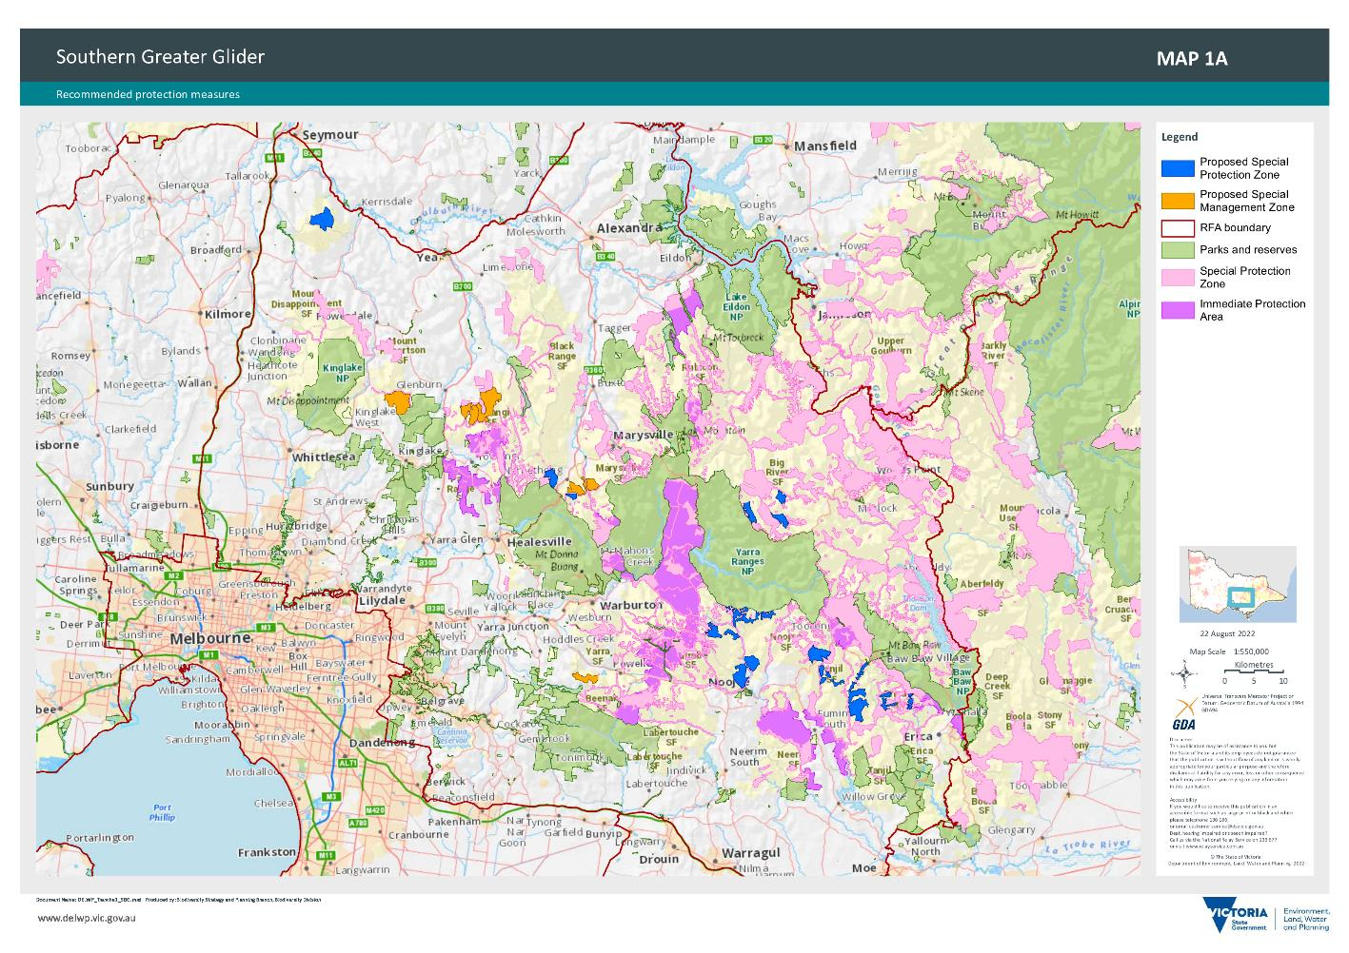

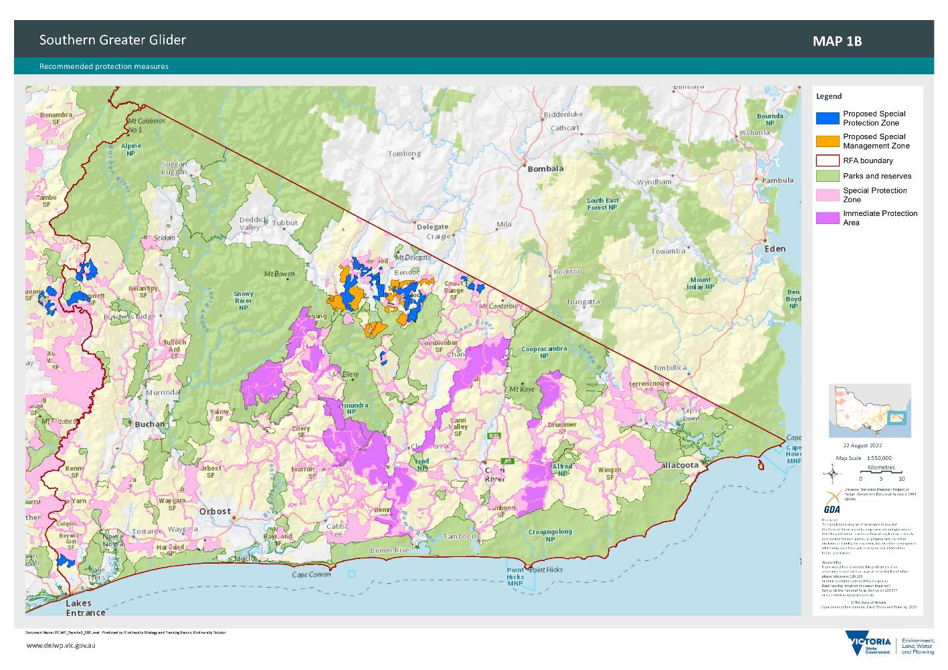

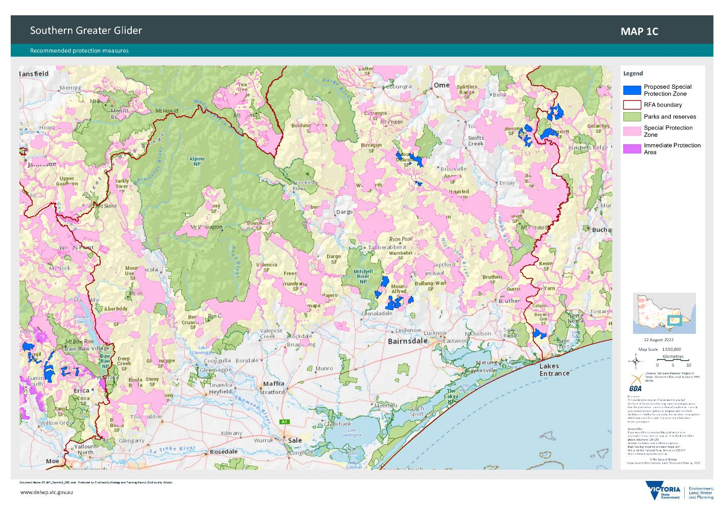

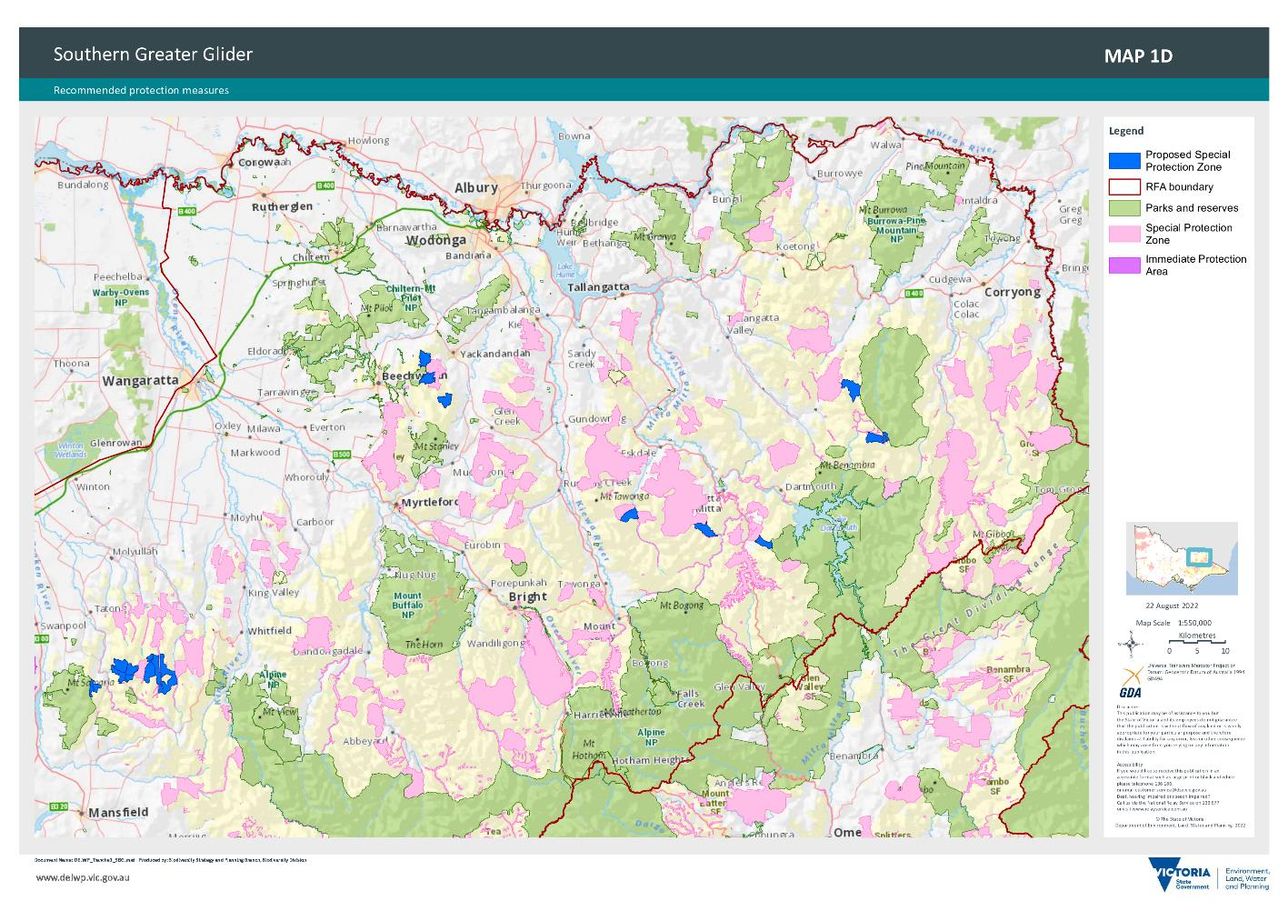

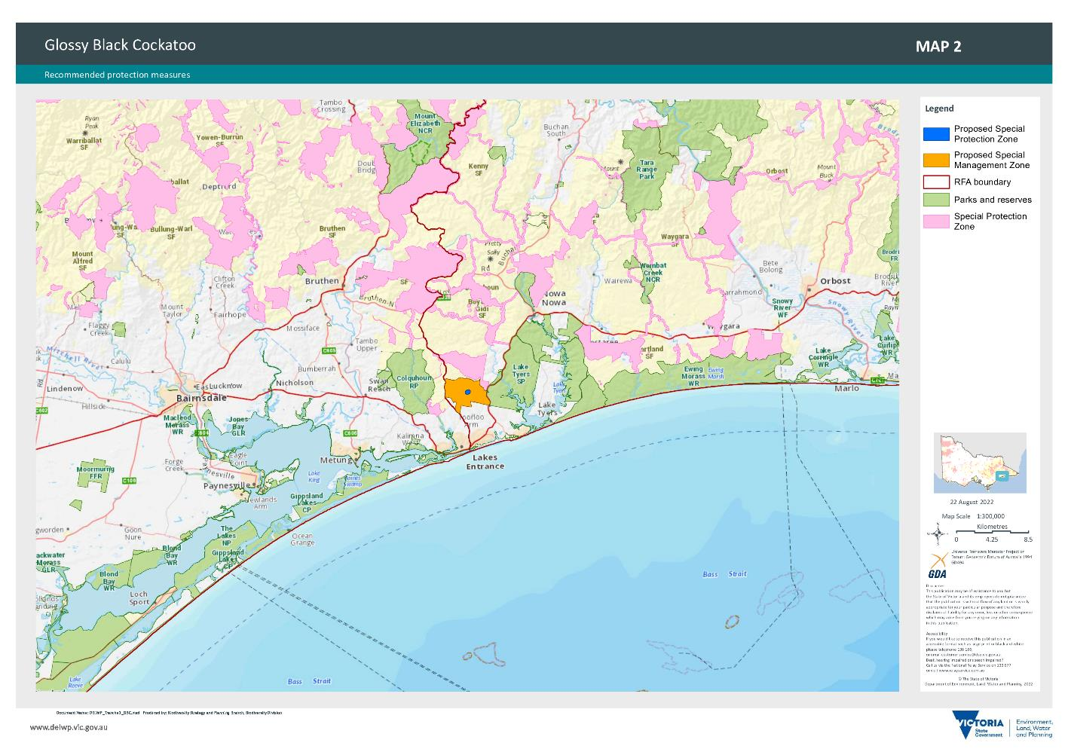

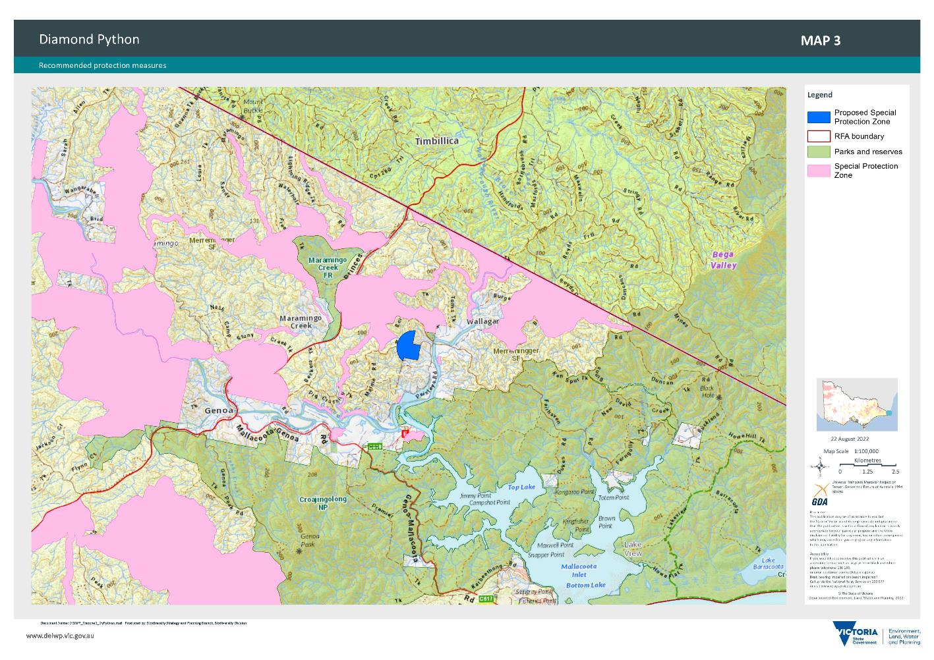

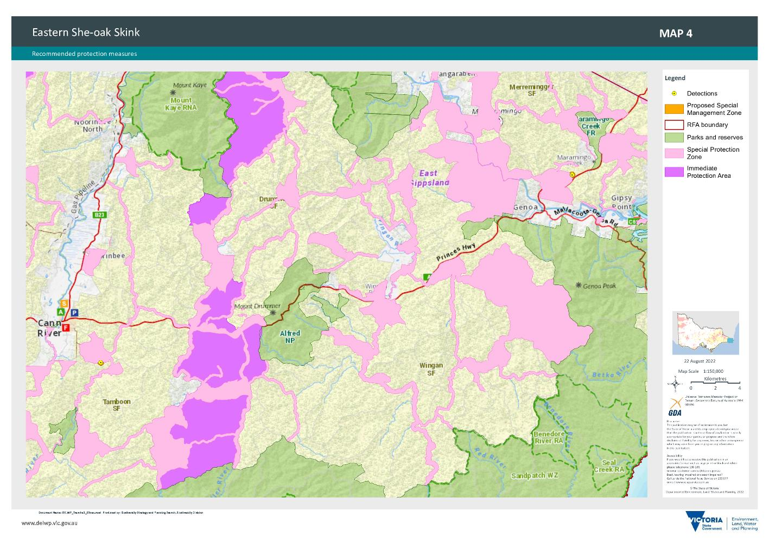

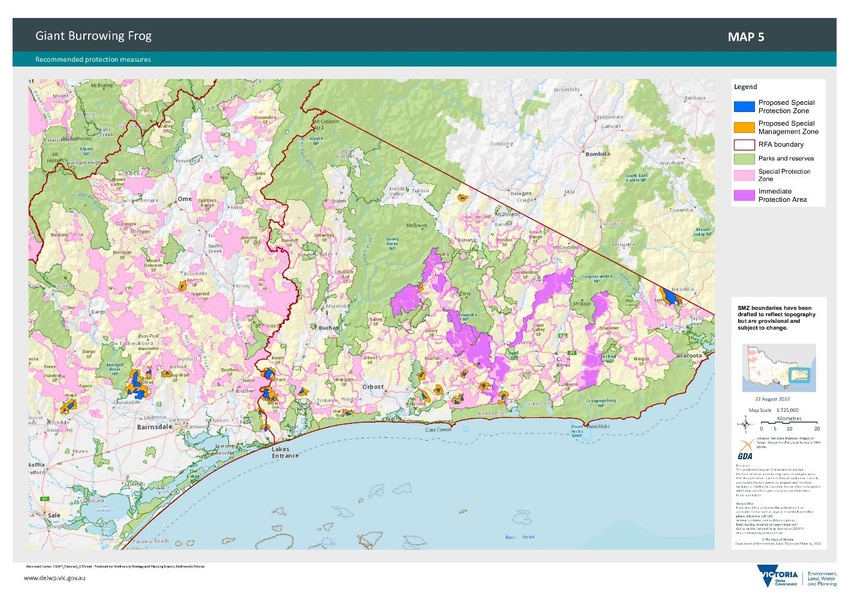

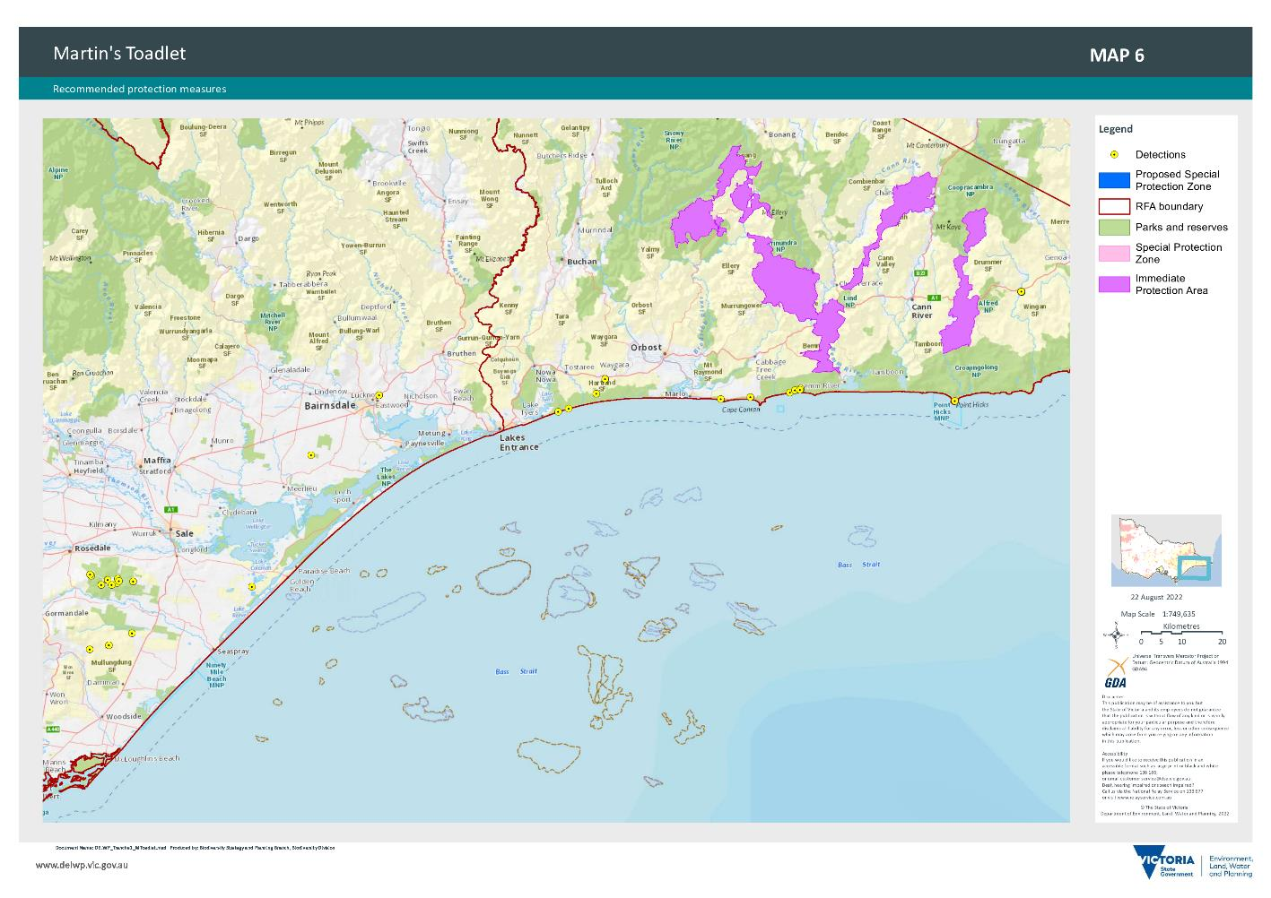

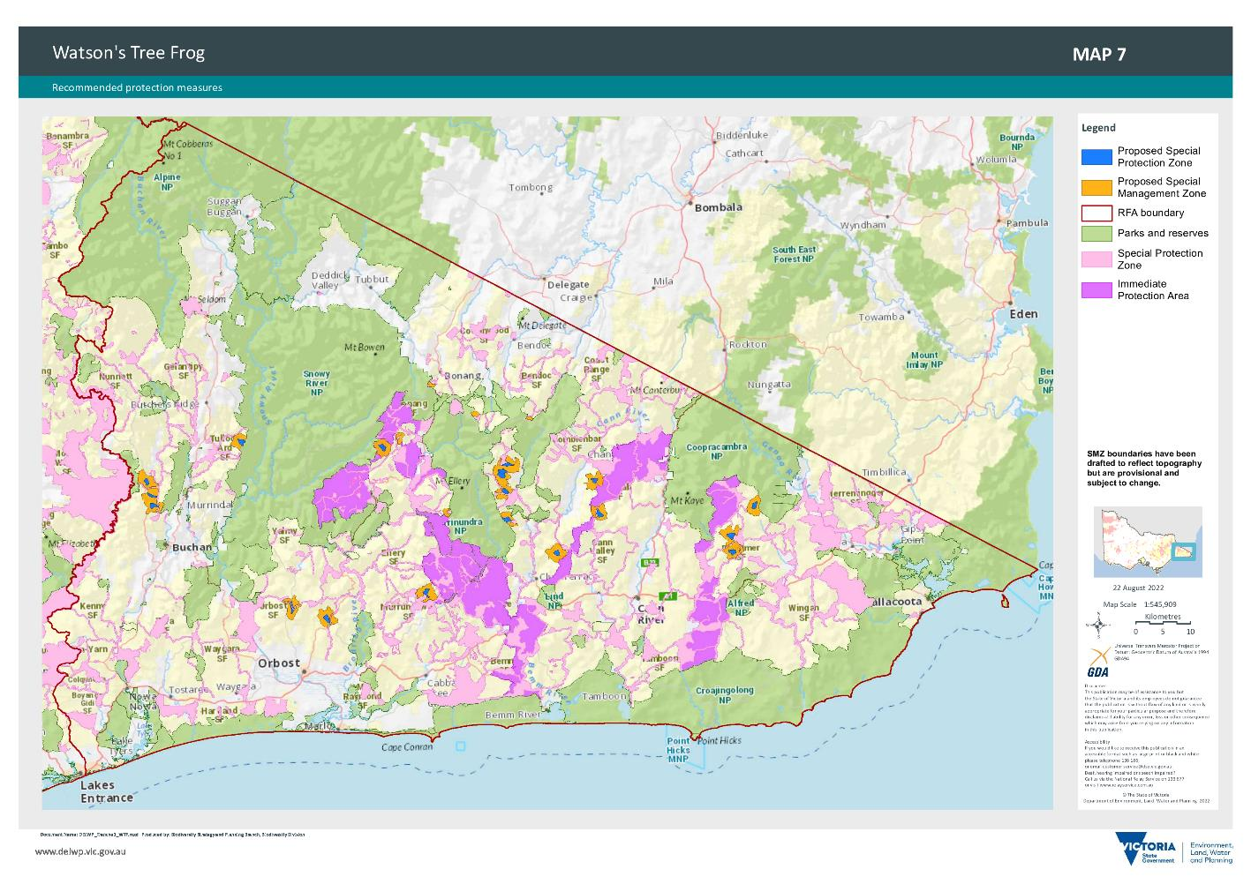

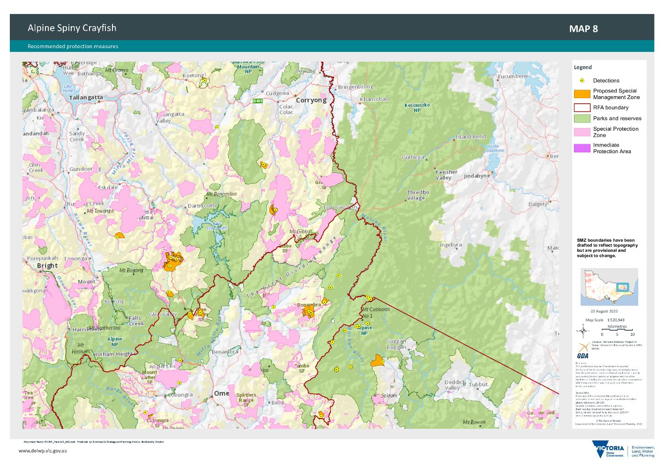

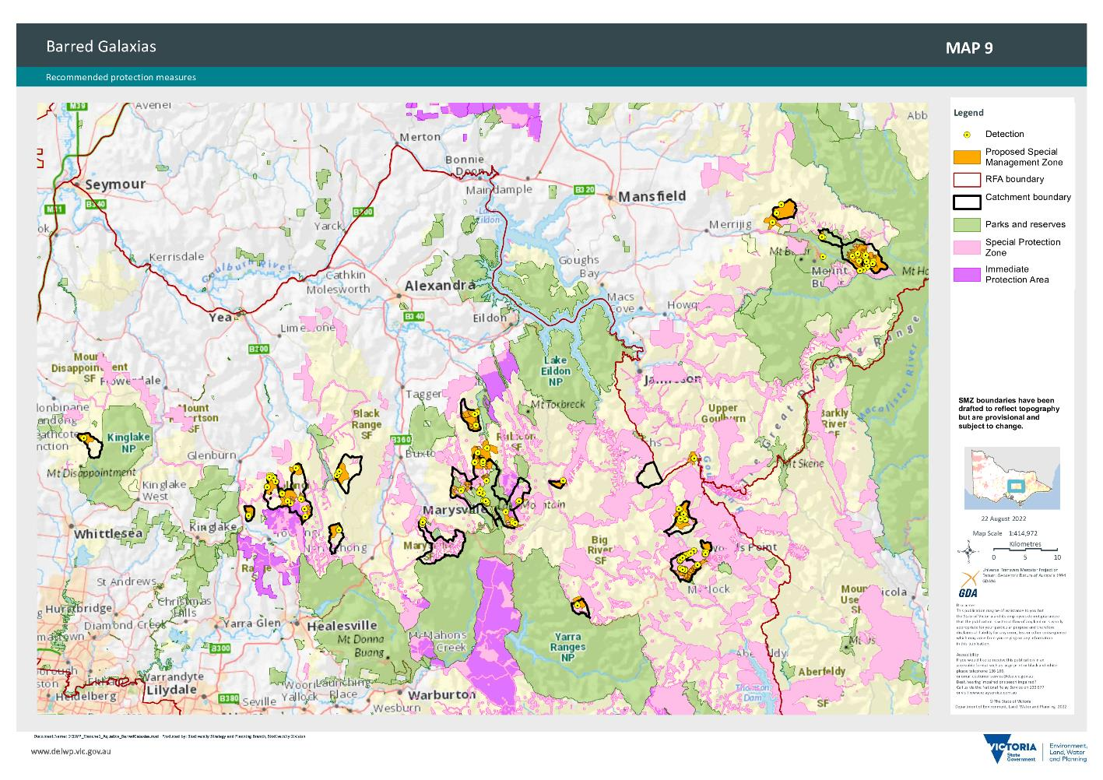

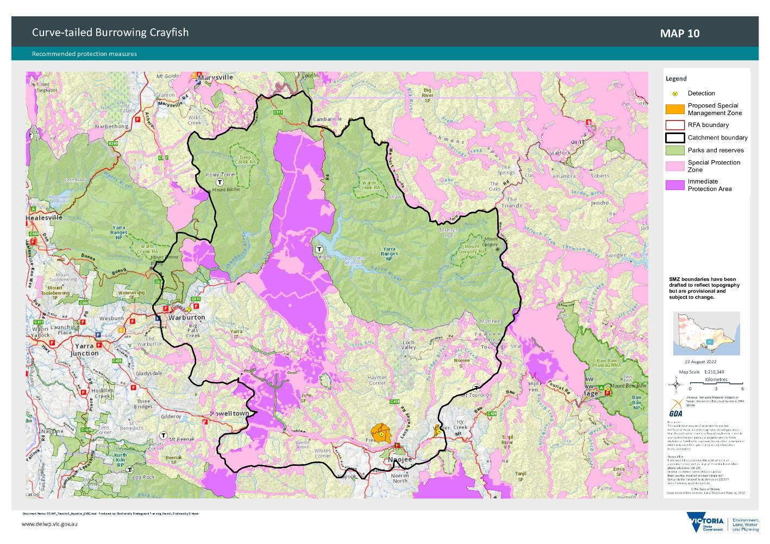

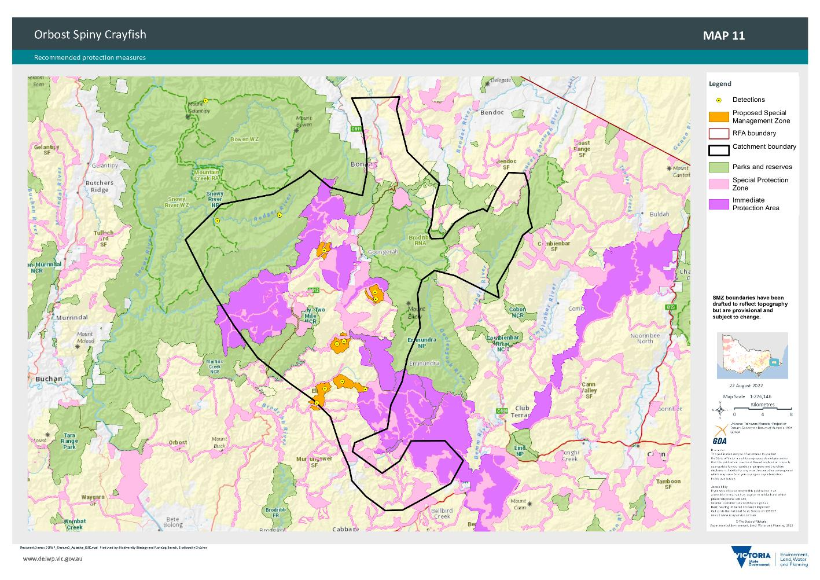

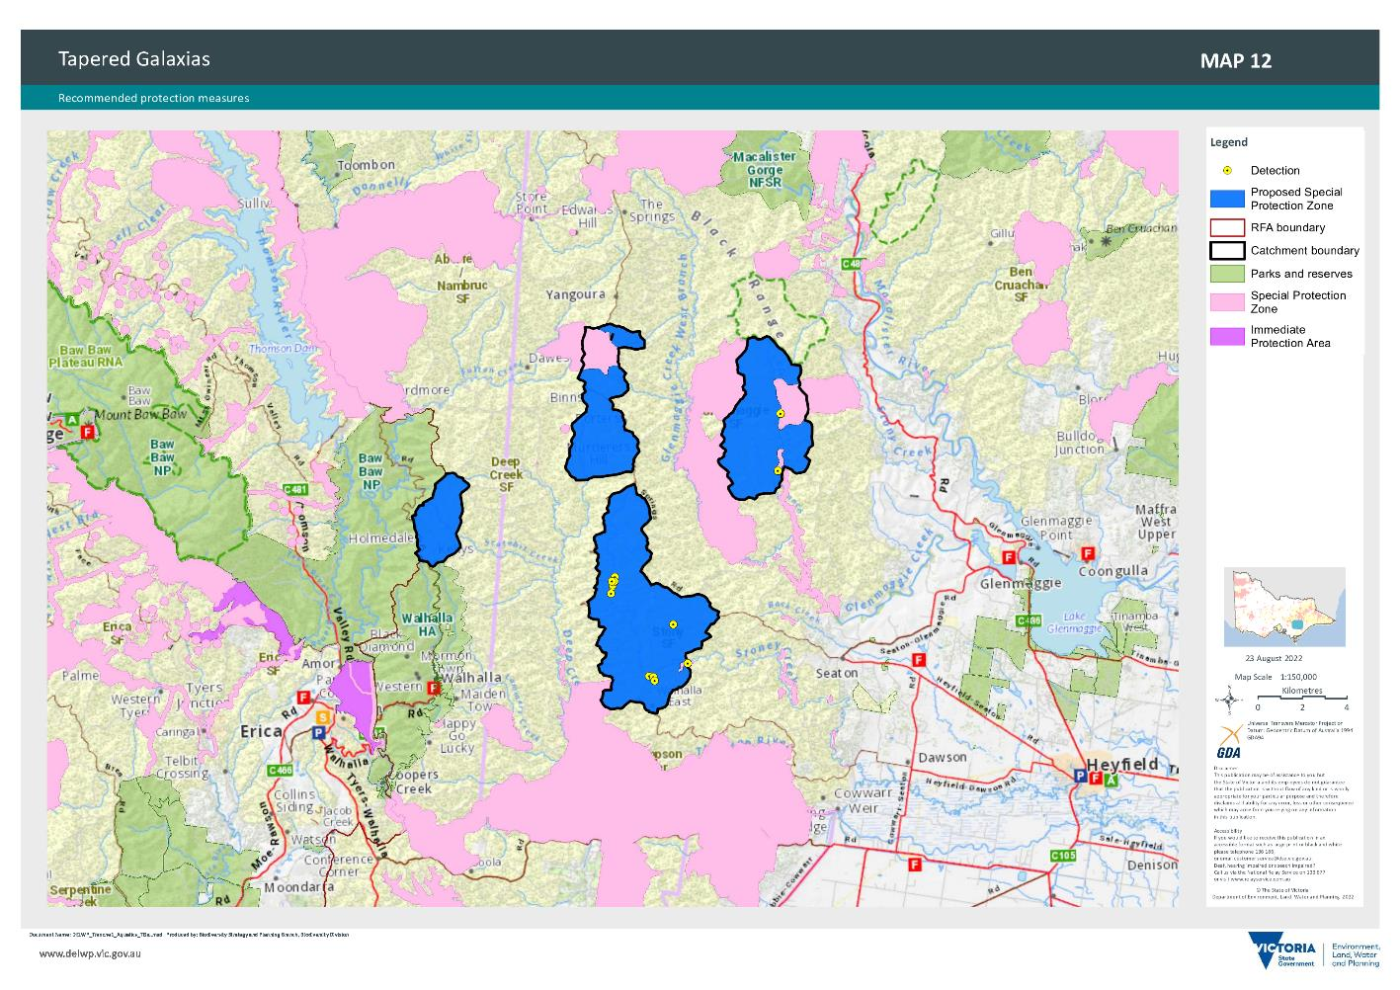

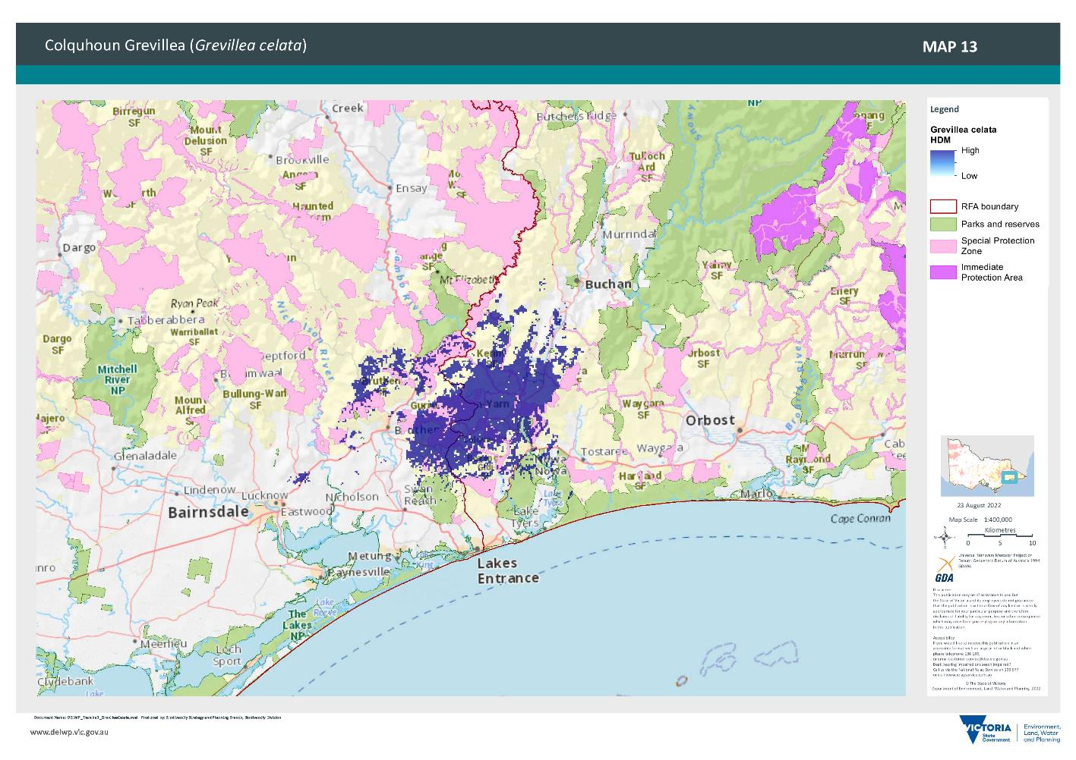

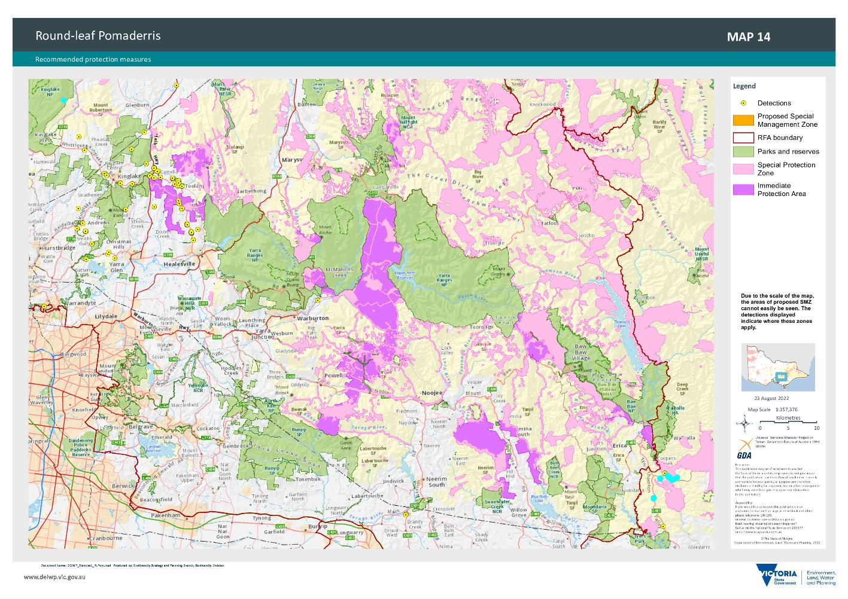

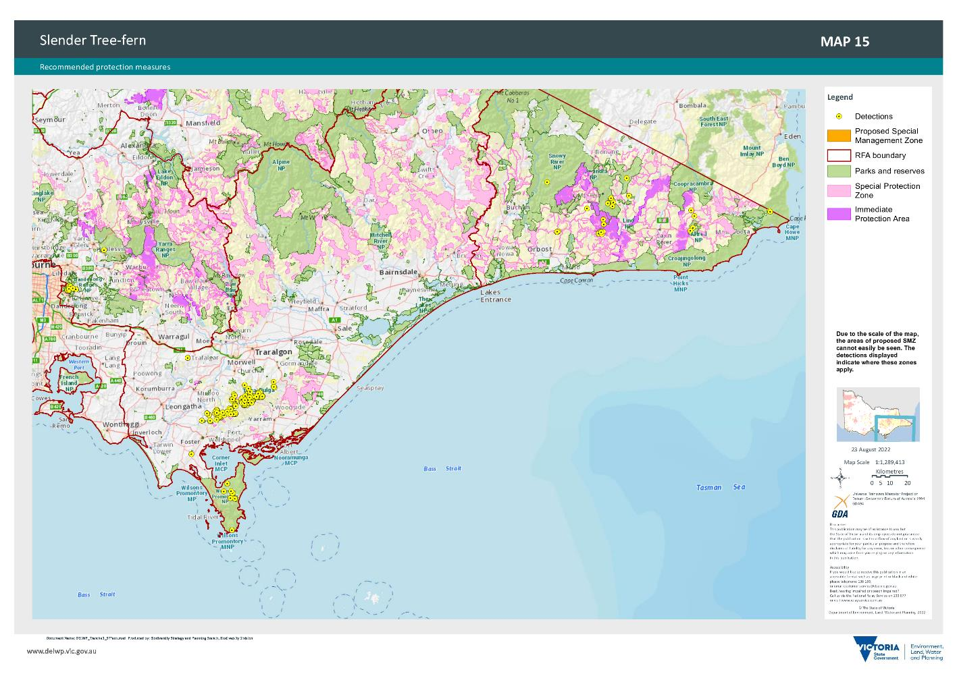

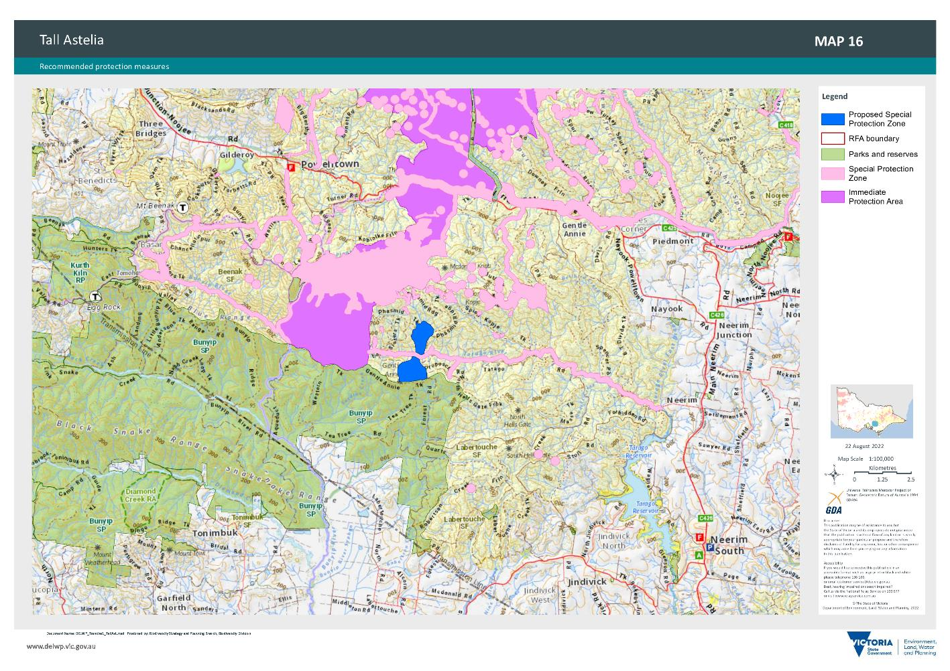

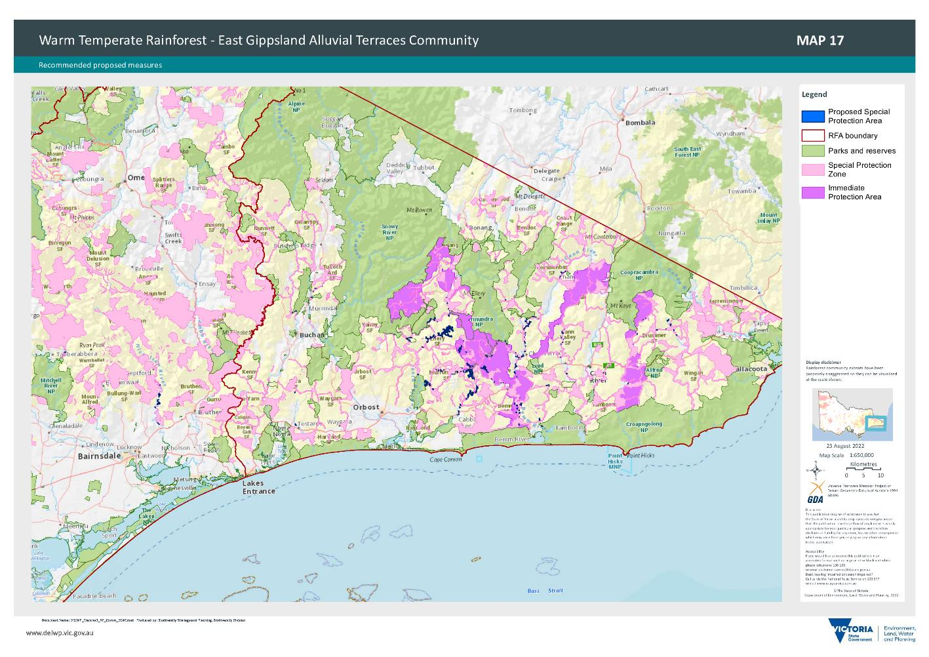

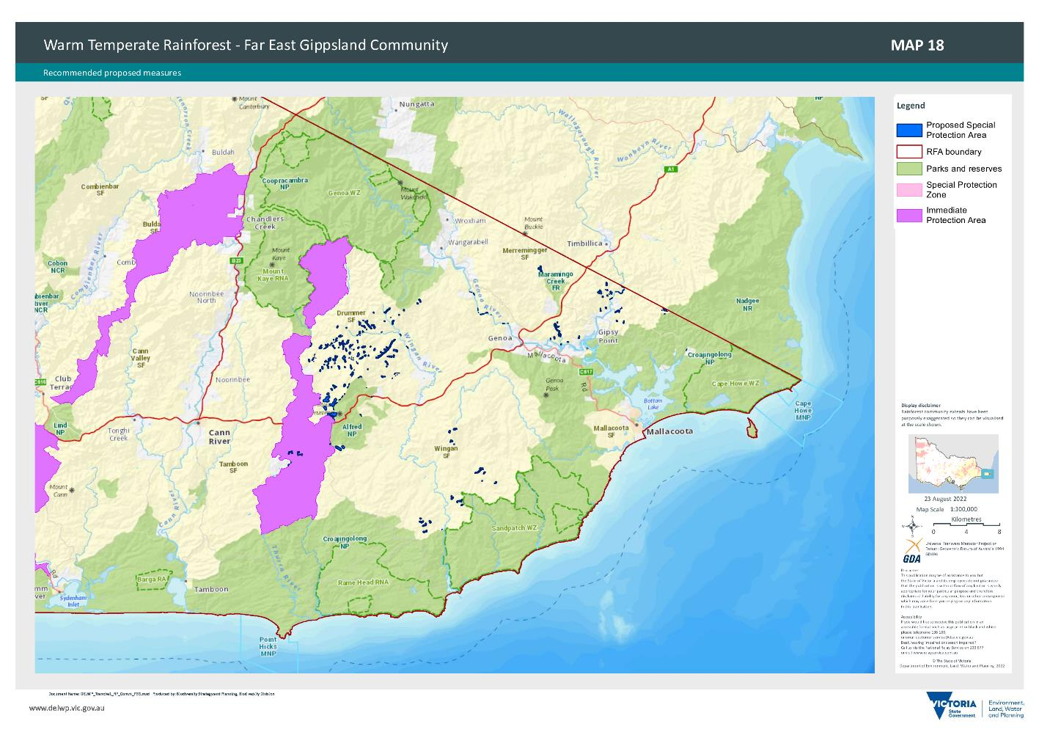

1. Management Standards and Procedures for Timber Harvesting in Victoria’s State Forests 2021
2. Estimates for West RFA region come from the Timber Utilisation Plan dated September 2021