Introduction
Biodiversity Response Planning (BRP) is a long-term area-based planning approach to biodiversity conservation in Victoria. It is designed to strengthen alignment, engagement and participation between government, Traditional Owners, non-government agencies and the community.
DELWP Regional staff have been working with stakeholders on actions to conserve biodiversity in specific landscapes, informed by the best available science and local knowledge.
These Fact Sheets capture a point in time, reflecting data and knowledge available in 2020. They provide information for many (but not all) landscapes across Victoria, containing general information on the key values and threats in each area, as well as the priority cost-effective actions that provide the best protection of biodiversity. Fact Sheets are intended to provide useful biodiversity information for the community, non-government and government organisations during project planning and development.
Further information and the full list of Fact Sheets is available on the Department’s Environment website.

Landscape description
This 299,006ha area is a mostly vegetated landscape (72% native vegetation cover) and is mostly public land (75%). The landscape is predominantly within the Grampians National Park and Black Range State Park but also incorporates private land surrounding the parks.

Habitat Distribution Models identify 325 species with more than 5% of their Victorian range in this landscape
295 Plants
- 60 plants with more than 50% of their Victorian range in the landscape
- Notably, the Grampians Rice-flower (100% of Victorian range in the landscape, EPBC*-listed Vulnerable), Grampians Globe-pea (97% of Victorian range in landscape, EPBC*-listed Critically Endangered) and Grampians Bitter-pea (74% of Victorian range in landscape, EPBC*-listed Vulnerable)
6 Mammals
- Notably, the Heath Mouse (37% of Victorian range in landscape, near threatened), Red-neck Wallaby, Brush-tailed Phascogate, Swamp Rat

6 Reptiles
- 1 reptile with more than 50% of Victorian range in the landscape, notably the Mountain Dragon, Grampians form (100% of Victorian range in landscape)
- Stumpy-tailed Lizard, Striped Worm-Lizard
3 Amphibians
- Notably the Growling Grass Frog (4% of Victorian range in the landscape, endangered), Eastern Snake-necked Turtle (5% of Victorian range in landscape)
*Environment Protection and Biodiversity Conservation Act 1999 (Federal)

Strategic Management Prospects
Strategic Management Prospects (SMP) models biodiversity values such as species habitat distribution, landscape-scale threats and highlights the most cost-effective actions for specific locations. More information about SMP is available in NatureKit.

Which landscape-scale actions are most cost-effective in this landscape?
Some areas of this focus landscape (coloured areas on the map) have highly cost-effective actions which provide significant benefit for biodiversity conservation.
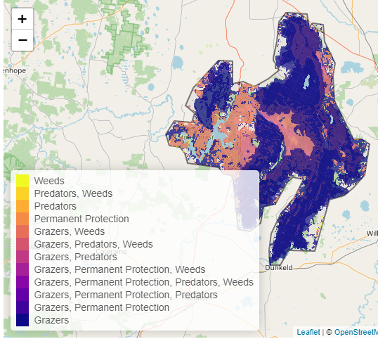
The SMP priority actions which rank among the top 3% for cost-effectiveness of that action across the state are in order:
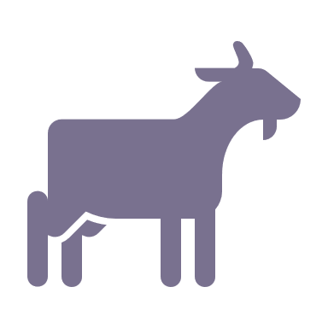 | Control goats 175,015ha
 | Control overabundant kangaroos 8,262ha
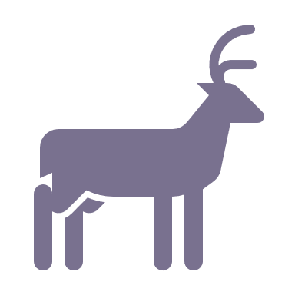 | Control deer 3,756ha
 | Control pigs 1,650ha
 | Revegetation 1,561ha
 | Permanent protection 1,377ha

In the top 10% of cost-effective actions, control goats, control deer, control rabbits and control weeds rank the highest.

The most cost-effective actions for flora & fauna
Plants - Control total grazing pressure, control deer, control goats, control weeds, control rabbits
Birds - Control goats, control deer, control total grazing pressure, combined fox and cat control
Mammals, Reptiles - Control foxes and cats, control total grazing pressure, control goats, control deer
Amphibians - Control deer, control total grazing pressure, combined fox and cat control

For a further in depth look into SMP for this landscape please refer to NatureKit.

