“We acknowledge the Wadawurrung people of the Kulin Nation as the Original Custodians of the lands which represents the following information. We pay respects to Elders past, present and emerging leaders that continue their obligations to care for Country. We care for Country, Culture and Wadawurrung people”.

Victorian Volcanic Plains (VVP) - East

Introduction
Biodiversity Response Planning (BRP) is a long-term area-based planning approach to biodiversity conservation in Victoria. It is designed to strengthen alignment, engagement and participation between government, the Original Custodians, non-government agencies and the community.
DELWP Regional staff with Wadawurrung Traditional Owners Aboriginal Corporation have been working with stakeholders on actions to conserve biodiversity in specific landscapes, informed by the best available science and local knowledge.
These Fact Sheets capture a point in time, reflecting data and knowledge available in 2020. They provide information for many (but not all) landscapes across Victoria, containing general information on the key values and threats in each area, as well as the priority cost-effective actions that provide the best protection of biodiversity. Fact Sheets are intended to provide useful biodiversity information for the community, non-government and government organisations during project planning and development.
Further information and the full list of Fact Sheets is available on the Department’s Environment website.
This Fact Sheet includes the information from the Strategic Management Prospects (SMP) Output Summary for the Bay zone and the feedback from our stakeholders.

Landscape description
The Victorian Volcanic Plains (VVP) - East area is 282,027ha. The native vegetation cover is 21% and the public land cover is 4%.
Significant waterways are Werribee River, Little River, Sutherland Creek (east and west branch) and Moorabool River. There are also many tributaries. The significant wetlands are Lake Modewarre and Lake Gherang. There are three reservoirs: Wuriboluc, Gong Gong and Kirks.
The VVP covers a large proportion of Wadawurrung Country. The VVP is a predominantly flat landscape. The grasslands are the dominant vegetation community with scattered trees and shrubs. Volcanic rocks were once scattered throughout much of the grasslands. Many creeks form into rivers across this zone. Much of the VVP vegetation has been destroyed or degraded since European settlement.
The high biodiversity values are in the larger public land areas such as Inverleigh Nature Conservation Reserve, You Yangs and the small number of grassland reserves.
This landscape has a partial overlap with both the Grasslands of Western Melbourne, and Port Phillip and Western Shoreline Ramsar landscapes. For more information, please refer to these Fact Sheets in the full list of Fact Sheets.

Cultural importance
Wadawurrung Country holds many values culturally and ecologically throughout the diverse landscape. Mountain country, grassland country, sea and coastal country provides for many flora and fauna species to inhabit the landscapes. Resources were aplenty and managed sustainably by the Wadawurrung. Due to previous land activities such as mining, land fragmentation and the introduction of pest species, the landscapes require good partnerships between Wadawurrung Original Custodians and land managers to reinvigorate Country. Wadawurrung land management practices will be supported and guided by the aspirations of the Wadawurrung Healthy Country Plan.
Initial Wadawurrung priority areas identified are – You Yangs, Lake Moddewarre, Lal Lal Falls, Parwan Creek and Werribee River.

Landscapes of interest added through feedback process
Trust for Nature – Victorian Midlands (Lethbridge, Bannockburn, Gheringhap areas) and Western Melbourne Ranges and Plains (Anakie, Little River, Quandong, Mambourin and Eynesbury area).
Central Highlands Water – Kirks, Gong Gong South and North, Pincotts (Webbs, Frank Cass, Ted Cass), Foresters, Black Swamp, Geddes Channel, Geddes Plantation.
Geelong City Council – Bio Sites (Port Phillip Bay Coastal Reserve, Limeburners Lagoon (Hovells Creek) Flora and Fauna Reserve, Kiddle Road, Mill Road, Old Melbourne Road, McClelland Av, Tad Ct, Hicks Road, Flinders Ave, Windermere Road, Spalding Dv, Pousties Road, Forest Road N, Kees Road, Peak School Road, Cherry Swamp Road, Hughes Road, Branch Road, Westgate/Goulburn Park Drive, Breguet Road, Robs Lane, Hams Lane, Argyle St, Plains Road, Calvert Road, Hovells Creek, West Gateway, Wilson Road, Little River Ripley Road, Minns Road, Sandy Creek Road, Chisholm Road, Mcintosh Road, Express Road/Minns Road, Bates Road, Jenkins Road, Constantine Road, Regent Street, Spalding Drive, Taylors Lane, O’Hallorans, Carrs Road, Sutherlands Creek Road, Staceys Road, Pringles Road, Clifton Road, Robbs Road, Atkinson Road, Mt Anakie Reserve, Granite Road, Sandy Creek Road, Mt Rothwell Road, Drysdale Road, Matfins Road, Gifkins Road, Swamp Road, Birds Road and serval unnamed roads. Mt Connata – Private land (Batesford, Anakie, Little River).
Ballarat Environmental Network – Bannockburn Bush Reserve, Teesdale Public Recreation Reserve, Teesdale Water Reserve, Wabdallah Water Supply Reserve, Mt Doran Recreation Reserve, Mt Doran Scenic Reserve, Barkers Dam Recreation Reserve, Meredith Police Paddock and Morrisons Racecourse – Borhoneyghurk.
Moorabool Shire Council – Grasslands Reserves (Lal Lal Falls, Werribee River Reserve, Parwan-Exford Road, North Western Railway, Cummings Road, Bacchus Marsh-Balliang Road, Parwan Gun Club, Greystones Reids Road, Paces Lane, Rowsley-Exford Road S, Daisybank Lane E, Nerowie Road N, Geelong-Bacchus Marsh Road, Springhill Road N, Ballan Road, Agars Road, Schools Road, Sharkeys Road, Mortons Road, Geelong-Ballarat Railway, Le Maitres Road, Lal La Road, Ballan-Meredith Road, Bayards Road, Gluepot Road, Grants Lane, Elaine-Egerton Road, Angees Road, Morrisons-Elaine Road, West of Borhoneyghurk Common, Dollys Creek Road, Ballan-Meredith Road, Egerton-Ballark Road, Mt Wallace-Ballark Road, Geelong-Ballan Road, Smiths Lane, Egerton-Bungeeltap Road, Gearys Lane, Manleys Road, Yendon-Egerton Road, Ingliston Settlement Road, Gillets Lane, Ingliston Road, Racecourse Road and Midlands Hwy). High Value Roadsides (Settlement Road, Atchinson Road, Ballan-Meredith Road, Egerton-Ballark Road, Ballan-Egerton Road, Lal Lal).
Victorian Volcanic Plains Biosphere – Large old trees.

Ecological Vegetation Classes (primary EVCs)
Endangered: Creekline Grassy Woodland, Alluvial Terraces Herb-rich Woodland, Plains Grassy Woodland, Plains Grassy Wetland, Grassy Woodland, Plains Grassland, Floodplain Riparian Woodland, Creekline Herb-rich Woodland, Red Gum Wetland, Plains Woodland/Plains Grassland Mosaic, Stream Bank Shrubland.
Environmental Protection and Biodiversity Conservation Act: Natural Temperate Grasslands of the Victorian Volcanic Plains, Grassy Eucalypt Woodland of Victorian Volcanic Plains, Seasonal Herbaceous Wetlands (Freshwater) of the Temperate Lowland Plains ecological community.
Flora and Fauna Guarantee Act: Western Plains Grasslands Community.

Habitat Distribution Models identify 63 species with more than 5% of their Victorian range in this landscape area (updated 26/07/2020) | The following have been identified as focal species by the Original Custodians and stakeholders
56 plants with more than 5% of Victorian range in area. Notably:  - Dwarf Spider-orchid (endangered, 87%), Small Golden Moths (endangered, 53%), Werribee Blue-box (endangered, 50%), Heath Spear-grass (rare, 48%), Drooping Mistletoe (rare, 48%), Gum-barked Bundy (vulnerable, 42%), Melbourne Yellow-gum (vulnerable, 39%), Sunshine Diuris (endangered, 39%), Brittle Greenhood (endangered, 36%), Brisbane Range Grevillea (rare, 33%), Fragrant Saltbush (rare, 31%) | 50 plants: Snow Gums, Bellarine Yellow-gum, Streaked Arrowgrass, Hooded Water-milfoil, Tree Bursaria, Sharp Club-sedge, Salt Club-sedge, Thread Rush, Tangled Shrub-violet, Large Kangaroo Apple, Sea Rush, Kangaroo Grass, Hedge Wattle, Sheep's Burr, Australian Salt-grass, Lake Water-milfoil, Black Wattle, Swamp Gum, Running Postman, Common Tussock-grass, Golden Wattle, Drooping Sheoak, Small-leaved Clematis, Pink Bindweed, Common Spike-sedge, Pale Rush, Small Loosestrife, Narrow-leaf Cumbungi, Lightwood, Cranberry Heath, Silver Banksia, River Bottlebrush, Water Ribbons, Kidney-weed, Weeping Grass, Common Reed, Blackwood, River Red-gum, Prickly Tea-tree, Slender Dock, Silver Wattle, Coarse Dodder-laurel, Tangled Lignum, Cherry Ballart, Austral Crane's-bill, Common Nardoo, Pale Knotweed, Tall Bluebell, Small-leaf Bramble, Wallaby Grass
4 reptiles with more than 5% of Victorian range in area
- Grassland Earless Dragon (critically endangered, 53%), Grass Skink (21%), Tussock Skink (vulnerable, 6%), Cunningham’s Skink (5%)
2 birds with more than 5% of Victorian range in area
- Orange-bellied Parrot (critically endangered, 7%), Striated Fieldwren (5%)
1 amphibian with more than 5% of Victorian range in area
- Pobblebonk Frog (13%)

Strategic Management Prospects
Strategic Management Prospects (SMP) models biodiversity values such as species habitat distribution, landscape-scale threats and highlights the most cost-effective actions for specific locations. More information about SMP is available in NatureKit.

Additional threats
Threats identified (in addition to those modelled in SMP) through the consultation process were illegal tracks, littering, barriers to on-ground management, inappropriate land use, water quality and quantity, native vegetation removal, urban encroachment, wildfire, and Phytophthora cinnamomi.

Which landscape-scale actions are most cost-effective in this landscape?
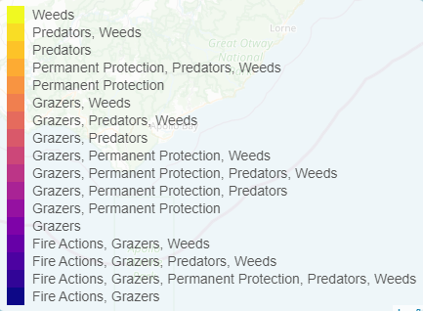
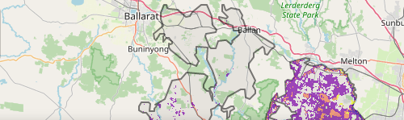
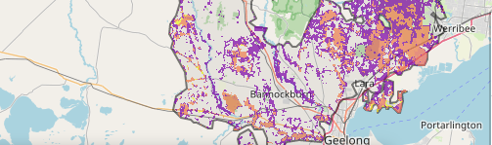
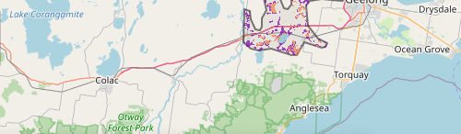
The map shows where the most cost-effective threat control actions in this landscape area. Actions in these areas will maximise biodiversity benefit across Victoria for multiple species.

The very best threat control actions to do in the Top 3% of cost-effective areas are: rabbits, weeds, overabundant kangaroos, goats, domestic grazing, permanent protection and foxes.
When we bring in the Top 10%, we also add the activities: cats, deer, grazing pressure (all grazers), ecological burning, and pigs.

Area available for highly cost-effective revegetation
3,755ha

For a further in depth look into SMP for this landscape please refer to NatureKit.

Priority Areas Map – Victorian Volcanic Plains (VVP) - East
Base layers: This data is from SMP and represents the best areas to carry out the most cost-effective actions for specific threats (also referred to as the Top 10% of Mean Cost-effectiveness (MCE) actions), and the Top 20% locations (these locations have been given names and are referred to as descriptors)
Priority Areas: Wadawurrung Priority Areas, stakeholder’s Landscapes of Interest (LoI), endangered Ecological Vegetation Classes (EVCs), National Parks & Reserves
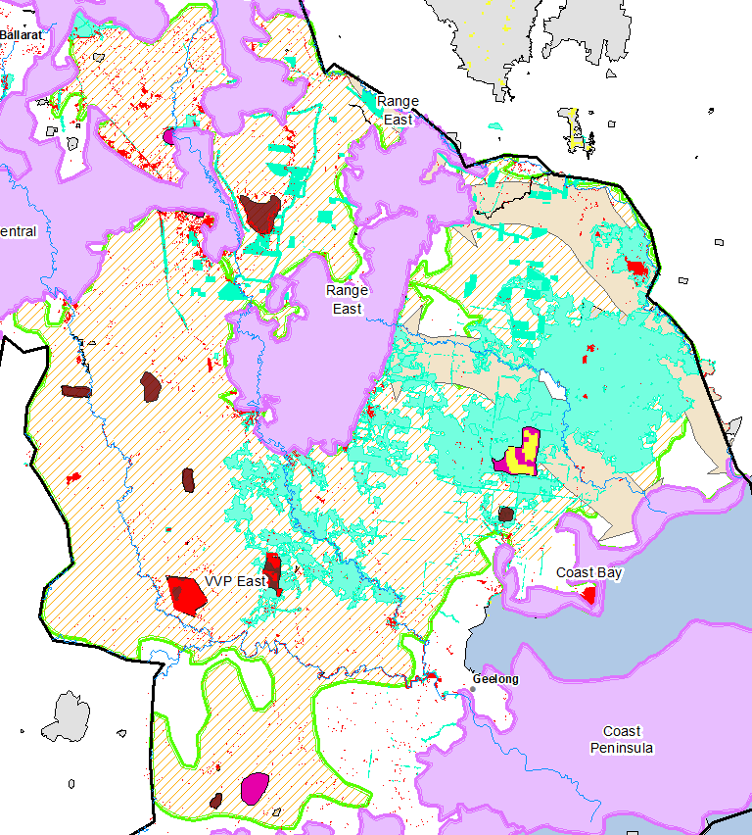
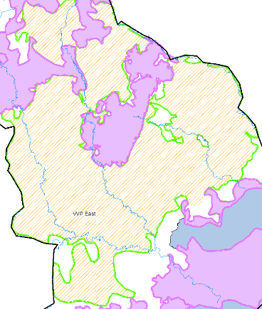
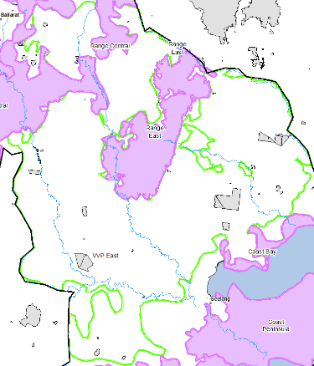
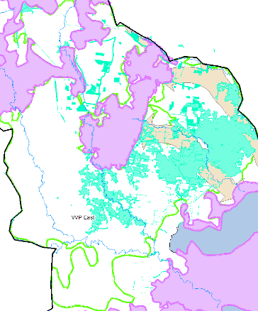
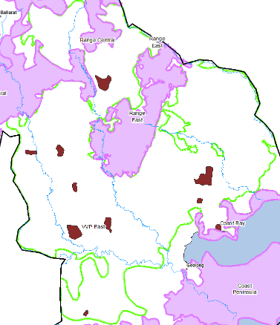
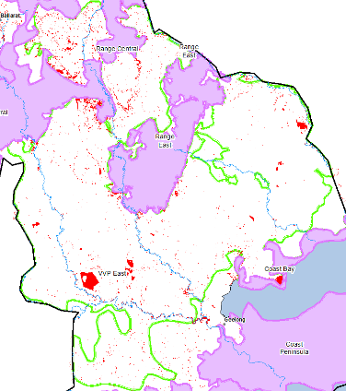
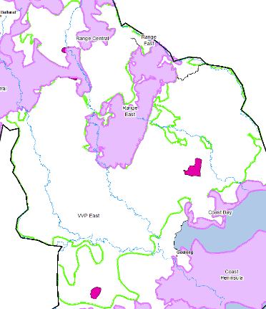
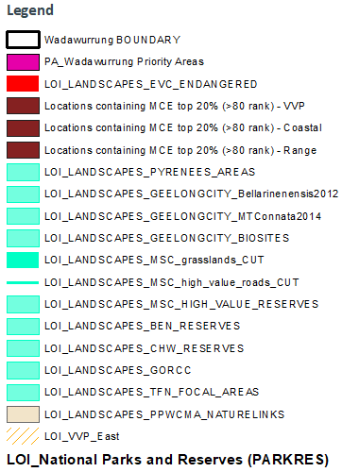
1
2
3
4
5
6
1/ VVP Zone (orange stripes); 2/ National Parks & Reserves (grey); 3/ Stakeholder’s LoI (aqua); 4/ Descriptors (brown); 5/ Endangered EVCs (red); 6/ Wadawurrung initial Priority Areas (pink)

