Introduction
Biodiversity Response Planning (BRP) is a long-term area-based planning approach to biodiversity conservation in Victoria. It is designed to strengthen alignment, engagement and participation between government, Traditional Owners, non-government agencies and the community.
DELWP Regional staff have been working with stakeholders on actions to conserve biodiversity in specific landscapes, informed by the best available science and local knowledge.
These Fact Sheets capture a point in time, reflecting data and knowledge available in 2020. They provide information for many (but not all) landscapes across Victoria, containing general information on the key values and threats in each area, as well as the priority cost-effective actions that provide the best protection of biodiversity. Fact Sheets are intended to provide useful biodiversity information for the community, non-government and government organisations during project planning and development.
Further information and the full list of Fact Sheets is available on the Department’s Environment website.

Landscape description
The Pyramid Hill landscape is 24,738ha in size and consists of predominantly freehold land with significant waterways through the area including Bullock and Mount Hope Creek. Refer to the map at the end of this Fact Sheet.

Cultural importance
We recognise that the entire landscape has high cultural value for Traditional Owners. Landscapes identified as having “notable” cultural importance is based on the density of recorded cultural heritage sites and knowledge shared by Traditional Owners. We also recognise that there are locations important to Traditional Owners not within these landscapes.

Stakeholder interest
As part of the BRP process, in October 2020 stakeholders were asked to nominate focus landscapes and actions of interest. Agriculture Victoria (North Central Irrigation Program) and Barapa Country Aboriginal Corporation nominated Pyramid Hill.
Possible future investment/project development in this landscape will be available to any interested stakeholders in addition to those who nominated this landscape.

0BEcological values identified by Traditional Owners, partners and community within this landscape
Cultural fire on Country:
- Rowlands – Barapa Land and Water (BLW) Flannerys Nature Conservation Reserve (NCR)
- Rowlands – BLW Flannerys NCR south central block
- Rowlands – Rowlands BLW Flannerys NCR
- Rowlands – BLW Flannerys NCR
- Rowlands – BLW Flannerys NCR north east block
- Rowlands – Flannery NCR East2
- Rowlands – Flannery centre block
- Rowlands – BLW Flannerys NCR south west block

 | Strategic management prospects information is unavailable for this landscape at this time | Traditional Owners, stakeholders and community groups identified the following species of interest within this landscape
 | Plants | - Chariot Wheels  - Scaly Mantle  - Yakka Grass
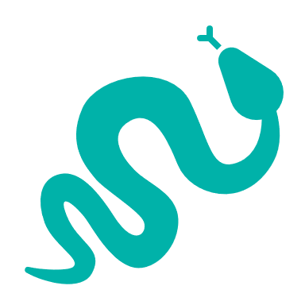 | Reptiles | - Bearded Dragon
 | Birds | - Brolga, Bush Stone-curlew  - Australian Painted Snipe

Traditional Owners, stakeholders and community groups identified the following threats within this landscape
No information provided

Strategic Management Prospects
Strategic Management Prospects (SMP) models biodiversity values such as species habitat distribution, landscape-scale threats and highlights the most cost-effective actions for specific locations. More information about SMP is available in NatureKit.

Additional threats
Threats identified (in addition to those modelled in SMP) through the consultation process were:
- alterations to hydrology
- land salinisation
- soil erosion
- habitat degradation due to extremes of climate and weather and lack of regeneration in some vegetation classes
- recreational activities causing fragmentation
- loss of vegetation, and erosion
- legacy use of public land
- private land use impacting biodiversity
- inappropriate land use planning
- inappropriate fire regimes (planned burning and bushfires)

Some individual threatened species may also require targeted intervention, beyond actions to manage landscape-scale threats, to improve their future prospects.

From the nomination process the following additional actions were also suggested for this landscape:
- weed control
- rabbit control
- cultural fire
- revegetation

For a further in depth look into SMP for this landscape please refer to NatureKit.

