Introduction
Biodiversity Response Planning (BRP) is a long-term area-based planning approach to biodiversity conservation in Victoria. It is designed to strengthen alignment, engagement and participation between government, Traditional Owners, non-government agencies and the community.
DELWP Regional staff have been working with stakeholders on actions to conserve biodiversity in specific landscapes, informed by the best available science and local knowledge.
These Fact Sheets capture a point in time, reflecting data and knowledge available in 2020. They provide information for many (but not all) landscapes across Victoria, containing general information on the key values and threats in each area, as well as the priority cost-effective actions that provide the best protection of biodiversity. Fact Sheets are intended to provide useful biodiversity information for the community, non-government and government organisations during project planning and development.
Further information and the full list of Fact Sheets is available on the Department’s Environment website.

Landscape description
Cobboboonee - Lower Glenelg focus landscape is 60,733ha in size with 75% native vegetation cover remaining. Public land makes up 89% of the area.
Current ecological modelling shows the Cobboboonee - Lower Glenelg focus landscape is largely located in the Glenelg Plain Bioregion. There are also large northern and eastern aspects of the landscape that fall within the Victorian Volcanic Plain. The landscape has over 18,800ha of threatened Ecological Vegetation Classes (EVC) and is largely dominated by Lowland Forest in the west with Deep Freshwater Marsh EVC located throughout the landscape. The Victorian Biodiversity Atlas has records of 34 federally protected species, 62 state protected species and 154 rare or threatened species on the Victorian Advisory List occurring within the landscape.
The Gunditj Mirring Traditional Owner Aboriginal Corporation are Traditional Custodians of this focus landscape, with current stakeholders including Birdlife Australia, Glenelg Hopkins Catchment Management Authority, Glenelg Shire Council, Greening Australia, Nature Glenelg Trust, Parks Victoria, Regional Roads Victoria, South West Environmental Alliance, Trust for Nature and Wannon Water.

Cultural importance
Cobboboonee - Lower Glenelg focus landscape is recognised by its Traditional Owners as occurring on Bocara Woorowarook Mirring (River Forest Country)¹. Central to this landscape is the lower Bocara (Glenelg River) and its tributaries. This section of the Glenelg River is listed and protected under the Heritage Rivers Act 1992² and is one of the broader landscape’s largest drainage basins, which flows into an internationally significant estuary².

Stakeholder interest
There are numerous valuable ecological assets present in this focus landscape, including those identified by Traditional Owners, partners and community.

0BEcological Values identified by Traditional Owners, partners and community within this focus landscape
Glenelg Estuary and Discovery Bay Ramsar Site | Nationally Important and other wetlands including Cordover Swamp, Grassy Flats Swamp and Tremaine Swamp
Cobboboonee National Park and Lower Glenelg National Park | Roosting habitat for Southern Bent-wing Bat

Habitat Distribution Models identify 79 species with more than 5% of their modelled Victorian range in this focus landscape | Threatened terrestrial species within this focus landscape requiring specific actions other than those identified in Strategic Management Prospects (SMP)
72 plants, notably:  - Coloured Spider-Orchid (Endangered)  - Scented Spider Orchid (Endangered)  - Wrinkled Cassinia (Vulnerable) | Rough Blown-grass  Colourful Spider-orchid  Lime Fern
2 mammals
- Swamp Antechinus (Near threatened)
- Heath Mouse (Near threatened)
4 birds, notably:
- Rufous Bristlebird (Near threatened)
1 amphibian
- Southern Smooth Froglet

Strategic Management Prospects
Strategic Management Prospects (SMP) models biodiversity values such as species habitat distribution, landscape-scale threats and highlights the most cost-effectiveness action for specific locations. For a further in depth look into SMP for this landscape please refer to NatureKit.

Which landscape-scale actions are most cost-effective in this landscape?
The coloured areas in the map below indicate where the identified landscape-scale actions are most cost-effective and will maximise biodiversity benefit across Victoria for multiple species.

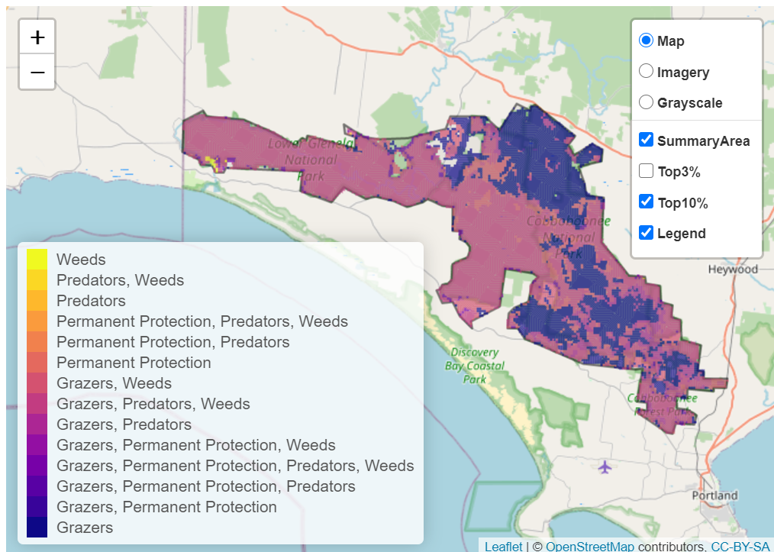

The main SMP priority actions within this focus landscape which rank among the top 10% for cost-effectiveness are listed below:
Control Pigs 57,964ha
Control Goats 56,331ha
Control Deer 49,816ha
Control Weeds 35,336ha
Control Foxes 33,095ha
Control Cats 33,043ha

Within this landscape, pig control, goat control, overabundant kangaroo control, deer control, permanent protection, rabbit control, weed control, fox control and cat control were also identified among the top 3% for cost-effectiveness.

Additional threats and considerations
Threats and considerations (in addition to those modelled in SMP) identified by Traditional Owners, partners and community groups during the BRP process for this focus landscape were:
Threats | Ecological processes and values requiring further considerations
Climate change | Wetland hydrology
Stock access to riparian and wetland areas | Groundwater-dependent ecosystems
Altered hydrology | Aquatic/riparian species and catchment influences
Koala over-browsing | Indicator species and ecosystem engineers

References
1. Parks Victoria, 2015. Ngootyoong Gunditj Ngootyoong Mara-South West Management Plan.
2. Glenelg Hopkins Catchment Management Authority, 2013. Glenelg Hopkins Regional Catchment Strategy: https://info.ghcma.vic.gov.au/wp-content/uploads/2017/04/11259_GHCMA_RSC_WEB.pdf

