|  |
| --- |
| Understanding Strategic Management Prospects (SMP) – Scatter Plots |

Strategic Management Prospects (SMP) scatter plots provide a view of the relative benefit that each species could receive from the most cost-effective actions in a defined area (polygon), plotted against the proportion of the species’ distribution in Victoria contained within that polygon. Each dot represents a different species and the colour of the dot represents the taxonomic group (Class of animal, or plant). The dot size is a measure of alignment between a species’ location and cost-effective action, with larger dots representing a higher match. Where the proportional distribution is high, large dots may indicate the need for more targeted management actions.

The y-axis shows the expected Change in Suitable Habitat within the polygon from undertaking the cost-effective actions, expressed as a proportion of the expected total suitable habitat without any management action. For example, a value of 0.5 suggests that, over 50 years, the cost-effective management regime would yield a 50% increase in suitable habitat within the polygon, relative to no biodiversity management regime).

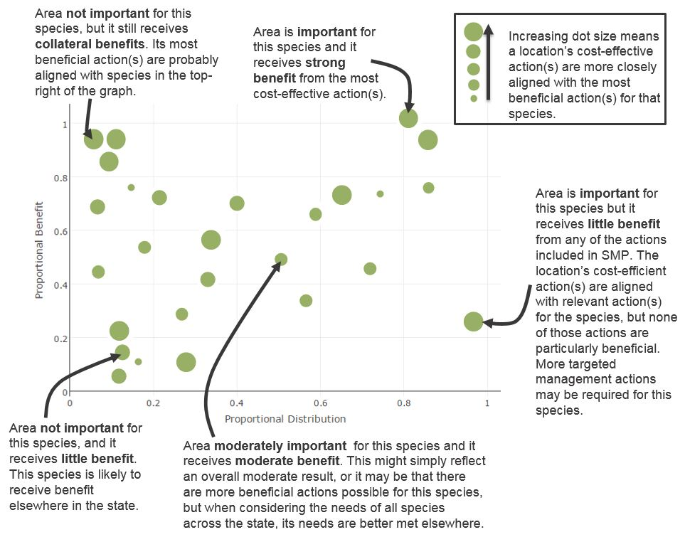The x-axis shows the Proportional Distribution for each species - the proportion of a species' habitat within Victoria that is contained within the polygon. Species to the right of the plot have a higher proportion of their Victorian distribution within the polygon, and are therefore more dependent on management actions within the polygon for their long-term persistence in Victoria.

Explore the information in the scatter plot by hovering a cursor over each dot to see the species and potential benefits. You can turn taxon groups on/off, or use the toolbar at the top to zoom in/out or pan around the plot.

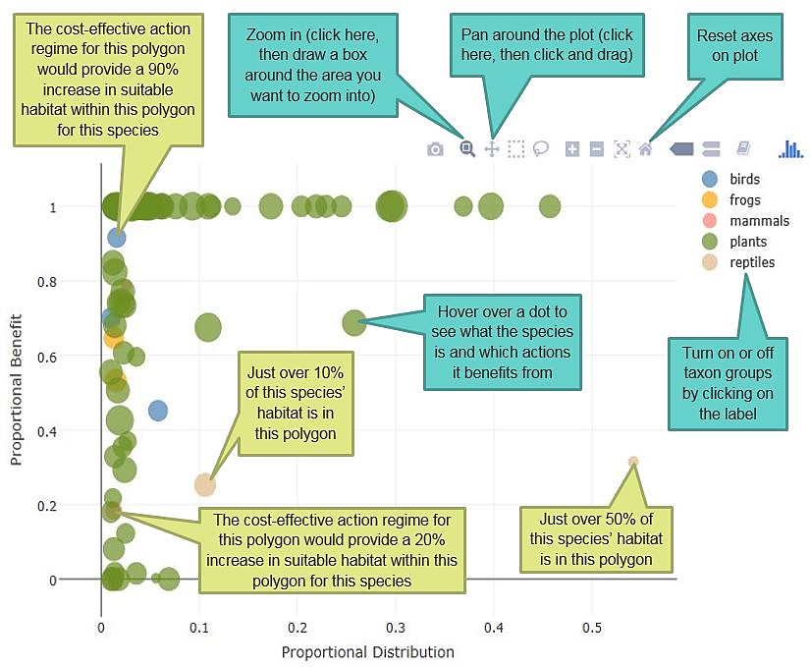

For more information about Strategic Management Prospects visit <https://www.environment.vic.gov.au/biodiversity/natureprint>.

|  |  |
| --- | --- |
| © The State of Victoria Department of Environment, Land, Water and Planning 2018  LogoThis work is licensed under a Creative Commons Attribution 4.0 International licence. You are free to re-use the work under that licence, on the condition that you credit the State of Victoria as author. The licence does not apply to any images, photographs or branding, including the Victorian Coat of Arms, the Victorian Government logo and the Department of Environment, Land, Water and Planning (DELWP) logo. To view a copy of this licence, visit http://creativecommons.org/licenses/by/4.0/  Disclaimer  This publication may be of assistance to you but the State of Victoria and its employees do not guarantee that the publication is without flaw of any kind or is wholly appropriate for your particular purposes and therefore disclaims all liability for any error, loss or other consequence which may arise from you relying on any information in this publication. | Accessibility  If you would like to receive this publication in an alternative format, please telephone the DELWP Customer Service Centre on 136186, email [customer.service@delwp.vic.gov.au](mailto:customer.service@delwp.vic.gov.au), or via the National Relay Service on 133 677 [www.relayservice.com.au](http://www.relayservice.com.au). This document is also available on the internet at [www.delwp.vic.gov.au](http://www.delwp.vic.gov.au). |

To view SMP products go to <https://naturekit.biodiversity.vic.gov.au>.