|  |
| --- |
| VBA - Generate a statewide single species report |
| How to generate a detailed statewide report for a single species in the Victorian Biodiversity Atlas |

### From the Species List & Maps section you can generate a summarised list of the taxa recorded in your chosen area OR the full list of all the detailed records for each species. For the latter you need to be a Registered User and login to the system. Follow these steps to generate detailed statewide records for a single species

## Tips

*Throughout the VBA each window has a* ***?*** *in the top right hand corner – this is window-specific help that will provide further details about how to complete the fields.*

*Make sure that you have allowed pop-ups from your browser (you will need to allow these from the VBA site)*

1. Visit VBA (https://vba.dse.vic.gov.au/vba/) and Login using your Login Name & Password
2. Navigate to the Search section in the top left of the Welcome page and then select Species and Surveys > Species Lists & Maps

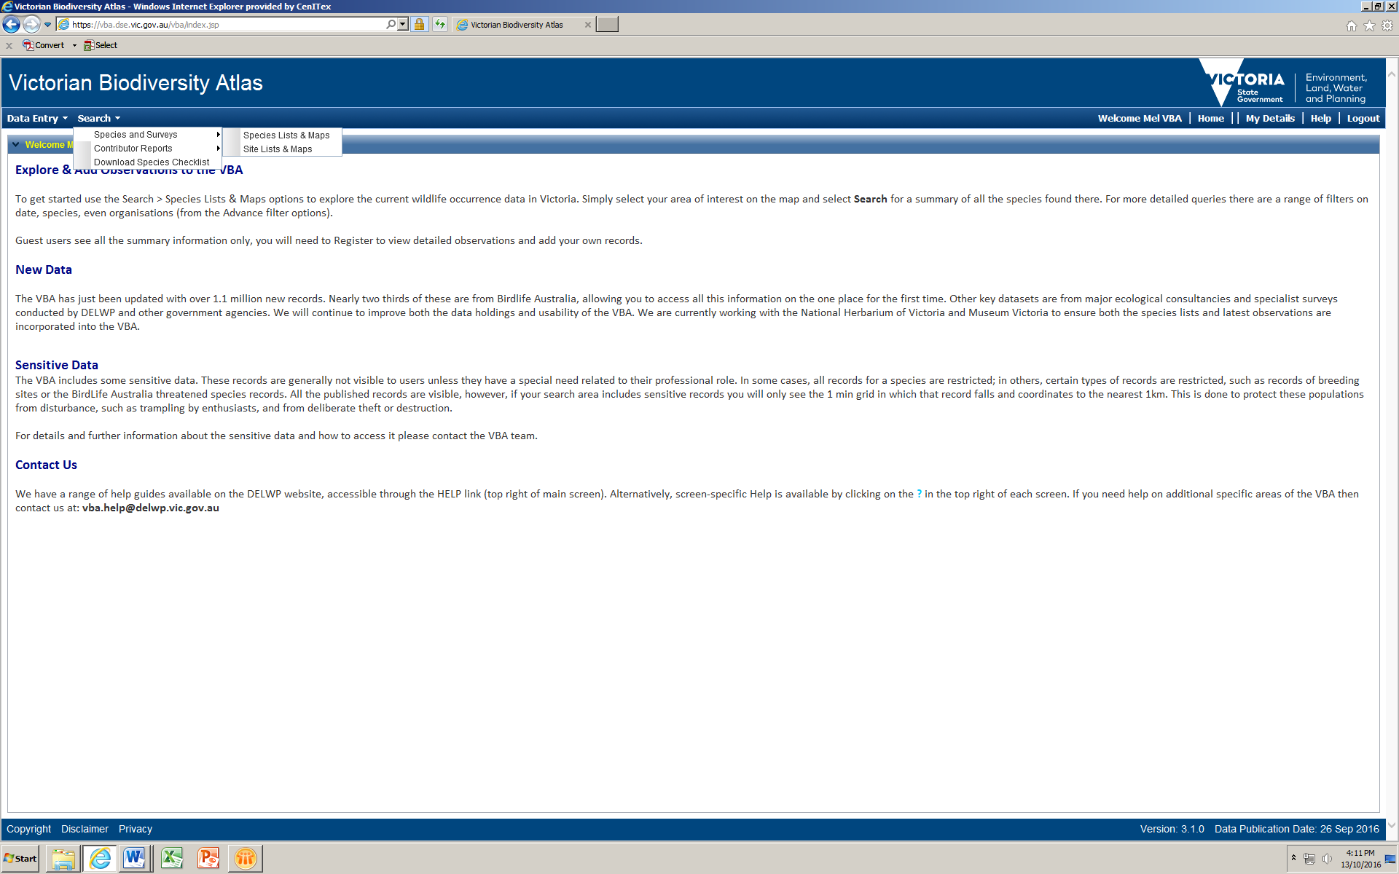

From here you have access to the spatial and non-spatial search elements to query the VBA database.

There are multiple ways you can select your search area. In this example you need to choose Victoria as your search area.

1. To select Victoria as your search area, tick the box All Victorian Sites.
2. Next, in the Common Filter section, type in the Taxon ID for the species you wish to extract records for.

*Note*: If you don’t know the Taxon ID, you can find this by typing in the scientific or common name and conducting a Summary search.

1. Select Detailed and click Search.

*Note*: the maximum number of records the report will return is 20,000.

1. The detailed information for this species will appear at the bottom of your screen. Here you can right click on any of the Species table headings to sort and select from the list of fields available.
2. Now you can now either Print or Export this list.

## detailed single sp search

|  |
| --- |
| **Related Quick Help Guides:**   * Search - Summary Species List for an Area * Search - Detailed Species List for an Area * Search - Species Distribution Map |

|  |  |
| --- | --- |
| © The State of Victoria Department of Environment, Land, Water and Planning 2017  LogoThis work is licensed under a Creative Commons Attribution 4.0 International licence. You are free to re-use the work under that licence, on the condition that you credit the State of Victoria as author. The licence does not apply to any images, photographs or branding, including the Victorian Coat of Arms, the Victorian Government logo and the Department of Environment, Land, Water and Planning (DELWP) logo. To view a copy of this licence, visit http://creativecommons.org/licenses/by/4.0/  Disclaimer  This publication may be of assistance to you but the State of Victoria and its employees do not guarantee that the publication is without flaw of any kind or is wholly appropriate for your particular purposes and therefore disclaims all liability for any error, loss or other consequence which may arise from you relying on any information in this publication. | Accessibility  If you would like to receive this publication in an alternative format, please telephone the DELWP Customer Service Centre on 136186, email [customer.service@delwp.vic.gov.au](mailto:customer.service@delwp.vic.gov.au) or via the National Relay Service on 133 677 [www.relayservice.com.au](http://www.relayservice.com.au). This document is also available on the internet at [www.delwp.vic.gov.au](http://www.delwp.vic.gov.au). |