New Growth
Engaging with Universities

Why engage with universities?
Connecting with universities can offer access to a large network of students with a new intake each year.
Many of these students are interested in volunteering their time and skills to assist the broader community.

There are varied benefits to reaching out and engaging with universities, including gaining greater diversity and a fresh perspective within your group.

Each university offers a range of courses with placement, internship and community involvement units, with their own systems and platforms to advertise any new and relevant opportunities in the area.

Flexible opportunities that are ‘short term’ or ‘project based’ tend to be preferred as the study load of students can fluctuate over the year, making it difficult for students to juggle multiple priorities.

Don’t be deterred by offering short term opportunities - students that have a positive experience with your group will be likely to share it with their peers and may become ongoing volunteers.

This document is intended to point your group in the right direction to connect with your local university and access a new community of students.

Victorian universities

Australian Catholic University
The Australian Catholic University (ACU) has a strong focus on community service, including the environment.

Opportunities:
ACU has a jobs portal platform called, CareerHub, which students and recent graduates can access and view. If you would like to advertise an opportunity with ACU, read over the Terms and Conditions and Register. Take the time to also review the Guidelines. Once submitted, the advertisement should be approved and visible to students within 48 hours.

Connect:
For enquiries please email: careers.service@acu.edu.au

Locations:
Ballarat and Fitzroy (Melbourne)

Charles Sturt University
Charles Sturt University (CSU) has a range of campuses. CSU has a strong environmental focus with a range of programs including the CSU Green program.

Opportunities:
To advertise an upcoming event/activity to CSU students, read the Terms and Conditions and fill out the ‘Promote your Job Vacancies’ form. Once accepted, it will be posted to Charles Sturt's online internal notice board.

Connect:
For more information about advertising upcoming activities and events follow the link to
Contact Faculty Workplace Learning

Location:
Albury Wodonga

Deakin University
Deakin University offers a range of environmental courses and has several environmental clubs.

Opportunities:
Deakin has updated their work placement arrangement to allow students to volunteer within the community. They use a platform called DeakinTALENT to advertise jobs and internships. You can Register your group and add events when desired. Before registering your group make sure you read through the Terms and Conditions for DeakinTALENT.

Connect:
For enquiries please email:
grad-recruitment@deakin.edu.au

Locations:
Burwood, Warrnambool, Waterfront Geelong, Waurn Ponds

Federation University
Federation University has recently launched Federation Advantage which recognises students for all the extra activities they take part in during their studies, including volunteering within the community.

Opportunities:
Federation University uses a platform called Edge to advertise opportunities across all campus as well as their partner providers. To advertise upcoming opportunities, register your group on the platform.

Connect:
For enquiries please email: Volunteer@federation.edu.au

Locations:
Ballarat, Berwick, Churchill and Horsham

La Trobe University
La Trobe offers course units that include community involvement and placements. Their Emerging Leaders program acknowledges students that volunteer in the community.

Opportunities:
CareerHub is La Trobe University's online portal, advertising opportunities to students and recent graduates. It has the option to reach all campuses at once or to target individual campuses. Your group can view the Terms Conditions and Register for CareerHub.

Connect:
For enquiries please: Phone: +61 3 9479 2459 (Monday – Friday, 9am to 4pm) or Email: careers@latrobe.edu.au

Locations:
Albury-Wodonga, Bendigo, Bundoora, City, Mildura and Shepparton

Monash University
Monash courses frequently require students to partake in volunteering as part of their degree. Opportunities are shared via Facebook. Short term opportunities, with approximately 20 hours per student, are preferred. Get in touch directly with the relevant Faculty to advertise opportunities.

Locations:
Caulfield, Clayton, Parkville and Peninsula

RMIT University
RMIT University use the online portal CareerHub to advertise Jobs, internships and Volunteering opportunities. RMIT also gives recognition for on and off campus co-curricular activities, including voluntary work through their Future Edge program.

Opportunities:
If your group wishes to advertise at RMIT, Register your group, making sure you read the Terms and Conditions and view this How to Guide, to gain the best results.

Connect:
For enquiries please email: careers@rmit.edu.au or phone on +61 3 9925 3901.

Locations:
Brunswick, Bundoora and City

Swinburne University
Swinburne prefer short term, one day a week, or once off activities, and recognise volunteering in a range of ways including through their Emerging Leaders Program.

Opportunities:
Swinburne promotes volunteering roles on a platform called Track it Forward, to advertise relevant events. Apply for a partnership via this Community Partner Application Form, and complete the Volunteer Request Form. Allow at least four weeks to ensure it is circulated to students.

Connect:
For enquiries please email: volunteer@swin.edu.au

Locations:
Croydon, Hawthorn and Wantirna

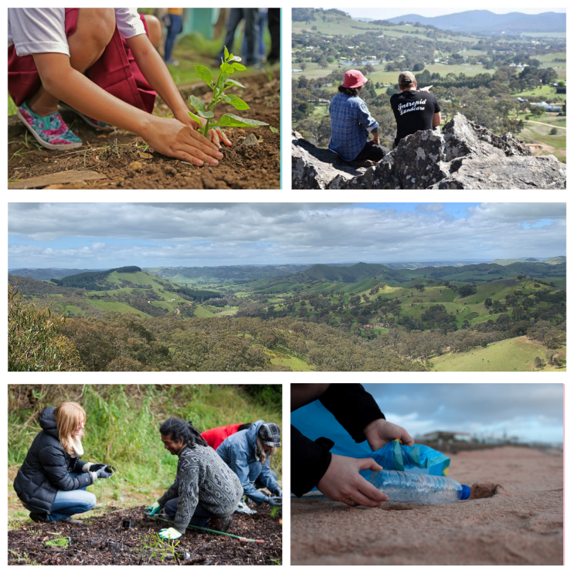
University of Melbourne
The University of Melbourne use Careers Online as their platform. They advertise opportunities for internships, volunteering, work experience and work shadowing. Each faculty has its own requirements and conducts their programs slightly different, to find out specifics visit here.

Opportunities:
To advertise an event/activity on Careers Online register your group. All opportunities must comply with their terms and conditions and Fair Work legislation.

Connect:
For enquiries please: Phone: +61 3 9035 5983 (Monday – Friday, 9am to 4pm) or
Email: careers-services@unimelb.edu.au

Locations:
Burnley, Creswick, Dookie, Parkville, Shepparton, Southbank and Werribee

Victoria University
At Victoria University (VU) they have a VU Vollies volunteering program. Once a year Victoria University hold a V4U Day, which is a full day where all students in the program volunteer with participating partner organisations

Opportunities:
This Handbook steps through the VU Vollies volunteering program, to advertise relevant events, apply for partnership via this Partnership Form, and request volunteers for an event via the Request Form. Allowing at least 4 weeks to insure it can be circulated.

Connect:
For enquiries please: Phone: +61 3 9919 5738 (Monday – Friday, 9am to 4pm) or Email: vollies@vu.edu.au

Locations:
City, Footscray, St Albans, Sunshine and Werribee

