“We acknowledge the Wadawurrung people of the Kulin Nation as the Original Custodians of the lands which represents the following information. We pay respects to Elders past, present and emerging leaders that continue their obligations to care for Country. We care for Country, Culture and Wadawurrung people”.

Victorian Volcanic Plains (VVP) - West

Introduction
Biodiversity Response Planning (BRP) is a long-term area-based planning approach to biodiversity conservation in Victoria. It is designed to strengthen alignment, engagement and participation between government, the Original Custodians, non-government agencies and the community.
DELWP Regional staff with Wadawurrung Traditional Owners Aboriginal Corporation have been working with stakeholders on actions to conserve biodiversity in specific landscapes, informed by the best available science and local knowledge.
These Fact Sheets capture a point in time, reflecting data and knowledge available in 2020. They provide information for many (but not all) landscapes across Victoria, containing general information on the key values and threats in each area, as well as the priority cost-effective actions that provide the best protection of biodiversity. Fact Sheets are intended to provide useful biodiversity information for the community, non-government and government organisations during project planning and development.
Further information and the full list of Fact Sheets is available on the Department’s Environment website.
This Fact Sheet includes the information from the Strategic Management Prospects (SMP) Output Summary for the Bay zone and the feedback from our stakeholders.

Landscape description
The Victorian Volcanic Plains (VVP) - West area is 329,287ha. The native vegetation cover is 12% and the public land cover is 3%.
Significant waterways are Burrumbeet Creek, Mount Emu Creek, Fiery Creek, Trawalla Creek, Wongan Creek, Broken Creek, Barwons Waterholes, Gnarkeet Chain of Ponds, Naringhil Creek, Kuruc A Ruc Creek, and Ferrers Creek. The significant wetlands are the Burrumbeet cluster (Horseshoe Lagoon, Lake Learmonth, Lake Burrumbeet, Black Swamp), Lake Goldsmith, Lake Wongan, Slater Lake, Streatham cluster (Lake McLarne, Pink Lake, Lake Oundell, Nerrin Nerrin Swamp, Salt Lake).There is one reservoir: St Enocks.
The VVP cover a large proportion of Wadawurrung Country. The VVP is a predominantly flat landscape. The grasslands are the dominant vegetation community with scattered trees and shrubs. Volcanic rocks were once scattered throughout much of the grasslands. This zone contains a small section of the Volcanic Lakes system. Within the VVP, many vegetation communities have been destroyed or degraded since European settlement.
The high biodiversity values are shown in the tiny number of grassland reserves such as Blacks Creek Nature Conservation Reserve. Some lakes/wetlands also have high biodiversity values.
This landscape has a partial overlap with the Creswick landscape. For more information please refer to the Creswick Fact Sheet in the full list of Fact Sheets.

Cultural importance
Wadawurrung Country holds many values culturally and ecologically throughout the diverse landscape. Mountain country, grassland country, sea and coastal country provides for many flora and fauna species to inhabit the landscapes. Resources were aplenty and managed sustainably by the Wadawurrung. Due to previous land activities such as mining, land fragmentation and the introduction of pest species, the landscapes require good partnerships between Wadawurrung Original Custodians and land managers to reinvigorate Country. Wadawurrung land management practices will be supported and guided by the aspirations of the Wadawurrung Healthy Country Plan.
Initial Wadawurrung Priority Area identified: Lake Burrumbeet.

Landscapes of interest added through feedback process
Ballarat Environmental Network – Skipton Common, Haddon Recreation Reserve, Winter Swamp, Yalla-Y-Porra Grassland Reserve, Derwent Jacks Reservoir and Scarsdale Public Purpose Reserve.
Central Highlands Water – St Enocks Reservoir.
Pyrenees Shire – Beaufort Habitat Linkage.
Victorian Volcanic Plains Biosphere – Large old trees.

Ecological Vegetation Classes (primary EVCs)
Endangered: Creekline Grassy Woodland, Plains Grassy Woodland, Plains Grassy Wetland, Grassy Woodland, Plains Grassland, Floodplain Riparian Woodland, Creekline Herb-rich Woodland, Stream Bank Shrubland, Grassy Woodland/Heathy Dry Forest Complex, Riparian Woodland, Plains Sedgy Wetland, Brackish Drainage-line Aggregate.
Environment Protection and Biodiversity Conservation Act: Natural Temperate Grasslands of the Victorian Volcanic Plains, Grassy Eucalypt Woodland of Victorian Volcanic Plains, Seasonal Herbaceous Wetlands (Freshwater) of the Temperate Lowland Plains ecological community.
Flora and Fauna Guarantee Act: Western Plains Grasslands Community.
Habitat Distribution Models identify 81 species with more than 5% of their Victorian range in this landscape area (updated 26/07/2020) | The following have been identified as focal species by the Original Custodians and stakeholders
76 plants with more than 5% of Victorian range in area. Notably:  - White Sunray (endangered, 34%), Turf Curly Sedge (rare, 30%), Salt-lake Tussock-grass (vulnerable, 25%), Clumping Leek-orchid (endangered, 24%), Grassland Sun-orchid (endangered, 24%), Button Wrinklewort (endangered, 24%), Basalt Sun-orchid (endangered, 24%), Fragrant Leek-orchid (endangered, 23%), Spiny Peppercress (endangered, 21%) | 41 plants: Snow Gums, Hooded Water-milfoil, Sharp Club-sedge, Salt Club-sedge, Thread Rush, Large Kangaroo Apple, Sea Rush, Kangaroo Grass, Hedge Wattle, Sheep's Burr, Australian Salt-grass, Lake Water-milfoil, Black Wattle, Swamp Gum, Running Postman, Common Tussock-grass, Golden Wattle, Drooping Sheoak, Pink Bindweed, Common Spike-sedge, Pale Rush, Small Loosestrife, Narrow-leaf Cumbungi, Lightwood, Cranberry Heath, Silver Banksia, River Bottlebrush, Water Ribbons, Kidney-weed, Weeping Grass, Common Reed, Blackwood, River Red-gum, Prickly Tea-tree, Slender Dock, Silver Wattle, Tangled Lignum, Cherry Ballart, Austral Crane's-bill, Small-leaf Bramble, Wallaby Grass
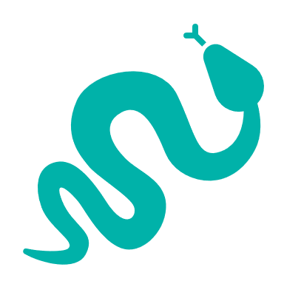
4 reptiles with more than 5% of Victorian range in area
- Tussock Skink (vulnerable, 10%), Grass Skink (8%), Striped Legless Lizard (endangered, 7%), Corangamite Water Skink (critically endangered, 5%)
1 bird with more than 5% of Victorian range in area
- Brolga (vulnerable, 6%)

Strategic Management Prospects
Strategic Management Prospects (SMP) models biodiversity values such as species habitat distribution, landscape-scale threats and highlights the most cost-effective actions for specific locations. More information about SMP is available in NatureKit.

Additional threats
Threats identified (in addition to those modelled in SMP) through the consultation process were native vegetation removal, littering, barriers to on-ground management, inappropriate land use, water quality and quantity, Phytophthora cinnamomi, and stock.

Which landscape-scale actions are most cost-effective in this landscape?
The map shows where the most cost-effective threat control actions in this landscape are. Actions in these areas will maximise biodiversity benefit across Victoria for multiple species.

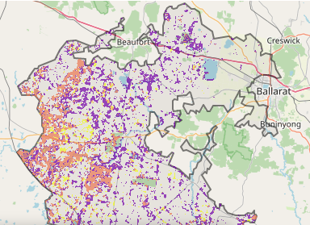
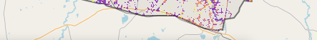
The very best threat control actions to do in the Top 3% of cost-effective areas are: rabbits, weeds, domestic stock grazing and permanent protection.
When we bring in the Top 10%, we also add the activities: pigs, foxes, overabundant kangaroos, cats ecological burning, grazing pressure (all grazers) and goats.

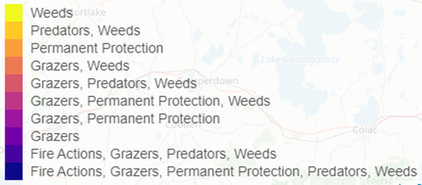

Area available for highly cost-effective revegetation
298ha
For a further in depth look into SMP for this landscape please refer to NatureKit.

Priority Areas Map – Victorian Volcanic Plains (VVP) - West
Base layers: This data is from SMP and represents the best areas to carry out the most cost-effective actions for specific threats (also referred to as the Top 10% of Mean Cost-effectiveness (MCE) actions), and the Top 20% locations (locations have been given names and are referred to as descriptors)
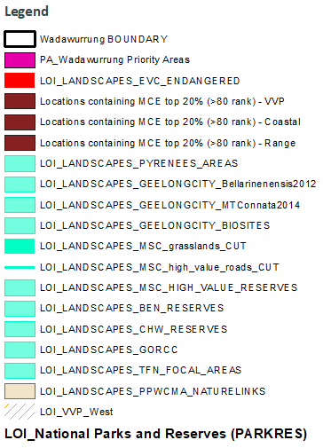
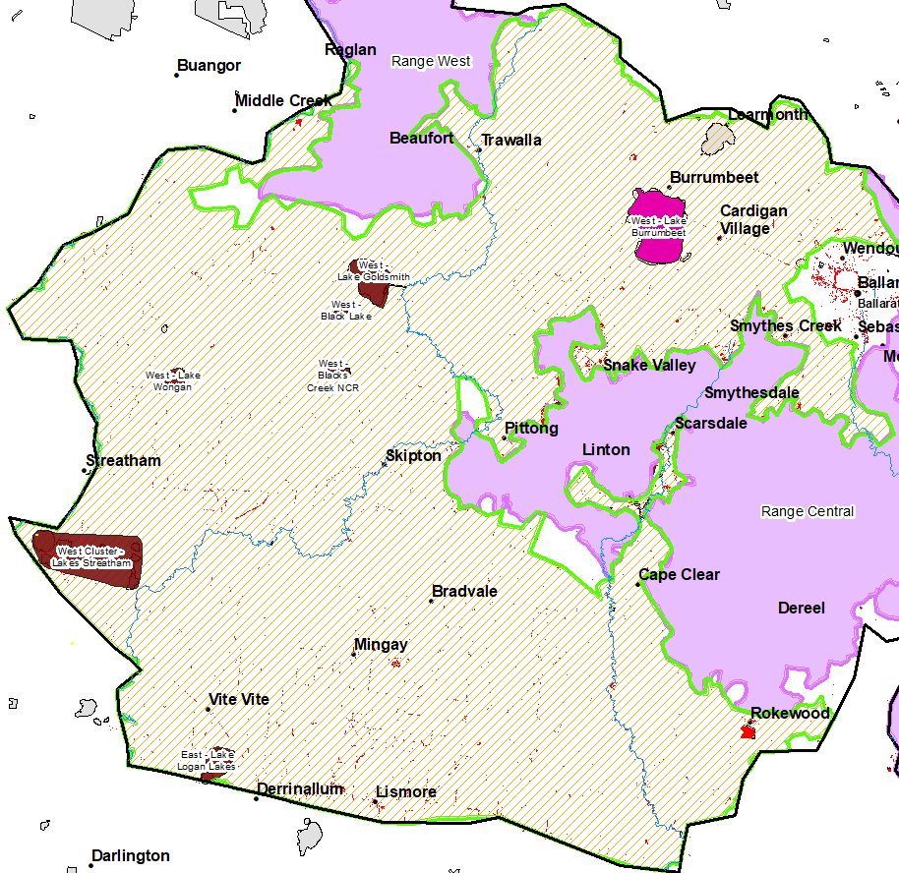
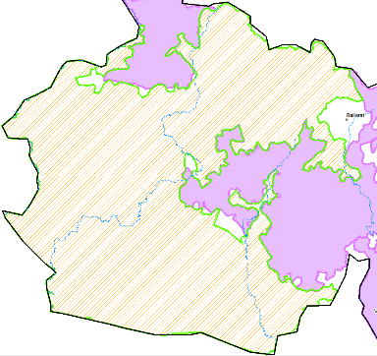
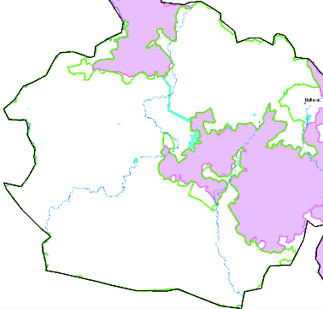
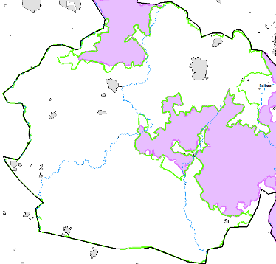
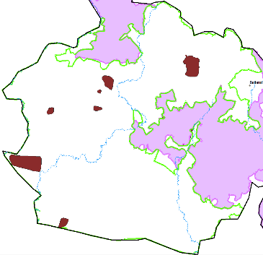
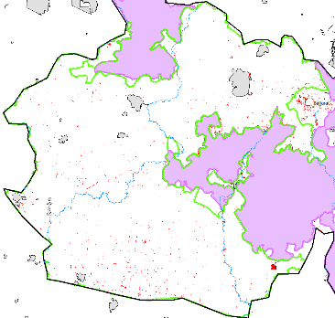
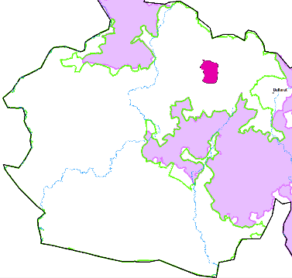
Priority Areas: Wadawurrung Priority Areas, stakeholder’s Landscapes of Interest (LoI), endangered Ecological Vegetation Classes (EVCs), National Parks & Reserves
1/ VVP Zone (orange stripes); 2/ National Parks & Reserves (grey); 3/ Stakeholder’s LoI (aqua); 4/ Descriptors (brown); 5/ Endangered EVCs (red); 6/ Wadawurrung initial Priority Areas (pink)
1
6
55
4
3
2

