Introduction
Biodiversity Response Planning (BRP) is a long-term area-based planning approach to biodiversity conservation in Victoria. It is designed to strengthen alignment, engagement and participation between government, Traditional Owners, non-government agencies and the community.
DELWP Regional staff have been working with stakeholders on actions to conserve biodiversity in specific landscapes, informed by the best available science and local knowledge.
These Fact Sheets capture a point in time, reflecting data and knowledge available in 2020. They provide information for many (but not all) landscapes across Victoria, containing general information on the key values and threats in each area, as well as the priority cost-effective actions that provide the best protection of biodiversity. Fact Sheets are intended to provide useful biodiversity information for the community, non-government and government organisations during project planning and development.
Further information and the full list of Fact Sheets is available on the Department’s Environment website.

Landscape description
The Kerang Ramsar Wetlands is 93,720ha in size with 28% of the area covered in native vegetation. Public land covers 19% of the area, which includes the Kerang Wetlands Ramsar site, and other public land including Johnsons and Hird Swamps. Refer to the map at the end of this Fact Sheet.

Cultural importance
We recognise that the entire landscape has high cultural value for Traditional Owners. Landscapes identified as having “notable” cultural importance is based on the density of recorded cultural heritage sites and knowledge shared by Traditional Owners. We also recognise that there are locations important to Traditional Owners not within these landscapes.

Stakeholder interest
As part of the BRP process, in October 2020 stakeholders were asked to nominate focus landscapes and actions of interest. North Central Catchment Management Authority, Goulburn-Murray Water, Barapa Country Aboriginal Corporation, Coliban Water and Parks Victoria all nominated Kerang Ramsar Wetlands.
Possible future investment/project development in this landscape will be available to any interested stakeholders in addition to those who nominated this landscape.

0BEcological values identified by Traditional Owners, partners and community within this landscape
Federally listed under the Environment Protection and Biodiversity Conservation Act 1999 (EPBC) Buloke communities present (presents as semi-arid Chenopod Woodland) that are located around some Kerang wetlands
Several of these are considered threatened at the international, national or state level and/or are listed on international migratory bird agreements (Japan-Australia Migratory Bird Agreement (JAMBA), China-Australia Migratory Bird Agreement (CAMBA) and Republic of Korea-Australia Migratory Bird Agreement (ROKAMBA)) or the Bonn Convention
The wetlands provide important feeding and nesting habitat for more than 50 waterbird species and 76 waterbird species have been recorded at the site
Cultural fire on Country:
- Winlaton - Winlaton Nature Conservation Reserve (NCR) North East block
- Kerang – Barapa Land and Water (BLW)-Tragowel swamp NCR Block 1
- Kerang South - BLW Tragowel Swamp NCR
- Kerang - BLW Kerang Wildlife Reserve (WR)
- Macorna North - BLW Johnson Swamp WR block 1
- Macorna North - BLW Johnson Swamp WR block 2
- Teal Point - BLW-McDonald Swamp
- Winlaton - Winlaton NCR
- Winlaton - Winlaton NCR North Central block
- Macorna North - Hird Swamp WR
- Winlaton - Winlaton NCR South East block
- Winlaton - Winlaton NCR East block

 | Habitat Distribution Models identify 42 species with more than 5% of their Victorian range in this landscape area | Traditional Owners, stakeholders and community groups identified the following species of interest within this landscape
 | 39 Plants, notably:  - Downs Nutgrass (Cyperus bifax), vulnerable with 16% of its Victorian range in area  - Blackseed Glasswort (Tecticornia pergranulata subsp. divaricata), vulnerable with 15% of its Victorian range in area  - Six-point Arrowgrass (Triglochin hexagona), vulnerable with 13% of its Victorian range in area | - Hoary Scurf pea  - Spreading Scurf-pea  - Buloke  - Downy Swainson-pea
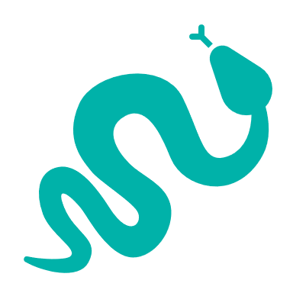 | 1 Reptile:  - Hooded Scaly-foot, critically endangered with 8% of its Victorian range in area | - Samphire Skink, Broad-shelled Turtle, Murray River Turtle
 | 2 Birds:  - White-winged Fairy-wren, no rating with 7% of its Victorian range in area  - Ground Cuckoo-shrike, vulnerable with 6% of its Victorian range in area | - Australasian Bittern  - Painted Snipe  - Brolga  - Freckled Duck  - Blue-billed Duck  - White-bellied Sea-Eagle  - Wedged-tailed Eagle
 | Amphibians | - Growling Grass Frog
Other | Fish:  - Murray Hardyhead  - Murray Cod

Traditional Owners, stakeholders and community groups identified the following threats within this landscape
Soil compaction and physical damage to vegetation by cattle, stock, deer, pigs and rabbits
Woody and non-woody weeds, for example, Typha (inhibits the diversity of emergent and herbaceous wetland vegetation communities)
Pest animals including:
- cats and foxes – predation on native aquatic species
- deer and pigs
Environmental water/flow (regulation)

Strategic Management Prospects
Strategic Management Prospects (SMP) models biodiversity values such as species habitat distribution, landscape-scale threats and highlights the most cost-effective actions for specific locations. More information about SMP is available in NatureKit.

Additional Threats
Threats identified (in addition to those modelled in SMP) through the consultation process were:
- alterations to hydrology
- land salinisation
- soil erosion
- habitat degradation due to extremes of climate and weather and lack of regeneration in some vegetation classes
- recreational activities causing fragmentation
- loss of vegetation, and erosion
- legacy use of public land
- private land use impacting biodiversity
- inappropriate land use planning
- inappropriate fire regimes (planned burning and bushfires).
Some individual threatened species may also require targeted intervention, beyond actions to manage landscape-scale threats, to improve their future prospects.

Which landscape-scale actions are most cost-effective in this landscape?
The coloured areas indicate where the identified landscape-scale actions and locations are most cost-effective and will maximise biodiversity benefit across Victoria for multiple species.
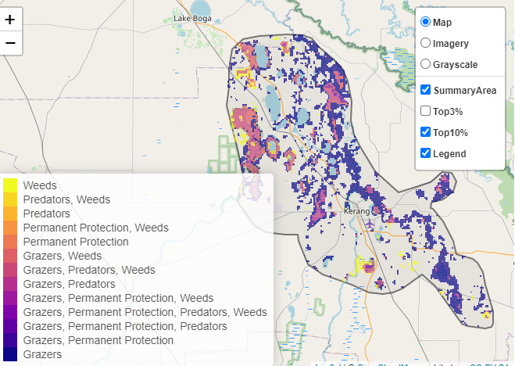
The SMP priority actions which rank among the top 10% for cost-effectiveness of that action across Victoria for much of the landscape are in order of the top 3 actions, see map and list below:
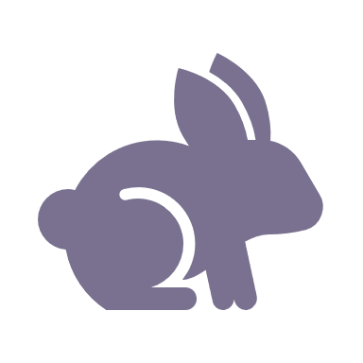 | Control rabbits 16,114ha
 | Control pigs 11,183ha
 | Control weeds 9,123ha

Of the top 10% of cost-effective actions, controlling rabbits provides the most cost-effective biodiversity benefits when considering all flora and fauna.

From the nomination process the following additional actions were also suggested for this landscape:
- action planning and monitoring
- fox control
- cat control
- culture fire
- protecting Southern Purple Spotted Gudgeon

The most cost-effective action for flora and fauna
Plants - Control rabbits
Mammals, birds, amphibians, reptiles - Combined cat and fox control

For a further in depth look into SMP for this landscape please refer to NatureKit.

