|  |
| --- |
| **Emergency Response**  **Aerial Shooting Operation**  **SUMMARY REPORT** |
|  |
|  |

delwp.vic.gov.au

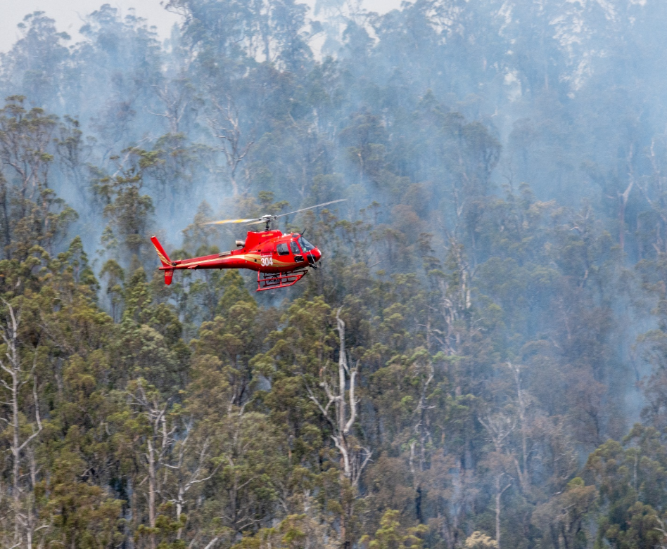

|  |  |
| --- | --- |
|  |  |

https://www.environment.vic.gov.au/invasive-plants-and-animals/managing-invasive-species-after-fire

Acknowledgements

|  |  |  |  |
| --- | --- | --- | --- |
|  |  |  |  |

This activity was funded through the State of Victoria’s Emergency Management of the 2019-20 bushfire and the Victorian Government’s Bushfire Biodiversity Response and Recovery Program. The operation was collaboratively delivered by staff from Emergency Management Victoria, Department of Environment, Land, Water and Planning, Parks Victoria, Country Fire Authority and specialised aviation contractors.

Photo credit

Deer impact: DELWP Gippsland

Helicopter: DELWP

Deer: Parks Victoria

|  |
| --- |
| Acknowledgment  We acknowledge and respect Victorian Traditional Owners as the original custodians of Victoria's land and waters, their unique ability to care for Country and deep spiritual connection to it. We honour Elders past and present whose knowledge and wisdom has ensured the continuation of culture and traditional practices.  We are committed to genuinely partner, and meaningfully engage, with Victoria's Traditional Owners and Aboriginal communities to support the protection of Country, the maintenance of spiritual and cultural practices and their broader aspirations in the 21st century and beyond. |
| © The State of Victoria Department of Environment, Land, Water and Planning 2020  This work is licensed under a Creative Commons Attribution 4.0 International licence. You are free to re-use the work under that licence, on the condition that you credit the State of Victoria as author. The licence does not apply to any images, photographs or branding, including the Victorian Coat of Arms, the Victorian Government logo and the Department of Environment, Land, Water and Planning (DELWP) logo. To view a copy of this licence, visit <http://creativecommons.org/licenses/by/4.0/>  **ISBN** 978-1-76105-406-8 **(pdf/online/MS word)**  Disclaimer  This publication may be of assistance to you but the State of Victoria and its employees do not guarantee that the publication is without flaw of any kind or is wholly appropriate for your particular purposes and therefore disclaims all liability for any error, loss or other consequence which may arise from you relying on any information in this publication.  Accessibility  If you would like to receive this publication in an alternative format, please telephone the DELWP Customer Service Centre on 136186, email [customer.service@delwp.vic.gov.au](mailto:customer.service@delwp.vic.gov.au), or via the National Relay Service on 133 677 [www.relayservice.com.au](http://www.relayservice.com.au). |

Contact for Enquiries

**Email:** Biodiversityresponse.bushfire@delwp.vic.gov.au

Contents

Glossary 4

Summary 5

1. Introduction 7

1.1. Purpose and Scope of the Report 7

2. Background 7

2.1. The 2019-20 Bushfires 7

2.2. Biodiversity response and recovery preliminary report 8

2.3. Priority 7-day Actions 8

2.4. State Controller Wildlife 9

3. Intensified and Sustained Threat Management 9

3.1. Window of Opportunity 11

4. Emergency Response Aerial Shooting Operation 11

4.1. The Operation 11

4.2. Target and Non-Target Species 12

4.3. Objectives 14

5. Results 14

5.1. Operational Effectiveness 14

5.1.1. Localised Eradication 15

5.2. Benefit to Biodiversity 15

5.2.1. Plant Communities 15

5.2.2. Change in Suitable Habitat 15

5.2.3. Fauna (excluding invertebrates) of most concern 16

5.2.4. Flora of most concern 16

6. Going Forward 17

7. References 18

# 

# Glossary

|  |  |
| --- | --- |
| Term | Definition |
| BBRR program | The Victorian Government’s Bushfire Biodiversity Response and Recovery program, which delivers actions to support and protect Victoria’s plants and animals following the fires. For more information on the BBRR program, visit: [www.wildlife.vic.gov.au/home/biodiversity-bushfire-response-and-recovery](http://www.wildlife.vic.gov.au/home/biodiversity-bushfire-response-and-recovery) |
| Protecting Victoria's Environment - Biodiversity 2037 | The Victorian Government's ambitious plan to stop the decline of our biodiversity and achieve overall biodiversity improvement over the next 20 years. |
| Change in Suitable Habitat (CSH) | A spatially explicit, species-specific measure that the Victorian Government uses under *Biodiversity 2037* to quantify the benefit of conservation actions. It is calculated using local-scale estimates of species persistence under action and no-action scenarios to assess the difference an action makes to the local persistence probability of individual species. |
| Economic return on investment | A performance measure used to evaluate the efficiency of an investment. The benefit of an investment (or return) is divided by the cost of the investment. |
| Effective search area | Effective search area is defined by calculating a 2km convex hull around the control flight path. |
| Emergency response | The period over which bushfires were active in Victoria, and delivery of the aerial shooting operation was via an incident management team (IMT) under the Emergency Management Victoria (EMV) framework.  For more information visit: <https://www.emv.vic.gov.au/> |
| Ecological Vegetation Classes (EVC) | Ecological Vegetation Classes (EVC) are the standard unit for classifying vegetation types in Victoria. EVCs are described through a combination of floristics, lifeforms and ecological characteristics. |
| Fire recovery | The period after the emergency response has concluded. |
| Introduced large herbivores | A large plant-eating animal that is not native to Australia. In the context of the emergency response aerial shooting operation, introduced large herbivores included deer, feral cattle, feral goats and feral pigs (although feral pigs are technically omnivores). |
| Invasive species invasion curve | The invasion curve shows the stages of invasive species management from pre-arrival (prevention) to long-term control. After a species is introduced, management costs increase, and likelihood of eradication decreases as time passes. |
| Local persistence | The probability or likelihood of a species surviving within a given area. |
| Management area | The area considered effectively managed for introduced large herbivores by the emergency response aerial shooting operation.  The calculation of the management area is a combination of:   * The helicopter flight path buffered by 200m either side of the aircraft. * A buffer placed around each controlled animal (feral goats 1km, deer 2km, feral cattle and pigs 5km). |
| Pest predators | An animal that naturally preys on other animals and is not native to Australia. In the context of the emergency response aerial shooting operation, pest predators included feral cats and foxes. |
| Plant community | A collection or association of plant species within a designated geographical unit, which forms a relatively uniform patch, distinguishable from neighbouring patches of different vegetation types. |
| Priority area | Areas of public land (including national park, wilderness park and state forest) identified as highest priority for aerial shooting for the immediate protection of native plant and animal species of most concern following the 2019-20 bushfires. |
| State Controller Wildlife | Appointed by the Emergency Management Commissioner in accordance with the State Emergency Management Plan, a State Controller is responsible for planning and control of response activities for an anticipated or occurring Class 2 emergency.  The role of the State Controller Wildlife was to guide the delivery of emergency actions for wildlife welfare and biodiversity protection in accordance with the Victorian Emergency Management arrangements. |

# Summary

Background

The 2019-20 bushfires were exceptional in size and impact on native plants and animals in Victoria. These fires generated a new level of public scrutiny and expectation on the government’s response to protecting not just lives and built assets from fire impacts, but also the natural environment and wildlife. For the first time in Victoria’s history, a State Controller Wildlife was stood up within the incident control structure and endorsed the delivery of an emergency response aerial shooting operation for introduced large herbivores and pest predators as a critical immediate action to mitigate the risk of localised or species extinction.

The Operation

The emergency response aerial shooting operation was conducted for 11 operational weeks between 10 February 2020 and 8 May 2020. In 42 days of operation, 73 missions were undertaken, including 210 hours total flight time (i.e. transit and control time) and 152 control flight hours.

Areas of operation were prioritised to protect species of most concern following the bushfire as identified in the *Victoria’s bushfire emergency – Biodiversity response and recovery preliminary report - Version 1*. The operation was delivered on public land across parks and state forests, with primary efforts focused on the protection of Alpine Bogs, the Snowy River Corridor and the Howe Wilderness / Howe Flat. Priority areas were expanded throughout the course of the operation as information on at risk species and plant communities evolved.

The objectives of the operation were to:

* Reduce the immediate and short-term post-fire impact of introduced large herbivores and pest predators on the survival and recovery of threatened flora and fauna species.
* Deliver the highest priority on safety, compliance and humane destruction of target species.
* Optimise a critical window of opportunity for management efficiency and effectiveness when canopy and ground cover is reduced and target pest species are still largely congregating around limited resources (shelter, food, water) and are yet to significantly disperse across the landscape.

Results

Setting the objectives for an unprecedented emergency response operation is different to business as usual as the ability to set expected targets is reduced by great uncertainty around fire severity and impact on the density and distribution of target species. Consequently, the key measure of success for the operation was clearing or reducing target animals to the lowest possible numbers from identified high priority habitats to provide immediate relief to native species of most concern following the bushfire and facilitate their recovery and survival.

The operational effectiveness outcomes for the operation are as follows:

|  |  |
| --- | --- |
| **Indicator** | **Effectiveness** |
| **Extent of Target Management Area Treated** | **255,992** hectares of priority habitat treated |
| **Target Species Controlled** | **1558** target animals controlled:  1,434 Sambar Deer, 39 Fallow Deer, 43 feral pigs, 27 feral goats, 9 feral cattle, 6 foxes |
| **Reduction in Deer Abundance & Density^** | Reduced by **50%** within the effective search areas |
| **% of animals observed that were controlled\*** | **90%** of observed animals were controlled |
| **Average number of animals per minute** | **1** target animal controlled every **3.7** minutes on average in the Snowy River NP & surrounds and **1** target animal controlled every **5.9** minutes on average across all priority areas. |
| **Localised Eradication** | Likely localised eradication of **feral cattle** within the Snowy River Corridor and **feral goats** within Mount Mittamatite Regional Park. |

^ Based on spatial abundance modelling of Sambar Deer using operational mission data (DELWP 2021)

* There was no opportunity for the remaining 10% of observed animals under the strict rules of engagement, such as not shooting if the animal is likely to fall into water and only shooting if an instantly fatal shot is highly probable.

The benefits to biodiversity for the operation are as follows:

|  |  |
| --- | --- |
| **Indicator** | **Effectiveness** |
| **Ecological Vegetation Communities (EVCs) Protected** | **21** of the **29** EVCs significantly impacted by the 2019-20 bushfires were managed under the aerial shooting operation. |
|  | **34** of the **47** EVCs impacted by multiple fires since the year 2000 were managed under the aerial shooting operation. |
|  | **52%** of Alpine Bogs, **30%** of Littoral Rainforest, **21%** of Warm Temperate Rainforest and **12%** of Cool Temperate Rainforest within identified priority locations were managed under the aerial shooting operation. |
| **Expected Increase in Probability of Local Persistence** (Change in Suitable Habitat) under sustained long-term management | **691** flora and fauna (excluding invertebrates) species in total are expected to increase in probability of local persistence under sustained long-term herbivore control, including **32** EPBC, **64** FFG and **401** DELWP Advisory listed species. |
|  | **22** fauna species identified as of most concern in the Biodiversity Response and Recovery Report are expected to increase in probability of local persistence (Change in Suitable Habitat) under sustained long-term herbivore control. |
|  | **72** flora species identified as of most concern in the Biodiversity Response and Recovery Report are expected to increase in probability of local persistence (Change in Suitable Habitat) under sustained long-term herbivore control. |

Conclusion

Aerial shooting from helicopters as an emergency response operation is a highly effective and efficient way to manage introduced animals for the benefit to biodiversity, especially where there is good visibility and in inaccessible or remote terrain. The open canopy, loss of understorey and the congregation of animals around scarce resources as a result of the 2019-20 bushfires provided a time-critical management opportunity perfectly suited for aerial shooting.

The ground-breaking success of embedding a specialist Aerial Shooting Operations Team into the incident command and control structure, and the proven ability to capitalise on a time-critical and valuable opportunity to significantly reduce the abundance and density of introduced animals immediately post fire sets out a blueprint for the future.

Aerial shooting is continuing as part of the Victorian Government’s Bushfire Biodiversity Response and Recovery program (BBRR) building on the outcomes of the emergency response to ensure that introduced animals are prevented from re-establishing or are kept at low population levels to assist the long-term recovery of important native flora and fauna species and their habitat.

# Introduction

The 2019-20 bushfires were exceptional in size and impact on native plants and animals in Victoria. These fires generated a new level of public scrutiny and expectation on the government’s response to protecting not just lives and built assets from fire impacts, but also the natural environment and wildlife.

The Victorian Government’s response to the bushfires delivered many firsts. This included the standing up of a State Controller Wildlife within the incident control structure for the first time in Victoria’s history, the development and delivery of rolling 7-day priority actions, including the fire-ground extraction of native species at risk of extinction in the wild and the immediate management of threats (introduced animals) though the delivery of an emergency response aerial shooting operation.

The emergency response aerial shooting operation commenced on Monday 10 February 2020 and concluded on Friday 8 May 2020 after 11 weeks and 42 days of operation and was delivered through the incident management structure. The integration of a specialised aerial shooting operations team into local incident management teams demonstrated an effective way to simultaneously deliver multiple outcomes - protection of life, property and biodiversity - via the command and control structure that sets out a blueprint for the future.

## Purpose and Scope of the Report

The purpose of this report is to provide the context within which the emergency response aerial shooting operation was designed and delivered and to document the results of the operation. The findings of this report were derived from analysis by experienced experts of comprehensive data collected through the delivery of the operation, including from real-time telemetry downloaded from the aircraft. An additional technical report has been prepared with detailed methodology on the analysis and the findings in full (DELWP 2021). This report does not include the on-going fire recovery aerial shooting operations that are currently being undertaken as part of the BBRR program, the results of which will be reported on at a later stage.

A separate process is being run to capture the key operational learnings with recommendations made to inform continuous improvement for future aerial shooting operations, both under emergency management, fire recovery and business as usual land management.

# Background

## The 2019-20 Bushfires

The 2019-20 bushfires were exceptional in size and impact and have had a devastating effect on native plants and animals in Victoria. More than 1.5 million hectares of Victoria was burnt, and many habitats and threatened species were severely impacted with vast areas of high severity fires (i.e. >80% of the canopy scorched) (Figure 1). Eastern Victoria is home to some of Victoria’s most significant biodiversity, including alpine environments, the southernmost reaches of cool temperate rainforest and endemic species found nowhere else in the state, like the Eastern Bristlebird. The impact of the fires was predicted to be devastating for species persistence in Victoria.

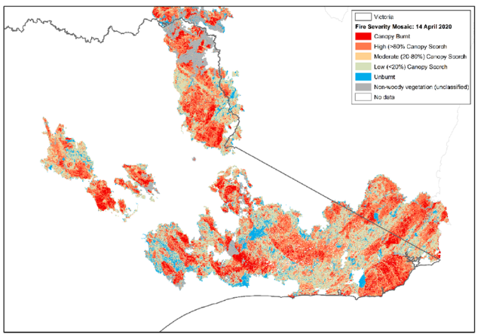

**Figure 1: Map of fire extent and severity across Eastern Victoria from the 2019-20 fire season**

## Biodiversity response and recovery preliminary report

The Victorian Government’s Department of Environment, Land, Water and Planning (DELWP) worked with partners, experts and key stakeholders to document the initial impact of the 2019-20 fire season on biodiversity, and guide planning for biodiversity response and recovery to ensure sound and timely decisions on government priorities and investment could be made.

*[Victoria’s bushfire emergency – Biodiversity response and recovery](https://www.wildlife.vic.gov.au/__data/assets/pdf_file/0030/484743/Victorias-bushfire-emergency-Biodiversity-response-and-recovery-Version-2-1.pdf) preliminary report* (DELWP 2020a) was released by the Victorian Government on 23 January 2020 along with a $17.5 million funding package for the first phase of the BBRR program.

The report, and subsequent updated version released in August 2020 (DELWP 2020b) highlighted the species, habitats and plant communities of most immediate concern. The report identified:

* 244 species with more than 50% of their modelled habitat within the burnt area, including 215 rare or threatened species.
* 43 species had more than 50% of their modelled habitat impacted by high severity fire, including 42 rare or threatened species.
* Nine ecological vegetation classes (EVCs) had more than 50% of their extent burnt.

## Priority 7-day Actions

Simultaneous to the development of the *Victoria’s bushfire emergency –Biodiversity response and recovery report*, the Victorian Government identified and delivered critical immediate actions to mitigate the risk of localised or species extinction. These became known as the priority 7-day actions and included:

* Airborne information gathering.
* A fire suppression plan to protect Howe Range/Howe Flat/Cape Howe.
* Species extraction of the Eastern bristlebird and aquatic fauna (*galaxias* spp).
* Supplementary feeding for wildlife welfare.
* Intensified and sustained management of threats – the delivery of an immediate emergency response aerial shooting operation for introduced large herbivores and predators

## State Controller Wildlife

For the first time in Victoria’s history, a State Controller Wildlife was deployed under formal emergency response arrangements. The role of the State Controller Wildlife was to guide the delivery of emergency actions for wildlife welfare and biodiversity protection through the State Control Centre (SCC) under the Emergency Management Victoria (EMV) framework for managing the 2019-20 bushfires. The State Controller Wildlife was instrumental in facilitating the delivery of the priority 7-day actions, including the emergency response aerial shooting operation.

# Intensified and Sustained Threat Management

***Why control introduced animals immediately after fire?***

Controlling introduced animals as soon as possible after fire is a critical immediate action to help ensure the survival of threatened native flora and fauna and their habitats.

* A fire-reduced understorey can result in a **5-fold** increase of introduced predators (foxes and feral cats) in fire-affected areas.
* The relative consumption of prey will **at least double** post fire, expediting in many cases the risk of localised or species extinction.
* Fire causes a magnet effect for herbivores resulting in a **3-fold** strengthening of herbivore use.
* Shifts in diet and behaviour are commonly amplified in the first few weeks to months post-fire.
* The open canopy, loss of understorey and congregation of animals around scarce resources provide a time-critical management opportunity perfectly suited for aerial shooting.

Bushfires favour introduced predators by removing vegetation and reducing habitat complexity, potentially exposing native prey species to an enhanced risk of predation by novel predators (Gearyet al. 2020). In addition, bushfires amplify the effects of introduced herbivores as they compete with native species for scarce resources, impacting remaining or returning habitat and the persistence of native flora and vegetation communities at a time when they are most vulnerable.

A fire reduced understorey can result in a 5-fold increase in the occurrence of (introduced) predators and the relative consumption of prey will double (Hradsky 2017). These shifts in diet and behaviour are commonly amplified in the first few weeks to few months post-fire (Hradsky 2020). Figure 2 illustrates the way fire and (introduced) predators can interact to diminish populations of native animals, potentially driving species towards extinction.

Two predation scenarios.
The top half of the image shows the scenario of dense understorey vegetation, where it's difficult for predators to detect and catch prey. This leads to a low per capita predation rate and low predator activity and/or abundance. The native mammal survival is high and population is abundant.
The second scenario is the bottom half of the image is where there's an open understorey and it's easier for predators to detect and catch prey. This leads to a higher per capita predation rate and higher predator activity and/or abundance. The native mammal survival is low and the population is sparse/locally extinct.

**Figure 2: How fire creates a predation pinch point temporarily exacerbating the impact of introduced predators on small and medium sized mammals (figure taken from Hradsky 2020).**

Fire causes a magnet effect for herbivores, resulting in a 3-fold strengthening of herbivore use (Westlake et al. 2020). Rapidly removing large introduced herbivores such as deer, feral goats and feral pigs in and around fire affected areas is important to encourage recovery of vegetation and reduce competition for food between native and introduced animals. The impacts of introduced herbivores on sensitive plant communities across eastern Victoria are well documented and include impacts on recruitment, spreading weeds and significantly damaging native vegetation and critical habitat by grazing, trampling plants, rubbing against trees and wallowing (Peel et al. 2005).

Figure 3 illustrates the impacts that the 2019-20 bushfires have had on some of our sensitive alpine ecosystems. Further impacts from introduced large herbivores were identified as the greatest risk in the immediate post-fire period and without urgent management action, many alpine bogs and fens are likely to contract in size or disappear entirely (Tolsma 2020).

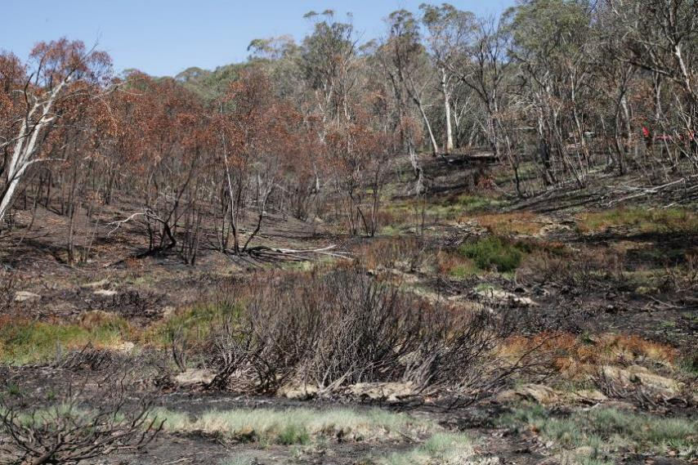

**Figure 3: Burnt bog below Davies Plain Hut, 27 February 2020 (Photo: Parks Victoria).**

## Window of Opportunity

The control of introduced animals as soon as possible after fire takes advantage of a time-critical window of opportunity when parks and forests are closed to the public due to safety risks caused by the fire, and animals are congregating around limited food and water and have yet to disperse across the landscape. Furthermore, the reduction in vegetation provides excellent visibility of target species and greater operational efficiency in reducing numbers in priority areas - the open canopy and loss of understorey provides a management opportunity perfectly suited for aerial shooting (Figure 4).

Given the lack of ground access to fire-affected areas for safety reasons, immediate threat management from the air is the only viable option.

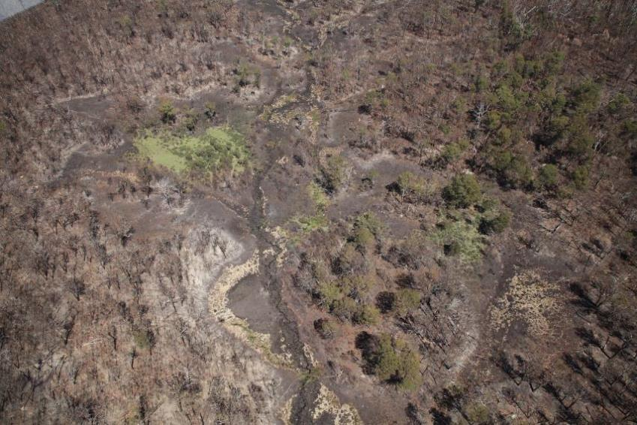

**Figure 4: Aerial view of part of burnt Forlorn Hope Plain, 27 February 2020. The pale crescent shape in centre foreground is the remains of a burnt Sphagnum bog. (Photo: Parks Victoria)**

# Emergency Response Aerial Shooting Operation

## The Operation

The emergency response aerial shooting operation was conducted for 11 operational weeks between 10 February 2020 and 8 May 2020. In 42 days of operation, 73 missions were undertaken, including 210 hours total flight time (i.e. transit and control time) and 152 control flight hours.

33 highly experienced staff with specialised skills were valued members of the Aerial Shooting Operations Team, drawn from four organisations: DELWP, Forest Fire Management Victoria, Parks Victoria and the Country Fire Authority (CFA).

The operation was endorsed by the State Controller Wildlife and authorised by the State Response Controller. The operation was delivered by a specialised taskforce – an Aerial Shooting Operations Team (ASOT) (Figure 5) - embedded into local Incident Management Teams. The integration of the ASOT into local incident command and control demonstrated an effective way to simultaneously deliver multiple outcomes - protection of life, property and biodiversity.

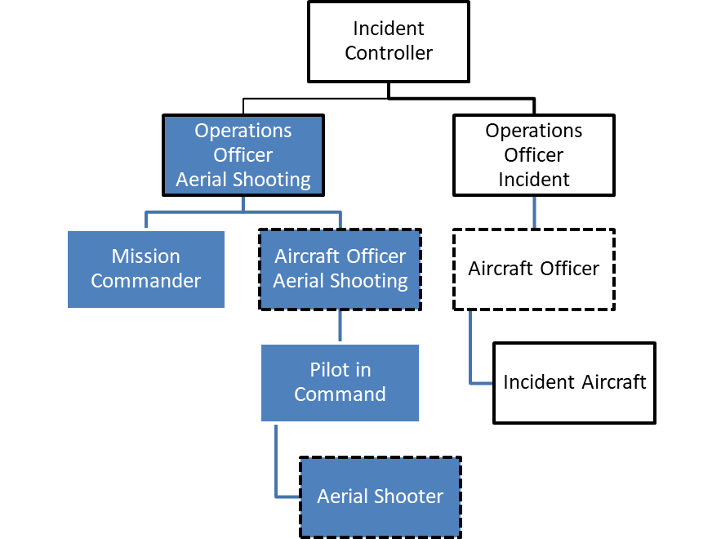

**Figure 5: Aerial Shooting Operations Team Structure and its relationship to the Local Incident Controller. Source:** **Aerial Shooting Operations Plan – Emergency Response Operation (Forest Fire Management Victoria (2020).**

## Target and Non-Target Species

#### Target species

The target species for the operation were deer (all species), feral goats, feral pigs, feral cats and foxes. Feral cattle were permitted targets in the Snowy River National Park only as they have been an eradication target for over a decade and are confirmed feral and unowned. Large herbivore targets (including pigs) took priority over foxes and cats. The destruction of deer as part of the operation was authorised under an Authority to Control Wildlife (ATCW) permit issued by the Office of the Conservation Regulator (DELWP) in consultation with the Game Management Authority.

#### Non-Target (No Shoot Species)

Non target (no shoot species) included horses, wild dogs, rabbits, native wildlife and any other animal not listed as a target species.

#### Priority Areas

Areas of operations were prioritised to protect species of most concern following the bushfire as identified in the [*Victoria’s bushfire emergency – Biodiversity response and recovery*](https://www.wildlife.vic.gov.au/__data/assets/pdf_file/0030/484743/Victorias-bushfire-emergency-Biodiversity-response-and-recovery-Version-2-1.pdf) *preliminary report* *version 1* and helping to deliver on *Protecting Victoria's Environment – Biodiversity 2037*. The operation was delivered on public land across parks and state forests, with primary efforts focused on the protection of Alpine Bogs, the Snowy River Corridor and the Howe Wilderness / Howe Flat. Priority areas were expanded throughout the course of the operation as information on at risk species and plant communities evolved (Table 1; Figure 6).

**Table 1: List of priority areas and the public land within each area**

|  |  |
| --- | --- |
| **Priority Area** | **Public Land** |
| **Snowy River National Park (NP) & Surrounds** | Snowy River NP, Tullock Ard State Forest (SF) |
| **Eastern Alps & Surrounds** | Alpine NP (including the Cobberas, Cowombat, Forlorn Hope and Davies Plain areas), Nunniong SF, Tambo SF, Benambra SF, Beloka SF |
| **Alpine National Park – High Plains** | Alpine NP (including the Bogong and Dargo High plains and Cobungra areas) |
| **Mount Buffalo National Park** | Mount Buffalo NP |
| **Coastal Areas** | Croajingolong NP (including the Cape Conran Coastal Park, Cape Howe Wilderness and Howe Flat), Tamboon SF, Wigan SF, Bemm SF, Mallacoota SF |
| **Wabba Wilderness Park (WP)** | Wabba WP |
| **Burrowa-Pine Mountain National Park** | Burrowa-Pine Mountain NP |
| **Mount Mittamatite Regional Park (RP)** | Mount Mittamatite RP |
| **Errinundra National Park & Surrounds** | Errinundra NP, Combienbar SF, Ellery SF, Murrangowar SF, Club Terrace SF |
| **Coopracambra National Park & Genoa Area** | Coopracambra NP, Merremingger SF, Drummer SF |
| **Nunniong Area** | Nunniong SF, Nunniong Plains Natural Features and Scenic Reserve, Nunnet SF, Marble Gully/Mount Tambo Nature Conservation Reserve (NCR), Splitters Range SF, Tambo SF |
| **Brodribb River Corridor** | Brodribb Flora Reserve, Orbost SF, Murrangowar SF, Ellery SF, Martins Creek NCR |
| **Tom Groggin** | Alpine NP, Tom Groggin SF |

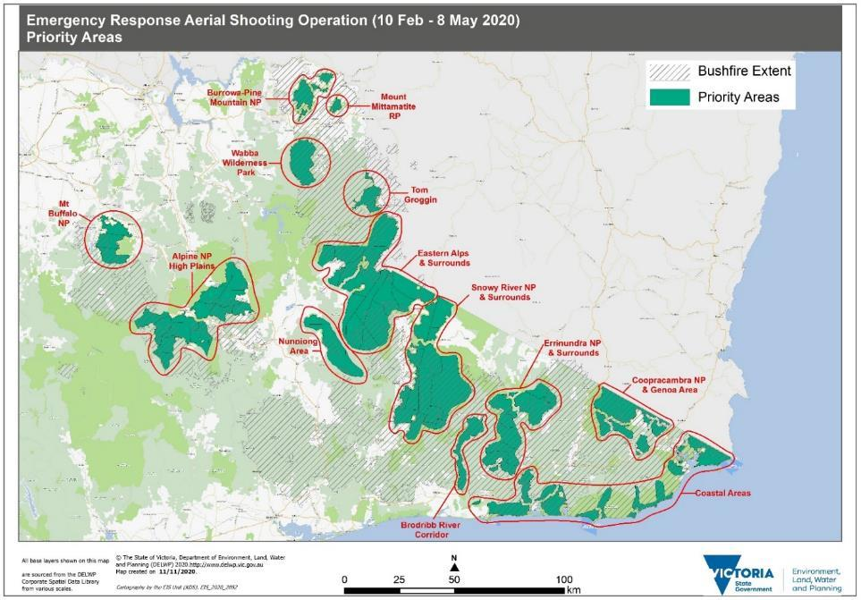

**Figure 6: Priority areas identified for the emergency response aerial shooting operation, to assist survival and recovery of threatened species and plant communities.**

## Objectives

The objectives of the operation were to:

* Reduce the immediate and short-term post-fire impact of introduced large herbivores and predators on the survival and recovery of threatened flora and fauna species.
* Deliver the highest priority on safety, compliance and humane destruction of target species.
* Optimise a critical window of opportunity for management efficiency and effectiveness when canopy and ground cover is reduced and the target pest species are still largely congregating around limited resources (shelter, food, water) and are yet to significantly disperse across the landscape.

In the context of this unprecedented emergency response operation, our ability to set expected targets was reduced by great uncertainty around fire severity and impact on the density and distribution of target species. Consequently, the key measure of success for the emergency response aerial shooting operation was to reduce the abundance of target animals to the extent possible from identified high priority habitats, to provide immediate relief to native flora and fauna of most concern following the bushfire and facilitate their recovery and survival.

# Results

The results of the emergency response aerial shooting operation have been described using operational effectiveness and benefits to biodiversity. This section provides a summary of the results. A separate technical report has been prepared describing the methodologies used and providing more detailed results and findings (DELWP 2021).

## Operational Effectiveness

The operational effectiveness outcomes for the operation are presented in Table 2.

**Table 2. Summary of the operational effectiveness for the Emergency Response Aerial Shooting Operation.**

|  |  |
| --- | --- |
| **Indicator** | **Effectiveness** |
| **Extent of Target Management Area Treated** | **255,992** hectares of priority habitat treated |
| **Target Species Controlled** | 1,434 Sambar Deer  39 Fallow Deer  43 feral pigs  27 feral goats  9 feral cattle  6 foxes  Total of **1558** target animals controlled |
| **Reduction in Deer Abundance & Density^** | Reduced by **50%** within the effective search areas |
| **% of animals observed that were controlled\*** | **90%** of observed animals were controlled |
| **Average number of animals per minute** | On average, **1** target animal was controlled every **5.9** minutes  **1** target animal controlled every **3.7** minutes on average in the Snowy River NP & Surrounds |

^ Based on spatial abundance modelling of Sambar Deer using operational mission data (DELWP 2021)

* There was no opportunity for the remaining 10% of observed animals under the strict rules of engagement, such as not shooting if the animal is likely to fall into water and only shooting if an instantly fatal shot is highly probable.

A note about the operational effectiveness for the emergency response aerial shooting operation. The results relating to number of animals controlled or average number of animals per minute must be seen within the context of the key measure of success for the operation - to reduce the abundance of target animals to the extent possible from identified high priority habitats, to provide immediate relief to native flora and fauna of most concern following the bushfire and facilitate their recovery and survival.

To that end, low numbers from a mission or a low catch per unit of effort (meaning when the aircrew spent more time searching rather than finding target animals) were valued outcomes. In that context, a high percentage of all observable animals cleared from an area is a key indication of operational effectiveness.

It is also important to remember that aerial control was the only option for immediate threat management following the bushfires and as such, direct comparisons of effectiveness between the emergency response operation and management programs in other contexts is not recommended.

### Localised Eradication

#### Eradication of feral cattle from the Snowy River National Park

Feral cattle have been an eradication target within the Snowy River National Park for over a decade, with Parks Victoria investing significant resources in ground-based control to try and eradicate the mob, which has been confirmed feral and unowned. The emergency response aerial shooting operation controlled all remaining nine feral cattle, a significant achievement given the feral cattle were wily and skilled at hiding, and in doing so delivered the likely localised eradication of feral cattle from the Snowy River National Park. While Parks Victoria will establish surveillance to confirm the eradication, multiple reconnaissance flights over the course of the 11-week operation with no further sightings of feral cattle have resulted in declaring the population eradicated. In the context of the invasive species invasion curve (Victorian Government 2010), this result is estimated to provide an economic return on investment of 1:25.

#### Potential Eradication of feral goats from Mount Mittamatite Regional Park

Feral goats have been an eradication target for Parks Victoria within Mount Mittamatite Regional Park for the past 15 years. The emergency response aerial shooting operation controlled all observable feral goats, 23 in total. While Parks Victoria will establish surveillance to confirm localised eradication, multiple reconnaissance flights and subsequent ground searches with no further feral goat sightings provides confidence in the potential eradication of this isolated population. In the context of the invasive species invasion curve (Victorian Government 2010), this result is estimated to provide an economic return on investment of 1:25.

## Benefit to Biodiversity

### Plant Communities

The emergency response aerial shooting operation delivered benefits to biodiversity in a significant percentage of fire impacted Ecological Vegetation Classes (EVCs) and listed threatened plant communities:

* 21 of the 29 Ecological Vegetation Classes (EVCs) significantly impacted by the 2019-20 bushfires were managed under the aerial shooting operation
* 34 of the 47 EVCs impacted by multiple fires since the year 2000 were managed under the aerial shooting operation
* 52% of Alpine Bogs, 30% of Littoral Rainforest, 21% of Warm Temperate Rainforest and 12% of Cool Temperate Rainforest within priority areas were managed under the aerial shooting operation

### Change in Suitable Habitat

The benefit to biodiversity from the emergency response aerial shooting operation is measured by the potential Change in Suitable Habitat. Change in Suitable Habitat (CSH) is the measure the Victorian Government uses under *Protecting Victoria's Environment – Biodiversity 2037* to quantify the benefit of conservation actions. It is calculated using local-scale estimates of species persistence under action and no-action scenarios to assess the difference an action makes to the local persistence probability of individual species under sustained action (Thomson et al. 2020). In the case of the emergency response aerial shooting operation, an increase in the probability of local persistence is what is expected if the CSH achieved through the operation were maintained under sustained long-term management.

A total of 691 flora and fauna (excluding invertebrates) species are expected to increase in probability of local persistence (Change in Suitable Habitat) under sustained long-term herbivore control across the management area, inclusive of 32 *Environment Protection and Biodiversity Conservation Act 1999* and 64 *Flora and Fauna Guarantee Act 1988* and 401 DELWP Advisory listed species (Table 4).

**Table 4: Change in Suitable Habitat expected from sustained long-term herbivore control across management area.**

|  |  |  |  |  |
| --- | --- | --- | --- | --- |
| **Change in Suitable Habitat (CSH)** | **Total species** | **Listed under the EPBC Act*^** | **Listed under the FFG Act\*** | **Listed under the DELWP Advisory List\*** |
| >30% | 3 species | 2 species | 2 species | 3 species |
| 20% to 30% | 2 species | 1 species | 1 species | 2 species |
| 10% to 20% | 37 species | 3 species | 10 species | 34 species |
| 5% to 10% | 105 species | 6 species | 14 species | 102 species |
| 1% to 5% | 544 species | 20 species | 37 species | 260 species |
| **Total >1%** | **691 species** | **32 species** | **64 species** | **401 species** |

* the same species may be included under one or more of these statutory listing processes

^ this list includes species currently under assessment

### Fauna (excluding invertebrates) of most concern

Twenty-two fauna species impacted by bushfire and identified as of most concern in the Biodiversity Response and Recovery Report are expected to increase in probability of local persistence (Change in Suitable Habitat) under sustained long-term herbivore control across the management area (DELWP 2021).

Key fauna species expected to receive significant benefit from sustained long-term herbivore control within the management area:

* Brush-tailed Rock Wallaby (*Petrogale penicilliate*) with a CSH of 35% under sustained long-term herbivore control.
* Alpine She-oak Skink (*Cyclodomorphus praealtus*) with a CSH of 30.7% under sustained long-term herbivore control.
* Eastern Bristlebird (*Dasyornis brachypterus*) with a CSH of 13.4% under sustained long-term herbivore control.
* Alpine Water Skink (*Eulamprus kosciuskoi*) with a CSH of 12.8% under sustained long-term herbivore control.

### Flora of most concern

Seventy-two flora species impacted by bushfire and identified as of most concern in the Biodiversity Response and Recovery Report are expected to increase in probability of local persistence (Change in Suitable Habitat) under sustained long-term herbivore control across the management area (DELWP 2021).

Key flora species expected to receive significant benefit from sustained long-term herbivore control within the management area:

* Snowy River Westringia (*Westringia cremnophila*) with a CSH of 18% under sustained long-term herbivore control.
* Summer Leek-orchid (*Prasophyllum uvidulum*) with a CSH of 17.3% under sustained long-term herbivore control.
* Green Grevillea (*Grevillea jephcotti*) with a CSH of 14.1% under sustained long-term herbivore control.
* Suggan Buggan Wax-flower (*Philotheca myoporoides subsp. Brevipedunculata*) with a CSH of 12% under sustained long-term herbivore control.

# Going Forward

Aerial shooting from helicopters as an emergency response operation is a highly effective and efficient way to manage introduced animals for the benefit to biodiversity, especially where there is good visibility and in inaccessible or remote terrain. The open canopy, loss of understorey and the congregation of animals around scarce resources as a result of the 2019-20 bushfires provided a time-critical management opportunity perfectly suited for aerial shooting.

The results from the current operation are consistent with other studies on the efficacy of aerial control of large herbivores, which have generally shown that significant reductions in abundance is achievable by aerial control over a range of habitats (Nugent et al. 1987; Saunders 1993; Parkes et al. 1996; Ferris 2010).

The ground-breaking success of embedding a specialist Aerial Shooting Operations Team into the incident command and control structure, and the proven ability to capitalise on a time-critical and valuable opportunity to significantly reduce the abundance and density of introduced animals immediately post fire provides a blueprint for future bushfires.

A debrief of the emergency response aerial shooting operation has been conducted and a report on the learnings is underway. This report will detail the operational aspects and actions for improving and progressing the use of aerial shooting as a management tool more broadly into the future, under emergency management, fire recovery and business as usual land management. It will include recommendations on planning, resourcing, operational procedures, communications and stakeholder engagement.

Aerial shooting is continuing as part of the immediate and short-term (0-1 year post fire) fire recovery effort, funded under phase one of the Victorian Government’s BBRR program. Aerial shooting remains a priority in phase two of the program addressing the medium-term (1-3 years post fire) recovery actions. The fire recovery aerial shooting program will build on the outcomes of the emergency response to ensure introduced animals are prevented from re-establishing or are kept at low population levels to assist the long-term recovery of important native flora and fauna species and their habitat. The operation will shift into new areas as introduced animals disperse and areas of park and forest impacted by severe fire activity start to regenerate.

Ground shooting efforts will also complement aerial operations, by following up after aerial shooting operations to control those animals for which there was no opportunity. Ground shooting will also be used to control target animals that are not suited to aerial control, such rainforest with a dense canopy. It is acknowledged that shooting (and particularly aerial shooting during the daylight hours) is not the most effective control method for foxes and feral cats. A suite of other control techniques such as baiting and trapping, along with the strategic use of exclusion fencing, will ensure that native flora and fauna species of most concern following the bushfires will be given the best chance of recovery.

# References

DELWP (2020a). Victoria’s bushfire emergency: Biodiversity response and recovery, Version 1, January 2020. Biodiversity Division, Department of Environment, Land, Water and Planning, Victoria.

DELWP (2020b). Victoria’s bushfire emergency: Biodiversity response and recovery, Version 2, August 2020. Biodiversity Division, Department of Environment, Land, Water and Planning, Victoria.

DELWP (2021). Emergency Response Aerial Shooting Operation: Technical Report, January 2021. Biodiversity Division, Department of Environment, Land, Water and Planning, Victoria.

Ferris, B. (2010). The 2008 - 2009 Aerial Feral Pig and Feral Goat Shooting Program: A Case Study in Northern New South Wales, Australia. *Proceedings of the Vertebrate Pest Conference,* 24 (24).

Forest Fire Management Victoria (2020). Aerial Shooting Operations Plan – Emergency Response Operation. February 2020.

Geary, W. L., Doherty, T. S., Nimmo, D. G., Tulloch, A. I., & Ritchie, E. G. (2020). Predator responses to fire: A global systematic review and meta‐analysis. *Journal of Animal Ecology*, ***89***(4), 955-971.

Hradsky, B. A., Mildwaters, C., Ritchie, E. G., Christie, F., Di Stefan, J. (2017). Responses of invasive predators and native prey to a prescribed forest fire. Journal of Mammalogy, **98**(3), 835–847.

Hradsky, B. A. (2020). Conserving Australia’s threatened native mammals in predator-invaded, fire-prone landscapes. *Wildlife Research*, ***47***(1), 1-15.

Nugent, G., Parkes, J. P., and Tustin, K. G. (1987). Changes in the density and distribution of red deer and wapiti in northern Fiordland. *New Zealand Journal of Ecology,* **10**, 11–21.

Parkes, J., Henzell, R. and Pickles, G. (1996) Managing Vertebrate Pests: Feral Goats. Australian Government Publishing Service, Canberra.

Peel, B., Bilney, R., and Bilney, R. (2005). Observations of the ecological impacts of sambar Cervus unicolor in East Gippsland, Victoria, with reference to destruction of rainforest communities. *Victorian Naturalist* 122, 189–200.

Saunders, G. (1993). Observations on the effectiveness of shooting feral pigs from helicopters in western New South Wales. *Wildlife Research,* **20**, 771-776.

Thomson, J., Regan, T.J., Hollings, T., Amos, N., Geary, W.L., Parkes, D., Hauser, C., and White, M. (2020). Spatial conservation action planning in heterogeneous landscapes. *Biological Conservation.*

Tolsma, A. (2020). BBRER Theme 1: Immediate reconnaissance - Activity 9: Threatened flora & vegetation communities. Post-fire assessment report: Alpine Bogs. Bushfire Biodiversity Response and Early Recovery Program. Arthur Rylah Institute for Environmental Research, Department of Environment, Land, Water and Planning, Heidelberg, Victoria.

Victorian Government (2010) Invasive Plants and Animals Policy Framework. Department of Primary Industries, Victoria. https://agriculture.vic.gov.au/__data/assets/pdf_file/0009/582255/Invasive-Plants-and-Animals-Policy-Framework-IPAPF.pdf

Westlake, S. M., Mason, D., Lázaro-Lobo, A., Burr, P., McCollum, J. R., Chance, D., & Lashley, M. A. (2020). The magnet effect of fire on herbivores affects plant community structure in a forested system. *Forest Ecology and Management*, *458*, 117794.